Adiponectin Serum Levels in AdolescentBoys with Type 1 Diabetesin Relationships to Pubertal Growth,Development and Glycemic control
Dr. Hayam Kamal Nazif ,Professor of Pediatrics. Institute of Postgraduate Childhood Studies. Medical Studies Department for Children.Ain- Shams University
Dr. Mohamed Hesham El Hefnawy, Professor of Diabetes andEndocrinology. Head of National Institute of Diabetes and Endocrinology
Dr. Laila Ibrahim AbouBasha , Professor of Clinical Chemistry. National Organization of Drug Control and Research
Hussein Mohamed Abd El Rahman Abbas . National Organization of Drug Control and Research
Abstract
Introduction: Adiponectin is a protein hormone secreted exclusively by adipocytes that regulate the metabolism of lipids and glucose. It has antidiabetic, antiatherogenic and anti-inflammatory properties.
Objective: To asses adiponectin serum levels in adolescent boys with type 1 diabetes mellitus (T1DM) and to assessits relationships with pubertal development, body mass index (BMI), glycemic control and insulin dosage.
Research design and methods: A case - control study was carried out on 45 adolescent boys with T1DM aged 12-18 years and 37 healthy control boys of similar age. Each of the cases and control groups were divided into four subgroups according to their Tanner stage .Theywere subjected to full history, reviewing medical records, auxology andpubertal stage assessment. Serum total adiponectinlevelwas determined by ELISA technique in addition to glycatedhaemoglobin(HbA1c) and fasting blood glucose.
Results: Mean adiponectin serum level (±SD) was significantly higher in T1DM boys compared to healthy control group (12.93 ± 5.24µg/mlversus 8.91± 3.21µg/ml) (P<0.001). Such higher serum levels of adiponectin were detected mainly at Tanner stage 2 (16.57 ± 4.60µg/mlvs 11.88±3.39µg/ml) (P=0.025) and Tanner stage 3 (12.77±3.71µg/ml vs.6.59±1.54µg/ml) (P=0.002). Adiponectin level decreased significantly during pubertal development in control groupand T1DM group. Adiponectin level was significantly higher in diabetic – poorcontrolled group than diabetic good-controlled group. Adiponectin was negativelycorrelated with pubertal stage, age, intermediate / long acting insulin dose and positively correlated to HbA1c in diabetic group. Incontrol group adiponectin levels were negatively correlated with pubertal stage and BMI.
Conclusion: Adiponectin serum levels in adolescent boys with type 1diabetes were significantly higher than control mainly at early puberty. It decreased significantly during pubertal development and was strongly positively related to glycemic control.
مستويات هرمون الأديبونكتين بالذكور المراهقين المصابين بداء السكري من النوع الأول وعلاقته بتطور البلوغ وإنضباط مستوي السكر بالدم
المقدمه:- الأديبونكتين هو احد الهرمونات التي تفرز فقط بواسطه الخلايا الدهنيه للجسم وينظم عمليات الأيض للدهون والسكريات. والأديبونكتين له خصائص مضاده لداء السكري ولتصلب الشرايين وللالتهاب.
الهدف:- هو تقييم مستويات هرمون الأديبونكتين في الذكور المراهقين المصابين بداء السكري من النوع الأول ودراسة علاقة تلك المستويات مع تطور البلوغ ،معامل كتلة الجسم ، انضباط مستوى السكر بالدموجرعة الإنسولين.
الأساليب:- الدراسه الحاليه تم تنفيذها علي 45 من الذكور المراهقين المصابين بداء السكري من النوع الأول بالمرحله السنيه من 12-18 ومجموعه اخري ضابطه تشمل 37 مراهقا من الأصحاء بنفس المرحله السنيه. وقد تم تقسيم كلا من المرضي والأصحاء طبقا لتطور مرحلة البلوغ الي أربعة مجموعات من مرحله البلوغ الثانيه وحتي الخامسه حيث تم أخذ التاريخ المرضي ومراجعة السجلات المرضيه مع القياسلت الأنثربومتريه وتقدير مرحلة البلوغ وتم قياس مستويات الأديبونكتين الكلي بتقنية إليزا بالاضافة لقياس نسبة الهيموجلوبين السكري والسكر الصائم بالدم.
النتائج :- مستوي هرمون الأديبونكتين كان بصورة ملحوظه أعلي بالذكور المراهقين المصابين بداء السكري من النوع الأول مقارنة بالأصحاء .تلك المستويات الآعلي وجدت بصفهأساسيه بالمرحلة الثانيه والثالثه للبلوغ. كما ينحفض مستوي الأديبونكتين بمرضي السكري من النوع الاول وكذلك الاصحاء بصوره ملحوظه أثناء تطور البلوغ. ومستوي هرمون الأديبونكتين كان أعلي بمجموعة مرضي السكري ذات التحكم الردئ بانضباط السكر بالدم عن المجموعه ذات التحكم الجيد بانضباط مستوي السكر. وقد وجدت علاقه عكسيه بالمصابين بداء السكري من النوع الأول بين مستوي هرمون الأديبونكتين و مرحلة البلوغ والسن وجرعة الإنسولين متوسط وطويل المفعول وبصوره طرديه مع مستوي الهيموجلوبين السكري. و بالمجموعه الضابطه توجد علاقه عكسيه بين مستوي الأديبونكتين و مرحلة البلوغ و معامل كتلة الجسم.
الخلاصه:- مستويات هرمون الأديبونكتين في الذكور المراهقين المصابين بداء السكري من النوع الأول أعلي بصوره ملحوظه عن الأصحاء وحاصة بالمراحل الأولي لتطور البلوغ وينحفض مستواه بصوره ملحوظه أثناء تطور البلوغ كما ترتبط بصوره ملحوظه بإنضباط مستوي السكر بالدم .
Introduction
Type 1 diabetes is generally thought to be precipitated by an immune-associated, if not directly immune-mediated, destruction of insulin-producing pancreatic β cells (Todd, 2010).The global incidence of type 1diabetes is increasing worldwide, at an annual rate of 3-5%, particularly in children under the age of 5 years, and this trend leads to a significant health burden (Patterson et al., 2009).
Adiponectin is a protein hormone secreted exclusively by adipocytes that regulate the metabolism of lipids and glucose (Savino et al., 2008).Among adipokines, adiponectin has gained considerable attention because of its antidiabetic, antiatherogenic and anti-inflammatory properties.Circulating adiponectin levels are determined by various genetic, anthropometric, hormonal, inflammatory, dietary, and pharmacological factors (Dalamaga et al., 2012).
The data concerning adiponectin in children and adolescents with type 1 diabetes are sparse and controversial. While some studies have showed that serum adiponectin levels were higher in T1DM Children and adolescents(Abd El- Maksoud et al., 2009; Barnes et al., 2008), other studies did not report any difference (Habeeb et al., 2012;Morales et al., 2004)
The relationship of adiponectin to glycemic control is controversial with some studies showing strong relationship( Barnes et al., 2008)and others failed to demonstrate such relationship(Galler et al., 2007).In addition, the effect of insulin therapy in modifying adiponctin serum level in T1DM adolescents is controversial.
Pubertal development is characterized by many physiological changes, involving both hormonal and metabolic processes, and these factors together with psychological issues are frequently responsible for poor glycaemic control. Treatment may be complicated by poor compliance, difficulties in targeting insulin therapy and concerns about weight gain (Dunger, 1992).Studies in adolescents have documented that pubertal development has an effect on adiponectin serum levels and that gender difference in adiponectin develop during pubertal development (Böttner et al., 2004).
Aim of the study:
To assessadiponectin serum levels in adolescent boys with type 1 diabetes mellitusand to explore the relationships between adiponectinand pubertal development, body mass index, glycemic controland insulin treatment.
Subjects and methods:
The present study was a case- control study conducted on 45 diabetic adolescents boys aged 12-18 years previously diagnosed as type 1 diabetes, recruited from diabetes clinic at the National Institute of Diabetes and Endocrinology, Cairo, EGYPTand 37 healthy controls boys.Written informed consent was obtained from the parents, and the study was approved by the Ethics Committee of the Institute of Postgraduate Childhood Studies and by that of the National Organization forTeaching Hospitals and Institutes.
Each ofthe cases and control groups were further divided into four subgroups according to their Tanner stage (Tanner stage 2-5) each containing a number ranging from 11-12 boys for casesand 8 -10 boys for the control. The cases and control groups were cross matched by age, Tanner stage and BMI. Within each Tanner stage the cases and control were matched by age andBMI.
Inclusion criteria for cases were:males , 12- 18 years old , Tanner stage 2: 5,diagnosis of type 1 diabetes according to criteria of American Diabetes Association(ADA, 2014), no diabetic complicationsand disease duration not less than 1 year. All patients were on insulin therapy only(two daily or multiple daily injections) with no other concomitant medications.
All cases were subjected to following:-
1- Full medical history and reviewing the medical records: To collect data concerningchronological age, age of onset of diabetes, diabetic duration, insulin regimen, insulin type, daily insulin dose.
2-Clinical examinations included:Auxology (weight, height assessment and BMI calculation).Auxological data were evaluated according to Egyptian percentile Charts(Ghalli et al., 2002).Pubertal assessmentwas done according to Tanner criteria(Tanner, 1962).
3-Laboratory investigations
After an overnight fast venous blood samples were obtained in the morning and dividedinto two parts. The first partwas used for fasting plasma glucose by the enzyme glucose oxidase methodand Glycated hemoglobin using HPLC fully automated system (Bio-Rad D-10 Haemoglobin testing system).The second part was immediately centrifuged at 4000 revolution for 5 minutes. Aftercentrifugation, serum was separated, stored at −20◦C until hormone determination.Serum adiponectin in samples was determined using an ELISA KITS (Assay Max Human Adiponectin ELLISA Kit) provided by Assaypro LLC company (USA). Intra-assay and inter-assay coefficients of variation were 4.3 % and 7.2 % respectively.
Statistical analysis
All statistical calculations were done using computer program SPSS (Statistical Package for the Social Science; SPSS Inc., Chicago, IL, USA) version 15 for Microsoft Windows. Comparison of numerical variables was done using Student ttest for comparing 2 groups when data was normally distributed and Mann Whitney U test when not normally distributed. P values less than 0.05 was considered statistically significant.
Results:
Table (1): Comparison between control and diabetic groups as regards number of cases at various pubertal stages
Variables |  |  | Group |  | X2 | P value
 |  |  | Control | Diabetic
Pubertal stage | T2 | Number | 10 | 12 | 0.124 | 0.989
 |  | % within Group | 27.0% | 26.7%
 | T3 | Number | 8 | 11
 |  | % within Group | 21.6% | 24.4%
 | T4 | Number | 10 | 11
 |  | % within Group | 27.0% | 24.4%
 | T5 | Number | 9 | 11
 |  | % within Group | 24.3% | 24.4%
Total |  | Number | 37 | 45
 |  | % within Group | 100.0% | 100.0%
Table (1)shows that there was statistically no significant difference between control and diabetic groups as regards number of cases at various pubertal stages (P=0.989).
Table (2): Comparison between control and diabetic groups as regards descriptive and clinical parameters
Variables | Control (n=37) | Diabetic (n=45) | t-test
 | Mean ± SD | Mean ± SD | t | P value
Age (years) | 14.67 ± 1.61 | 14.69 ± 1.54 | -0.061 | 0.951
Weight(kg) | 44.43 ± 10.42 | 46.41 ± 10.55 | -0.849 | 0.398
Height(cm) | 153.56 ± 11.55 | 157.19 ± 10.05 | -1.523 | 0.132
Body mass index  <5th BMI percentile  5-85 BMI percentile | 18.56 ± 2.00  16.02±0.69  (n=6)  19.06 ±1.79  (n=31) | 18.56 ± 2.56  15.61 ±1.05  (n=8)  19.19 ±2.33  (n=37) | 0.016  0.824  -0.266 | 0.987  0.426  0.791
Systolic BP(mm/Hg) | 110.22 ± 6.28 | 110.56 ± 7.63 | -0.213 | 0.832
Diastolic BP(mm/Hg) | 64.37 ± 3.52 | 71.78 ± 8.34 | -5.408 | 0.0001**
Fasting glucose (mg/dl) | 80.66 ± 8.35 | 176.80 ± 52.31 | -12.143 | <0.0001**
HbA1C  HbA1C in diabetic good-controlled (n=12)  HbA1C in diabetic poor- controlled (n=33) | 5.60 ± 0.47 | 9.39 ± 1.29  7.66± 0.78  10.02±0.73 | -18.349 | <0.0001**
Age of onset of diabetes( years) | _ | 9.18 ± 3.20 | _ | _
Duration of diabetes(years) | _ | 5.51 ±3.33 | _ | _
Insulin dose per day(units) | _ | 50.24 ± 20.36 | _ | _
Insulin dose per kg(units/kg) | _ | 1.09 ± 0.37 | _ | -
Dose of regular insulin(units) | _ | 27.07 ± 10.68 | _ | _
Dose of intermediate/long acting insulin (units) | _ | 22.73 ±1 2.97 | _ | _

Table (2) shows descriptive and clinical parameters of control and diabetic groups.
Table (3): Comparison between control and diabetic groups regardingadiponectin serum levels
Variable | Control (N=37) | Diabetic ( N=45) | t | P value
 | Mean ± SD | Mean ± SD
Adiponectin (µg/ml) | 8.91 ± 3.21 | 12.93 ± 5.24 | -4.266 | 0.0001**
Table (3) shows thatAdiponectin serum level (±SD) was significantly higher in T1DM boys compared to healthy control group (12.93 ± 5.24 µg/ml versus 8.91 ± 3.21 µg/ml) (P<0.001)
Table (4): Comparison of adiponectin serum levels between control and diabetic groups at various pubertal stages
 | Pubertal stage | Control | Diabetic | Mann-Whitney test
 |  | Mean ±SD | Mean ± SD | Z | P
Adiponectin (µg/ml) | T2 | 11.88 ± 3.39 | 16.57 ± 4.60 | -2.242 | 0.025*
 | T3 | 6.59 ± 1.54 | 12.77±3.71 | -3.139 | 0.002**
 | T4 | 8.90 ± 2.80 | 11.21 ± 5.93 | -0.704 | 0.481
 | T5 | 7.70 ± 2.11 | 10.84 ±0. 94 | -1.861 | 0.063

Table (4) showsthatthe higher levels of adiponectin in T1DM adolescent boys were detected mainly at Tanner stage 2 (16.57 ± 4.60µg/ ml vs 11.88 ± 3.39µg/ml) (P=0.025) and Tanner stage 3 (12.77±3.71 µg/ml vs.6.59 ± 1.54 µg/ml) (P=0.002).The difference was not significant at T4 (P= 0.481) and T5 (P= 0.063).
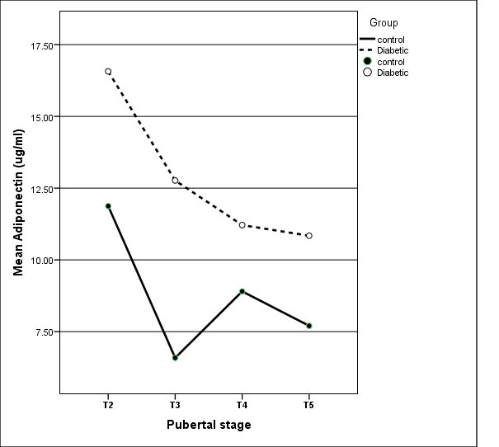
Figure (1): Variation in adiponectin serum level during pubertal development in control and diabetic groups
Figure (1) shows thatadiponectin serum levels decreased significantly during pubertal development in control group and T1DM group so that level at Tanner stage 5 was significantly lower than level at Tanner stage 2 (7.70 ±2.11 versus11.88 ± 3.3µg/ml, P= 0.009) in control group and (16.57 ± 4.60µg/ml versus10.84 ± 4.94µg/ml, p <0.043) in T1DMgroup. Also there was significant decrease of adiponectin level between Tanner stage 2 and Tanner stage 3 in control group (11.88 ± 3.39 versus 6.59±1.54µg/ml, P=0.001). The rate of decline in adiponectin serum level in T1DM boys was more smooth and regular in diabetic than control group.
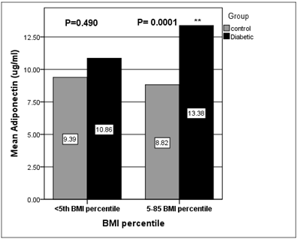
Figure (2): Comparison between control and diabetic groups as regards serum adiponectin level according to BMI percentile
Figure (2) shows thatthere was no difference between control and diabetic as regards adiponectin serum levels in underweight groups (P= 0.334) while the difference was significant between control and diabetic in normal weight groups (P≤0.0001).
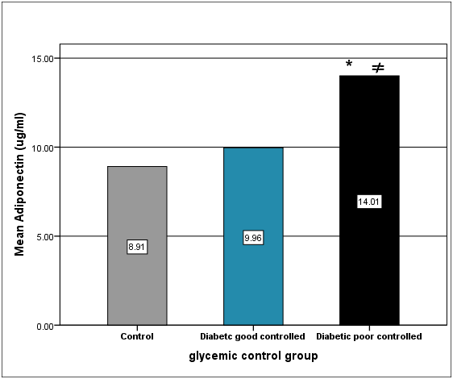
Figure (3): Adiponectin serum levels in control,diabetic good - glycemic control and diabetic poor- glycemic control groups groups
*Higher in diabetic (poor- controlled) than diabetic (good- controlled) P=0.018
≠ Higher in diabetic (poor-controlled) than control group P<0001
Figure 3 shows thatAdiponectin serum levels were significantly higher in T1DM poor- controlled group (HbA1c ≥8.5%) than in good-controlled group (HbA1c<8.5%)(14.01±5.22 µg /ml versus 9.96 ±4.15ug/ ml P<0.001) and higher than control group (14.01±5.22µg /ml versus 8.91±3.21µg/ ml P=0.018), however, there was no significant difference between good controlled diabetic group and control group (P=1.00).
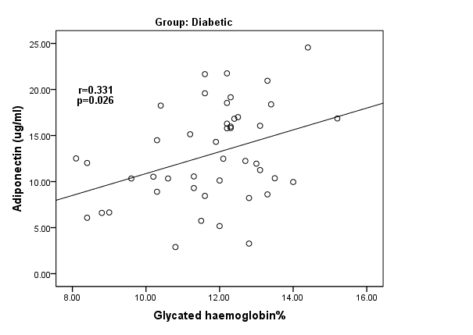
Figure(4):Correlation of adiponectin to glycatedhaemoglobin in the diabetic group
Figure(4) shows a significantpositive correlation of adiponectin to glycatedhaemoglobin in the diabetic group
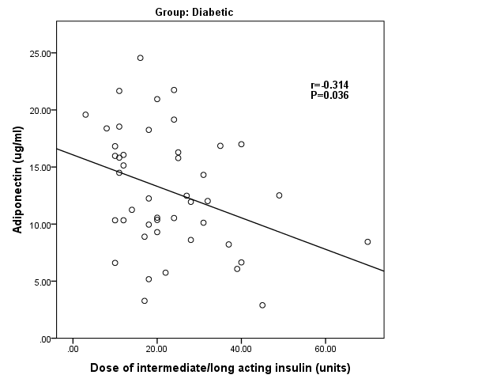
Figure(5):Correlation of adiponectin to dose of intermediate/ long acting insulin in the diabetic group
Figure(5) shows a significant negativecorrelation of adiponectin to dose of intermediate/ long acting insulinin the diabetic group
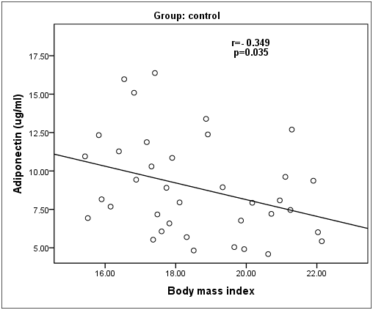
Figure (6): Correlation of adiponectin to body mass index in control group
Figure (6) shows a significant negative correlation of adiponectin to BMI incontrol group
Table (4): Stepwise multiple regression analysis of T1DM group with adiponectin as dependent variable
predictors |  | Standardized  Beta Coefficient  β | Std. Error  SEβ | P | R2 | ANOVA  P
 | Pubertal stage  Dose intermediate/kg  HbA1C % | -0.293  -0.277  0.269 | 0.616  3.091  0.428 | 0.035  0.043  0.047 | 0.325 | 0.001
Stepwise Regression analysis model in T1DM boys with adiponectin as dependent variable showed that Tanner stage (β= -0.293,p=0.035), dose of intermediate /long insulin (β= -0.277, p=0.043.) andGlycatedhaemoglobin% (β= 0.296, p=0.047) to be most significant predictors of adiponectinlevel in T1DM boys explaining 32.5% of variation in adiponectin serum levels 1nT1DM boys (R square =0.325, P=0.001)
Discussion
The results of the present study revealed that mean adiponectin serum level (±SD) was significantly higher in T1DM group compared to healthy control group.Most studies in children and adolescents with T1DM revealed similar results to our study regarding elevated adiponectin serum levels inT1DM adolescents(Jaleel et al., 2013; Abd El- Maksoud et al., 2009; Barnes et al.,2008).
In diabetic patients with constant hyperglycemia,the glycosylation process is probably altered,and this could lead to an altered adiponectin function. Consequently, a modified adiponectin molecule could lead to a diminished negative feedback, a mechanism that is an essential part of hormonal systems, and thus to increased adiponectin concentrations in diabetes (Saraheimoet al., 2005).In accordance with this theory we detected significant positive relationship between adiponectin andHbA1c and serum adiponectin levels was significantly higher in diabetic poor- glycemic control group than diabetic -good glycemic control group.
Low levels of insulinin T1DM patients cause future expression of adiponectin gene and more adiponectin secretion (Faraj et al., 2008).In accordancewith this theory Celi et al., (2006) postulated that lack of insulinization in T1DM leads to an elevation of adipoectin concentrations. However, a possible role of insulin therapy in modifying adiponectin serum levels was postulated by Celi et al., (2006) andHabeeb et al., (2012).
A third hypothesis was postulated by Schalkwijk et al., (2006) who postulated that adiponectin may be enhanced in type 1 diabetic patients as a physiologic counter regulatory response to mitigate endothelial damage and vascular damage. However, in present study elevated adiponectin levels could not be related to this theory as our patients did not have known complications of T1DM as detected by reviewing medical records and clinical examinations.
In contrast to results of elevated serum adiponectin level in adolescents with T1DM, Celi et al., (2006) and Morales et al.,(2004) reported that adiponectin levels adolescents with type 1 diabetes did not differ from those in healthy subjects.These authors may have analyzed male and female patients at different pubertal stages together whereas adiponectin is affected by gender and pubertal development.
In the present studyAdiponectin serum levels decreased significantly during pubertal developmentboth in control and diabetic groups.Several studies in healthy adolescent boys showed similar pattern of decline of adiponectin serum levels during pubertal development (Bottner et al., 2004; Martos-Morenoet al., 2006; Andersen et al., 2007)andTSOU et al., (2004) demonstrated thatadiponectin levels exhibited a V shape (transient drop) with a remarkable trough in boys aged 10–12 years. Such remarkable dropin adiponectin levels coincideswith the occurrence of an increase in testosterone level associated with male puberty.
InT1DM children and adolescents the longitudinal study by Galler et al., (2007) revealed that serum adiponectin levels decreased during puberty and were significantly lower at the end of puberty compared with pre-pubertal stage.Similarly ,Karmifar et al., (2013)demonstrated thatadiponectin level was negatively associated with puberty state (prepuberty – puberty- post puberty) in T1DM adolescents.
In the present study higher serum levels of adiponectin in T1DM adolescent boys were detected ,when compared with Tanner stage-matched control, only at Tanner stage 2 and Tanner stage 3 (early puberty). Gökşen et al., (2013) found that there were no differences in adiponectin levels between T1DM (17.6±4.0 years) adolescents and controls (16.43±4.1) at such late pubertal stages. In T1DM pubertal girls Iniguez et al., (2008) observed higher adiponectin levels at Tanner stage 2 and Tanner stage 3 only(early puberty) with similar levels at Tanner stage 4 and Tanner stage 5 (late puberty).
Glycemic control in diabetic subjects is known to deteriorate during puberty.In both the intensive and the conventional treatment groups, adolescents had 1% higher average long-term blood glucose levels (measured by HbA1c) compared with the adults (Diabetes Control and Complications Trial, 1994).In addition to endocrine changes associated with puberty, leading to greater insulin resistance many adolescents experience a deterioration in metabolic controloften attributable to erratic meal and exercise patterns, poor adherence to treatment regimens, hazardous and risk taking behaviours and eating disorders (Court et al.,2009).
Adiponectin serum level in present study was significantly higher in T1DM poor- controlled group than in good - controlled group and higher than control group, however, there was no significant difference between good controlled diabetic group and control group. These results were similar to those of Karamifar et al., (2013).Such variation in adiponectin serum levels between different glycemic control groups reflects the importance of metabolic control in determining serum adiponectn levels in T1DM and possibility of depending on adiponectin serum levels as sensitive biomarker of glycemic control in T1DM patients.
We detected a significant positive correlation between adiponectn and HbA1C levels In T1DM Group. In agreement with our study several studies in children and adolescents with T1DM have documented such relationship between adiponectin and HbA1c (Karamifar et al., 2013; Habeeb et al., 2012; Barnes et al., 2008). Such correlation was explained by altered glycosylation process in diabetic patients as explained previously. On the other hand, other studies in children and adolescents with T1DM failed to show such relationship between adiponectin and glycemic control (Goksen et al., 2013; Abd El – Maaksoud et al., 2009; Galler et al., 2007).
Strong negative correlation between adiponectin and dose of intermediate/ long acting insulin /kg was detected in the present study. Such correlation was present even after adjustment for HbA1C, insulin type and insulin regimen. Dose of intermediate/ long acting insulin/ kg in our study, though increased between Tanner stages in diabetic group, this difference didn’t reach significance.
The relationship of adiponctin to insulin is controversial. In an older in vitro study by Fasshauer et al., (2002) chronic exposure of insulin decreased adiponectin gene expression in the cultured 3T3-L1 adipocytes. In more recent study by Blümer et al., (2008) insulin had a direct stimulatory effect on adiponectin gene expression in 3T3-L1 adipocytes.
In healthy adolescentsRiestra et al., (2011);Iniguez et al., (2008);Tsou et al., (2004) reported that adiponectin serum levels negatively correlated with serum insulin and insulin resistance. On the other hand Celi et al., (2006) ;Kettaneh et al., (2006) ;Snehalatha et al., (2008) did not find correlation of adiponectin to fasting insulin and insulin sensitivity in healthy control subjects.
One of explanations of elevated adiponectin levels in T1DM is that absolute endogenous insulin deficiency may contribute to elevated serum adiponectin in type 1 diabetes (Imagawa et al ., 2002).
In adult studies for subjects with type T1DM and similar to our results Insulin dose was inversely related to adiponectin serum level in the studies byMaahs et al., (2007) and Pereira et al., (2012).
In T1DM Egyptian adolescents, Habeeb et al., (2012) revealed normal adiponectin level in the studied uncomplicated T1DM adolescent patients and suggested that absolute insulin deficiency may contribute to elevated level of serum adiponectin in type I diabetes, but appropriate regular treatment with insulin returned these levels to normal. ThoughCeli et al., (2006) found no correlation of adiponectin to insulin dosage, they assumed that the higher adiponectin levels detected in prepubertal T1DM children in comparison to control in their study may be attributable to inefficient insulin treatment, as demonstrated by positive association of adiponctin concentration with HbA1c in their study.
On the other hand,Abd El-Maksoud et al., (2009) found no relationship between adiponectin and daily insulin dose. Similarly, Iniguez et al., (2008) didn’t detect relationship of adiponectin to insulin dose in a study of T1DM adolescents girls and explained this by the fact that other factors, such as number of insulin injection and type and proportion of prandial / basal insulin concentrations, may be important for determining the insulin levels reaching the adipose tissue and thus affect the adiponectin secretion. And that self – report of insulin dose in pediatric group is not a reliable index of insulinization.
Such negative correlation of adiponectin to intermediate/ long insulin dose /kg in our study may reflect low intermediate / long acting insulin dosage (inefficient insulin treatment), as demonstrated by positive association between adiponectin and HbA1c in our study. In view of such negative correlation of adiponectin to insulin dosage in our study elevated adiponectin levels at early puberty , associated with poor metabolic control, may be related to inappropriate insulin dosage at this early stages where insulin requirements is the highest during male developmentas detected byWiegand et al., (2008) .The increase of insulin dose at late pubertal stages together with improved insulin sensitivity and glycemic control may have reduced adiponetin levels to normal.
There was an inverse relationship between adiponectin and BMI in control group. Several studies in healthy adolescents have documented that traditional inverse relationship between adiponectin and BMI(Anderson et al., 2007;Bottneret al.,2004). Jaleel et al., (2013) and Panagopoulou et al., (2008) reported such relationship in obese participants at adolescent age group compared with controls. On the other hand,other studies in healthy adolescents revealed a weak or no correlation of adiponctin to anthropometric measurements (Schoppen et al., 2010;Snehalatha et al., 2008;Mitsnefes et al., 2007).
Such relationship was explained by heightened oxidative stress, chronic inflammation and macrophage infiltration of adipose tissues. Reactive-oxygen species (ROS) and pro-inflammatory cytokines are potent inhibitors of adiponectin gene expression in cultured adipocytes and could, therefore, contribute to lowering adiponectin release by “obese” adipose tissue (Guerre-Millo, 2008).
InT1DM subjectsin the current studyno correlation was detected between adiponectin and BMI.Similar to our results Karamifar et al., (2013) ;Abd El-Maksoud et al., (2009) andHeliman et al., (2009) foundno correlation of adiponectin with BMI in T1DM adolescents.As all of our patients were of normal or underweight group with no cases of overweight or obesity when plotted on Egyptian percentile for BMI (Ghalli et al., 2002), such distribution of subjects may be a cause of non-correlation with serum adiponectin levels in T1DM group and weak correlation in control group as several studies had documented that the relationship of adiponectin to obesity parameters become evident only in overweight or obese subjects.Adiposity had a greater impact on adiponectin levels in girls than in boys as suggested by Woo et al., (2005) and all of our patients were of male gender. In addition in adolescent boys increment in BMI may be mainly attributed to accumulation of fat-free tissue, it is expected that BMI may not correlate to adiponectin during pubertal development (Xu et al., 2012).Several studies in adolescents showed that adiponectinis more closely related to waist circumference, a surrogate measure of central adiposity, than with total adiposity as assessed by BMI, (Wagner et al., 2008, Huang et al., 2004). However, In contrast to previous results other studies byGaller et al., (2007) ;Gökşen et al., (2013) ; Atwa and Shora et al., (2011) detected the traditional inverse relationship between adiponectin and adiposity in T1DM children and adolescents.
Conclusion
Adiponectin serum levels in adolescent boys with type 1diabetes were significantly higher than control mainly at early puberty. It decreased significantly during pubertal development and was strongly related to pubertal stage and glycemic control.
References
- Abd El-Maksoud AM, El Hefnawy MH, Abdel-Ghaffar AR, et al. (2009): Adiponectin, leptin, and lipid profile in type 1 diabetic children and adolescents. J Clin Lipidol; 3(4):269-274.
- American Diabetes Association. (2014): Diagnosis and classification of diabetes mellitus. Diabetes Care; 37(Supplement 1):S81-S90.
- Andersen KK, Frystyk J, Wolthers OD, et al. (2007): Gender differences of oligomers and total adiponectin during puberty: a cross-sectional study of 859 Danish school children. The Journal of Clinical Endocrinology & Metabolism; 92(5):1857-1862.
- Atwa H, Shora H. (2012): Glycemic Control Could Reverse Subclinical Atherosclerotic Changes and Normal Adiponectin Levels in Lean Type-1 Diabetic Children. Journal of Clinical and Basic Cardiology; 14(1):3-6.
- Barnes M, Curran‐Everett D, Hamman R, et al. (2008): Determinants of adiponectin levels in young people with Type 1 diabetes. Diabetic Medicine; 25(3):365-369.
- Blümer RM, van Roomen CP, Meijer AJ, et al. (2008): Regulation of adiponectin secretion by insulin and amino acids in 3T3-L1 adipocytes. Metabolism; 57(12):1655-1662.
- Böttner A, KratzschJr, Müller G, et al. (2004): Gender differences of adiponectin levels develop during the progression of puberty and are related to serum androgen levels. The Journal of Clinical Endocrinology & Metabolism; 89(8):4053-4061.
- Celi F, Bini V, Papi F, et al. (2006): Circulating adipocytokines in non‐diabetic and Type 1 diabetic children: relationship to insulin therapy, glycaemic control and pubertal development. Diabetic medicine; 23(6):660-665.
- Court JM, Cameron FJ, Berg-Kelly K, et al. (2009): Diabetes in adolescence. Pediatr Diabetes; 10 Suppl 12:185-194.
- Dalamaga M, Diakopoulos KN, Mantzoros CS. (2012): The role of adiponectin in cancer: a review of current evidence. Endocrine reviews; 33(4):547-594.
- Dunger D. (1992): Diabetes in puberty. Archives of disease in childhood; 67(5):569.
- Faraj M, Beauregard G, Tardif A, et al. (2008): Regulation of leptin, adiponectin and acylation-stimulating protein by hyperinsulinaemia and hyperglycaemia in vivo in healthy lean young men. Diabetes & metabolism; 34(4):334-342.
- Fasshauer M, Klein J, Neumann S, et al. (2002): Hormonal regulation of adiponectin gene expression in 3T3-L1 adipocytes. Biochemical and biophysical research communications; 290(3):1084-1089.
- Galler A, Gelbrich G, Kratzsch J, et al. (2007): Elevated serum levels of adiponectin in children, adolescents and young adults with type 1 diabetes and the impact of age, gender, body mass index and metabolic control: a longitudinal study. European Journal of Endocrinology; 157(4):481-489.
- Ghalli I, Salah N, Hussien F, et al. (2002).Egyptian growth curves 2002 for infants, children and adolescents. Paper presented at the Proceedings of the 1st National Congress for Egyptian Growth Curves, Cairo University, 11 December 2003.
- Gökşen D, Levent E, Kar S, et al. (2013): Serum Adiponectin and hsCRP Levels and Non-InvasiveRadiological Methods in the Early Diagnosis ofCardiovascular System Complications in Children andAdolescents with Type 1 Diabetes Mellitus. Journal of clinical research in pediatric endocrinology; 5(3):174.
- Guerre-Millo M. (2008): Adiponectin: an update. Diabetes & metabolism; 34(1):12-18.
- Habeeb NMM, Youssef OI, Saab AAR, et al. (2012): Adiponectin as a marker of complications in type I diabetes. Indian pediatrics; 49(4):277-280.
- Heilman K, Zilmer M, Zilmer K, et al. (2009): Elevated plasma adiponectin and decreased plasma homocysteine and asymmetric dimethylarginine in children with type 1 diabetes. Scandinavian Journal of Clinical & Laboratory Investigation; 69(1):85-91.
- Huang KC, Lue BH, Yen RF, et al. (2004): Plasma adiponectin levels and metabolic factors in nondiabetic adolescents. Obesity research; 12(1):119-124.
- Imagawa A, Funahashi T, Nakamura T, et al. (2002): Elevated serum concentration of adipose-derived factor, adiponectin, in patients with type 1 diabetes. Diabetes Care; 25(9):1665-1666.
- Iniguez G, Torrealba IM, Avila A, et al. (2008): Adiponectin serum levels and their relationships to androgen concentrations and ovarian volume during puberty in girls with type 1 diabetes mellitus. Horm Res; 70(2):112-117.
- Jaleel A, Aheed B, Jaleel S, et al. (2013): Circulating Levels of Adipokines and TNF in Patients with and without Type 1 Diabetes. Journal of Dow University of Health Sciences; 7(1).
- Karamifar H, Habibian N, Amirhakimi G, et al. (2013): Adiponectin is a good marker for metabolic state among type 1 diabetes mellitus patients. Iranian journal of pediatrics; 23(3):295.
- Kettaneh A, Heude B, Oppert J-M, et al. (2006): Serum adiponectin is related to plasma high-density lipoprotein cholesterol but not to plasma insulin-concentration in healthy children: the FLVS II study. Metabolism; 55(9):1171-1176.
- Maahs DM, Ogden LG, Snell-Bergeon JK, et al. (2007): Determinants of serum adiponectin in persons with and without type 1 diabetes. American journal of epidemiology; 166(6):731-740.
- Martos-Moreno GÁ, Barrios V, Argente J. (2006): Normative data for adiponectin, resistin, interleukin 6, and leptin/receptor ratio in a healthy Spanish pediatric population: relationship with sex steroids. European journal of endocrinology; 155(3):429-434.
- Mitsnefes M, Kartal J, Khoury P, et al. (2007): Adiponectin in children with chronic kidney disease: role of adiposity and kidney dysfunction. Clinical Journal of the American Society of Nephrology; 2(1):46-50.
- Morales A, Wasserfall C, Brusko T, et al. (2004): Adiponectin and leptin concentrations may aid in discriminating disease forms in children and adolescents with type 1 and type 2 diabetes. Diabetes Care; 27(8):2010-2014.
- Panagopoulou P, Galli-Tsinopoulou A, Fleva A, et al. (2008): Adiponectin and insulin resistance in childhood obesity. Journal of pediatric gastroenterology and nutrition; 47(3):356-362.
- Patterson CC, Dahlquist GG, Gyürüs E, et al. (2009): Incidence trends for childhood type 1 diabetes in Europe during 1989–2003 and predicted new cases 2005–20: a multicentre prospective registration study. The Lancet; 373(9680):2027-2033.
- Pereira RI, Snell-Bergeon JK, Erickson C, et al. (2012): Adiponectin dysregulation and insulin resistance in type 1 diabetes. The Journal of Clinical Endocrinology & Metabolism; 97(4):E642-E647.
- Riestra P, García-Anguita A, Lasunción MA, et al. (2011): Relationship of adiponectin with metabolic syndrome components in pubertal children. Atherosclerosis; 216(2):467-470.
- Saraheimo M, Forsblom C, Fagerudd J, et al. (2005): Serum adiponectin is increased in type 1 diabetic patients with nephropathy. Diabetes care; 28(6):1410-1414.
- Savino F, Petrucci E, Nanni G. (2008): Adiponectin: an intriguing hormone for paediatricians. ActaPaediatrica; 97(6):701-705.
- Schalkwijk CG, Chaturvedi N, Schram MT, et al. (2006): Adiponectin is inversely associated with renal function in type 1 diabetic patients. The Journal of Clinical Endocrinology & Metabolism; 91(1):129-135.
- Schoppen S, Riestra P, García-Anguita A, et al. (2010): Leptin and adiponectin levels in pubertal children: relationship with anthropometric variables and body composition. Clinical Chemistry and Laboratory Medicine; 48(5):707-711.
- Snehalatha C, Yamuna A, Ramachandran A. (2008): Plasma adiponectin does not correlate with insulin resistance and cardiometabolic variables in nondiabetic Asian Indian teenagers. Diabetes Care; 31(12):2374-2379.
- Tanner JM. (1962): Growth at adolescence.
- The Diabetes Control and Complications Trial Research Group. (1994): Effect of intensive diabetes treatment on the development and progression of long-term complications in adolescents with insulin-dependent diabetes mellitus: Diabetes Control and Complications Trial. Diabetes Control and Complications Trial Research Group. J Pediatr; 125(2):177-188.
- Todd JA. (2010): Etiology of type 1 diabetes. Immunity; 32(4):457-467.
- Tsou P-L, Jiang Y-D, Chang C-C, et al. (2004): Sex-related differences between adiponectin and insulin resistance in schoolchildren. Diabetes Care; 27(2):308-313.
- Wagner A, Simon C, Oujaa M, et al. (2008): Adiponectin is associated with lipid profile and insulin sensitivity in French adolescents. Diabetes & metabolism; 34(5):465-471.
- Wiegand S, Raile K, Reinehr T, et al. (2008): Daily insulin requirement of children and adolescents with type 1 diabetes: effect of age, gender, body mass index and mode of therapy. European Journal of Endocrinology; 158(4):543-549.
- Woo JG, Dolan LM, Daniels SR, et al. (2005): Adolescent sex differences in adiponectin are conditional on pubertal development and adiposity. Obesity research; 13(12):2095-2101.
- Xu L, Li M, Yin J, et al. (2012): Change of body composition and adipokines and their relationship with insulin resistance across pubertal development in obese and Non-obese Chinese children: the BCAMS study. International journal of endocrinology; 2012.

