The relation between speech recognition in noise and the speech-evoked brainstem response in children with sensorineural hearing loss
Nadia Mohamed Kamal, Amany Ahmad Shalaby, Hesham Mohamed Taha.
Unit of Audiology, Department of Otorhinolaryngology, Ain Shams University

Corresponding Author:
Ghada Moharram Mohammad Khalil
Abstract:
Background: Understanding speech in noise is one of the most complex activities encountered in everyday life and it poses particular demands on subjects with hearing impairment. Successful perception of speech in noise is dependent on cognitive factors as well as sound processing at peripheral, subcortical and cortical level.
Both behavioral and physiological measures have been used to understand the important factors that contribute to perception-in-noise abilities.
Subcortical auditory responses represent the acoustics of the evoking stimulus with high fidelity; consequently, c-ABR response provides a unique neural framework within which to objectively assess the biological processes underlying speech-in-noise perception.
Objectives: to study the effect of background noise on subcortical speech encoding in both normal and sensorineural hearing loss children and correlate these neurophysiological results with behavioral measures.
Subjects and methods: Sixty two children were included in this study, divided into two groups, control group consists of thirty normal-hearing children and study group consists of thirty two children with mild to moderately severe sensorineural hearing loss age ranged from 5 to 14 years old. All were subjected to basic audiological evaluation, word recognition test in quiet and noise and c-ABR using speech syllable /da/ in quiet and in noise.
Results: showed that in quiet, SNHL group demonstrated very close results to normal hearing children. However in background noise delayed neural timing in the region corresponding to the CV formant transition (onset and offset, wave C). Also robustness of CV frequency representation decreases in SNHL, with decline of amplitude of the transient regions of CV (onset, offset, VA complex amplitude).
Conclusions: c-ABR is highly sensitive to noise degradation. In other words, with c-ABR we can suspect the impact of noise in SNHL children.
Keywords: C-ABR, Speech in noise, SNHL
العلاقه بين اختبار تفسير الكلام في الضوضاء واختبار استجابه جذع المخ السمعيه للكلام في الاطفال ذوي الضعف السمعي الحسي عصبي
يُعد فهم الكلام في الضوضاء أحد الأنشطة الأكثر تعقيدًا التي يتم مواجهتها في الحياة اليومية وبالنسبة لضعاف السمع هي أكثر صعوبة . .والاستقبال الناجح للكلام في الضوضاء يعتمد على عوامل عدة منها معالجة الصوت على المستوى الطرفي وجذع المخ والقشرة الدماغية.و يوفر اختبارالاستجابات السمعية لجذع المخ للجهود المُثارة للكلام ( (c-ABRإطارًا عصبيًّا فريدًا عن طريق تقييم موضوعي للعمليات البيولوجية التي تكمن خلف استقبال الكلام في الضوضاء .
وكان الهدف من هذا العمل دراسة تأثير وجود خلفية من الضوضاء على ترميز الكلام على مستوى جذع المخ في الأطفال ذوي ضعف سمع حسي عصبي ، وربط هذه النتائج العصبية مع التدابير السلوكية.
ولقد اشتملت هذه الدراسة على اثني وستين طفلاً تراوحت أعمارهم من 5-14 عامًا مقسمين إلى مجموعتين . وتتكون المجموعة الضابطة من ثلاثين طفلاً يتمتعون بالسمع الطبيعي، وتتألف مجموعة الدراسة من اثني وثلاثين طفلاً من ضعاف السمع الحسي العصبي درجته من : بسيطة إلى متوسطة.
ولقد تم عمل الاختبارات التالية لهم جميعًا: اختبار سمع باستخدام النغمات النقية و اختبار تفسير الكلمات في الهدوء والضوضاء واختبار استجابة جذع المخ للجهود المثارة للكلام. وذلك باستخدام المقطع /da/ سواء في الهدوء أو الضوضاء .
ولقد أظهرت الدراسة أنه في حالة الهدوء جاءت نتائج محموعة الاطفال ضعاف السمع قريبة جدًا من الأطفال ذوي السمع الطبيعي. ولكن في حالة وجود ضوضاء تأخر التوقيت العصبي للانتقال من الساكن للمتحرك في الحروف (onset / offset / wave c) مع تناقص (VA complex amplitude) .كما أظهرت الدراسة أن هناك علاقة كبيرة بين التدابير السلوكية من جهة ومقاييس c-ABR من جهة اخرى. وهذا يشير الى أن استجابة جذع المخ للجهود المثارة للكلامc-ABR حساسة بدرجة مرتفعة لتأثيرات الضوضاء على ترميز الكلام وعلى ضعاف السمع خاصة.

Introduction
Understanding speech-in-noise (SIN) is a highly complex task that involves the interaction between peripheral sensory organ as well as central auditory pathways and cognitive functions (memory and selective attention).
Speech perception in background noise is difficult for many individuals, and for children with hearing loss it is an extremely challenging process.
Extracting the target speech from competing background noise requires precise neural processing of timing (speech onsets, offsets, and transitions between phonemes) and spectral components of stimulus (F0 & Formant frequencies).
These aspects of speech are well represented in the auditory brainstem response to complex sounds (c-ABR) (Kraus and Nicol, 2005).
c-ABR is well-suited for the SIN perception as it mimics the speech stimuli well in both the time and frequency domains, and it is reliable and consistent across time Furthermore, it provide an objective tool would be of benefit in assessment of non- or poorly communicative hearing-impaired children (Anderson et. al, 2010)
Despite the rapid advances in H.A.s in the field of SIN perception, they are addressed mainly for adults and older population rather than for children.
Using c-ABR in early detection of SIN difficulties that “may be faced” by hearing impaired children will open a new insight in H.A. fitting strategies in children and allow for early intervention with whatever FM systems or auditory training to avoid language and learning complications.
The purpose of the study is to explore the relation (if any) between behavioral and electrophysiological measures of speech in noise ability in hearing impaired children.
Material and methods
The study protocol was approved by Research Ethics Committee (REC), Faculty of medicine, Ain Shams University.
Informed consent was obtained from legal representatives of the subjects.

Subjects:
Subjects were divided into two groups:
A. Normal hearing (NH) participants:
Thirty well developed children, (13 male & 17 female). Ages ranged from 5 to 13 years old (mean 7.99, SD 2.34). All subjects had: bilateral normal peripheral hearing (hearing threshold levels were ≤ 15 dBHL) and normal middle ear functions. All have average intellectual ability (IQ) and average scholastic achievement.
B. Hearing impaired (HI) participants:
Thirty two Subjects, (18 male & 14 female), ages ranged from 6 to 14 years (Mean 9.1, SD 2.61).They were age and gender matched with normal hearing (NH) participants. All HI participants had mild to moderately severe (not exceeding 70 dBHL) symmetrical SNHL. sensorineural hearing loss of cochlear origin based on basic Audiological assessment and click evoked Auditory Brainstem response.
(Each child had identifiable and repeatable wave V in response to click stimuli which were proportionate to pure tone audiometry threshold at 2-4 KHz). All hearing impaired (study group) participants had mild to moderately-severe (26-70 dB HL) symmetrical sensorineural hearing loss with varying audiometric configurations.
The following are exclusion criteria:
- Mentally retarded or below average intellectual ability (IQ) based on psychometric evaluation.
- Asymmetric pure-tone thresholds (defined as > 15 dB difference at 2 or more frequencies between ears).
- Middle ear pathologies (evidenced by otological examination and immittancemetry).
- Behavioral disorders (e.g. hyperactivity, autism spectrum disorders).
- Children with limited language development not appropriate for speech evaluation tests.
- Systemic diseases or complaints (e.g. any endocrinal, vascular, renal or neurological).
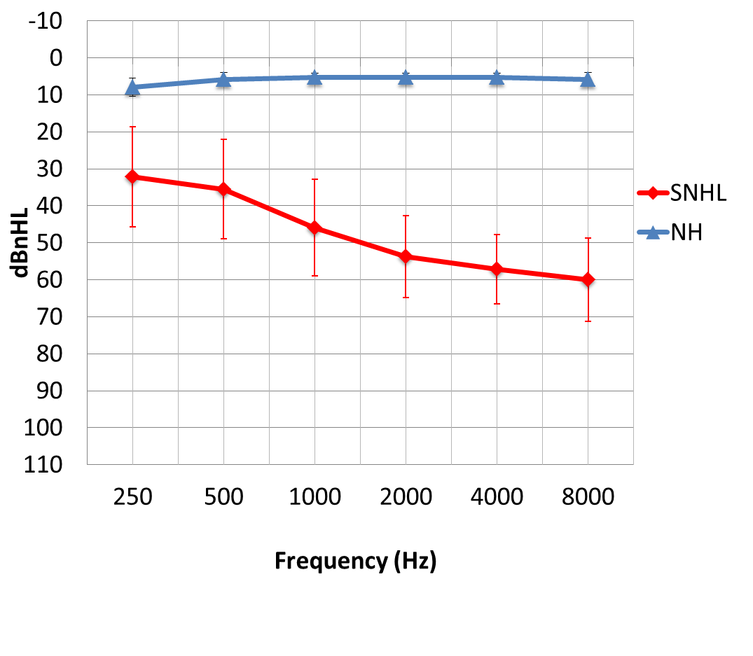
Figure (1): Mean PTA thresholds (250 - 8000 Hz) of right ear in
NH & SNHL participants including standard deviations.
Methods
All children were submitted to:
- Behavioral Speech recognition measures
Using Recorded Arabic (PBKG) words (Soliman, 1976). Speech stimuli were presented at 40 dB SL (with reference to PTA). Listeners had to repeat the words heard. The scores were calculated by counting the number of words correctly repeated.
Speech recognition scores were obtained in two listening conditions:
1st condition was in quiet, the 2nd was in background noise.
(Pink noise used simultaneously, ipsilaterally, at 0 SNR)
Both the signal and the noise were presented simultaneously via TDH-49 headphones to the right ear.
- c-ABR measures
c-ABRs were recorded under the two following conditions:
A quiet condition (no background noise) & background noise condition (using pink noise with +10 dB signal to noise ratio).
Both the signal and the noise were presented simultaneously via an ER3A insert phone to the right ear. Responses were recorded using the Biologic Navigator Pro AEP v7.0 system. Using 40-ms /da/ syllable presented at 50dB SL or at the most comfortable level.
The following parameters were measured:
- Percentage of identification of all c-ABR peaks.
- Onset response (latencies and amplitudes of peaks V & A) and V/A complex measures (latency, amplitude & slope)
- Offset response (latencies and amplitudes of peaks O).
Results
- Behavioral Speech recognition measures
Table (1): Independent t test between NH & SNHL participants in speech tests:
 |  | N | Mean | SD | P
WRT q % | NH | 30 | 99.47 | 1.74 | .00
 | SNHL | 32 | 79.38 | 11.59
WRT n % | NH | 30 | 92.53 | 6.87 | .00
 | SNHL | 32 | 59.75 | 23.39
The difference (Δ) | NH | 30 | 6.93 | 6.47 | .00
 | SNHL | 32 | 19.63 | 17.13
* P ≤ 0.05; statistically significant
There is significant difference between NH & SNHL participants as regards Word recognition in quiet (WRT q %), Word recognition in noise (WRT n %) tests and the difference (Δ) between both tests due to noise degradation.
- c-ABR measures
Normal hearing children:
All c-ABR waves could be detected in all subgroups in quiet and noise, except for wave C. It was detected in 93.3% (n=28) of children in quiet. And in 86.7% (n=26) of children in background noise. No significant difference in wave C detectability (P > .05) between quiet and noise conditions.

Sensorineural hearing loss children:
In Quiet: All c-ABR waves could be detected in all SNHL participants, except for waves C (detected in 78.13% n=25), wave D (detected in 93.75% n=30) & wave O (detected in 96.88% (n=31) of children.
In Noise: All c-ABR waves were degraded & showed different % of detectability showed in table (2)
Table (2) shows number (N) & Percent of identification of c-ABR waves in the SNHL group:
N= 32 |  | V | A | C | D | E | F | O
Quiet | Detected | 32 | 32 | 25 (78.1%) | 30 (93.8%) | 32 | 32 | 31 (96.9%)
 | Absent | 0 | 0 | 7 | 2 | 0 | 0 | 1
Noise | Detected | 30  (93.8%) | 30 (93.8%) | 18 (56.3%) | 22 (68.8%) | 28 (87.5%) | 29 (90.6%) | 24  (75%)
 | Absent | 2 | 2 | 14 | 10 | 4 | 3 | 8
Comparison between NH and SNHL children:
Table (3) shows Independent t test of c-ABR measures in quiet between NH & SNHL groups:
c-ABR |  | Group | N | Mean | SD | t | P
Transient response | Vlat | NH | 30 | 6.43 | 0.27 | -1.55 | 0.13
 |  | SNHL | 32 | 6.65 | 0.76
 | Vamp | NH | 30 | 0.10 | 0.06 | -0.37 | 0.71
 |  | SNHL | 32 | 0.11 | 0.07
 | Alat | NH | 30 | 7.42 | 0.40 | -1.57 | 0.12
 |  | SNHL | 32 | 7.68 | 0.84
 | Aamp | NH | 30 | -0.21 | 0.07 | -1.00 | 0.32
 |  | SNHL | 32 | -0.19 | 0.08
 | VAlat | NH | 30 | 0.99 | 0.27 | -0.61 | 0.55
 |  | SNHL | 32 | 1.03 | 0.26
 | VAamp | NH | 30 | 0.31 | 0.10 | 0.40 | 0.69
 |  | SNHL | 32 | 0.29 | 0.10
 | VAslope | NH | 30 | -0.32 | 0.09 | 0.06 | 0.95
 |  | SNHL | 32 | -0.32 | 0.23
 | Olat | NH | 30 | 47.57 | 0.74 | -3.34 | 0.00
 |  | SNHL | 31 | 48.83 | 1.94
 | Oamp | NH | 30 | -0.17 | 0.12 | 0.86 | 0.39
 |  | SNHL | 32 | -0.21 | 0.23
P ≤ 0.05; statistically significant
In quiet: there were no significant differences between NH & SNHL except for Wave O latency.
Table (4) show Independent t test of c-ABR measures in noise between NH & SNHL groups
c-ABR |  | Group | N | Mean | SD | t | P
Transient response | Vlat | NH | 30 | 6.87 | 0.50 | -1.05 | 0.30
 |  | SNHL | 30 | 7.06 | 0.86
 | Vamp | NH | 30 | 0.07 | 0.05 | 2.20 | 0.03
 |  | SNHL | 32 | 0.05 | 0.04
 | Alat | NH | 30 | 7.89 | 0.52 | -0.89 | 0.37
 |  | SNHL | 30 | 8.06 | 0.92
 | Aamp | NH | 30 | -0.13 | 0.08 | -1.03 | 0.31
 |  | SNHL | 32 | -0.11 | 0.06
 | VAlat | NH | 30 | 1.01 | 0.20 | 0.24 | 0.81
 |  | SNHL | 30 | 1.00 | 0.26
 | VAamp | NH | 30 | 0.21 | 0.10 | 2.14 | 0.04
 |  | SNHL | 32 | 0.16 | 0.08
 | VAslope | NH | 30 | -0.20 | 0.09 | -1.09 | 0.28
 |  | SNHL | 30 | -0.18 | 0.08
 | Olat | NH | 30 | 48.05 | 1.23 | -3.66 | 0.00
 |  | SNHL | 24 | 49.74 | 2.12
 | Oamp | NH | 30 | -0.14 | 0.15 | 0.34 | 0.73
 |  | SNHL | 32 | -0.16 | 0.24
P ≤ 0.05; statistically significant
In noise: there were no significant differences between NH &SNHL except for: Wave V amplitude, VA amplitude & Wave O
Correlations between Behavioral & Electro-physiological measures:
Table (5) shows Pearson’s correlation between Behavioral measure (Noise degradation in word recognition score between quiet and noise) & c-ABR components: (Only significant variables are displayed
Speech ABR variables | The difference in word recognition
 | r* | p value
V latency in noise | .45 | .01
A latency in noise | .49 | .01
A amplitude in noise | .48 | .01
VA amplitude in noise | -.49 | .00
VA slope in noise | .39 | .03
O amplitude | -.47 | .01

Discussion
- Behavioral Speech Recognition tests:
All NH children could correctly discriminate in quiet more than 90% of the PBKG words, ranged from 92 to 100%, and most of them had 100% correct score (n=27/30). (Table1)
In background noise, NH children were able to correctly discriminate from 80% to 100% of PBKG words with 0 S/N ratio. The noise degradation score (Δ between quiet & noise word recognition score %) was 6.9% (ranged from 0% to 20%). The noise degradation score in the majority of NH children (n=27/30) was less than 12%. (Table 1)
Notably, the majority of children with SNHL had good speech discrimination in quiet (mean =79.4%). However, there was a wider performance range than NH children, ranged from 96% to 52% correct score. The majority had more than 76% correct score (n=22/32) and only three children had less than 60% score. (Table 1)
On the other hand, children with SNHL were much more prone to noise than NH children (mean = 59.8% correct score) in word recognition test in noise. Noise degradation score ranged from between quiet and noise conditions (0% to 64%) in SNHL. (Table 1)
In SNHL children, beside decreased audibility, these perceptual difficulties in noise are thought to be related to cochlear distortions specifically, to the loss of frequency resolution. A wider-than-normal auditory filter might result in spectral smearing of auditory features (such as formant peaks) and reduced effective SNR (as the speech signal is masked by energy at a broader-than-normal range of frequencies). Even with early and appropriate intervention, the quality of the acoustic signal thus remains degraded for many children with hearing loss (Moore 1998).
- Speech ABR (c-ABR) test
NH children showed 100% detectability for all c-ABR waves across all age subgroups, only wave C was detected in (93.3%) of children in quiet. These results agreed with Vander-Werff and Burns, (2011) who found that wave C, in particular, was the least detectable.
The addition of background noise had very mild influence on wave detectability in NH children. All waves could be detected in 100% of children only wave C decreased to (86.7%) detectability, which didn’t reach significant difference between quiet and noise.
Lucky enough, children with up to moderately-severe SNHL can show wave detectability close to NH children in quiet. Only wave C, D & O showed no marked change in detectability (78.13%), (93.75%) & (96.88%) respectively (table 2).
Moreover, SNHL in quiet showed no significant difference from NH children except for delayed neural timing of the offset (wave O) (table 3). In background noise, changes in c-ABR were very prominent. All c-ABR waves were degraded & showed different % of detectability in SNHL children as compared to NH children (table2).
comparison between SNHL and NH revealed decreased robustness of onset encoding (V & VA amplitudes & Δ V amplitude) and delayed neural timing of the offset (wave O & Δ O latency) in SNHL than NH (tables 4).
Most notably, responses that encode transient events in the stimulus represented in the onset (waves V and A), the formant transition (wave C) and the offset (wave O) were highly compromised in background noise. On the other side (wave F) of the sustained response, that encodes the periodicity of the vowel, remained easily identifiable in background noise. The other sustained response (waves D & E) also showed more resilience to the effects of noise (Table 2). The present results agreed with Hornickel et al., (2009), Musser, (2011) and Anderson et al, (2013).
The overall resistance of the FFR versus the disruption of the transient response in noise suggests a relative independence of brainstem encoding processes (Russo et al 2004).
Moreover, Russo et al, (2004) added that region corresponding to the CV Time varying formant transitions (onset, offset & wave C) are more susceptible to the effects of background noise as compared to steady-state vowels (wave D, E & F). Since these transitory segments (such as stop consonants) are shorter in duration and lower in amplitude, they are more easily masked by noise.

Relationship between Behavioural and Electro-physiological measures
Results showed significant correlation with many c-ABR parameters (table 5). This indicates that c-ABR is highly sensitive to noise degradation. In other words, with c-ABR we can suspect the impact of noise in SNHL children.
Conclusions
Children with up to moderately-severe SNHL can show wave detectability close to NH children in quiet.
Children with SNHL have deficits in the subcortical representation of speech, in the region corresponding to the CV formant transients (onset and offset, wave C), while the steady-state region (mainly wave F) showed more stability in noise.
Findings of the current study support the idea that a relationship exists between SIN performance and the neurophysiologic response of the c-ABR.
c-ABR is highly sensitive to noise degradation. In other words, with c-ABR we can suspect the impact of noise in SNHL children.
References
- Anderson, S., Parbery-Clark, A., White-Schwoch, T., Drehobl, S., & Kraus, N. (2013). Effects of hearing loss on the subcortical representation of speech cues. The Journal of the Acoustical Society of America, 133(5), 3030–8.
- Anderson, S., Skoe, E., Chandrasekaran, B., & Kraus, N. (2010). Neural timing is linked to speech perception in noise. The Journal of Neuroscience, 30(14), 4922-4926.
- Hornickel J, Skoe E, Nicol T, Zecker S, Kraus N. 2009 Subcortical differentiation of voiced stop consonants: Relationships to reading and speech in noise perception. Proc Natl Acad Sci USA. ;106:13022–13027.
- Kraus, N., & Nicol, T. (2005): Brainstem origins for cortical ‘what’and ‘where’pathways in the auditory system. Trends in neurosciences, 28(4), 176-181.
- Moore BCJ. (1998) Cochlear Hearing Loss. London, England: Whurr.
- Moore, B. C. (2008). The role of temporal fine structure processing in pitch perception, masking, and speech perception for normal-hearing and hearing-impaired people.Journal of the Association for Research in Otolaryngology,9(4),399-406.
- Russo, N., Nicol, T., Musacchia, G., & Kraus, N. (2004). Brainstem responses to speech syllables. Clinical Neurophysiology,115(9), 2021-2030.
- Soliman S. (1976): Speech discrimination audiometry using Arabic phonetically balanced words. Ain Shams Medical Journal 27: 27-30.
- Vander-Werff and Burns, (2011): Brain Stem Responses to Speech in Younger and Older Adults. Ear and Hearing,32 (2): 168–180.

