**Use of osteocalcin and deoxypyridinoline for early detection of osteoporosis in obese children**

**Abstract**

**Background:** Osteoporosis in obese people is a major health problem. Awareness of osteoporosis and its complications is growing. Early diagnosis by measurement of bone formation and turnover markers and treatment can prevent and reduce the disease complications especially fractures.

**Aim:** Early detection of osteoporosis in obese children by using bone formation and bone turnover markers.

**Methods:** a case-control sample of 80 pre-pubertal, Egyptian children aged 6-10 years were divided into 40 cases with simple obesity (BMI **≥** 95th percentile) and 40 controls (non-obese). Physical examination that included weight, height, hip circumference and waist circumference were performed. Body mass index (BMI) and waist-hip ratio were calculated. Blood and urine samples were collected. Serum was separated and assayed for Osteocalcin. Urine was collected, centrifuged and assayed for deoxypyridinoline.

**Results:** Males were more than females in controls, cases and total number, where they were (32 males and 8 females) in controls, (26 males and 14 females) in cases and (58 males and 22 females) in the total number.Family history of obesity was negative in 42.5% of controls, while it was positively related in 37.5% of cases. Statistically significant difference (p<0.01) was found between obese and non-obese children as regards weight where the (Mean ±SD was 55.45±11.68) in obese and was 32.83±8.57) in non-obese group. And for the BMI, (Mean ±SD was 18.64±2.75) in obese and was (31.03±3.75) in the non-obese. Serum Osteocalcin showed a significant decrease in obese children in comparison to the non-obese group (p<0.01). While, deoxypyridinoline, there was no significant difference between obese and non-obese children. (p> 0.05).

**Conclusion:** Osteocalcin can be used as an early predictor of osteoporosis in obese children ,While urinary DPD, as it did not give us any significant data in addition to its high price, so we do not recommend its use in this early age.

**Key words:** Obesity – Osteocalcin – Deoxypyridinolone – prepubertal children

**استخدام الاوستيوكالسين والديوءكسيبيريدينولين للكشف المبكر عن هشاشة العظام في** **الاطفال البدناء**

**المستخلص**

**مقدمة:** تعد هشاشة العظام في الاشخاص البدناء مشكلة صحية خطيرة. ويتنامي الوعي بهشاشة العظام وعواقبها مما يجعل الاكتشاف المبكر بقياس دلالات الهدم والبناء في العظام مع العلاج وسيلة هامة لمنع وتقليل حدوث عواقب المرض وخاصة الكسور.

**الهدف من الدراسة**:الاكتشاف المبكر لهشاشة العظام في الاطفال البدناء باستخدام دلالات الهدم والبناء في العظام.

**طرق اجراء البحث**: باستخدام دراسة عينة وعينة ضابطة علي 80 طفل مصري في مرحلة ما قبل البلوغ من سن 6-10 سنوات تم تقسيمهم الي 40 حالة يعانون من السمنة و40 طفل ﺫوي وزن طبيعي خضع جميع الاطفال في الدراسة الي تاريخ مرضي وشخصي وعائلي وفحص اكلينيكي شامل وقياسات انثروبومترية ونمو مثل الوزن والطول ومحيط الوسط والارداف ومن ثم تم حساب معدل الكتلة والنسبة بين محيط الوسط والارداف. ثم تم اﺨﺫ عينة بول وعينة دم حيث تم فصل البلازما وقياس نسبة الاوستيوكالسين كما تم قياس محتوي البول من الديؤكسيبيريدينولين.

**النتائج**: اظهرت الدراسة ان الاطفال اﻠﺫكور كانوا اكثر من الاناث في العينة والعينة الضابطة والعدد الكلي وان 37.5% من الاطفال البدناء لديهم تاريخ عائلي للإصابة بالسمنة كما اظهرت الدراسة ان هناك فرق احصائي واضح بين الاطفال البدناء والاطفال ﺫوي الوزن الطبيعي في كل القياسات الانثروبومترية ما عدا الطول. واوضحت الدراسة انه وجد نقص واضح في نسبة الاوستيوكالسين في الاطفال البدناء بالمقارنة بالاطفال ﺫوي الوزن الطبيعي بينما لم يظهر الديؤكسيبيريدينولين اي نتائج ﺫات دلالة سواء بين الاطفال البدناء او ﺫوي الوزن الطبيعي.

**Introduction**

Osteoporosis is a major health problem.it is a disease of progressive bone loss associated with increased risk of fractures. The disease often develops unnoticed over many years, with mild symptoms and signs, until fractures occur **(Scott et al., 2010).**

Osteoporosis develops as a result of imbalance between bone resorption and bone formation **(Naim & Khashayar, 2006).**

Osteoporosis is a major global public health concern. Although it is considered as a disease of the elderly, there is now universal agreement that osteoporosis has pediatric origin because if individuals fail to achieve optimal peak bone mass (PBM) and strength in childhood and adolescence, there is a likelihood of development osteoporosis later life **(Sub Lim, 2010).**

Awareness of osteoporosis and its complications is growing, as the use of treatments that favorably alter the natural history of the disorder. So, there is increasing reasons to develop strategies for screening in order to target treatment more effectively and reduce the number of fractures **(Scott et al., 2010).**

A dramatic increase in prevalence of pediatric obesity has occurred in most countries over the past few decades. This is of a particular significance given the fact that overweight children and adolescents are at increased risk of multiple medical comorbidities as well as psychological and behavioral difficulties **(Nowica and Flodmark, 2008).**

Understanding the relationship between pediatric obesity and bone health is relevant for health professionals, because childhood and adolescence are two critical periods in the prevention and development of diseases in adulthood **(National Osteoporosis Foundation, 2013), (Fernandes et al., 2011).**

Early diagnosis by measurement of bone formation and turnover markers and treatment can prevent and reduce the disease complications especially fractures **(Sambrook & Cooper, 2006).**

Childhood and adolescence are important phases of the human development during which the adult bone mass density is determined and, therefore, problems during this period of life could compromise bone health in adulthood **(Junior et al., 2013).**

Bone status can be described by measuring bone mineral density, which provides information on both bone mineral content and bone fragility. Bone mineral density measurement, however, does not provide data on the rate of bone remodeling (whether formation exceeds or lags resorption). This information is obtained, qualitatively, by measuring biochemical bone markers (the biochemical substance produced or released during bone turnover). Both measurements complement each other and are needed to get a clear understanding of bone status (**Vesper, 2004**).

Many physiological and pathological processes may influence bone metabolism resulting in changes in serum concentration of bone turnover markers. Measurements of these parameters offer many advantages for investigating skeletal diseases in children and adolescents as well as monitoring the response to treatment **(Ambroszkiewicz, 2007).**

Osteocalcin, the major non-collagenous protein, synthetized by osteoblasts plays an important role in the regulation of bone growth and in the correct deposition of the minerals in the matrix. Its expression follows the proliferative phase of osteoblastic differentiation, so it can be considered a marker of mature osteoblasts. Serumlevels of Osteocalcin and deoxypyridinoline are not stable throughout our life and are greater in infants and children than in adults. Peak values occur at puberty. Children have significantly elevated bone marker levels due to high skeletal growth velocity and rapid bone turn over during childhood growth **(Yang, 2006; Ambroszkiewicz, 2007).**

The bone resorption marker deoxypyridinoline (DPD) reflects the level of osteoclastic activity in the bone-remodeling process. Accelerated osteoclastic activity increases bone turnover. Elevated levels of resorption markers indicate increased osteoclastic activity and a higher risk for osteoporotic hip fracture, independent of bone mineral density (BMD). Even when BMD is not in the osteoporotic range, increases in urine DPD indicate increased osteoclastic-bone resorption and risk for fracture **(McCormic, 2007).**

Therefore, the spread of obesity among prepubertal children and frequent occurrence of fractures raises the need for a tool for early detection of osteoporosis among obese children.

Theaim of the present study was to compare between the measurements of serum Osteocalcin (as a bone formation marker) and urinary DPD (as a bone turn over marker) in obese and non-obese prepubertal children for early detection of osteoporosis in childhood.

**Subjects and methods**

This case-control study included eighty (80) Egyptian children, aged 6-10 years, divided into 40 cases (obese) and 40 controls (non-obese). They were enrolled from the outpatient clinic of the Institute of Postgraduate of Childhood Studies, Ain Shams University during the period from September 2012 till March 2013.

**Inclusion criteria:** Children with simple exogenous obesity. Their BMI exceeding 95th percentile for obese and above 5th to less than 85th percentile for non-obese according to the Egyptian Growth Charts **(Ghali et al., 2008)**.Theywere taken from both sexes and aged from 6-10 years.

**Exclusion criteria:** Childrenwiththe following conditions were excluded from the study: Congenital & endocrinal causes of obesity (e.g. Hypothyroidism, Cushing disease), Syndromatic obesity such as; Prader-Willi syndrome and Laurance-Moon- Beidel syndrome) and Corticosteroid therapy; which causes alteration in lipid and glucose metabolism.

Written informed consent was taken from all patients’ parents before enrollment in the study and after full explanation of their role in the research. The consent was approved by the ethical committee of the National Research Center and Institute of postgraduate childhood studies, Ain Shams University.

All children included in the study will be subjected to the following:

**I-Full history taking:**

This includes personal history (age, sex…etc), past history for systemic diseases, drug administration (as corticosteroids), and family history of obesity, diabetes, hypertension.

**II-Thorough clinical examination:**

-General examination: pulse, blood pressure and temperature.

-Systemic examination: head and neck, cardiac, chest, abdominal and neurological examination.

**III-Anthropometric measurements and auxology:**

All anthropometric measurements will be obtained using standardized equipment, and following the recommendations of the International Biological program **(Hiernaux and Tanner, 1969).**

1. **Body weight**.
2. **Body height**.
3. **BMI:**

|  |  |
| --- | --- |
| BMI = | Weight (kg) |
| Height (m2) |

BMI will be evaluated according to the Egyptian Growth Charts **(Ghali, 2008).**

Obesity will be considered when BMI exceeds 95th percentile (**Schwarz and Freemark, 2010).**

1. **Waist circumference**:

Will be evaluated according to waist circumference percentile curves for British children (which are used for the Egyptian children) **(Hassan et al, 2008).**

1. **Hip circumference**.
2. **Waist- hip ratio:** will be calculated by dividing waist circumference / hip circumference.

**IV-Laboratory Investigations:**

One fasting blood sample will be collected in the first visit; (5 cc venous blood samples). Samples will be collected in plain vacutainers and subsequently, serum will be separated and stored at -20 oC until assay will be performed. Urine is collected in a sterile container, centrifugation for 20 minutes at the speed of 2000-3000 r.p.m., remove supernatant. If precipitation appeared, centrifugal again. The assay includes:

* 1. Serum Osteocalcin (As bone formation marker).

2- Urinary deoxypyridinoline (DPD) (As bone resorption marker).

**Results:**

As regards the distribution of children according to sex in our sample males were more than females in controls, cases and total number, where they were (32 males and 8 females) in controls, (26 males and 14 females) in cases and (58 males and 22 females) in the total number.

**Table (1): Distribution of the studied sample according to sex.**

|  |  |  |  |  |  |  |
| --- | --- | --- | --- | --- | --- | --- |
| group  Sex | Case | | Control | | Total | |
| N | % | N | % | N | % |
| Male | 26 | 32.5 | 32 | 40.0 | 58 | 72.5 |
| Female | 14 | 17.5 | 8 | 10.0 | 22 | 27.5 |
| Total | 40 | 50.0 | 40 | 50.0 | 80 | 100 |

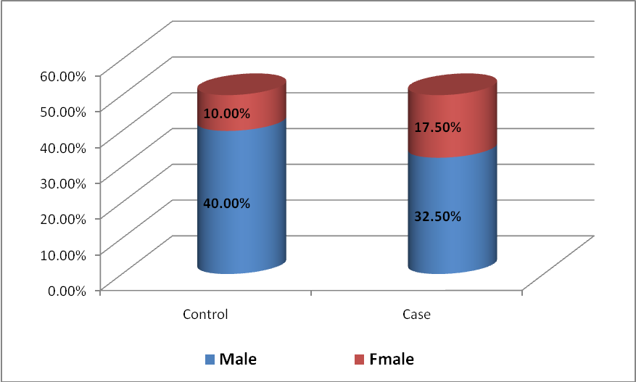

**Figure (1): Distribution of the studied sample according to sex.**

Also, we studied the distribution of the sample according to family history of obesity where we found that family history is negative in 42.5% of controls, while it was positively related in 37.5% of cases. So, we can say that there is genetic predisposition of obesity.

**Table (2): Distribution of the studied sample according to family history of obesity.**

|  |  |  |  |  |  |  |  |  |
| --- | --- | --- | --- | --- | --- | --- | --- | --- |
| group | Control | | Case | | Total | | X2 | P |
| N | % | N | % | N | % | 29.09 | <0.01 |
| Negative | 34 | 42.5 | 10 | 12.5 | 44 | 55.0 |
| positive | 6 | 7.5 | 30 | 37.5 | 36 | 45.0 |
| Total | 40 | 50.0 | 40 | 50.0 | 80 | 100 |

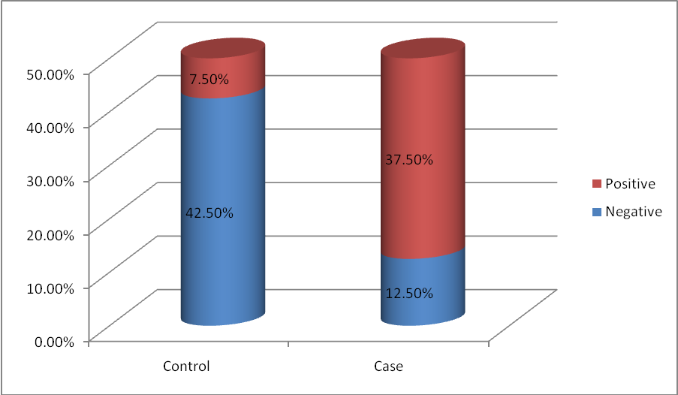

**Figure (2): Distribution of the studied sample according to family history of obesity.**

As regards the Age and anthropometric measurements of the studied sample, all variables showed significant increase in obese children in comparison to control group except for the height.

We found statistically significant difference (p<0.01) between obese and non-obese children as regards weight where the (Mean ±SD was 55.45±11.68) in obese and was 32.83±8.57) in non-obese group. And for the BMI, (Mean ±SD was 18.64±2.75) in obese and was (31.03±3.75) in the non-obese.

**Table (3): Age and anthropometric measurements of the studied sample.**

|  |  |  |  |  |
| --- | --- | --- | --- | --- |
|  | **Obese**  **N=40** | **Non Obese**  **N=40** | **t value** | **P** |
| **Mean ± SD** | **Mean ± SD** |
| Age | 8.75±1.35 | 7.95±1.71 | 2.32 | <0.05* |
| Weight (kg) | 55.45±11.68 | 32.83±8.57 | 9.81 | <0.01* |
| Height (cm) | 133.10±10.52 | 132.25±9.93 | 0.372 | >0.05 |
| BMI (kg/m2) | 31.03±3.75 | 18.64±2.75 | 16.81 | <0.01* |
| Waist circumference | 95.30±6.60 | 65.08±7.07 | 19.75 | <0.01* |
| Hip circumference | 101.15±6.56 | 72.25±8.50 | 17.02 | <0.01* |
| Waist/hip ratio | 0.94±0.02 | 0.90±0.05 | 4.31 | <0.01* |

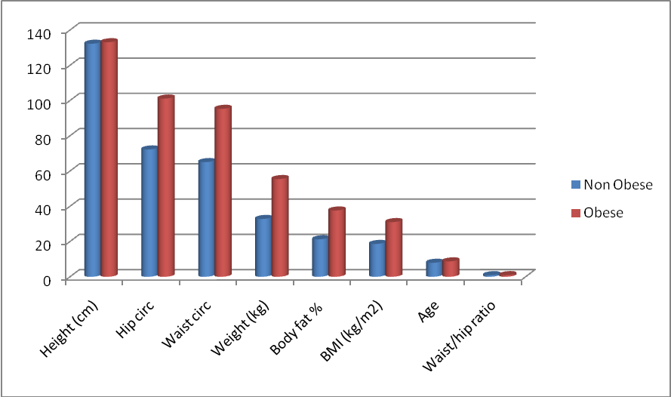

**Figure (3):** **Age and anthropometric measurements of the studied sample**.

**Table (4): comparison between obese and non-obese in chemistry variables (Osteocalcin and deoxypyridinoline).**

|  |  |  |  |  |  |  |
| --- | --- | --- | --- | --- | --- | --- |
|  | **Obese**  **N=40** | | **Non Obese**  **N=40** | | **t value** | **P** |
| **Mean ± SD** | **Range** | **Mean ± SD** | **Range** |
| OSC | 33.13±11.83 | 10.60-58.15 | 39.06±7.29 | 23.27-51.20 | 2.69 | <0.01* |
| Dpd | 289.02±130.17 | 112.86-602.27 | 306.55±194.81 | 86.12-652.58 | 0.473 | >0.05 |

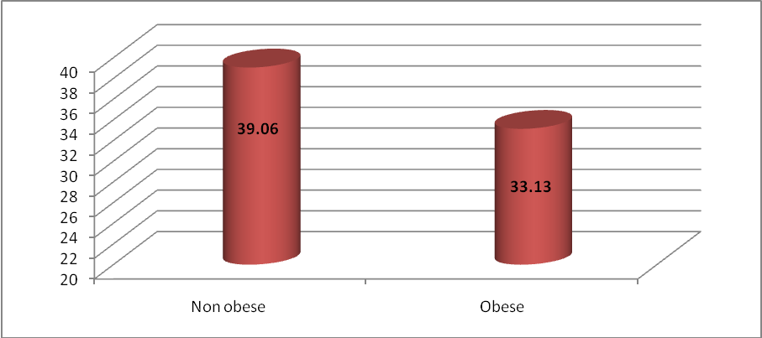

**Figure (4): comparison between obese and non-obese in Osteocalcin (ng/ml)**

As regards the comparison of serum Osteocalcin between obese and non-obese children (as a bone formation marker), it showed a significant decrease in obese children in comparison to the non-obese group. (p<0.01).

While, for deoxypyridinoline (DPD) (as a bone turnover marker), there was no significant difference between obese and non-obese children. (p> 0.05).

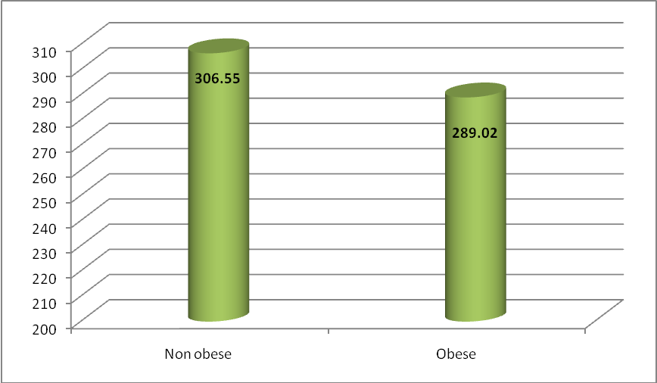

**Figure (5): comparison between obese and non-obese in DPD (nmol/L)**

**Discussion:**

In modern society osteoporosis is a highly occurring disease and constitutes a public health concern due to its impact on public costs **(National Osteoporosis Foundation, 2013).**

Childhood and adolescence are important phases of the human development during which the adult bone mass density is determined and, therefore, problems during this period of life could compromise bone health in adulthood **(Junior et al., 2013).**

Overweight and obesity may contribute to bone fractures in children; however, the mechanism involved is not clear **(Abou El-Soud et al., 2006).**

The distribution of the sample according to family history of obesity we found that family history is negative in 42.5% of controls, while it was positively related in 37.5% of cases. So, we can say that there is genetic predisposition of obesity.

The intergenerational relationship between parent and child obesity has been well described, **Rhee et al., 2012** in a twin study have estimated that genes are responsible for 40–75% of the phenotypic variance of obesity. However, evolutionary changes in the genome cannot explain the tremendous increase in obesity prevalence over the past 30 years. Most likely, the genetic susceptibility to obesity has always existed, but is now becoming more evident due to the influence of the obesogenic environment. this is similar to the study of **Elkhayat et al., 2013**, who found that obese children group had significantly higher percentages of family history of obesity, as well as intake of junk food when compared to controls (P<0.001). Also, **Moreira et al., 2007** showed that overweight parents are more likely to have overweight children. The incidence of obesity in children was 6% if both parents were non obese, while it rises to 22.7% if one parent is obese and to 30.8% if both parents were obese and maternal obesity was associated with increased birth weight and direct measures of fatness such as skin folds are also greater in newborn infants of obese mothers.

As regards the Age and anthropometric measurements of the studied sample, all variables showed significant increase in obese children in comparison to control group except for the height. We found statistically significant difference (p<0.01) between obese and non-obese children as regards weight where the (Mean ±SD was 55.45±11.68) in obese and was 32.83±8.57) in non-obese group. And for the BMI, (Mean ±SD was 18.64±2.75) in obese and was (31.03±3.75) in the non-obese.

BMI provides the most useful population-level measure of overweight and obesity as it is the same for both sexes and for all ages of adults. However, it should be considered a rough guide because it may not correspond to the same degree of fatness in different individuals **(WHO, 2012).**

This is similar to the study of **Elkhayat et al., 2013** which showed significantly higher mean values of weight, weight for age, BMI, waist, hip and mid upper arm circumferences, waist: hip ratio as well as biceps, triceps, subscapular, suprailiac and abdominal skin folds thickness among cases than controls, also, **Salem et al. (2002)** recommended that BMI should be used routinely to screen for overweight and obesity in children and adolescents as it is easy to use in a clinical setting and correlates with subcutaneous and total body fat.

These results are in accordance with the fact that anthropometric measurements are accepted sensitive indicators of growth patterns, obesity and health status of a child **(Chatterjee et al., 2006).**

Our results showed that, all anthropometric parameters are increased (except for height) in obese children, that means that there is a positive relation between obesity and body composition especially body fat. This result is similar to that obtained by **Cobayashi et al., 2005 and Abou El-Soud et al., 2006** where they found that obesity in children and adolescents was accompanied by increased regional and perhaps total bone measurements. In contrast with our findings, other investigators have reported normal **(Manzoni et al., 1996)** or decreased **(Goulding et al., 2000)** anthropometric parameters. Also, **Elkhayat et al., 2013** found that there were no significant differences between cases and controls in the mean height and height for age (P>0.05), whereas, overweight and obese group showed significantly higher mean values of weight, weight for age, BMI, z-score of BMI, waist and hip circumferences, waist: hip ratio and biceps, triceps, subscapular, suprailiac and abdominal skin folds when compared to controls (P<0.001).

Osteocalcin which was used in our research as a bone formation marker was found to be significantly decreased in obese children in comparison to non-obese children. While the urinary DPD which was used as bone turnover marker showed no significant difference between obese and non-obese groups although it was high in obese children but not to the degree to be significant.

The bone resorption marker deoxypyridinoline (DPD) reflects the level of osteoclastic activity in the bone-remodeling process. Accelerated osteoclastic activity increases bone turnover. Elevated levels of resorption markers indicate increased osteoclastic activity and a higher risk for osteoporotic hip fracture, independent of BMD. Even when BMD is not in the osteoporotic range, increases in urine DPD indicate increased osteoclastic-bone resorption and risk for fracture **(McCormic, 2007).**

DPD levels are influenced by muscle-collagen breakdown. Using serial testing of DPD to evaluate for therapeutic efficacy may not provide a useful indicator of bone resorption **(McCormic, 2007).**

Ourresults were similar to **Wang et al., 2013** who found that serum Osteocalcin levels were negatively correlated with fat percentage and visceral fat area (r = -0.24 and r = -0.46, respectively, P < 0.05); however, no statistically significant association was found between obesity degree and serum Osteocalcin levels (r = -0.29, P = 0.052). In addition, serum Osteocalcin levels were significantly lower in obese (44.46 ± 9.73 μg/ml). These findings indicate that body composition is related to serum Osteocalcin levels in obese children. Also, **Gwang et al., 2013**, found that, serum total Osteocalcin levels were significantly lower in overweight or obese children (76.96±27.08ng/ml vs. 66.91±21.39ng/ml, p=0.020) and it was negatively associated with body fat.



So, we can use Osteocalcin as an early predictor of osteoporosis in obese children to avoid continuation of the problem of osteoporosis in the adult period especially in pre and post-menopausal females. While for the urinary DPD, as it did not give us any significant data either in obese or non-obese children in addition to its high price, so we do not recommend the use of the urinary DPD as a bone turn over marker in this early age.

**References**

1. **Abou El-Soud NH, Youssef MM, Mohsen MA and Kazem YA (2006):** Obesity in children and adolescents:Effect on bone mineral content and density. J Med Sci; 6 (5): 786-792.
2. **Ambroszkiewicz J, Klemarczyk W, Gajewska J, Chelchowska M and Laskowska- Klita T (2007):** Serum concentration of biochemical bone turnover markers in vegetarian children. Advances in Medical Sciences. Vol. 52.
3. **Burguera B and Thomas T (2002):** Is leptin the link between fat and bone mass? Journal of Bone and Mineral Research. Vol. 17. Issue 9; 1563-1569.
4. **Chatterjee S, Chatterjee P and Bandyopadhyay A (2006):** Skinfold thickness, body fat percentage and body mass index in obese and non-obese Indian boys. Asia Pacific J Clin Nut., 15: 231-235.
5. **Cobayashi F, Lopes L A and Taddei J A (2005):** Bone mineral density in overweight and obese adolescents. J Pediatr, 81: 337-42.
6. **El Khayat HA, Emam EK, Hassan N E, Kandeel W A et al (2013):** Impact of body fat mass on bone mineral density and content and on serum level of c- terminal telopeptide of type 1 collagen among overweight and obese children and adolescents. Journal of Applied Sciences Researches; 9(1): 770-777.
7. **Ghalli I, Salah N , Hussien F, Erfan M , El-Ruby M , Mazen I, et al( 2008):** Egyptian growth curves 2002 for infants, children and adolescents. Recently published in: Int Sartorio A, Buckler JMH, Marazzi N, editors.
8. **Goulding A, Taylor R A and Jones I E (2000):** Overweight and obese children have low bone mass and area for their weight. Int J Obes Relat Metab Disord., 24: 627-632.
9. **Gwang SK, Yoonsunk J, Kim HS et al (2013):** Reduced serum total Osteocalcin is associated with central obesity in Korean children. Journal of the Academy of Nutrition and Dietitics.
10. **Hassan NE, El- Masry SA and El-Sawaf AE (2008):** Waist circumference and central fatness of Egyptian primary school children. La Revue de Sante de la Mediterranee orientale, Vol. 14. No. 4.
11. **Hiernaux J and Tanner J M (1969):** Growth and physical studies, In J.S. Weiner, S.A. Lourie (Eds.), Human Biology: A guide to field methods. London: IBP; Oxford, UK: Blackwell Scientific Publications.
12. **Klein K O, Larmore K A, Lancey E, Brown J M, Considine R V and Hassink S G (1998):** Effect of obesity on estradiol level, and its relationship to leptin, bone maturation, and bone mineral density in children. J Clin Endocrinol Metab., 83: 3469-75.
13. **Manzoni P, Brambilla P and Pietrobelli A (1996):** Influence of body composition on bone mineral content in children and adolescents. Am J Clin Nutr., 64: 603-607.
14. **Maor G, Rochwerger M, Segev Y and Phillip M (2002):** Leptin acts as a growth factor on the chondrocytes of skeletal growth centers. J Bone Miner Res., 17: 1034-43.
15. **Mc Cormick B, Stone I and corporate analytical team (2007):** Economic costs of obesity and the case for government intervention. Obesity reviews (8) Supp.1:161-164.
16. **Moreira P, Padez C, Mourao-Carvalhal I, Rosado V. (2007):** Maternal weight gain during pregnancy and overweight in Portuguese children.
17. **Naim M Maalouf M D and Khashayer Sakhaee M D (2006):** Treatment of osteoporosis in patients with liver diseases and in transplant. [Current Treatment Options in Gastroenterology](http://link.springer.com/journal/11938). Volume 9, [Issue 6](http://link.springer.com/journal/11938/9/6/page/1), pp 456-463.
18. [**National Osteoporosis Foundation**](http://www.optasiamedical.com/nofs-newly-revised-2013-clinicians-guide-to-osteoporosis-highlights-importance-of-vertebral-imaging/) **(2013):** [The National Osteoporosis Foundation’s Newly Revised 2013 Clinician’s Guide to Osteoporosis Highlights Importance of Vertebral Imaging](http://www.optasiamedical.com/nofs-newly-revised-2013-clinicians-guide-to-osteoporosis-highlights-importance-of-vertebral-imaging/). Available at: www.optasiamedical.com/nofs.
19. **Nowicka P and Flodmark C E (2008):** Family in pediatric obesity management – a literature review. International Journal of Pediatric Obesity. 3: 44-50.
20. **Rhee K E, Phelan S and McCaffery J (2012):** Early determinants of obesity: genetic, epigenetic and in utero influences. Int J of Pediatr. Vol .2012, article ID 463850, 9 pages.
21. **Salem MA, El Alfy MS, El Beblawy NM, Tash F, Zaki M and Farid S (2002):** Prevalence of obesity in school children and its link to type 2 diabetes mellitus. Egyptian Journal of Pediatrics, 19(3):397-416.
22. **Sambrook P and Cooper C (2006):** Osteoporosis. Lancet 2006 Jun 17; 367(9527): 2010-8.
23. **Schoenau E, Neu C M, Rauch F and Manz F (2001):** The development of bone strength at the proximal radius during childhood and adolescence. J Clin Endocrinol Metab., 86: 613-8.
24. **Schwarz S and Freemark M** (**2010)**: Pediatric Obesity, Available at: <http://emedicine.medscape.com/article/985333-overview>.
25. **Scotte C, Tonnarelli B, Papadimitropoulos A, Scherberich A, et al., (2010):** Recapitulation of endochondral bone formation using human adult mesenchymal stem cells as a paradigm for developmental engineering. PNAS; Vol. 107no, 16: 7251-7256.
26. **Sub Lim J (2010):** Pediatric dual energy X-ray absorptiometry: Interpretation and clinical and research application. Korean J of Pediatrics; 53(3): 286-293.
27. **Vesper H, Cosman F, Endres B.D, Garnero P, Hoyle R.N, Kleerekoper M, Mallinak J. S. N (2004):** Application of biochemical markers of bone turnover in the assessment and monitoring of bone disease: approved guidline. ISBN; 24(22).
28. **Wang JW, Tang QY, Ruan HJ and Caiw W (2013):** Relationship between serum Osteocalcin levels and body composition in obese children. J Pediatr Gastroentrol Nutr. Nov (16).
29. [**WHO (2012):** Obesity and overweight](https://www.google.com.sa/url?sa=t&rct=j&q=&esrc=s&source=web&cd=1&cad=rja&ved=0CCkQFjAA&url=http%3A%2F%2Fwww.who.int%2Fmediacentre%2Ffactsheets%2Ffs311%2Fen%2F&ei=np3PUqPqCoKp0QWRgoHIAw&usg=AFQjCNFGC7GjyG1PORGZxDb1PSD6xnDxGA) available at: **www. =Who. int/ mediacenre/ factsheets/fs311/en.**
30. **Yang R, Lee M, Hu H, Pollin T et al (2006):** Acute –phase serum Amyloid A: An inflammatory adipokines and potential link between obesity and its metabolic complications. PLOS Med 3(6): e287. DOI: 10.1371/ Journal. Pmed. 0030287.