A study of risk factors of viral gastroenteritis during infancy

Lobna Sayed Sherif2, Rokaya Mohammmed El Sayed5 , Randa Kamal abdelRaouf1, Mohamed Ahmed Ali4, Amany Salah El Din El Wakkad3, Amira Sayed El Refaay2

1 Medical Studies Department, Institute of Postgraduate Childhood Studies, Ain Shams University

2Child Health Department, 3Medical Physiology Department, and 4Virology Laboratory, National Research Centre, Cairo, Egypt

5Abo El Rish Paediatric Hospital, Faculty of Medicine, Cairo University

Abstract

Introduction: Diarrhea is a leading cause of mortality in children under 5 years of age. The number of viral agents associated with diarrheal disease in humans has progressively increased.

Aim of the study: To investigate the predisposing risk factors associated with viral gastroenteritis during infancy.

Methodology: The study was carried out on 80 infants aged ≤ 6 months enrolled from gastroenteritis department in Abo El Rish paediatric hospital, Cairo University. From September 2011 to may 2012 Self designed questionnaire was verbally administered to mothers including (age of the infant, family number, working of mother, the usage of private feeding tools for infants, exclusive breast feeding or mixed feeding, attendance of a day care nursery).Studied infants were subdivided into two groups, exclusively breast fed group and the non exclusively breast fed infants. Stool samples were obtained from the infants on admission. Viruses were screened using RT-PCR for rotaviruses, astroviruses and noroviruses, and by PCR for detection of adenoviruses.

Results: The infants’ mean age was 4.8±1.4 months and 57% were males. The mean of family size was 4.4±1.0 and 12% of them were attending day care nursery. By using RT-PCR and PCR to detect causative viruses Rota virus was detected in 42 infants 18 (52.9%) of them were exclusively breast fed and 24 (53%) of them were from the non exclusively breast fed group with no significant statically difference. There was no significant impact of the social data on the incidence of Rota virus infection.

Conclusion: Breast feeding was associated with low risk of viral gastroenteritis, food handling hygiene and social parameter didn’t affect the risk of viral gastroenteritis

Keywords: viral gastroenteritis – predisposing factors - risk factors – Rota virus – breastfeeding - infants.

الاسباب المؤدية للنزلات المعوية الفيروسية للأطفال

مقدمة:يعتبر الاسهال اهم اسباب الوفيات للأطفال دون الخامسة و قد تزايدت اعداد المسببات الفيروسية للإسهال في الاطفال زيادة مضطردة في الاونة الاخيرة

الهدف من الدراسة: دراسة الاسباب المؤدية للإسهال و النزلات المعوية الفيروسية في الاطفال

الاساليب : تمت الدراسة علي ثمانين طفل اعمارهم اقل من ستة اشهر تم اختيارهم من الاطفال المحجوزين بوحدة النزلات المعوية بمستشفي ابو الريش الجامعي تم اتخاذ استبيان شفوي من امهات الاطفال المشمولين بالدراسة و يشمل معلومات عن عمر الطفل و عدد افراد الاسرة عمل الام استخدام ادوات خاصة بالطفل تغذية الطفل اذا كانت رضاعة طبيعية ام صناعية ام تم الفطام المبكر و اذا كان الطفل يحضر دار حضانة

تم تقسيم الاطفال المدرج بالدراسة الي مجموعتين : مجموعة الرضاعة الطبيعية المطلقة و مجموعة لا تتبع الرضاعة الطبيعية المطلقة و تم اخذ عينة براز من الطفل عند دخول الطفل للمستشفى

تم تحليل الفيروسات في البراز بواسطة البي سي ار وذلك لفيروس الروتا و الادينو فيروس و النورو فيروس و الاسترو فيروس

النتائج : كان متوسط عمر الطفل بالشهر 1.4± ٤٫٨

و كانت نسبة الذكور فيهم ٥٧٪ من اجمالي الاطفال و متوسط عدد افراد الاسرة كان ٤٫٤± ١

ومن اجمالي الاطفال بلغ عدد المترددين علي دور الحضانة ١٢٪ من الاطفال المشتركين في الدراسة و باستخدام البي سي ار لتشخيص الفيروسات المسببة للنزلات المعوية وجد فيروس الروتا في انتين و اربعين طفل منهم ٥٢٫٢٪ من مجموعة الرضاعة الطبيعية المطلقة و منهم ٥٣٪ من مجموعة الاطفال المتبعين نظام التغذية المختلطة

و لم يظهر فى الدراسة تاثير للعوامل الاجتماعية علي نسبة الاصابة بفيروس الروتا

الخلاصة: الرضاعة الطبيعية المطلقة كانت مصاحبة لنسبة اقل للاصابة لفيروسات النزلات المعوية و لم يظهر تاثير للعوامل الاجتماعية و طرق تدبير الطعام للطفل

Introduction:

Diarrhea is a leading cause of mortality in children under 5 years of age. Infectious diahrrea may be due to viral, bacterial or parasitic agents (Wilhelmi et al., 2003).

The number of viral agents associated with diarrheal disease in humans has progressively increased. Rotavirus is the most common cause of severe diarrhea in children under 5 years of age. Human astroviruses, caliciviruses and enteric adenovirus are also important etiologic agents of acute gastroenteritis. Other viruses such as toroviruses, coronaviruses, picobirnaviruses, Aichi virus and human bocavirus are increasingly being identified as causative agents of diarrhea. Vaccination against rotavirus could prevent cases of severe diarrhea and reduce the mortality attributable to this disease (De Cal et al., 2008).

Although rotavirus infection is the major universal early infection in childhood, norovirus is the second most common etiologic agent of viral gastroenteritis whatever the age group (Green, 2007).

Factors associated with infant diarrhoeal illnesses can be divided into exposure and resistance factors. The former includes water quality, availability, and household sanitation, and the latter includes infant feeding methods and nutritional status. These, together with other variables, have been collectively referred to as intermediate determinants in the epidemiology of diarrhoeal diseases (Fertleman et al., 2008).

Aim of the study:

To investigate the predisposing risk factors associated with viral gastroenteritis during infancy.

Patients and methods

Eighty infants aged 6 months and less were enrolled in the study from gastroenteritis department in Abo Elrish pediatric hospital Cairo University, from September 2011 to May 2012 Gastroenteritis was defined as the passage of 3 or more loose or liquid stools per day, or more frequently than is normal for the individual (WHO, 2009) .

Infants who had received any dose of rota virus vaccine or with symptoms indicate surgical or extra intestinal causes of diahrrea were excluded from the study.

Informed consent was collected from mothers of the infants enrolled in the study prior to participation. The mothers of the included infants were asked to participate in a verbally administrated Self designed questionnaire which include (age of the infant, family number, working of mother if any, the usage of private tools for infants in feeding , if the infant was exclusively breast fed or not , if the infant is attending a day care nursery or not).

Studied infants were subdivided into two groups, exclusively breast fed group and the non exclusively breast fed infants.

Laboratory investigations:

Stool samples were obtained from the infants on admission using a wooden tongue depressor from the diaper of the infants in a sterile plastic cups.

Collected samples were diluted and prepared for PCR and stored at – 80 ° and subjected to extraction of both viral RNA and DNA in the samples to facilitate the detection of both RNA gastroenteritis viruses (rotaviruses, noroviruses, adenoviruses and astroviruses ). (Promega, USA, Cat. # G2101).

Statistical analysis:

Quantitative data were analyzed using SPSS version 18 , with mean values for continuous variables compared using Independent t-test, and differences between proportions assessed using either the chi-square test and McNemar test. The level of statistical significance for all tests was set at 0.05.

Results

Eighty infants were enrolled in the study between September 2011 and May 2012. Demographic data were available for 79 infants as one dropped from the study. Potential risk factors that have been analyzed in the current study are breast fed or not, food-handling hygiene, infant attending a day-care centre, size of family, age and sex. All risk factors in the questionnaire were studied to clarify the most effective predisposing risk factor in viral gastroenteritis.

The infants’ mean age was 4.8±1.4 months and 57% were males. The mean of family size was 4.4±1.0 and 12% of them were attending day care nursery(table 1).

In the present study, 2 (5.9%) of the exclusively breast fed infant had working mothers with significant difference comparing with non exclusively breast fed infants 20 (44.4%)(table 2).

Regarding feeding data 34 (43.0%) of infants were exclusively breast fed , 23 (29.1%) had mixed feeding and 22 (27.8%) were formula fed (table 3) .

Thirty one mothers used tap water ( 39.2% ) , 12 ( 15.2%) used boiled water , 21 ( 26.6%) used mineral water and 15 (19%) didn’t use water at all for drinking or formula preparation of their infants.

The mean age of starting weaning in the current study was 4.0±0.7 months with 25(31.6%) of mother have started with cow milk products, 13 (16.5%) with cereals and 10 (12.7%) with vegetables.

By using RT-PCR and PCR to detect causative viruses Rota virus was detected in 42 infants 18 (52.9%) of them were exclusively breast fed and 24 (53%) of them were from the non exclusively breast fed group with no significant statically difference. There was no significant impact of the social data on the incidence of Rota virus infection (table 4&5).

Table 1: Sociodemographic data of the studied infants

|  |  |  |  |  |  |
| --- | --- | --- | --- | --- | --- |
| Parameter | Total | Exclusive  BF | Non-excl.  BF | t#/÷2& | P value |
| Number of cases | 79 | 34 | 45 |
| Age in months | Mean ±SD | Mean ±SD | Mean ±SD | 3.328 | <0.001* |
| 4.8±1.4 | 4.2±1.3 | 5.2±1.2 |
| Family size | 4.4±1.0 | 4.4±1.0 | 4.3±1.0 | 0.576 | 0.566 |

t#: Independent t-test, χ2&: Chi square test, *Significant at p <0.001

Table 2: Sociodemographic risk factors among studied infants

|  |  |  |  |  |  |
| --- | --- | --- | --- | --- | --- |
| Parameter | Total | Exclusive  BF | Non-excl.  BF | t#/÷2& | P value |
| Number | No. ( %) | No. ( %) |
| Sex:  Male  Female | 45  34 | 20 (58.8%)  14 (41.2%) | 25 (55.6%)  20 (44.4%) | 0.084 | 0.771 |
| Care giver:  Mother  Relatives  Nursery | 44  26  9 | 25 (73.5%)  7 (20.6%)  2 (5.9%) | 19 (42.2%)  19 (42.2%)  7 (15.6%) | 7.753 | 0.021* |
| Working mothers | 22 | 2 (5.9%) | 20 (44.4%) | 14.333 | <0.001* |
| Personal tools | 33 | 16 (47.1%) | 17 (37.8%) | 0.686 | 0.408 |

t#: Independent t-test, χ2&: Chi square test, *Significant at p <0.001

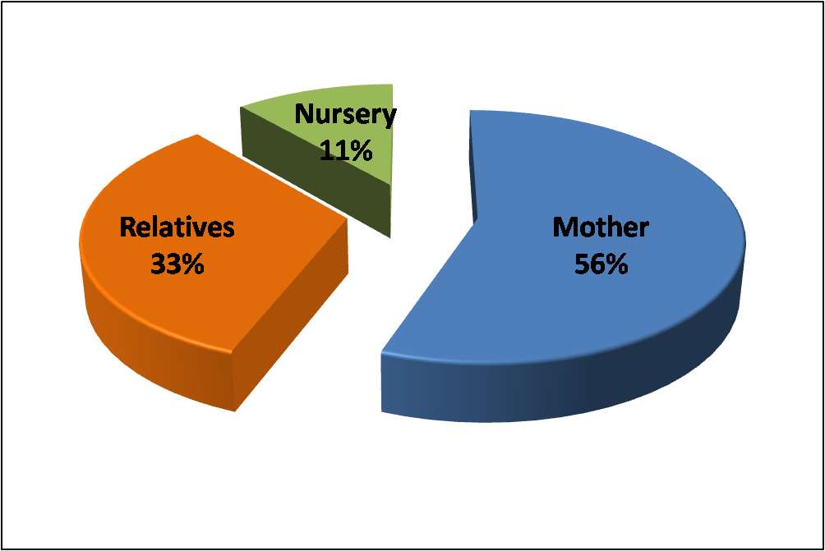

Figure 1: Caregivers in the studied infants

Table (3): Feeding data of the studied infants (N=79)

|  |  |  |
| --- | --- | --- |
|  | No | % |
| Type of feeding  Breast  Mixed  Formula | 34  23  22 | 43.0  29.1  27.8 |
| Water  None  Boiled  Mineral  Tap | 15  12  21  31 | 19.0  15.2  26.6  39.2 |
| Cow milk | 25 | 31.6 |
| Cereals | 13 | 16.5 |
| Vegetables & fruits | 10 | 12.7 |
|  | Mean±SD | Range |
| Food starting age (month) (N=34) | 4.0±0.7 | 3.0–6.0 |

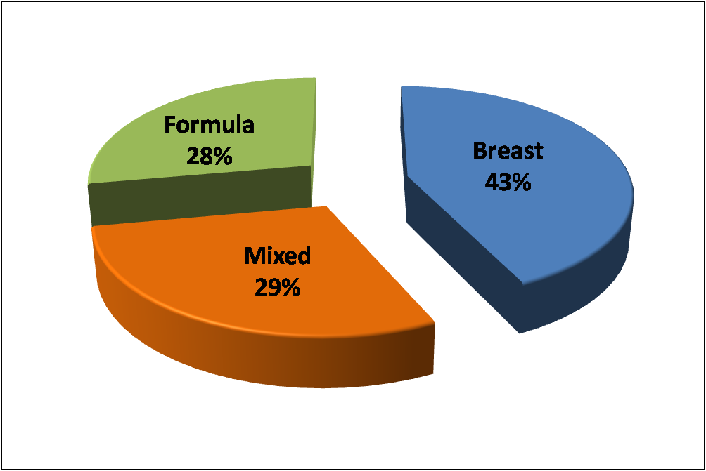

Figure 2: Type of feeding in the studied infants

Table (4): Causative viruses detected by PCR in the studied infants

|  |  |  |  |  |  |
| --- | --- | --- | --- | --- | --- |
|  | Total  (N=79) | Exclusive  (N=34) | Non-excl.  (N=45) | ÷2& | P value |
| Rota (PCR) | 42 | 18 (52.9%) | 24 (53.3%) | 0.001 | 0.972 |
| Astro (PCR) | 2 | 0 (0%) | 2 (4.4%) | 1.550 | 0.213 |
| Adeno (PCR) | 5 | 2 (5.9%) | 3 (6.7%) | 0.020 | 0.887 |

χ2&: Chi square test

Table (5):Comparison between Rotavirus PCR positive and negative as regards Social data

|  |  |  |  |  |
| --- | --- | --- | --- | --- |
|  | Positive  (N=42) | Negative  (N=37) | t#/÷2& | P value |
| Age (month) | 4.9±1.2 | 4.7±1.5 | 0.503# | 0.617 |
| Family num. | 4.3±1.0 | 4.5±0.9 | 1.007# | 0.317 |
| Sex  Male  Female | 23 (54.8%)  19 (45.2%) | 22 (59.5%)  15 (40.5%) | 0.177& | 0.674 |
| Care giver  Mother  Relatives  Nursery | 24 (57.1%)  12 (28.6%)  6 (14.3%) | 20 (54.1%)  14 (37.8%)  3 (8.1%) | 1.206& | 0.547 |
| Working | 12 (28.6%) | 10 (27.0%) | 0.023& | 0.879 |

t#: Independent t-test, χ2&: Chi square test

Discussion

Gastroenteritis is a major cause of morbidity and mortality worldwide, especially in developing countries, where malnutrition and poor local health services are factors responsible for the increased severity of diarrhea. In infants, gastroenteritis is responsible for thousands of hospitalizations and each year causes 611,000 deaths in developed countries (Patel et al., 2008) and 2 to 2.5 million deaths in socioeconomically developing countries (O’Ryan et al., 2005).

Viral pathogens are the most common causes of gastroenteritis in the community (Matty et al., 2003) and presents a major public health concern worldwide. It is mostly a disease of young children (Eckardt and Baumgart, 2011).

In the current study , virology results was in favor to the study conducted by Kalaf et al. (2011) in which rotavirus was detected in 33% (66/200) of children examined. Rotavirus was observed at closely similar rates among male and female patients, 33.6% (40/119) and 32.1% (26/81), respectively. However, the virus was detected significantly more frequently (P < 0.04, OR = 2.64) among diarrheic children aged ≤ 24 months (36.1%, 60/166) than among diarrheic children aged >24 months (17.6%, 6/34).

In another study by Abugalia et al., (2011) twenty-seven (63%) of the 43 stool samples were rotavirus-positive. Emergency room subjects were more likely to test positive than outpatients (100% vs. 53% , p = 0.03). The mean ages of rotavirus-positive and rotavirus-negative children were similar (16.5 months vs. 15.4 months; p = 0.69).

Rota virus infection in our results is non significantly less in exclusively breastfed infant comparing with non exclusively breast fed , this is in favor to Nafficy et al., (1999) describe the epidemiology of rotavirus diarrhea in a population-based cohort of children under 3 years of age residing in Abu Homos, Egypt, in 1995-1996. Rotavirus diarrhea incidence rates (episodes per person-year) were 0.13 for infants aged <6 months, 0.61 for those aged 6-11 months, 0.17 for those aged 12-23 months, and 0.15 for those aged 24-35 months. Fifty-six percent of children with rotavirus diarrhea had clinical dehydration; 90% of rotavirus diarrheal episodes occurred between July and November. In infants under 1 year of age, receipt of breast milk was associated with a lower incidence of rotavirus diarrhea.

In a study by Sánchez-Uribe et al. (2012) dietary, socioeconomic, and environmental factors were independently associated with risk of developing rotavirus disease, in this study 85 rotavirus case patients and 170 control children were enrolled in this investigation. The median age of case patients and controls was 15 months (range, 3–26 months). Factors associated with decreased risk of rotavirus gastroenteritis included having received 1 or 2 doses of Rota virus vaccine breastfeeding at the time of evaluation and living in a home with 7 or more people associated with an increased risk for rotavirus disease.

Breastfeeding has also been previously associated with a reduced risk of rotavirus diarrhea among infants (Dennehy et al ., 2006 ).

This is in favor to our results as breastfeeding was associated with reduced risk of Rota virus infection.

In our study allocation of private tools for infant feeding didn’t significantly affect viral infection.

Not only are hygienic measures unlikely to control this infection, but the socioeconomic conditions, with high levels of crowding, are also likely to exacerbate the situation (Aaby et al., 1995).

This is in contrast to a case-control study was conducted by De wit et al (2008) in which the risk factors for gastroenteritis attributable to norovirus , Sapporo-like virus , and rotavirus were studied. For Norovirus gastroenteritis, having a household member with gastroenteritis, contact with a person with gastroenteritis outside the household, and poor food-handling hygiene were associated with illness Transmission of Rota and Sapporo-like virus pathogens occurs primarily from person to person. However, for NV gastroenteritis, food borne transmission seems to play an important role.

In our study water supplementation didn’t affect the incidence or the severity of gastroenteritis but only the use of tap water was more frequent in Rota virus positive cases.

Gillian et al., (2002) founded that not supplementing an infant with water is the other significant factor predisposing infants to diarrheal episodes.

This may be due to many factors: the age group in our study was less than 6 months so the percentage of infants who doesn’t receive any water supply was 19 % and the high proportion of mothers who using mineral water 25.5 % or mothers who boiled the water 15.5%.

Strina et al (2012 ) conducted A case-control study, aimed at identifying factors associated with rotavirus diarrhoea cases presenting to health facilities, in which Infants aged <1 year, not being breast fed was the main determinant, followed by socioeconomic factors, and crowding and contact outside the home; in older children, socioeconomic factors followed by contact inside and outside the home were the main determinants. Environmental and sanitation variables were not associated with diarrhoea in the final model.

This is in favour to our results as t here was no significant impact of the social data on the Rota virus infection

Conclusion

Breast feeding was associated with low risk of viral gastroentritis, food handling hygiene and social parameter didn’t affect the risk of viral gastroenteritis

Recommendations

Exclusive breast feeding should be encouraged for protection against viral gastroenteritis .Vaccination to prevent severe rotavirus infection is recommended for infants starting at age 2 months.

References:

1-Abdollah B. Naficy, Remon Abu-Elyazeed, Jennifer L. Holmes, et al.,(1999): Epidemiology of Rotavirus Diarrhea in Egyptian Children and Implications for Disease Control American Journal of Epidemiology vol.150, No. 7

2-Aaby P, Jensen H and Nielsen B (1995): Crowding and health in low-income settlements: case study report,Bissau. Copenhagen: COWI consult; 140 32-33

3- Dennehy PH, Cortese MM, Begue R et al ., (2006):A casecontrolstudy to determine risk factors for hospitalization for rotavirus gastroenteritis in U.S. children. Pediatr Infect Dis J; 25:1123–31.

4- De Wit M and van Duynhoven Y( 2008 ): Risk Factors for Norovirus, Sapporo-like Virus, and Group A Rotavirus Gastroenteritis Emerg Infect Dis. 2003 December; 9(12): 1563–1570.

5- Green K.Y.(2007) Caliciviradae: the noroviruses,p. 949-980. In D.M. Knipe and P.M. Howley (ed.), Fields virology, 5th ed., vol. 1. Lippincott, Williams & Wilkins, Philadelphia, PA.

6-Fertleman C and Gillian R. Bentley (2008): Factors Predisposing Infants To Gastroenteritis Among Poor, Urban, Filipino Families The Internet Journal of Pediatrics and Neonatology ISSN: 1528-8374.

7- Kalaf RN, Elahmer OR, et al. (2011). Rotavirus in children with diarrhea in Tripoli, Libya. Libyan J Med 6.

8-Sánchez-Uribe E,1 Marcelino Esparza-Aguilar,1 Paul A. Gastañaduy, Rishi D (2003): Risk Factors Associated With Rotavirus Gastroenteritis During a Community Outbreak in Chiapas, Mexico During the Postvaccination Era Journal of the Pediatric Infectious Diseases Society Advance Access [Clin Microbiol Infect.](http://www.ncbi.nlm.nih.gov/pubmed/12667234) Apr; 9(4):247-62.

9- WHO /UNICEF. Diarrhoea: Why children are still dying and what can be done. 2009 Available at: <http://www>.unicef.org/health/files/Final_Diarrhoea_Report_October_2009_final.pdf

10-O’Ryan M, PradoV and PickeringL: (2005) :A millennium update on pediatric diarrheal illness in the developing world. Semin Pediatr Infe

11-[Wilhelmi de Cal I](http://www.ncbi.nlm.nih.gov/pubmed?term=Wilhelmi%20de%20Cal%20I%5BAuthor%5D&cauthor=true&cauthor_uid=19100169), [Mohedano del Pozo RB](http://www.ncbi.nlm.nih.gov/pubmed?term=Mohedano%20del%20Pozo%20RB%5BAuthor%5D&cauthor=true&cauthor_uid=19100169), [Sánchez-Fauquier A](http://www.ncbi.nlm.nih.gov/pubmed?term=S%C3%A1nchez-Fauquier%20A%5BAuthor%5D&cauthor=true&cauthor_uid=19100169). (2008): Rotavirus and other viruses causing acute childhood gastroenteritis]. [Enferm Infecc Microbiol Clin.](http://www.ncbi.nlm.nih.gov/pubmed/19100169) Nov;26 Suppl 13:61-5.

12-[Wilhelmi I](http://www.ncbi.nlm.nih.gov/pubmed?term=Wilhelmi%20I%5BAuthor%5D&cauthor=true&cauthor_uid=12667234), [Roman E](http://www.ncbi.nlm.nih.gov/pubmed?term=Roman%20E%5BAuthor%5D&cauthor=true&cauthor_uid=12667234)a nd [Sánchez-Fauquier A](http://www.ncbi.nlm.nih.gov/pubmed?term=S%C3%A1nchez-Fauquier%20A%5BAuthor%5D&cauthor=true&cauthor_uid=12667234).(2003): Viruses causing gastroenteritis[Clin Microbiol Infect.](http://www.ncbi.nlm.nih.gov/pubmed/12667234) Apr;9(4):247-6