Impact of Medical Counseling Program on Quality of Life in Children with Neuromuscular Diseases and their Families

Dr. Ahmed Mohamed Osman El-Kahky

**Professor in Medical Department-Institute of Postgraduate Childhood Studies- Ain Shams University**

Dr. Samia Samy Aziz

**Professor in Medical Department-Institute of Postgraduate Childhood Studies- Ain Shams University**

**Hanna Saber Ibrahim**

**Abstract**

**Introduction:**

Neuromuscular diseases are defined as disorders of the motor unit

They may be genetically determined, congenital or acquired Unfortunately , most neuromuscular diseases (NMDs) are incurable diseases. However, an effective rehabilitation program can help maintain a patient’s quality of life (QOL), as well as maximize the patient’s physical and psychosocial functions

**Aim:**  Our study was done is to assess the quality of life for patients with neuromuscular diseases.

**Subjects and methods:** This was a prospective, interventional and uncontrolled study conducted at Abo Reesh teaching hospital between January 2014-2015. The study was carried on infants, children and adolescents suffering from neuromuscular diseases and they were attending neurology clinic throughout one year. Sixty patients were selected from outpatient clinic with well-known diagnosis of NMD variant. Written informed consent was obtained from parents after briefing of the study aims and benefits.

**Results:** An individualized neuromuscular quality of life questionnaire program in an Arabic version submitted to patients with NMD who reported significantly lower QoL across all QoL domains, physical and psychosocial. With advancing age, patients reported decreased physical functioning and daily activities. While psychosocial functioning was impaired in a significant number of patients (60%), older patients did not tend to perceive lower psychosocial QoL despite their increased physical limitations.

**Conclusion:** all treatment measures either medical or surgical should be directed to increase quality of life better than treatment of the cause of alleviating the symptoms, Measurement of treatment success is beyond the primary goal as modern directions in medicine targeting the whole individual not only the system affected ,Psychological dimension is an important part of the disease process and treatment as well, physician should not omit this option during treatment planning.

Key words:Quality of life –Neuromuscular dis.-Med .counselling

**تأثير البرنامج الارشادي الطبي على حياة الأطفال المصابين بأمراض العصب-عضلية وأسرهم**

**المقدمة :**

يصاب الاطفال سنوياً بأمراض مكتسبة او منقولة وراثياً تهاجم انسجة الجسم العصبية والعضلية وتؤدي الى تباطؤ في فعاليتها وبالنتيجة الى حدوث ضعف بالحركة والاحساس والاتزان كعواقب لاصابات تطال العصب والعضلة في فترة عمرية هي قمة النمو العصبي والعضلي مما ينعكس على بنية الطفل وتعامله مع المجتمع وردة فعل المجتمع تجاهه.

إن هذه الاصابات العصبية والعضلية المختلفة تخضع لطرق مختلفة من العلاج الجراحي والطبي المطوّل والذي ينصب على التقليل من الاعراض البادية على المريض. ولكن هذه العلاجات المختلفة انصبت على قياس مدى انحسار هذه الاعراض وليس على الحالة العامة للمريض والامه الداخلية والوضع النفسي الناتج عن الاعاقة البدنية وعلاقة الطفل بمجتمعه.

لقد كان الهدف من الدراسة هو قياس جودة الحياة للاطفال المصابين باعتلال الاعصاب والعضلات بنوعيهما (الولادي والمكتسب) من خلال دراسة مسبقة اعتمدت نظام الاستبيان (إستبيان عالمي تم تعريبه)

**المنهجية:** لدراسة 60 حالة طبية مصابة من المترددين على مستشفي ابو الريش الجامعى بعد اخد موافقة كتابية من المريض او المسؤلين عنه وقد تم فحص جميع االمرضى اكلينكيا وخاصة الفحص العصبى لهم وعمل جميع التحاليل الضرورية بما فيها من رسم العضلات واختبارات توصيل الأعصاب كما تم دراسة شجرة الوراثة لعائلة المصاب .

**النتائج** :قد اظهرت النتائج المستخلصة انخفاض جودة الحياة بصورة عامة وارتفاع في اعداد المصابين بسوء الحالة النفسية مع شعور بردة فعل غير جيدة من المجتمع المحيط أدت الى انخفاض في تعامل الفرد المصاب مع البيئة المحيطة وكذلك الاعمال اليومية والنشاطات المدرسية.

ونستخلص من هذا البحث اهمية التعالم مع الفرد المصاب ككل وليس كجزء فلا يمكن التعامل مع الجهاز العصبي او العضلي بمعزل عن الحالة النفسية مثلاً او بمعزل عن البعد الاجتماعي وعلى الرغم من ان هذين البعدين الاخيرين قلا لا يستطيع الطبيب المختص توفيرهما كخدمة طبية للمريض لذلك يستدعي وجود مؤسسات ترعى هذه الحالات بالاخص وتوفر لها العلاج من كافة الجوانب الطبية والجراحية والنفسية والاستشارات الاجتماعية.

**كلمات دلالية: إعتلال الاعصاب, جودة الحياة**

**Introduction:**

NMDs are a group of diseases that affect any part of the nerve and muscle. These disorders include motor neuron diseases such as amyotrophic lateral sclerosis (ALS) and spinal muscular atrophy (SMA), which may involve motor neurons in the brain, spinal cord, and periphery, ultimately weakening the muscle**(Benatar 2006).**

NMDs also include peripheral neuropathies such as Charcot-Marie-Tooth disease (CMT), which affect not only motor but also sensory nerves. **(Benatar 2006).**

Finally, NMDs may directly affect all forms of muscle, particularly skeletal and cardiac muscle. **(Benatar 2006).**

The term muscular dystrophy (MD) refers to a heterogeneous group of genetic disorders that typically result in progressive degeneration followed by incomplete regeneration of skeletal muscles, ultimately resulting in the loss of contractile tissue. **(Landfeldt et al. 2014; Wei et al. 2015).**

The term neuromuscular diseases (NMD) encompass wide varieties of neuromuscular disease of different etiologies. The impact of having any variety of NMD is great in general. in the past, scientists thought that presence of multiple methods to diagnosis and new modalities of treatment was adequate in any national health trust**(Moyle et al. 2015)**.

Recently, progress of any disease or admission of any therapy should be linked to quality of life (QOL) research to obtain their impact on patients' life**(van Dulmen et al. 2015).**

## Quality of Life

The concept of quality of life (QOL) is regarded as a new concept in medicine. Within the last three decades, this interest has expanded to new visions, and QOL now has many disciplines, a new interest in the field of health care, from a focus on the cure of disease and the relief of suffering to the maintenance and enhancement of health**(Mark stro 2002).**

Quality of life research is approached either on healthcare system or patient-focused approach. Every classification has its own advantages or drawbacks**(van Dulmen et al. 2015)**.

Application of QOL research should be based on meticulous design, involved large scale of individuals and disease-specific if possible**(Schipper & Levitt 1985).**

Several studies take the NMD to target their research of QOL to. Knowing patients' satisfactions and their feedback are small areas in QOL research**(Brack et al. 2005).**

In Egypt, studying of NMD-QOL will be advantageous to health care systems whatever approach used.

**Aim of the study:**

The aim of the study is to assess the quality of life for patients with neuromuscular diseases

## Improving Quality of life in Neuromuscular Disease

1. Exercise paradigms to improve strength (Majmudar et al. 2014).
2. Stretching, bracing, and surgery for contractures and scoliosis: (Vialle et al. 2013).
3. Vocational, psychosocial, and quality-of-life issues (Yilmaz et al. 2010).

**Patient and Methods:**

**Data input**

Sixty-three patients were selected from outpatient clinic with well-known diagnosis of NMD variant.

**Inclusion criteria**

1. Both sexes
2. Below 18 years old
3. Well established diagnosis of a neuromuscular disease (peripheral nerves or muscle disease)

**Exclusion criteria**

1. Element of upper motor neuron disease with hypotonia
2. Generalized hypotonia with chronic diseases.

**Ethical consent**

Written informed consent was obtained from parents after briefing them on the study's aims and benefits.

**Methodology and data processing**

All patients were subjected to the following:

1. Full history taking with special stress on family history
2. Examination Full general examination for lung, heart and head with full neurological examination
3. Investigation CK, EMG, NCV and tissue biopsy (when indicated)
4. Family pedigree
5. Individualized neuromuscular quality of life questionnaire program (in an Arabic version submitted to patients as in Appendix A which has been translated from the English version ass in Appendix B)

**Data Analysis**

Analysis of data was done by IBM computer using SPSS (statistical program for social science version 12) as follows

1. **Description** of quantitative variables as mean, SD and range
2. **Description** of qualitative variables as number and percentage
3. **Chi-square** test was used to compare qualitative variables between groups.
4. **Unpaired t-test** was used to compare quantitative variables, in parametric data (SD<50% mean)’
5. **One way ANOVA** test was used to compare more than two groups as regard quantitative variable.

P value >0.05 insignificant , P<0.05 significant , P<0.01 highly significant

**Results:**

This was a prospective, interventional and uncontrolled study conducted at Abo Reesh teaching hospital between January 2014-2015. The study was carried on infants, children and adolescents suffering from neuromuscular diseases and they were attending neurology clinic throughout one year.

**Socio-demographic Distribution**

The age mean and standard deviation was 10.71 years ±2.91 with minimum 7 years and maximum 17 years (Figure 1).

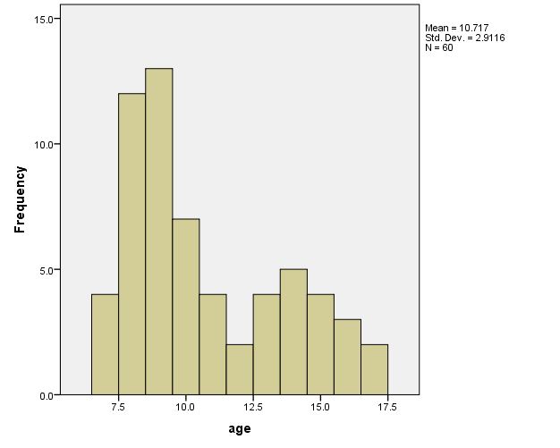

Figure 1: Histogram of age.

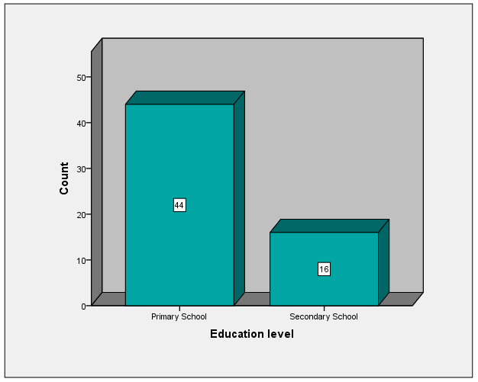

Figure 2: Bar chart of education level.

Those studying in the secondary level tend to decrease their performance due to depression and anxiety (0.004). Indeed, patients who were in the secondary school had a higher degree of pain (0.037) than primary with significant correlation with age (0.01).

**Diagnoses**

In table 1, the diagnoses are listed below**:**

|  |  |  |
| --- | --- | --- |
| Table 1: Diagnoses in our study | | |
|  | Frequency | Percent |
| ALS | 2 | 3.3 |
| BMD | 8 | 13.3 |
| CMT | 8 | 13.3 |
| DM | 23 | 38.3 |
| PN | 6 | 10.0 |
| SMA | 13 | 21.7 |
| Total | 60 | 100.0 |

Restriction in performing daily activities was not evenly distributed among diagnoses mentioned above; all diseases (but Duchene Myopathy) put great restriction in doing usual daily activities (0.002).

|  |  |  |  |  |  |
| --- | --- | --- | --- | --- | --- |
| Table 2: Descriptive statistics of duration. | | | | | |
|  | | Statistic | | Std. Error | |
| Mean | | | 4.083 | | .1546 |
| 95% Confidence Interval for Mean | Lower Bound | | 3.774 | |  |
| Upper Bound | | 4.393 | |  |
| Median | | | 4.000 | |  |
| Std. Deviation | | | 1.1973 | |  |
| Minimum | | | 2.0 | |  |
| Maximum | | | 8.0 | |  |
| Range | | | 6.0 | |  |

Longstanding duration is statistically correlated with psychological barrier in doing usual daily activities (0.0128) and therefore, they tend to decrease the limit of their achievements (0.005) in school and usual daily activities. Indeed, patients who had longstanding disease course have more severe psychological, physical pain and loss their inertia with statistically significant correlation (0.0001, 0.005 & 0.0128) respectively.

Patients with longer course tend to be depressed, anxious and losing hope to be as equal as their fellows (0.0001).

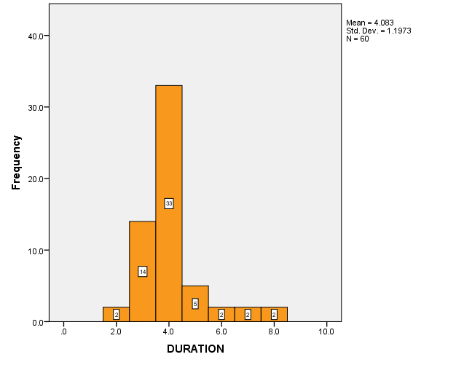

Figure 3: Bar chart of duration of illness.

**Discussion:**

Overall, patients with NMD reported signiﬁcantly lower QoL across all QoL domains, physical and psychosocial.

With advancing age, patients reported decreased physical functioning and daily activities. While psychosocial functioning was impaired in a signiﬁcant number of patients (~60%), older patients did not tend to perceive lower psychosocial QOL despite their increased physical limitations**(Benatar 2006).** In fact, adolescents with NMD tended to report better psychosocial QOL than their younger counterparts, especially better social QOL, suggesting that these patients may have developed coping skills over time, allowing preserved functioning in these areas**(Burns et al. 2012)**.

Our study ﬁndings support the ﬁndings of others that patients with more severe disease requiring mobility aids or having greater impairment of daily activities do not necessarily perceive between these age groups was statistically signiﬁcant (P = .027). However, parents reported higher physical functioning scores for the younger children compared with the old ones (P < .001). Older patients tended to report higher psychosocial health summary (P <0.05) with higher social functioning scale scores (P<0.001).

This difference was not observed by parent proxy-report as stated by **(Cohen & Biesecker 2010)**.Consistent with the self-reported physical functioning, the mean score for daily activities was signiﬁcantly higher for the 8-to 12-year-olds than for the 13- to 18- year-olds (P = .002).

**Conclusion:**

1. All treatment measures either medical or surgical should be directed to increase quality of life better than treatment of the cause of alleviating the symptoms.
2. Measurement of treatment success is beyond the primary goal as modern directions in medicine targeting the whole individual not only the system affected
3. Psychological dimension is an important part of the disease process and treatment as well , physician should not omit this option during treatment planning

**Further Research:**

1. Application of QOL researches on large scale prospective study on congenital diseases only and the effect of new techniques in treatment
2. Validity of QOL questionnaires in field of pediatrics

**References:**

Benatar, M., 2006. *Neuromuscular disease : evidence and analysis in clinical neurology* 1st ed., Totowa, NJ: Human Press. Available at: http://pharmacypracticenews.com/download/hyperglycemia_ppn1113.pdf.

Brack, T. et al., 2005. Quality of Life , Physical Disability , and Respiratory Impairment in Duchenne Muscular Dystrophy. , (11).

Cohen, J.S. & Biesecker, B.B., 2010. Quality of life in rare genetic conditions: A systematic review of the literature. *American Journal of Medical Genetics Part A*, 152A(5), pp.1136–1156. Available at: http://doi.wiley.com/10.1002/ajmg.a.33380.

Landfeldt, E., Lindgren, P. & Bell, C.F., 2014. The burden of Duchenne muscular dystrophy.

Markstro, A., 2002. Quality-of-Life Evaluation of Patients With Neuromuscular and Skeletal Diseases Treated With Noninvasive and Invasive Home Mechanical Ventilation *. , pp.1695–1700.

Moyle, W. et al., 2015. Influencers on quality of life as reported by people living with dementia in long-term care: a descriptive exploratory approach. *BMC geriatrics*, 15, p.50. Available at: ???

Schipper, H. & Levitt, M., 1985. Measuring quality of life: risks and benefits. *Cancer treatment reports*, 69(10), pp.1115–25. Available at: http://www.ncbi.nlm.nih.gov/pubmed/3899354.

van Dulmen, S.A. et al., 2015. Supporting a person-centred approach in clinical guidelines. A position paper of the Allied Health Community - Guidelines International Network (G-I-N). *Health Expectations*, 18(5), pp.1543–1558.