Recent Epidemiological Aspects of Ebolavirus disease
Wassef O.S,**EL Shorbagy O.S and ***Wassif S.M*
*Department of Community medicine Faculty of Medicine Benha University,
**Department of Medical Studies, Institute of Postgraduate Childhood Studies Ain Shams University.
***Department of Community medicine Faculty of Medicine Zagazig University.
Abstract
Ebola virus disease (EVD) or Ebola hemorrhagic fever (EHF) is a disease of humans and other primates caused by an Ebolavirus. It is severe, often fatal disease in humans and non human primates. The first Ebolavirus species was discovered in 1976 in what is now the Democratic Republic of the Congo near the Ebola River. Since then, outbreaks have appeared sporadically. This work aim to highlights and raise the awareness of health professionals about Ebolavirus disease.
The virus is spread through direct contact to people from animals and spreads in the human population through human-to-human transmission; Once human infection occurs, the disease may spread between people, as well through a sick person's blood or body fluids (urine, saliva, feces, vomit, and semen) meanwhile Ebola virus has been found in semen for up to 3 months.
Symptoms start 2days to 3 weeks after contracting the virus, These includes: Fever, sore throat, muscle pain and headaches. Vomiting, diarrhea and rash follow, along with decreased functioning of the liver and kidneys. Affected people may begin to bleed both within the body and externally. The diagnosis is confirmed by isolating the virus, detecting its RNA or proteins, or detecting antibodies against the virus in a person's blood.
لمرض فيروس الإيبولا الوبائية المستجدة الملامح
مرض فيروس الإيبولا (EVD) أو حمى الإيبولا النزفية (EHF)هو أحد الأمراض التى تصيب الانسان نتيجةالاصابة بفيروس الإيبولا . تهدف هذة المراجعة المكتبية الى القاء الضوء ورفع الوعى المعرفى للعاملين فى المجال الطبى بوبائيات مرض فيروس الإيبولا.
تبدأ اعراض المرض عادةً في الظهور بعد فترة حضانة تبدا من يومين إلى ثلاثة أسابيع من الإصابة بالفيروس، وتتمثل في حمى والتهاب بالحلق وآلام فى العضلات وصُداع. وعادةً ما يتبعها غثيان وقيء وإسهال، ويصاحبها انخفاض فى وظائف الكبد والكلي. وحينئذا يبدأ فى بعض الأشخاص التعرض لمشاكل النزيف في هذه المرحلة.
ويمكن الإصابة بالفيروس عن طريق الاتصال بـ الدم أو سوائل الجسم للحيوان المصاب بالعدوى (عادةً خفاش الفاكهة) ولا يوجد دليل قاطع على انتشار المرض عبر الهواء في البيئة الطبيعية. ويُعتقد أن خفاش الفاكهةهو الذى يحمل الفيروس ويقوم بنشره دون الإصابة به. وبمجرد إصابة الإنسان بالعدوى، يمكن للمرض أن ينتشر بالانتقال من شخص لاخر.وقد لوحظ ان الذكور الناجون من المرض قادرون على نقل العدوى عن طريق المنى لما يقرب من شهرين. ويمكن تشخيص المرض بفحص عينات الدم للكشف عن وجود أجسام مضادة للفيروس أو الحمض النووي الريبي أو وجود الفيروس نفسه لتأكيد التشخيص.
Introduction Ebola virus disease (EVD) or Ebola hemorrhagic fever (EHF) is a disease of humans and other primates caused by an Ebolavirus. It is severe, often fatal disease in humans and non human primates (such as monkeys, gorillas, and chimpanzees). The first Ebolavirus species was discovered in 1976 in the Democratic Republic of the Congo near the Ebola River. Since then, outbreaks have appeared sporadically. CDC, (2014)
Ebola virus is a zoonotic pathogen with bats being the most likely reservoir. The name Ebolavirus is derived from the Ebola River in Republic of the Congo where Ebola virus was first discovered and the first recorded Ebola virus disease outbreak occurred. Five species are known, and four of these cause Ebola virus disease in humans, a type of hemorrhagic fever having a very high case fatality rate. EVD was first identified in Sudan (now South Sudan) and the Republic of the Congo. The disease typically occurs in outbreaks in tropical regions of sub-Saharan Africa. From 1976 (when it was first identified) through 2013, the World Health Organization reported a total of 1,716 cases. The largest outbreak to date is the ongoing 2014 West Africa Ebola outbreak, which is affecting Guinea, Sierra Leone, Liberia and Nigeria. As of August 2014,(2,615) suspected cases resulting in the deaths of (1,427) have been reported. Ebola virus has a high risk of death, killing between 50% and 90% of those infected with the virus. The disease has the highest case-fatality rate averaging 83% since first described in 1976, up to 90% that have been recorded in one epidemic (2002–2003) CDC, (2014).
Objective
To upraise the awareness of health professionals about Ebola virus disease
Methods
Systematic review of literature through access to the available internet web sites e.g WHO and CDC in order to identify the recent epidemiological Aspects of Ebolavirus disease.
Epidemiological Characteristics
The reservoir are various species of fruit bats that considered the most likely natural reservoir that have been reported to be as intermediary hosts. The source of infection. The virus was believed to be the meat of infected monkeys upon which the chimpanzees preyed.
Disease Transmission : The virus is spread through direct contact The virus is transmitted to people from animals and spreads in the human population through human-to-human transmission; (through broken skin or mucous membranes).Once human infection occurs, the disease may spread between people, as well.
Asick person's blood or body fluids (urine, saliva, feces, vomit, and semen) Ebola virus has been found in semen for up to 3 months. People who recover from Ebola are advised to abstain from sex or use condoms for 3 months.
- Objects (such as needles) that have been contaminated with infected body fluids. Transmission has been attributed to reuse of unsterilized needles and close personal contact.
- The virus may be acquired upon contact with blood or bodily fluids of an infected animal, meanwhile transmission between natural reservoir and humans is rare.
- Fruit bats are believed to carry and spread of the virus without being affected.
- In Africa, Ebola may be spread as a result of handling bushmeat (wild animals hunted for food) and contact with infected bats
Those at highest risk include
Healthcare workers
- Family and friends of patients with Ebola

Diagnosis: The medical history, especially travel and work history are important to suspect the diagnosis of EVD. The diagnosis is confirmed by isolating the virus, detecting its RNA or proteins, or detecting antibodies against the virus in a person's blood.

Geographical Distribution
Confirmed, probable, and suspect cases and deaths from Ebola virus disease in Guinea, Liberia, Nigeria, and Sierra Leone

 | Confirmed | Probable | Suspect | Total  (by Country)
Guinea
Cases | 482 | 141 | 25 | 648
Deaths | 287 | 141 | 2 | 430
Liberia
Cases | 322 | 674 | 382 | 1378
Deaths | 225 | 301 | 168 | 694
Nigeria
Cases | 13 | 1 | 3 | 17
Deaths | 5 | 1 | 0 | 6
Sierra Leone
Cases | 935 | 37 | 54 | 1 026
Deaths | 380 | 34 | 8 | 422
Totals
Cases | 1 752 | 853 | 464 | 3 069
Deaths | 897 | 477 | 178 | 1 552
Source: WHO "Ebola virus disease, West Africa - update 28 August 2014
This table showed that Sierra Leone top the list of confirmed (cases & deaths) during west Africa outbreak 2014, meanwhile Liberia came first in the total number by country of confirmed, probable & suspected cases.
Map of Ebola Case distribution and outbreak across Africa
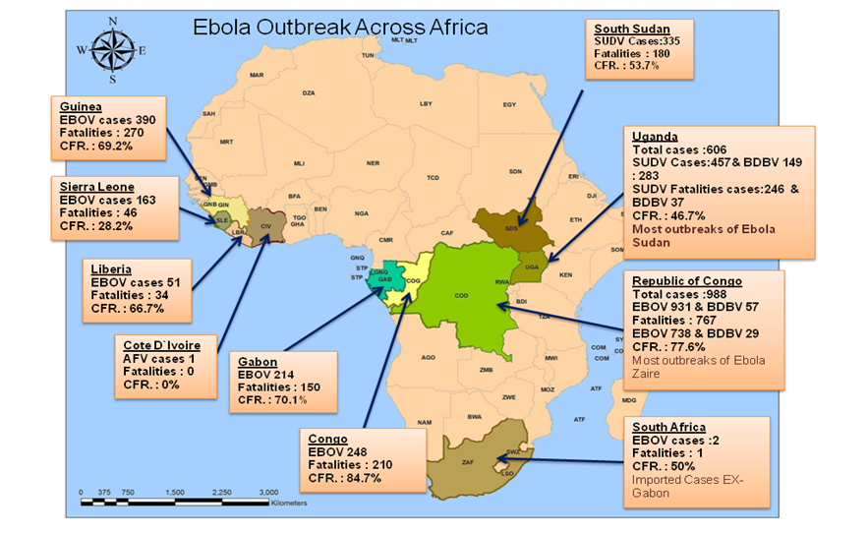 Source: CDC,CORAP,H5N1, SierraLione,MOH, UNICEF& WHO updated 25 Jun 2014
N.B. EVD types are EBOV = Ebola Zaire, SUDV = Ebola Sudan, BDBV = Ebola Bundibugyo and TAFV = Ebola Ivory Coast
The map shows the bulk of the outbreaks have occurred within central Africa and the most deadly, Ebola Zaire causing the most cases in the Republic of Congo (formally Zaire). The most recent outbreak has actually occurred in West Africa, originating from Guinea
The 2014 Ebola outbreak is the largest Ebola outbreak in history and the first in West Africa and the current outbreak is affecting multiple countries in West Africa, CDC 31 Aug, 2014
Clinical Picture : Symptoms start 2days to 3 weeks after contracting the virus, These includes:
- Fever, sore throat, muscle pain and headaches.
- Vomiting, diarrhea and rash follow, along with decreased functioning of
- the liver and kidneys.
- Affected people may begin to bleed both within the body and externally.
Prevention includes: Ebola viruses being a contagious disease, prevention predominantly involving behavior changes.
- No human vaccine is currently available. Efforts are under way to develop a vaccine. Vaccines have protected nonhuman primates. Immunization takes six months, which hinder the counter-epidemic use of the vaccines.
- Decreasing the spread of disease from infected animals to humans. This may be done by checking such animals for infection and killing and properly disposing of the bodies if the disease is discovered.
- Properly cooking meat and wearing protective clothing when handling meat may also be helpful.
- Washing hands when around a person with the disease. Samples of bodily fluids and tissues from people with the disease should be handled with special caution.
Travelling to an area with known Ebola cases, make sure to do the following:
- Practice careful hygiene. Avoid contact with blood and body fluids.
- Do not handle items that may have come in contact with an infected person’s blood or body fluids.
- Avoid funeral or burial rituals that require handling the body of someone who has died from Ebola.
- Avoid contact with bats and nonhuman primates or blood, fluids, and raw meat prepared from these animals.
- Avoid hospitals where Ebola patients are being treated. After you return, monitor your health for 21 days and seek medical care immediately if you develop symptoms of Ebola.CDC, (2014)
- Infection control : Early diagnosis of the disease and using standard precaution for all patients in the healthcare setting.

Recommended measures when caring for those who are infected include isolating them, sterilizing equipment, and wearing protective clothing including masks, gloves, gowns, and goggles.

Proper full-body Personal protective equipment and disinfection. Techniques to avoid infection involve not contacting infected blood or secretions, including from those who are dead.

The Ebola virus can be eliminated with heat (heating for 30 to 60 minutes at 60 °C or boiling for 5 minutes). On surfaces, some lipid solvents such as some alcohol-based products, detergents, sodium hypochlorite (bleach) or calcium hypochlorite (bleaching powder), and other suitable disinfectants at appropriate concentrations can be used as disinfectants.

Airline crews are instructed to isolate anyone who has symptoms resembling Ebola virus. Hand washing is important but can be difficult in areas where there is not enough water.

Quarantine: known as enforced isolation, is usually effective in decreasing spread of disease. Governments often quarantine areas where the disease is occurring or individuals who may be infected. The World Health Organization has assessed that Egypt is safe from the virus, which is rampant in West and Central Africa. Precautionary measures to combat the Ebola virus, especially for travelers visiting from the countries of Central and West Africa. Quarantine screens passengers travelling from affected countries for the disease during a period that ranges between 1-21 days. This comes as Egypt is required to take all possible precautionary measures toward travelers from Africa, especially those from Guinea, Sierra Leone, Nigeria and Liberia in order to prevent the virus from entering the country, A committee has been formed to take necessary actions and draw plans to keep the virus away. The Ministry Of Health is monitoring the virus’ spread and take appropriate preventive measures to counter it; Daily News Egypt , (2014)

Treatment of ebolavirus: No specific treatment exists. Early treatment may increase the chance of survival. Treatment is primarily supportive in nature and includes:
Balancing fluids and electrolytes to counter dehydration, oral rehydration therapy or intravenous fluids Administration of anticoagulants early in infection to prevent or control disseminated intravascular coagulation, Administration of pro -coagulants late in infection to control bleeding, maintaining oxygen levels, pain management, and the use of medications to treat bacterial or fungal secondary infections

References
- Center for disease control and prevention (CDC) 2014 24/7 saving live protecting people "Ebola outbreak in west Africa 2014"
- CDC,CORAP,H5N1,SierraLione,MOH, UNICEF& WHO updated 25 Jun 2014
- Daily News Egypt August 2, 2014
- Ministry of Health’s Prevention Sector,
"Strict precautionary measures in Egyptian airports to combat Ebola".
- WHO (2014)

Ebola virus disease, West Africa - update 28 August 2014
- WHO (2014)
March 2014 Ebola virus disease Fact sheet N°103"
- WHO (2014) "Ebola virus disease" Fact sheet NO. 103
Updated April 2014

