Association of Cytotoxic T Lymphocyte Antigen 4 Gene Polymorphism with Type 1 Diabetes in Children
Randa Kamal Abdel Raouf¹, Mona Hussein El Samahy², Hesham Wahid Eldin Mostafa³ , Khalda Said Amr⁴, Manal Mansour Abdel Rahman³, Marwa Wageeh Abou El Naga³ .
¹Department of Medical Studies, Institute of Postgraduate Childhood Studies ,Ain Shams University,Cairo,Egypt;²Department of Pediatric, Faculty of Medicine, Ain Shams University, Egypt;³Child Health Department, National Research Center, Cairo, Egypt; ⁴Medical Molecular Genetics Department, National Research Center, Cairo, Egypt.
ABSTRACT
Background: Type-1 diabetes mellitus (T1DM) is an autoimmune disease in which combinations of environmental and genetic factors contribute to T-cell mediated destruction of insulin-secreting β-cells of the pancreas. The (CTLA-4) encodes of the T cell receptor involved in the control of T cell proliferation.
The aim of this study was to investigate the association of CTLA-4 gene exon 1 49 A/G polymorphism with T1DM in children and its relation to diabetic complications.
Subjects and methods: A total of 100 subjects were included in this cross sectional, case-control study. Fifty children with T1DM aged 10-18 years (12.5±2.0 years), and fifty children as a control group. All candidates were subjected to full clinical evaluation and anthropometric measurements. All the patients had the following laboratory investigation been done (RBG, average HbA1c, Quantitative determination of urinary microalbumin). CTLA-4 gene polymorphism PCR-RFLP was done for all the subjects.
Results: CTLA-4 genotyping among the diabetic group was: the mutant homozygous genotype GG in 15(30%), the mutant heterozygous genotype AG in 29(58%) and wild homozygous genotype AA in 6(12%). However, among the control group: it was 3(6%) with GG genotype, 19(38%) with AG genotype and 28(56%) with AA genotype with P value < 0.001 which denoting a higher prevalence of AG and GG genotype in diabetic group with highly statistical significance. There was a significant association between CTLA-4 mutant genotypes and patients with younger age of onset of diabetes (P=0.011) and higher dose of insulin (P=0.002). CTLA-4 +49 mutant genes did not have any impact on complications of type 1 diabetes.
Conclusion: The results of the present study shows that the CTLA-4 A/G +49 polymorphism was associated with type 1 diabetes in Egyptian children with a significant association between CTLA-4 mutant genotypes and patients with younger age of onset of diabetes and higher dose of insulin.
Key Word: T1DM, CTLA- 4, Antigen, Polymorphism

ارتباط تعدد الأشكال في جين مستضد 4 للمفاويات التائيه السامه للخلايا
بداء السكرى من النوع الأول في الأطفال
المستخلص:
الخلفية: ان مرض السكري من النوع الاول هو مرض مناعي وتتحد فيه العوامل الجينيه والبيئيه لتدمير خلايا بيتا المفرزه للانسولين في البنكرياس بواسطه الخلايا التائيه. ان جين مستضد 4 لليمفاويات التائية السامة للخلايا(ستلا 4) يشفر احدى المستقبلات التي تظهر على الخلايا التائيه والذي بدوره يتحكم في تكاثر الخلايا التائيه وموت الخلايا التائيه المبرمج.
الهدف من الدراسة: الهدف من هذه الدراسه هو دراسة ارتباط تعدد الأشكال في جين مستضد 4 للمفاويات التائيه السامه للخلايا بداء السكرى النوع الأول في الأطفال واحتمالية ارتباطه بمضاعفات السكر.
الأساليب: دراسة حالة لمراقبة مستعرضة شملت مائه طفل, خمسون منهم مرضى بالنوع الاول من السكري تتراوح اعمارهم من 10-18 سنه (12.5 ± 2) وخمسون اخرون اصحاء كمجموعه ضابطه . تم أخذ التاريخ الكامل والفحص السريري والقياسات الانثروبومترية وتحاليل معمليه (قياس مستوى السكر بالدم مع اخذ متوسط القياسات, قياس مستوى الهيموجلوبين السكري, قياس مستوى الزلال المجهري بالبول, قياس تعدد الأشكال في جين مستضد 4 للمفاويات التائيه السامه للخلايا بطريقة (بي سي ار) يليها طريقة (رفلب).
النتائج: جين مستضد 4 للمفاويات التائيه السامه للخلاياكان كالاتي: GG في 15(30%), AG في 29(58%), AA في 6(12%) في المرضى, وبالنسبه للمجموعه الضابطه : GG في 3(6%), AG في 19(38%), AA في 28( 56%) . مما يؤكد ان GG , AG اكثر بفرق ذو دلاله احصائيه في المرضى. يوجد علاقه ذو دلاله احصائيه بين جين مستضد 4 للمفاويات التائيه السامه للخلايا وصغر السن عند الاصابه بالمرض وكذلك جرعه الانسولين ولا يوجد علاقه من اي نوع بين جين مستضد 4 للمفاويات التائيه السامه للخلايا ونسبه الهيموجلوبين السكري ولا بين جين مستضد 4 للمفاويات التائيه السامه للخلايا ومضاعفات مرض السكري.
الاستنتاج: يوجد علاقه ذو دلاله احصائيه بين جين مستضد 4 للمفاويات التائيه السامه للخلايا ومرض السكري من النوع الاول وخاصه عند صغر السن عند الاصابه بالمرض وكذلك جرعه
الانسولين المرتفعه .
الكلمات المفتاحية: داء السكرى النوع الأول, مستضد 4 للمفاويات التائيه السامه للخلايا, مستضد, تعدد الأشكال.

Introduction

Diabetes mellitus is a metabolic disease characterized by chronic hyperglycemia resulting from defects in insulin secretion, insulin action, or both (ISPAD, 2009). The chronic hyperglycemia of diabetes is associated with long term damage, microvascular complications (e.g. retinopathy, nephropathy and neuropathy) and macrovascular complications (e.g. myocardial infarction, angina pectoris and stroke).(Grandy and Fox, 2008) .
Type 1diabetes (T1D) is considered as one of the most common chronic diseases in children, the cause of the disease is an autoimmune process directed against the beta-cells of the islets of Langerhans leading to progressive and irreversible destruction of these cells causing complete and definitive cessation of endogenous insulin production. Accordingly, these patients should be treated with insulin since the beginning of the disease. (Egyetem et al., 2010). At present, the incidence of Type 1 diabetes is on the rise, while its age of onset decreases (Haliloğlu et al., 2011).

An effective treatment that leads to improved metabolic control is essential to prevent severe diabetes related complications and minimize long-term ones (Araujo and Mazza, 2008).
Type 1 diabetes mellitus is a T-cell mediated organ specific autoimmune disease ( Nistico et al, 1996).
There are over 20 regions in the human genome that are associated with TIDM, but most of it make only small contribution to the susceptibility of type 1 diabetes ( Radha et al, 2003). Cytotoxic T- lymphocytic antigen 4 gene (CTLA-4), is one of the genes associated with TIDM (SiMonds et al, 2005).
CTLA4 is a protein that plays an important regulatory role in the immune system. In humans, the CTLA4 protein is encoded by the CTLA4 gene ( Dariavach et al, 1988).
Cytotoxic T lymphocyte-associated antigen 4 (CTLA-4) gene is a member of the immunoglobulin super family ( Dariavach et al, 1988). It is located on chromosome 2q33 (Teft et al, 2006).
There is evidence to suggest that CTLA-4 is an important negative regulator of T cell responses involved in the maintenance of peripheral T cell tolerance ( Kosmaczewska et al, 2001). T cells are regulated by their surface receptors such as T-cell receptor (TCR), and co-stimulatory molecules, optimizing T-cell activation. Some of these co-stimulatory molecules such as CD28 have a positive co-stimulatory signals which complete T cell activation, but others such as the cytotoxic T-lymphocyte antigen 4 (CTLA-4), induce inhibitory effects on T cells (Olive et al, 2011). Because of its inhibitory role, CTLA-4 gene is a strong candidate gene for involvement in autoimmune diseases ( Kosmaczewska et al, 2001).
Several diseases of presumed autoimmune etiology, including Graves’ disease, Hashimoto’s thyroiditis (Awata et al, 1998), insulin dependent diabetes mellitus (Abe et al, 1999), and Addison disease have been associated with CTLA-4 gene polymorphism (Vaidya et al, 2000).
Polymorphism of the CTLA-4 gene could thus have effects upon the immune response. Of the several CTLA-4 gene polymorphisms, three have been most frequently studied, namely a dinucleotide microsatelite (AT)n marker at position 642 of the 3’-untranslated region of exon 4: CTLA-4 3’(AT)n18 in the promoter region CTLA-4 C(–318)T3, and the single nucleotide polymorphism in exon 1CTLA-4 A(49)G (Harper et al, 1991). There are many studies revealed a significant association of CTLA-4 exon 1 49 A/G polymorphism with T1DM and a recent study was done on Maduria population in India indicates the same results. (Philip and Isabel, 2011)
Additionally, CTLA4 has become a focus of research interest since it is a useful therapeutic target for immunotherapy in cancer and autoimmune diseases (Gough et al., 2005).
Aim of the present study was to investigate the association of CTLA-4 gene exon 1 49 A/G polymorphism with T1DM in children and its possible relation to diabetic complication.
Subjects and Methods:
The present study was conducted at the Diabetes Clinic, Children's Hospital, Ain Shams University. Fifty (50) type 1 diabetic patients (with age range 10-18 years) were collected from the regular attendants of the clinic for follow up during a full calendar year. All patients were diagnosed as diabetics according to Criteria for the Diagnosis of Diabetes; American Diabetes Association(ADA) Guideline for 2011 (ADA, 2011).
Inclusion criteria:
- Cases diagnosed with Type 1 diabetes mellitus.
- Age: 10-18 years.
- Gender: both sexes
- Patients receiving human insulin therapy.
Exclusion criteria:
- Cases diagnosed with Type 1 diabetes mellitus and associated with another chronic disease (e.g. chronic renal failure, cardiac diseases chronic chest disease…etc.).
- Patients with other autoimmune diseases as Graves' disease, celiac disease etc…
Ethical aspect of the study:
Written informed consent was obtained from the parents after explanation of the aim of the study, its benefits and expected risks for their children if they participate in the study. Informed verbal assent was taken also from all the patients as their age exceeds eight years after a simplified explanation of the aim and benefits of the study for them. All the patients data were confidential, neither the data nor the collected samples were used in other researches.
Approval was taken to conduct this research from the Ethical Committee of the Institute of Postgraduate Childhood Studies Ain Shams University, the Ethical Committee of the Faculty of Medicine Ain Shams University and the Ethical Committee of the National Research Center (NRC).
Methods:
All patients and controls were subjected to complete medical history and thorough clinical examination. Anthropometric measurement in the form of height, weight and body mass index was done. All the patients had the following laboratory investigation been done :
Routine investigations for all cases:
- Routine home glucose monitoring using Bionime GS300 blood glucose monitoring system and mean value over two weeks was calculated.
- Glycosylated Hb (HbA1c) by HPLC (high performance liquid chromatography) was done every three months and mean value all over the entire study was calculated (Rewers et al., 2009).
- Quantitative determination of urinary microalbumin (Coonrod et al., 1993).
Molecular Analysis: CTLA-4 (+49 A/G) gene polymorphism typing : This was done by PCR amplification followed by restriction fragment length polymorphism (RFLP) method (Abe et al, 1999).
Statistical Analysis:
Quantitative data were analyzed using SPSS version 16, with mean values for continuous variables compared using Independent t-test, and differences between proportions assessed using either the chi-square test and McNemar test. The level of statistical significance for all tests was set at 0.05.
Results
The results of the following study will be presented with the following tables and figures. This study was conducted on 50 children with type 1 diabetes 22 males (44%) and 28 females (56%) with a mean age of 12.5±2.0 years and 50 healthy controls 23 males (46%) and 27 females (54%) with a mean age of 12.7±2.8 years
Diabetic patients and control group are well matched as regards age and gender (p>0.05). There was no statistically significant difference regarding BMI between diabetic patients and controls (p>0.05). Family history of DM was significantly more frequent among diabetic patients than among control group(p=0.009). (table 1).
Table (1): Comparison between diabetic patients and controls as regards age, gender, BMI and a family history of diabetes mellitus
Characteristics  \ |  | Case  (N=50) | Control  (N=50) | P
Age  (years) | Mean±SD | 12.5±2.0 | 12.7±2.8 | ^0.663
 | Range | 10.0–18.0 | 10.0–18.0
BMI  (kg/m²) | Mean±SD | 0.2±1.0 | 0.4±1.0 | ^0.166
 | Range | -2.2–2.8 | -1.6–2.5
Sex | Male | 22 (44.0%) | 23 (46.0%) | #  0.841
 | Female | 28 (56.0%) | 27 (54.0%)
Family history |  | 32 (64.0%) | 19 (38.0%) | #0.009*
^Independent t-test, #Chi square test, *Significant
Diabetic patients showed significantly higher RBG, HA1C and Microalbuminuria compared to controls (p<0.001). (Table2)
Table (2): Comparison between Diabetic patients and control groups regarding RBS, HA1C and Microalbuminuria.
Characteristics |  | Case  (N=50) | Control  (N=50) | P
RBG  (mg/dL) | Mean±SD | 195.8±45.9 | 104.5±3.0 | <0.001*
 | Range | 111.0–320.0 | 98.0–112.0
HbA1c | Mean±SD | 8.0±1.4 | 6.2±0.2 | <0.001*
 | Range | 6.0–12.0 | 5.6–6.7
HbA1c > 7.5 |  | 28 (56.0%) | 0 (0.0%) | <0.001*
Microalbuminuria |  | 10 (20.0%) | 0 (0.0%) | <0.001*
^Independent t-test, *Significant
Mutant alleles (GG/AG) were significantly more frequent among diabetic
patients than among control group as well as G allele (P<0.001)(table 3 and figure 1)

Table (3): Comparison between diabetic patients and control group regarding distribution of CTLA4 genotypes and alleles
Genes |  | Case  (N=50) | Control  (N=50) | #P | OR  (95% CI)
Types | Homo.  GG | 15 (30.0%) | 3 (6.0%) | <0.001* | 23.33  (5.10–106.08)
 | Hetero.  AG | 29 (58.0%) | 19 (38.0%) | <0.001* | 7.12  (2.48–20.45)
 | Wild  AA | 6 (12.0%) | 28 (56.0%) | Reference
Mutation | Mutant  GG/AG | 44 (88.0%) | 22 (44.0%) | <0.001* | 9.33  (3.38–25.87)
 | Wild  AA | 6 (12.0%) | 28 (56.0%) | Reference
Alleles | G | 59 (59.0%) | 25 (25.0%) | <0.001* | 4.32  (2.36–7.89)
 | A | 41 (41.0%) | 75 (75.0%) | Reference
#Chi square test, *Significant

Figure (1): Comparison between diabetic patients and control group regarding genotypes of CTLA4 gene
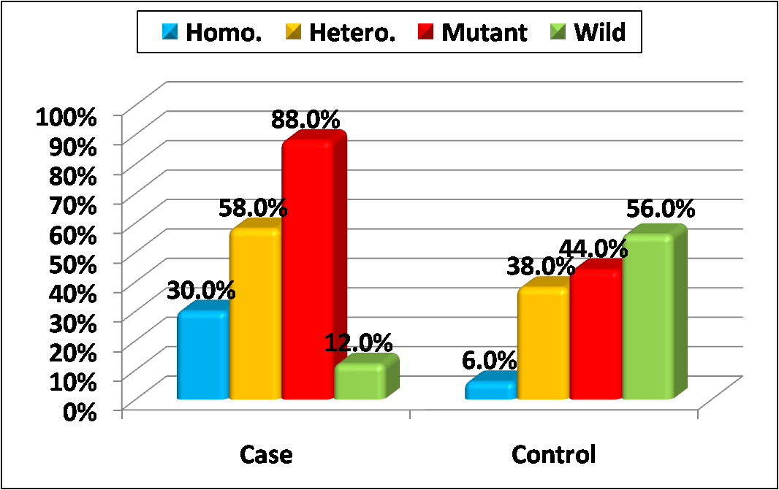
Table (4) and figures (2,3) show that: Mutant genes had significantly higher insulin dose and lower age of onset of diabetes.
Table (4): Comparison between mutant and wild genes regarding clinical characteristics among diabetic patients
Genes |  | Mutant  (N=44) | Wild  (N=6) | Mut./  Wild
Age at onset (years) |  | 8.9±3.1 | 13.0±1.4 | ^0.011*
Insulin dose (unit) |  | 52.8±21.1 | 29.8±4.7 | ^0.002*
Insulin type | Interm. | 32 (72.7%) | 4 (66.7%) | #0.756
 | Long | 12 (27.3%) | 2 (33.3%)
Nephropathy |  | 7 (15.9%) | 1 (16.7%) | #0.962
Previous hypoglycemia |  | 12 (27.3%) | 1 (16.7%) | #0.578
Previous ketacidosis |  | 29 (65.9%) | 3 (50.0%) | #0.446
^Independent t-test, #Chi square test, *Significant

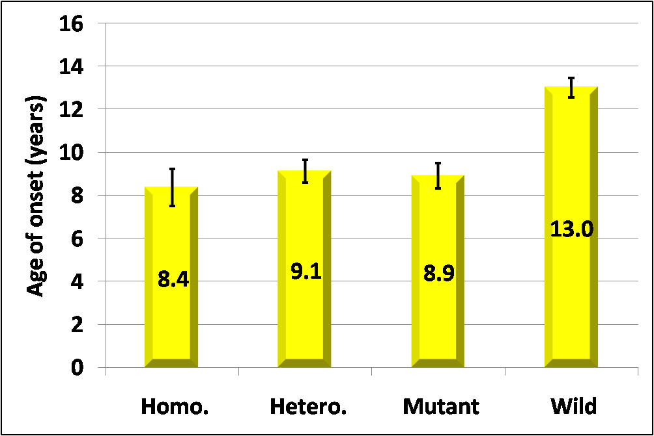
Figure (2): Comparison between different genotypes regarding age of onset among diabetic patients
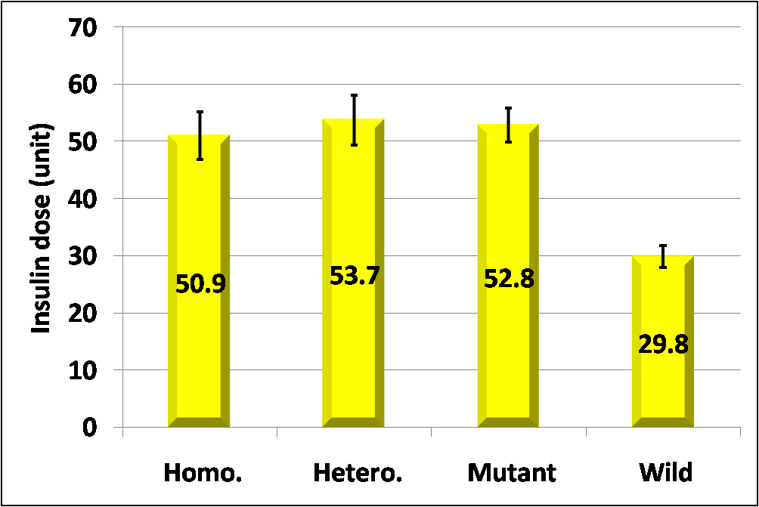
Figure (3): Comparison between different genotypes regarding insulin dose among diabetic patients

Discussion
Type 1 diabetes (T1D) is an organ-specific autoimmune disease that results from T cell-mediated destruction of insulin-producing pancreatic beta cells. This autoimmune disorder involves both genetic and environmental factors (Eizirik et al., 2009).
At present, the development of type 1 diabetes mellitus is a life sentence to a difficult therapeutic regimen that is only partially effective in preventing acute and chronic complications of the disease. Knowledge of the genetics of type 1 diabetes mellitus in our community would allow better disease definition and improved ability to identify individuals at risk of diabetes and its associated disorders.
Interest in CTLA-4 was raised because of its role in T cell signaling as a negative regulator of T-cell activation and effector function ( Carreno etal., 2000 & Wells etal., 2001)
In 1996, the cytotoxic T-lymphocyte antigen-4 gene (CTLA-4) encoded on chromosome 2q33 was identified as a further type 1 diabetes susceptibility gene. CTLA-4 is a surface molecule found on activated T cells which produces a negative signal by inhibiting the T cell receptor signaling complex ligand interactions (blocks binding of CD80 and CD86). Two major splice forms exist – encoding membrane bound and soluble forms. When CTLA-4 is knocked out, lymphoproliferative disorders result. An A49G polymorphism in exon 1 of CTLA-4 changes the amino acid sequence resulting in reduced cell surface expression. It is thought that inherited changes in CTLA-4 gene expression can increase T cell self-reactivity and therefore play an important role in autoimmune diseases such as type 1 diabetes.( Gillespie K., 2014 )
CTLA-4 gene has been described with an A/G polymorphism at position 49 in exon 1 leading to three genotypes, GG and AA homozygotes and AG heterozygote
Our study showed female predominance which comes in agreement with the assumption that female predominance is encountered in regions with low incidence mainly populations of non-European origin ( Gale and Gillespie., 2001). This was denied in a more recent study that reported equal incidence in both genders with female predominance only in autoimmune diseases (Soltesz etal., 2007).
There was no difference of statistical significance between patients and controls as regards age and sex thus allowing us to compare both groups Positive family history of diabetes was significantly more frequent in diabetic patients than control group in this study (P=0.009). This is expected as the pathogenesis of diabetes mellitus type 1 is multifactorial. Both genetic predisposition and environmental factors are involved in the deregulation of immune system with subsequent breakage of self-tolerance (Krejsek et al., 2004).
In the present work, the mean random blood glucose was significantly higher in diabetic patients (195.8±45.9 mg/dL) compared to control group (104.5±3.0 mg/dL) (P<0.001).
Patients in diabetic group exhibited significantly higher HbA1c and Microalbuminuria levels than did healthy subjects.
In the current study, CTLA-4 genotyping among the diabetic group: was the mutant homozygous genotype GG in 15(30%), the mutant heterozygous genotype AG in 29(58%) and wild homozygous genotype AA in 6(12%). However, among the control group: it was 3(6%) with GG genotype, 19(38%) with AG genotype and 28(56%) with AA genotype with P value < 0.001 which denoting a higher prevalence of AG and GG genotype in diabetic group with highly statistical significance. The same finding was found by El wafai et al. (2011) who conducted the same study but on different ethnic groups and found the CTLA-4 genotypes in diabetic patients as follow: GG genotype (23.1%),AG (53.8%) and AA (23.1%). However, among the control group: it was (0%) with GG genotype, (45.66%) with AG genotype and (54.34%) with AA genotype with P value = 0.0034.
In the current study, the frequency of G allele in the diabetic group 59(59%) and that of A allele 41(41%) however, among the control group the frequency of G allele 25(25%) and that of A allele 75(75%). Diabetic Patients have a higher number of mutant alleles than control group and it is statistically highly significant (p value < 0.001) so the G allele is associated with the type 1 diabetes. This finding was similar to Mosaad et al. (2012) who found that CTLA-4 G allele was significantly increased in T1D patients than in control group (P = 0.047). In our study CTLA-4 +49 mutant genes did not have any impact on complications of type 1 diabetes. Neither has it shown an impact on HbA1c. This result is correspondent with that reported by Mosaad, et al (2012) who also reported that the CTLA-4 GG genotype wasn’t associated with grades of diabetic control or diabetic complication
This work showed that there was a significant association between CTLA-4 mutant genotypes and patients with younger age of onset of diabetes (P=0.011) and higher dose of insulin (P=0.002) .This result is correspondent with that reported by Mosaad, et al (2012) who proved that CTLA-4 +49 GG homozygous genotype is associated with T1D in Egyptian children especially with younger age of onset and in younger patients.
The lack of agreement between our results and those of other authors may be due to unrecognized differences in environmental exposures, may be possibly due to differences in age, ethnicity, atopic status and disease severity among the populations, Another possible explanation may be that sample size has an effect on the contradictory result.
From this study we concluded that the CTLA-4 A/G +49 polymorphism was associated with type 1 diabetes in Egyptian children with a significant association between CTLA-4 mutant genotypes and patients with younger age of onset of diabetes and higher dose of insulin. However, this polymorphism did not have any impact on complications of type 1 diabetes.
References
Abe T., Takino H., Yamasaki H., Ozaki M., Sera Y., Kondo H., Sakamaki H., Kawasaki E., Awata T., Yamaguchi Y. and Eguchi K. (1999): CTLA-4 gene polymorphism correlates with the mode of onset and presence of ICA512 Ab in Japanese type 1 diabetes. Diabetes Res. Clin. Pract., 46, 169–175.
ADA. (2011): American Diabetes Association(ADA) Guideline for 2011 Classification and Diagnosis ;Diabetes Care 2011., 34.suppl 1.
Araujo MB., Mazza CS.(2008): Assessment of risk factors of poor metabolic control in type 1 diabetic children assisted in Apublic hospital in Argentina, pediatric diabetes., 9(5) :480-487. Accessed on 14/3/2012.[PubMed]
Awata T., Kurihara S., Iitaka M., Takei S., Inoue I., Ishii C., Negishi K., Izumida T., Yoshida Y., Hagura R., Kuzuya N., Kanazawa Y. and Katayama S. (1998): Association of CTLA-4 gene A-G polymorphism (IDDM12 locus) with acute-onset and insulin-depleted IDDM as well as autoimmune thyroid disease (Graves’ disease and Hashimoto’s thyroiditis) in the Japanese population. Diabetes, 47, 128–129.
Carreno BM, Bennett F, Chau TA, Ling V, Luxenberg D, Jussif J,
et al.(2000): CTLA-4 (CD152) can inhibit T cell activation by two different mechanisms depending on its level of cell surface expression. J Immunol ;16:1352–6.
Coonrod BA, Ellis D, Becker DJ, Bunker CH, Kelsey SF, Lloyd CE, Drash AL, Kuller LH, Orchard TJ.(1993): Predictors of microalbuminuria in individuals with IDDM. Pittsburgh Epidemiology of Diabetes Complications Study, 16(10):1376-1383.
Dariavach P, Mattéi MG, Golstein P, Lefranc MP.(1988): Human Ig superfamily CTLA-4 gene: Chromosomal localization and identity of protein sequence between murine and human CTLA-4 cytoplasmic domains. Eur J Immunol.;18:1901–1905.
Egyetem S, Orvostudományi A K, Belgyógyászati I.K, Budapest and Korányi S. U. (2010): Type 1 diabetes mellitus: pathogenesis, symptoms and therapy. Orv Hetil. 28; 151(13):533-539.
Eizirik DL, Colli M and Ortis F (2009): The role of inflammation in insulitis and beta cell loss in type 1 diabetes. Nat Rev Endocrinol; 5:219-226.
El Wafai RJ, Chmaisse HN, Makki RF, Fakhoury H(2011): Association of HLA class II alleles and CTLA-4 polymorphism nwith type 1 diabetes. Saudi journal of kidney diseases and transplantation; 22(2): 273-281
Gale EA, Gillespie KM(2001): Diabetes and gender. Diabetologia;44:3–15.
Gillespie K(2014):Non-HLA genes, CTLA4 - Type 1 diabetes mellitus. The Living Textbook of Diabetes ,Last modified on 13 August 2014 [internet]. Diapedia created by Driebit, Amsterdam 2104311115 rev. no. 36. Available from: http://dx.doi.org/10.14496/dia.2104311115.36 ) http://www.diapedia.org/type-1-diabetes-mellitus/2104311115/non-hla-genes
Gough S.C., Walker L.S., Sansom D.M. (2005): CTLA4 gene polymorphism and autoimmunity. Immunol. Rev. 204, 102–115.
Grandy S and Fox K. (2008): EQ-5D visual analog scale and utility index values in individuals with diabetes and at risk for diabetes: Findings from the Study to Help Improve Early evaluation and management of risk factors leading to Diabetes (SHIELD). Health and Quality of Life Outcomes, 6:18.
Haliloğlu B, Işgüven P, Yıldız M, Arslanoğlu I and Ergüven M.(2011): Complementary and alternative medicine in children with type 1 diabetes mellitus. J Clin Res Pediatr Endocrinol.; 3(3):139-143.
Harper K., Balzano C., Rouier E., Mattei M. G., Luciano H. F. and Goldstein P. (1991): CTLA-4 and CD28 molecules are closely related in both mouse and humans as to sequence, message expression, gene structure, and chromosomal location. J. Immunol., 147, 1037–1044.
ISPAD. (2009): International Society for Pediatric and Adolescent Diabetes, treatment of non-alcoholic fatty liver disease in children: swim at your own risk ., 10, 1-4. Accessed on 16/3/2012. [PubMed]
Kosmaczewska A., Ciszak L., Boc´ko D. and Frydeckai. (2001): Expression and functional significance of CTLA-4, a negative regulator of T cell activation. Arch. Immunol. Ther. Exp., 49, 39–45.
Krejsek J, Novosad J and Kopeckýo (2004): Immunopathogenesis of diabetes mellitus I. Vnitr Lek; 50(5):408-11.
Mosaad, Y.M., Elsharkawy, A.A., and El-Deek, B.S. (2012): Association of CTLA-4 (+49A/G) gene polymorphism with type 1 diabetes mellitus in Egyptian children. Immunol Invest 41, 28-37.
Nistico L, Buzzetti R, Pritchard LE, Van der Auwera B, Giovannini C, Bosi E.(1996): The CTLA-4 gene region of chromosome 2q33 is linked to, and associated with, type 1 diabetes.Belgian Diabetes Registry. Hum Mol Genet.;5:1075–1080.
Olive D, Thi S, Xerri L, Hirsch I, Nunès J (2011): The role of co-inhibitory signals driven by CTLA-4 in immune system. 1 Inserm U891, Centre de recherche en cancérologie de Marseille, F-13009, Marseille, France .Med Sci (Paris) ; 27 : 842–849.
Philip B, Isabel W (2011): Association of cytotoxic T lymphocyte-associated antigen 4 gene single nucleotide polymorphism with type 1 diabetes mellitus in Madurai population of Southern India. PG and Research Department of Zoology and Biotechnology, Lady Doak College, Madurai, Tamil Nadu 625 002, India ; 17(2): 85–89.
Radha V, Vimaleswaran KS, Deepa R, Mohan V.(2003):. The genetics of Diabetes mellitus. Indian J Med Res.;117:225–235. Accessed on 16/3/2012. [PubMed]
Rewers M, Pihoker C, Donaghue K, Hanas R, Swift P, Klingensmith GJ (2009): Assessment and monitoring of glycemic control in children and adolescents with diabetes. Pediatric Diabetes 10 (Suppl. 12): 71–81.
SiMonds SJ, Gough SC.(2005): Genetic insights into disease mechanism of autoiMunity. Br Med Bull. ;71:93–113.
Soltesz G, Patterson CC, Dahlquist (2007): EURODIAB Study Group. Worldwide childhood type 1 diabetes incidence–what can we learn from epidemiology? Pediatr Diabetes;8(Suppl):6–14.
Teft W.A., Kirchhof M.G., Madrenas J.(2006): A molecular perspective of CTLA-4 function. Annu. Rev. Immunol. 24, 65–97.
Vaidya B., Geatch H. R., Perros P., Ball S. G., Baylis P. H., Carr D., Hurrel S. J., James R. A., Kelly W. F., Kemp E. H., Young E. T., Weetman A. P., Kendall-Taylor P. and Pearce S. H. S. (2000): Association analysis of the cytotoxic T lymphocyte antigen-4 (CTLA-4) and autoimmune regulator-1 (AIRE-1) genes in sporadic autoimmune Addison’s disease. J. Clin. Endocrinol. Metab., 82, 688–691.
Wells AD, Walsh MC, Bluestone JA, Turka LA(2001): Signaling through CD28 and CTLA-4 controls two distinct forms of T cell anergy. J. Clin Invest;108:895–903.

