A comparative study on the effect of Romantic Comedies on females and males young adults
Amira Osman Karam El-Din – Lecturer
University College of Bahrain
Abstract
Romantic comedies have now become one of the top rated genres in Hollywood and most watched movies around the globe. Movies such as these are now an attraction to mostly female viewers who technically adore the cliché of “happily ever after”. Here and there, women are heard complaining about the men around them, fantasizing about that perfect love that in all reality, they might never really get. In order to dig deeper into the topic, a survey was made for young men and women ages 18-28 to see if romantic movies do give them unrealistic expectations for their love and sex life.
The researcher wants to examine not only the romantic expectations in their relationships, but the sexual expectations and whether the reality of intimate sex was in fact what was seen in movie love scenes. We want to ask both men and women, what are they expecting from the relationship? And whether or not their sexual satisfaction was emotionally fulfilled. Among knowing this, we will find out the difference between how both genders think, and if one is more affected than the other. With our results we might discover whether the flaw is in fact in the opposite gender around them, or if young people have just set the bar so high that not even the small tokens they receive are good enough?
To begin with, 100% of the women do watch romantic comedies, while only 52% of men do, revealing which gender would be more affected by the movies before even asking or analyzing the other questions.
Women are stereotypically more emotional than men, but the second hypothesis was also correct. The results show that females are more concerned about the romance and emotional satisfaction than the physical and the sexual or at least express it more than males do.
Introduction
Romantic comedies have now become one of the top rated genres in Hollywood and most watched movies around the globe. Movies such as these are now an attraction to mostly female viewers who technically adore the cliché of “happily ever after”. Here and there, couples are heard complaining about the opposite gender around them, fantasizing about that perfect love that in all reality, they might never really get.
Movies tend to perpetuate the belief that you only have “one true love”. Most films suggest that there is one person out there for you, and if you blow it, you’ve got to bend over backwards to get them back. There is in need to make the distinction between fairy tales and real life. People get such unrealistic expectations from movies that they often end up searching for Hollywood’s idea of the “perfect lover” instead of the perfect lover for each of them.
Aside from everyday love and romance which mostly women have high expectations for, both men and women have had various fantasies about sexual intimacy being so perfect because of the perfect and choreographed love scenes portrayed in Hollywood romantic comedies. Whether they were married or not, or have actually experienced love and sex, there is a built in fantasy of romantic, intimate, and passionate love-making that might or might not exist.
So, how do romantic comedies, which are basically funny movies about a love story that ends happily, give people of young ages 18-28 unrealistic expectations or experiences of a variety of feelings and emotions that they believe should be implied in real life, about romance, which in this research is specifically love and sex?
With research and analysis, we will have an interpretation of what real life romance is all about, and understand the main reason behind these unrealistic expectations of love and sex from both genders.
Young adults (chosen for this research): ages 18-28.
Operational terminology:
- Love:emotion of strong affection and personal attachment.
- Passion:intense emotion compelling feeling, enthusiasm, or desires for, in this case, love.
- Romantic Comedy:In a typical romantic comedy the two lovers tend to be young, likeable, and apparently meant for each other, yet they are kept apart by some complicating circumstance until, overcoming all obstacles, they are finally together at the end.
- Sexual intimacy: romantic love-making that not only pleases the body, but the emotions.
Research Objectives are to understand the following:
- Whether watching romantic comedies does in fact give women unrealistic expectations about love and sex.
- Whether watching romantic comedies does also give men unrealistic expectations about love and sex.
- The difference in mentality between males and females when it comes to romance and sex.
- Hypothesis:
Before distributing and receiving the results of the survey, the predicted outcomes of this research are:
- Women:
- Women are psychologically affected by romantic comedies leading to an unrealistic expectation about love and romance.
- Women are attached to the romantic connection of a relationship more that the physical connection.
- Women expect sex to be romantic and passionate more than physical.
- Men:
- The majorities of the men aren’t very affected by romantic comedies, and believe that love isn’t as passionate as shown in movies.
- The majorities of the men might be concerned about the physical connection of a relationship more than the romantic connection.
- The majorities accept sex even if it only satisfies them physically and not emotionally.
- Literature Review
What is Romance?
Romance is a mixture of pleasant and exciting feelings, such as anticipation, adventure, amorousness and caring, that surrounds a growing intimate relationship between a man and a woman.
Romance reaches its greatest potential with the complete development of emotional, spiritual, and physical intimacy. Emotional intimacy is being of one’s heart, which is the desire to make each other happy, to be together, and to belong to each other. Spiritual intimacy is being of one’s mind, which is sharing the same values and basic life goals, and working together to attain them. Physical intimacy is being of one’s body, which is sharing the pleasures and comforts of intimate sensuous affection.
Being of one’s heart; when romance is alive, each lover is eager to please the other for no other reason than to make him or her happy. The woman is able to focus on her man's happiness because she knows that he is watching out for her interests, so she doesn't have to worry about them, while the man similarly doesn't feel like he has to compete for his interests because she is eagerly concerned with them.
Being of one’s mind; this is when emotions and decisions are no longer all one’s own, but are intertwined with those of the lover. In order for romance to blossom fully in love, couples must make new values, priorities and goals together, which is only possible if they come to understand and trust each other. It does however, require choosing reality over fantasy.
Being of one’s body; it is very necessary that romance shares sexual intimacy. Sexual intimacy is glue that can bring two hearts together, and make romance complete. It can be an expression of love, desire, appreciation, and tenderness.
“God himself implanted the physical magnetism between the sexes for two reasons: for the propagation of the human race, and for the expression of that kind of love between man and wife that makes for true oneness…Sex can be a wonderful servant but a terrible master…It can be a creative force more powerful than any other in the fostering of love, companionship, happiness—or can be the most destructive of all of life's forces.” —Billy Graham http://www.drsterlingellsworth.com/images/handouts/Proper%20Sex.pdf
What is Romantic Comedy?
A romantic comedy is a dramatic story about romance between a couple that is told in a rather simple and humorous way. The question is why is this genre the most engaging between the rest?
The stories set up dramatic issues that revolve around romance, and they act out a couple of ideas that interest viewers. These ideas are that true love does in fact exist, no matter what there is that special someone out there just for us, and if we could only find them, we would experience true love, and finally, that true love is capable of overcoming any obstacles that we go through.
More than a love story, the “rom-com” as it is known in the film industry offers an amusing plot with endearing romantic encounters and the potential for a very touching conflict, though all turns out well in the end. This genre is unique for having certain characteristics that only it as a romantic comedy has. The same characteristics are implied on each story and each movie, and knowing the steps and orders of these characteristics helps viewers understand and sometimes predict the resolution of each movie.
Romantic comedies start out with a simple beginning of boy meets girl. The two lead roles are a man and woman who, against the odds, stumble across each other's path in any number of unusual and funny scenarios.
What makes a romantic comedy, comedy, is that in many films, the pair is all wrong for each other. In a humorous way, one may be sloppy and the other tidy or one may be wealthy while the other is less fortunate. Whatever it is, the two hardly seem destined to meet, so when they do, viewers can see the spark, but not initially in the romantic sense.
Either at their meeting point or during a change in one or the other's character or circumstances, the pair exchange a "look," a lingering, smoldering melding of glances that captivate each other and the audience for at least a few seconds. This “look” automatically lets the viewers know, even if the characters in the movie don’t, that the couple will eventually end up together.
Like every other genre, the characters come across threats, obstacles, or “the bad guys”. Something or someone will separate the lovers for a time, where the audience may fear a permanent break-up for part of the film. Eventually, however, the starring lovers will find and claim each other permanently.
The different meaning of physical affection to men and women:
Both men and women share the basic need to be intimate with their lovers. However, what this means from both a sexual and emotional standpoint is different for men and women. Boys and girls are socialized and taught differently about affection and being affectionate. Therefore, typically men and women enter this phase with different beliefs and expectations
about giving and receiving affection.
It’s been said that, typically, men give love and commitment in order to get physical affection and sex.
Women give physical affection and sex in order to get commitment and love.
It might also be said that men typically hunger for sex while women hunger for romance.
Men initially give and receive love to fulfill their physical needs; while women initially give and receive love to fulfill their emotional needs.
In our culture, there are vast differences as to what young people learn about the anatomy and physiology of boys and girls, men and women, and about sexuality.
Effects of watching Romantic Comedy
On romance:
According to researches, media effects are generally due to either cultivation theory, (Gerbner, Gross, Morgan, & Signorielli, 1994) or social cognitive theory (Bandura, 1986, 1994). Social cognitive theory suggests individuals may actively observe media portrayals of behaviors in romantic relationships for insight into how they themselves could behave in their own relationships. However, the fact that media is typically relying on unrealistic portrayals of relationships; it leads viewers to dream of unrealistic love and romance that might never come true.
According to Gerbner,” television has become the primary common source of socialization and everyday information for a heterogeneous population”. His cultivation theory states that it is the overall exposure to general media content that influences real world perceptions. However, my research proves that it is not only the overall media, but the genre viewed in specific that has an influence. Therefore, it is clear that viewers who watch a large amount of romance movies will come to cultivate beliefs and expectations of relationships are in fact like the ones in movies, full of fantasy.
On sex:
To begin with, romantic comedies are well known to portray the perfect relationship between physically beautiful characters, which obviously leads to relationships full of romance, physical intimacy, and passion. People who are repeatedly exposed to these perfect images may therefore come to see them as normal, which, in turn, could have a negative effect on their satisfaction when they actually have sexual activity.
Viewing sexually oriented media has been associated with young adults overestimating the sexual activity of peers (Ward & Rivadeneyra, 1999), experiencing dissatisfaction in their own lack of sexual activity (Baran, 1976), and endorsing unhealthy beliefs of women as sex objects (Ward & Friedman, 2006) and men as sex-driven (Ward, 2002).
According to social cognitive theory, studies suggest there may be an association between exposure to sexual content on television and initiation of sexual behavior. It is obvious that both male and females who frequently watch large amounts of sex-oriented television programs are more likely expect satisfying sexual behavior than those who watched comparatively less sexual content.
Data Collection:
In this research, a survey was distributed to 50 people, 25 males and 25 females, to use the statistics as a support for our discussion. Our questionnaire reveals how romantic comedies give both genders unrealistic expectations about romance.
Research:
In order to receive profound information for this research, a survey was conducted and given out to people hypothetically the ages who could watch romantic comedies. Distributing a survey during the day in University College of Bahrain was a method to easily interact with each of the 50 students we wanted to ask.
Population:
The main target for this research was males and females from the ages 18-28. The age of young adult was specifically chosen because According to Erikson, in the wake of the adolescent emphasis upon identity formation, “the young adult, emerging from the search for and insistence on identity, is eager and willing to fuse his identity with that of others. He [or she] is ready for intimacy, that is, the capacity to commit...to concrete affiliations and partnerships.” (Erikson, 1975). Therefore it is believed to be the age where the minds are most affected by the media.
Discussion and Analysis
Aside references such as books, articles, and internet, our main focus in obtaining accurate information about the effects of romantic comedies was through surveys and questionnaires. We considered this technique as an easy way to receive personal information from anonymous people who can easily relate to the issue due to the fact that they are at young adult ages and up to date with Hollywood movies.
Analysis of the results of the questions asked to the people:
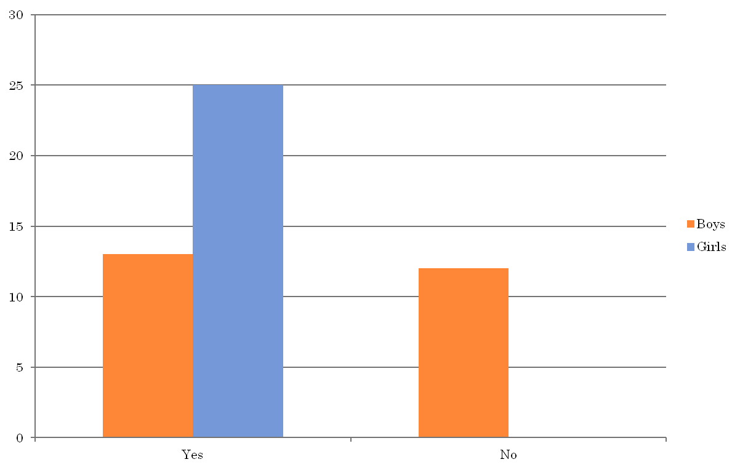
Chart #1 percentage of youth watching romantic comedies
To begin with, 100% of the women do watch romantic comedies, while only 52% of men do, revealing which gender would be more affected by the movies before even asking or analyzing the other questions.
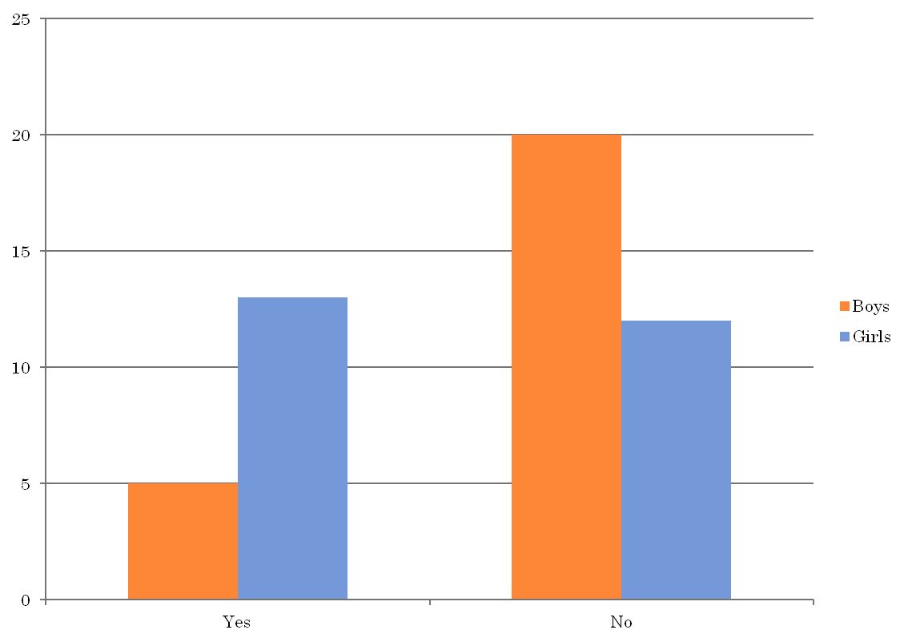
Chat#2 Percentage of people expecting their relationship to be more like the movies
It was expected a higher percentage of girls to answer that they expect their relationship to be more like movies, but only 52% answered yes. This shows that some girls already understand the unrealistic ideas these movies give even though they might want to have that relationship. Only 20% of the guys expected their relationship to be similar to the movies.
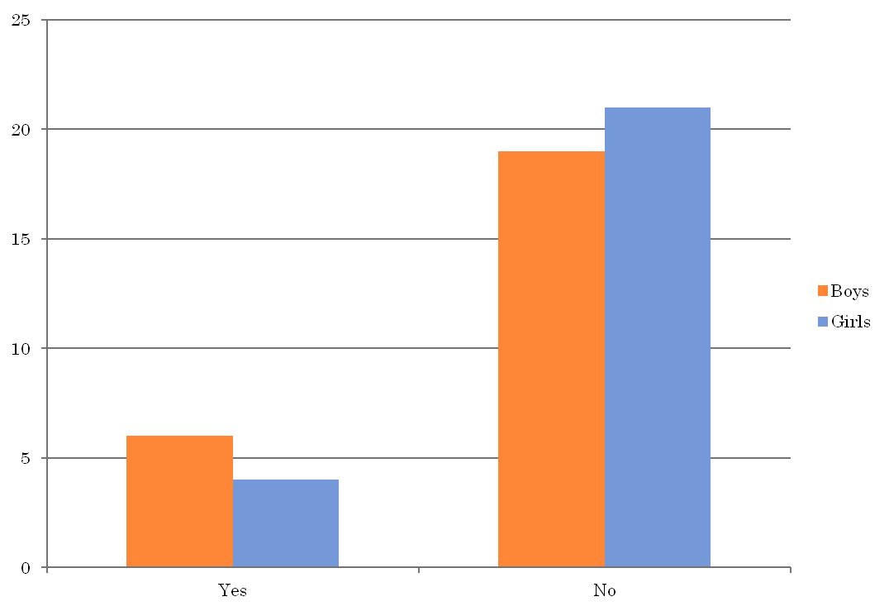
Chart# 3 Percentage of youth seeing their lovers similar to the men/women seen in movies
The result to this question proves the research’s point; which is that love isn’t what it seems like in movies. 76% of the guys and 84% of the girls said NO, that their lover is not similar to the ones in movies. What is interesting here is that 24% of the guys said yes, while only 16% of the girls did. This reveals that girls can be more passionate when it comes to relationships, seeing that more males are satisfied with their lovers, who in their case are girls.
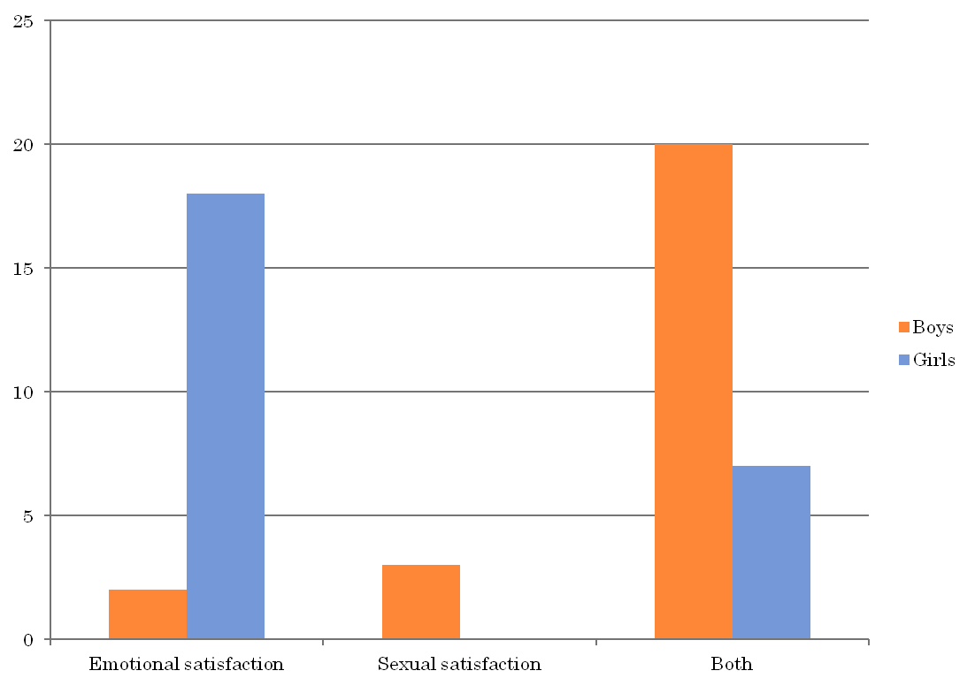
Chart#4 different reasons for being in a relationship
The difference in percentages here proves the research’s point exactly. Women are more compassionate than men. 72% of the girls chose “emotional satisfaction”, and luckily the majority of boys did not choose “sexual satisfaction” but both, which was 80%. However, it reveals that it’s not all about the emotions with the males.
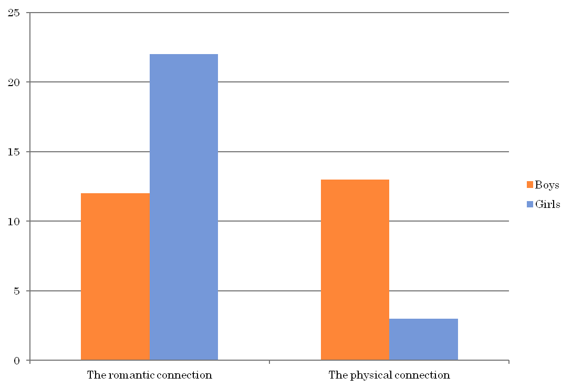
Chart#5 : Reactions after seeing love scenes
As predicted, 88% of the girls answered that they react to the romantic connection in a love scene. 48% of the boys chose romantic connection as well, which was a surprise because it’s about half of the males asked, where it was expected that the majority of the males would choose physical connection.
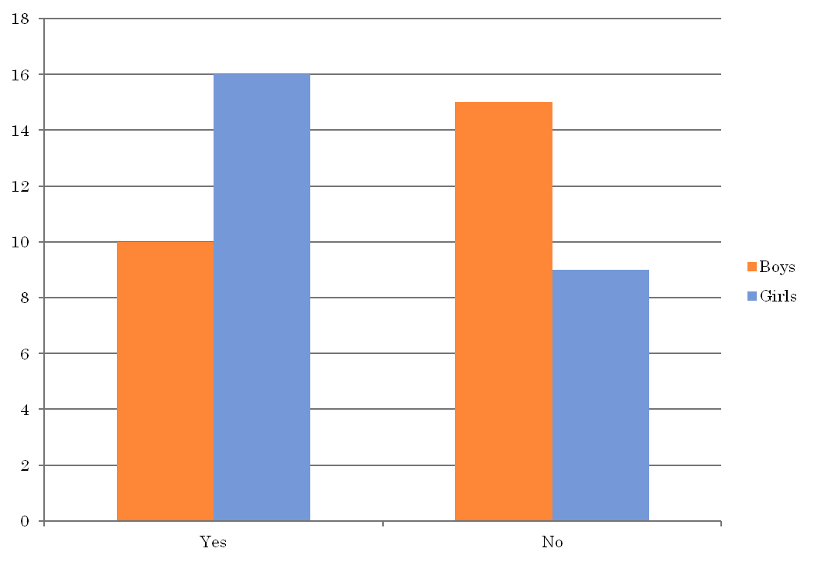
Chart#6 percentage of the necessity of love scenes
64% of the girls and 40% of the guys answered yes, as expected there was a gap between the percentage of the girls and the boys about passionate love-making, however it was expected that more girls find the passion necessary in real life, but 36% did not feel like it was necessary.
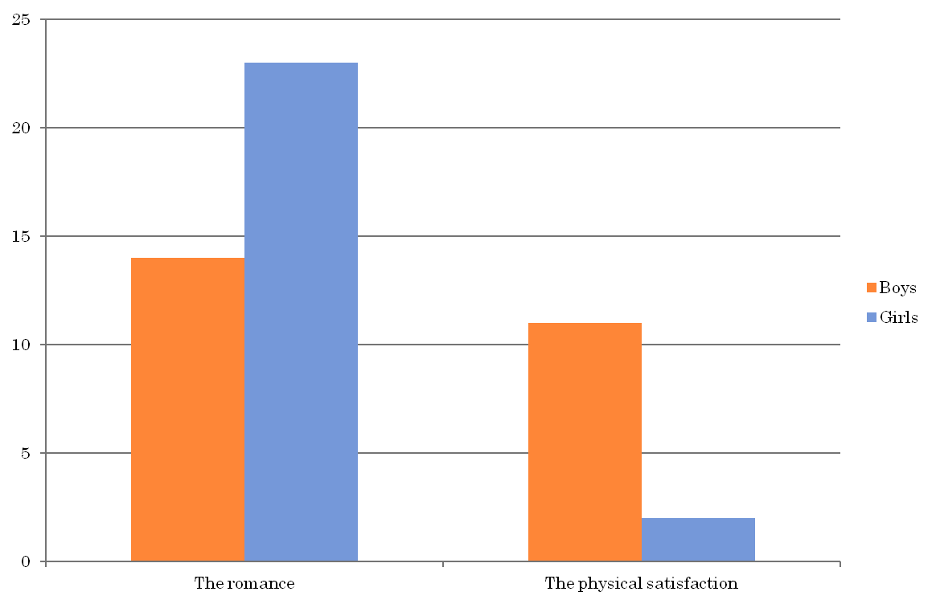
Chart# 7 Percentage of physically expressing love, romance of physical satisfaction
As expected, 92% of the girls chose the romance. Similar to question no.6, 56% of the boys chose romance as well, which was a surprise for it was expected the majority of males would choose the physical satisfaction.
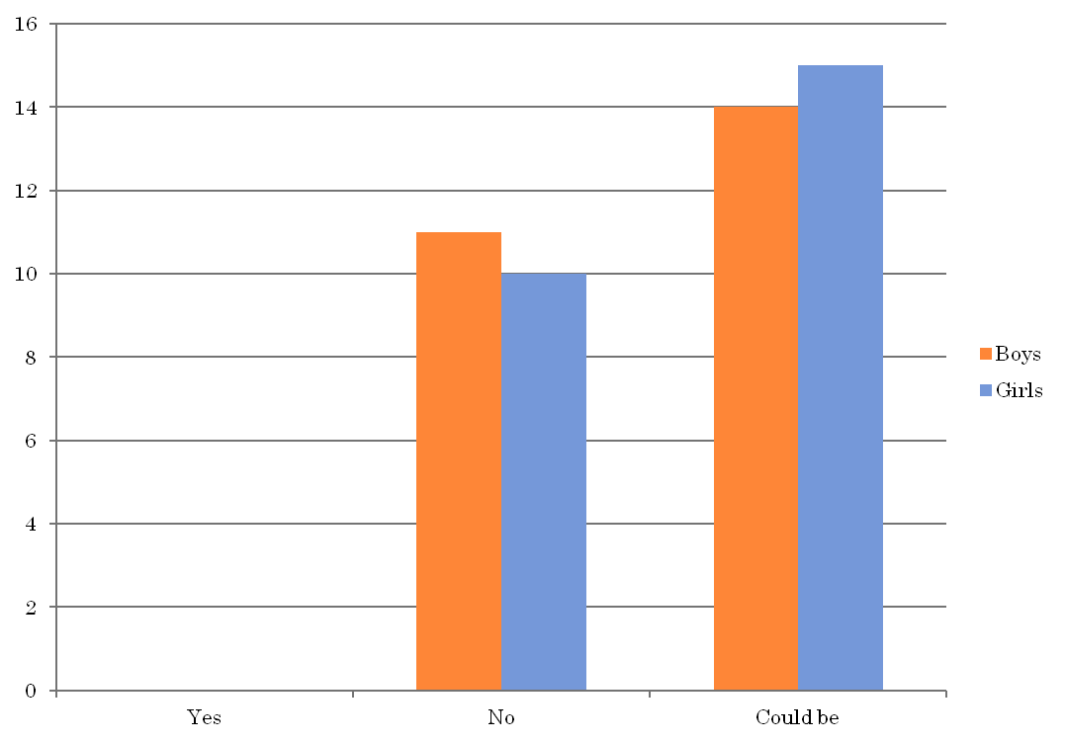
Chart#8 percentage of believing “love scenes” in movies are realistic
Apparently, no one finds “love scenes” in Hollywood movies realistic. But 60% of the girls and 56% of the guys believe these scenes could be true, but rare. There isn’t a big gap between the people who believe they could be true and the people who do not believe in them at all.
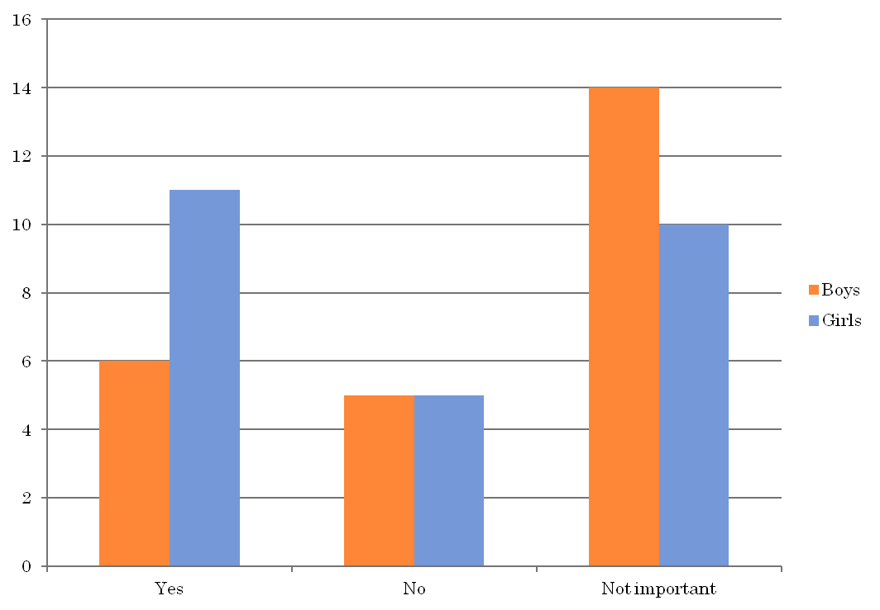
Chart#9 Percentage of youth wishing to have passionate life like romantic comedies
The percentage of girls who wished to have a passionate love life was fairly close to the ones who did not find passion to be important in a love life. 40% believed that it was not important and 44% wish to have that passion. Of course, the majority of the males said it was not very important, but fortunately, not many of them chose NO.
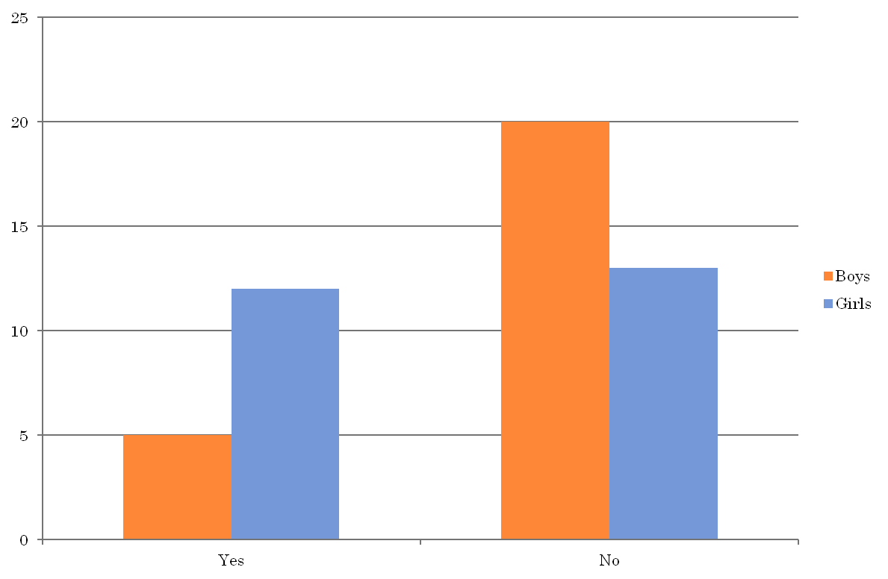
Chart#10 Percentage of youth satisfied about their passionate life
The final question in just to compare expectations and reality. 80% of the boys do not have a passionate love life. Maybe it is because they are not passionate from their side. And 52% of the girls do not have a passionate love life either. The percentage of both genders expecting a passionate and romantic love life was slightly higher than this, which shows expectations vs. reality.
Discussion with response to the Hypothesis:
The predictions were overall as an idea, correct. Researchers say that girls do in fact believe in unlikely happy endings, and a sense of the "perfect" relationship. They also believe that sex should always be perfect, and if someone is meant to be with you then they will know what you want without you needing to communicate it. Perhaps the girls did not agree 100% that they have unrealistic expectations, but they did not deny the idea that they want that perfect somebody. And now we know that these movies play a role in perpetuating these ideas in people's minds.
Women are stereotypically more emotional than men, but the second hypothesis was also correct. The results show that females are more concerned about the romance and emotional satisfaction than the physical and the sexual or at least express it more than males do.
Finally, girls are all about the romance, and as we see in our results, they actually believe that love-making is also all about the romance, because that is all that concerns them. Therefore, these expectations also blame on the movies, which portray sex as a passionate and emotional moment that not all of the people go through in real life.
Only the first prediction of the males’ results was precisely accurate. To begin with, the majority of them do not even watch romantic comedies, therefore they would not be affected by the unrealistic ideas they give to the people.
The results of whether boys are concerned about the sexual satisfaction more than the emotional satisfaction was a bit less than 50% and a bit less than expected. Although, there is a clear difference between the females’ needs from a relationship and the males’ needs from a relationship, which answers the question of whether women are more emotional and men are more physical.
The final hypothesis was also correct, and it seems that male’s will accept sex regardless if it pleases them emotionally or if it was romantic enough.
Conclusion
Since romantic comedies give unrealistic expectations that later lead to the realization of a disappointing reality, why do people, specifically girls, enjoy watching it?
From a social-cognitive theory perspective (Bandura, 1986, 1994), adolescents using films of this nature as a means to obtain information on what behaviors are successful in initiating and maintaining a relationship may find information on the former, but little on the latter.
My research and analysis does not prove or explain why this genre is continuously if it is believed that it has a more negative than a positive effect on viewers, however, it is not negotiable that people, in particular women, enjoy watching an emotional, spiritual, and intimate connection between a couple that can at least build a certain imagination that they can fantasize about even if it does not come true.
References
- Mohatta, CB, “What is Romance?” Ezine Articles, accessed January 02, 2006
http://ezinearticles.com/?What-is-Romance?&id=121514
- Wyatt, Angie Schuller, “How to Ignite a Spiritual Spark in Your Romance” Balance in Me, accessed July 16, 2011
http://balanceinme.com/balanced-relationship/spiritual-relationships/
Bandura, A. (1986). Social foundations of thought and action: A social cognitive theory. Englewood Cliffs, NJ: Prentice-Hall.
- Bandura, A. (1994). Social cognitive theory of mass communication. In J. Bryant & D. Zillman (Eds.), Media effects: Advances in theory and research (pp. 61–90). Hillsdale, NJ: Lawrence Erlbaum.
- Gerbner, G., Gross, L., Morgan, M., & Signorielli, N. (1994). Growing up with television: The cultivation perspective. In J. Bryant, & D. Zillman (Eds.), Media effects: Advances in theory and research (pp. 17–41). Hillsdale, NJ: Lawrence Erlbaum.
- Ward, L. M. (2002). Does television exposure affect emerging adults’ attitudes and assumptions about sexual relationships? Correlation and experimental confirmation. Journal of Youth and Adolescence, 31, 1–15.
- Ward, L. M., & Rivadeneyra, R. (1999). Contributions of entertainment television to adolescent’s sexual attitudes and expectations: The role of viewing amount versus viewer involvement. Journal of Sex Research, 36, 237–249.
- Ward, L. M., & Friedman, K. (2006). Using TV as a guide: Associations between television viewing and adolescents’ sexual attitudes and behavior. Journal of Research on Adolescence, 16, 133–156.
- Erikson, E.H. (1975). Childhood and Society. New York: Norton, p. 255.
- http://www.drsterlingellsworth.com/images/handouts/Proper%20Sex.pdf, April 2012
- http://itsjustkarma.com/sex-and-intimacy-2/physical-intimacy/, February 2012
- http://itsjustkarma.com/sex-and-intimacy-2/, April 2012
دراسة مقارنة لتأثير الكوميديا الرومانسية على الشباب من الجنسين
ملخص:
أصبحت الكوميديا الرومانسية الآن واحدة من فنون الدراما الأكثر مشاهدة والتي دائماً ما تصنف على أنها الأفضل من بين أفلام هوليود, حيث أنها الأكثر انتشاراً ومتابعة في جميع أنحاء العالم.
هذا النوع من الأفلام لاسيماأنه أصبح مصدر جذب للإناث بشكل أكبر, حيث أن الإناث يتأثرن دائماً بما يعرف عادة باسم "السعادة الأبدية".
أصبحنا نسمع الإناث في كل مكان يعربن عن عدم رضائهن علىالجنس الأخر حيث انهن أصبحن يتخيلن أن الحب المثالي الذي يشاهدونه في الكوميديا الرومانسية هو موجود بالفعل في الواقع, ولكن لايمكنهمن الحصول عليه أبداً. ومن أجل الخوض في الموضوع بصورة أعمق, أُجريت دراسة تستهدف الشباب, منهم الذكور والإناث الذين تتراوح أعمارهم مابين 18 و 28 سنة, للبحث ما إذا كانت الأفلام الرومانسية حقاً تضفي إليهم توقعات خيالية غير واقعية عن الحب والحياة الجنسية أم لا.
هدفنا ليس فقط دراسة التأملات الرومانسية لهؤلاء الشباب في علاقاتهم, بل أيضاً تريد الباحثة دراسة تأثير المشاهد الرومانسية على تقبلهم لشريك الحياة ورضائهم على حياتهم الجنسية .
وتكمن أهمية هذا البحث, في معرفة طريقة تفكير كلا الجنسين, ومعرفة ما اذا كان أحد الجنسين أكثر تأثراً من الجنس الآخر أم لا!
ومن أحد أهم نتائج البحث أن نسبة 100% من النساء يشاهدن أفلام الكوميديا الرومانسية, بينما 52% فقط من الرجال يشاهدون المثل, مما يكشف لنا بشكل واضح أي الجنسين قد يكون أكثر تأثراً بالأفلام وبعد إحصاء أراء الإناث والذكور تم ثبات صحة فروض البحث التي تفترض أن الإناث أكثر تأثراً من الذكور بهذه النوعية من الأفلام، يمكن أن يصل تأثر الإناث إلى مرحلى تجعلهن غير راضيات عن شريك الحياة بصفة دائمة نظراً لبعد الواقع عن الصورة الخيالية الحالمة التي تنقلها أفلام الكوميديا الرومانسية.
ونستخلص أن المرأة حقاً أكثر رومانسية من الرجل بشكل بديهي وهذا ما أظهرته العديد من الدراسات حيث تم التأكيد أن الإناث أكثر اهتماماً بالرومانسية والإشباع العاطفي بصورة أكبر بكثير من اهتمامهن بالإشباع الجسدي أو الجنسي، كما أن الإناث يعبرن عن عواطفهن بشكل أكبر من الذكور.

