Trend of Main Psychiatric Health Problems among Children and Adolescent at Different Districts in Egypt
Ehab Eid, PhD¹ Gehan Elhary, MD² Salah Mostafa, MD^{1*} Omar Elshourbagy, PhD¹
Magdy Karmeldein, PhD¹ Ismeil Yousef, MD³ Samia Samy, PhD¹ Reem Zakrya, PhD,¹
Samia Sabur, FM² Hassen Khadder, Ms¹ Hanan Elgamal, PhD¹
1. Department of Medical Studies for Children, Institute of Postgraduate Childhood Studies, Ain-Shams University
2. Military Hospital, Madina Monora, Saudi Arabia
3. Psychiatry and Neurology Dep., College of Medicine, Suez Canal University
* Salah Mostafa, MD [EGYPT], FACE [USA], Correspondent, salahmos42@gmail.com
Abstract:
Background: Mental disorders and suicide can result from the interaction of mental disorders and other factors were the second leading cause of death among children aged 12-17ys in 2010 at United States.
Objective: To study the prevalence of main psychiatric health problems in Egyptian children and adolescents for early intervention to help raising the new generations in an appropriate way assuring building up healthy society.
Methodology: First phase; a meta-analysis study data derived from Egyptian psychiatric informatics in children (EPIC), which were conducted from 1980 to 2005, including 57,802 subjects , studying the trend of main psychiatric health problems among children and adolescent at different governorates. Second Phase; Attention deficit hyperactivity disorders (ADHD) data are added to the data of EPIC regarding ADHD to study the prevalence of disease at different governorates.
Results: The first phase includes 57,802 subjects from different governorates in Egypt. Among this group there are 38,731 subjects (67.0 %), without psychiatric health problems and 19,071 subjects (33.0%), with psychiatric health problems, the trend of psychiatric health problems among children and adolescence at different periods. In general there was increase in psychiatric health problems prevalence among this age group and this difference statistically highly significant (P =0.0001). Also, the prevalence of main psychiatric health problems increase among those who lose their parent (81.5%) and (43.6%) on the other group and this difference was statistically highly significant (P =0.0001).
Second phase, prevalence of ADHD at different governorates showed non-significant difference between all studied governorates (P =0.999).
Conclusion: About 33 % of the studied group had main psychiatric health problems that showed increase by the time. A plan must be designed to overcome this problem which may lead to high morbidity and mortality among this important age group.
Keywords: Children Adolescents Main Psychiatric Health Problems Attention Deficit Hyperactive Disorders, ADHD Egypt
اتجاه لمشاكل الصحة النفسية الرئيسية بين الأطفال والمراهقين في مناطق مختلفة في مصر
الخلفة: الاضطرابات النفسية من أهم المشاكل الصحيةالتى تواجه الأطفال والمراهقين، وتعد السبب الرئيسي الثاني للوفاة بين الأطفال الذين تتراوح أعمارهم بين 12و17 سنة في الولايات المتحدة الأمريكية.
الهدف: دراسة انتشار المشاكل الصحية النفسية الرئيسية في الأطفال والمراهقين المصريين للتدخل المبكر و لحماية الأجيال الجديدة بطريقة مناسبة وضمان بناء مجتمع سليم.
المنهجية: المرحلة الأولى: شملت بيانات دراسة التحليل - متا المستمدة من مشروع المعلوماتية النفسية المصرية في الأطفال EPIC، التي أجريت 1980-2005، حيث شملت على 57802 فرد ، لدراسة الاتجاه الزمنى فى المشاكل الصحية النفسية الرئيسية بين الأطفال والمراهقين في مختلف المحافظات. المرحلة الثانية: نقص الانتباه واضطرابات فرط الحركه تم إضافة (ADHD) بياناتهم إلى بيانات من EPIC لدراسة مدى انتشار هذا المرض ADHD في المحافظات المختلفة.
النتائج: وتشمل المرحلة الأولى 57802 فرد من محافظات مختلفة في مصر. ومن بين هذه المجموعة هناك 38731 فرد (67.0 ٪)، من دون مشاكل الصحة النفسية و19071 فرد (33.0٪)، يعانون من مشاكل صحية نفسية. الاتجاه من المشاكل الصحية النفسية بين الأطفال والمراهقين في فترات مختلفة. بشكل عام كان هناك زيادة في انتشار المشاكل الصحية النفسية بين هذه الفئة العمرية ((P = 0.0001. وكان ارتفاع معدل انتشار المشاكل الصحية النفسية بين حالات الطلاق 92٪ والانفصال 74.3٪ ، وتزيد معدلات انتشار المشاكل الصحية النفسية بين هؤلاء الذين يفقدون آبائهم (81.5٪) و (43.6٪) فى المجموعة الاخرى. المرحلة الثانية: أظهرت نتائج هذه المرحلة من الدراسة ان اضطراب نقص الانتباه وفرط الحركة ADHD في مختلف المحافظات أن الفرق غير ملحوظ بين جميع المحافظات (P = 0.999).
الخلاصة: نحو 33٪ من الحالات تعانى من المشاكل الصحية النفسية والتي تزداد مع الوقت ويجب أن تكون هناك خطة للتغلب على هذه المشكلة التي قد تؤدي إلى الإصابة بالأمراض والوفيات بين هذه الفئة العمرية الهامة.
الكلمات المفتاحية: الأطفال المراهقين المشاكل الصحية النفسية اضطراب نقص الانتباه وفرط الحركة مصر
Introduction:
Mental disorders among children are described as serious deviation from expected cognitive, social and emotional development (RuthPerou et al., 2013). According to the world health organization (WHO) mental disorders are one of leading causes of disability in people between age 15-44ys (Kathleen, 2009).
Mental health is an important component of overall health and mental disorders that can cause suffering, disability, and, rarely, even death (Pratt et al., 2007). Chronic medical illness is often associated with emotional problems that may be the major source of concern compared with the original physical problem (Lane et al., 2002).
Worldwide, there are only a few standardized studies of juveniles in which extensive assessments of psychiatric status have been performed (Rani et al., 2006). Thus, data on psychiatric morbidity are needed to develop more effective plans to screen the youth population and to detect high-risk children and adolescents with psychiatric morbidity who need interventions in the community (Karen et al., 2005).
In Egypt, the total number of children ranging in age from 6 to 18 years in the 2011 Population Census was 26 418 350, which constitutes about 32.8% of the total Egyptian population (80 411 370) (Central Agency for Public Mobilization and Statistics, 2011).
Mental disorders and suicide which can result from the interaction of mental disorders and other factors was the second leading cause of death among children aged 12-17ys in 2010 at United States (RuthPerou et al., 2013). So, it was important to have information regarding psychiatric disorders prevalence and related risk factors among Egyptian children (Samia Aziz et al., 2009).
Objective:
The objective is to study the prevalence of main psychiatric health problems in Egyptian children and adolescents for raising the new generations in an appropriate way assuring building up healthy society.
Methodology:
This meta-analysis study was done in two phases:
The first phase: data was derived from Egyptian psychiatric informatics in children (EPIC) which was built in (collection of all relevant studies, 149 studies, conducted from 1980 to 2005, including 57,802 subjects. Data entry on the computer after proper preparation according to ICD-10 for met-analysis technique, type 3, for rebuilding the collected data in one national database allowing the use of the new national psychiatric data base to be accessible though website www.asu-epic.org.
The second phase: data include 20,194 subjects from 10 studies from 2002 to 2012 was re manipulated to high light on ADHD syndrome prevalence at different governorates.
Results:
The first phase includes 56,912 subjects from different governorates in Egypt. Among this group there are 38,731 subjects (67.0%) without psychiatric health problems and 19,071 subjects (33.0%) with psychiatric health problems all over the studied group.
Figure (1) shows the trend of psychiatric health problems among children and adolescence at different periods. In general there was increase in psychiatric health problems prevalence [CNS diseases, personality trait, neurotic stress related & somatoform disorders, depressive episode, mental retardation, specific developmental disorders, other behavioral and emotional disorders hyperkinetic and conduct disorders] among this age group and this difference statistically highly significant (P =0.0001). The period between 1980 and 1990 the psychiatric health problems represented 8.7%, compared with the period between 2001 and 2005 was 19.7% which mean that there is an increase in the prevalence of psychiatric health problems among this age group and there is high prevalence between the periods from 1991 to 1995 which was 26.3%. The highest prevalence was from 1996 to 2000 representing 45.3%.
Table (1) shows the prevalence of psychiatric health problems at different governorates. There was high prevalence at Cairo 41.6%, Kalubia 21% and Alexandria 12.1%. The lowest prevalence was at Gharbia 0.3% and Benisuf 0.3%. This difference was statically highly significant (P=0.0001).
Figure1; Trend of main psychiatric health problems at different periods
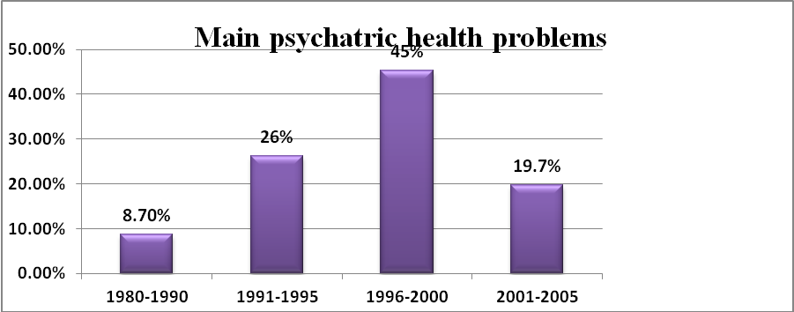
Chi-square = 6136.29, (P=0.0001)
Table1; Distribution of main psychiatric health problems at different Governorates
Governorates | Other health problems | % | Psychiatric  Problems | %
Cairo | 12636 | 33 | 7768 | 41.6
Alexandria | 306 | 0.8 | 2256 | 12.1
Port said | 0 | 0.0 | 594 | 3.2
Suez | 120 | 0.3 | 120 | 0.6
Dahlia | 2562 | 6.7 | 574 | 3.1
Sharkia | 7802 | 20.4 | 902 | 4.8
Kalubia | 2030 | 5.3 | 3911 | 21
Gharbia | 1 | 0.0 | 52 | 0.3
Monofia | 7135 | 18.6 | 534 | 2.9
Ismalia | 408 | 1.1 | 311 | 1.7
Giza | 4344 | 11.4 | 752 | 4
Benisufe | 786 | 2.1 | 50 | 0.3
Assuit | 131 | 0.3 | 827 | 4.4
Total | 38261 | 100 | 18651 | 100%
Chi-square=15021.13, P= 0.0001
Figure (2) shows the prevalence of main psychiatric health problems as regards gender. Main psychiatric health problems were more significantly prevalent among male (56.7%) than female (43.3%) (P=0.0001).
Figure (3) shows the effect of family stability on the prevalence of main psychiatric health problems among children and adolescent. It shows that statistically high prevalence of main psychiatric health problems was among divorce 92% and separation 74.3% but low prevalence at normal family 38.1%. (P=0.0001).
Figure 2; Main psychiatric health problem according to Gender
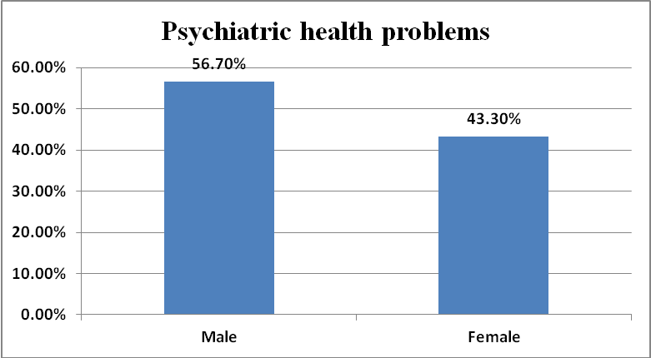
Chi-square=67.5, P=0.0001
Figure 3; Effect of family stability on main psychiatric health problems
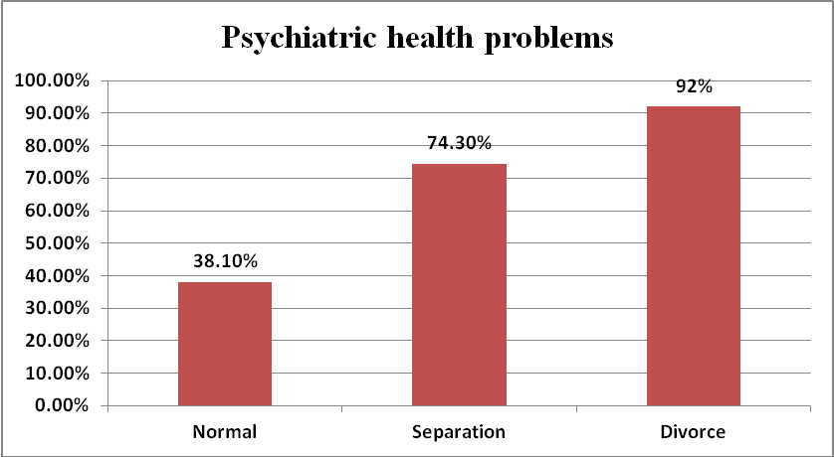
Chi-square=34.9, P=0.0001
Figure (4) shows the effect of parents’ loss in main psychiatric health problems. The prevalence of main psychiatric health problems was statistically highly significant (P=0.0001) among those who lose their parent (81.5%) and (43.6%) on the other group.
Figure 4, Effect of parent loss on the prevalence of main psychiatric health problems
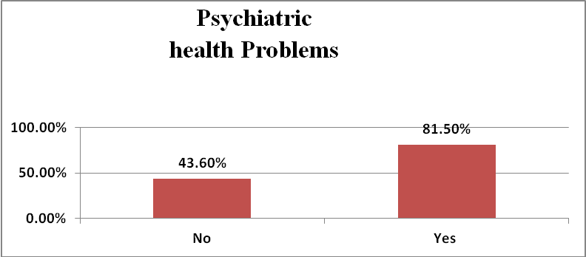
Chi square=12.877, P-value=0.0001
Table (2) shows the difference between BMI in those with psychiatric health problems and other health problems. The mean BMI among those with psychiatric health problems was (22.910) while the mean BMI among the other health problems was (16.967).and this difference was statistically highly significant (P =0.0001).
Table 2; Body mass index in main psychiatric and other health problems
 | Number | Mean | ± SD
Other health prob. | 1043 | 16.967 | 1.9728
Psychiatric prob. | 193 | 22.910 | 4.7128
t-test, t =-29.2, P=0.0001
Table (3) shows the prevalence of ADHD at different governorates but the difference was statistically insignificant difference between all studied governorates (P =0.999).
Table 3; Prevalence of ADHD by government
Governorates | ADHD | % | Other problem | % | Total examined
Cairo | 1345 | 2.5 | 31747 | 59.80 | 33092
Al Menofia | 205 | 0.38 | 9234 | 17.40 | 9439
Al Menia | 259 | 0.47 | 3964 | 7.47 | 4223
Assuit | 91 | 0.19 | 2380 | 4.48 | 2471
Dukahlia | 30 | 0.09 | 3106 | 5.85 | 3136
Ismalia | 42 | 0.10 | 672 | 1.27 | 719
Total | 1972 | 3.73 | 51103 | 96.27 | 53080
Chi square= 0.08 , P= 0.999
Discussion:
Mental disorders among children are described as serious deviations from expected cognitive, social and emotional development (RuthPerou et al., 2013). According to the World Health Organization (WHO), mental health disorders are one of the leading causes of disability worldwide. Three of ten leading causes of disability in people between ages of 15 and 18 are mental disorders, and the other causes are often associated with mental disorders (Kathleen, 2007).
This study was depending on the secondary data collected from Egyptian psychiatric informatics (EPIC).The data was reanalyzed which include 56,912 subjects age from 0 to 18 years old. The data from previous studies carried out in universities allover Egypt. Among this group there are 38,261 subjects (67.23%), without psychiatric health problems and 18,651 subjects (32.77%), with main psychiatric health problems all over the studied group.
This agrees with Kathleen (2007) who found that approximately one fourth of youth experience a mental disorder during the past year and about one third across their lifetime (RuthPerou et al., 2013).
Savita and Bichitra (2014) reported that the prevalence of psychiatric disorders in India was 23.33% in the school children and adolescent. Elhamid and Howe (2009) in Egypt found that the prevalence of psychiatric health problems 8.5%. Belfer (2008) found that up to 20% of children and adolescents suffer from a disabling mental illness.
In general there was statistically highly significant increase in psychiatric health problems prevalence among this age group (P =0.0001). The period between 1980 and 1990, the psychiatric health problems represented 8.7%, the period between 2001 and 2005 represented 19.7%, which mean that there was an increase in the prevalence of psychiatric health problems among this age group.
Higher prevalence was between 1991 and 1995 representing 26.3%, and from 1996 to 2000 representing 45.3%. This come with mental health surveillance among children United States (2005-2011) reported that 13-20% of children living in united states experience a mental health disorder and the surveillance during 1992-2011 showing an increase in the prevalence (RuthPerou et al., 2013).
There was statically highly significant prevalence at Cairo 41.6%, Kalubia 21% and Alexandria 12.1%.and the lowest prevalence was at Gharbia 0.3% and Benisuf 0.3% (P =0.0001).
Psychiatric health problems were more statistically highly significantlly prevalent among male (56.7%) than female (43.3%) (P =0.0001). This come with Costello which stated that 31% of girls and 42% of boys had at least one psychiatric disorder (Costello et al., 2003). Vicente et al. found that 19.3 % of boys and 25% of girls with psychiatric disorders in Chile (Vicente Saldivia et al., 2012).
The "behavior problems" are having a major impact on the child's bodily and social development. It is the major concern of frustration to parents. Parent-child relationship gets disrupted and creates family conflicts and disharmony. The family provides emotional support to an individual as well as plays a major role in the formation of one's personality. The quality and nature of the parental nurturance that the child receives will profoundly influence his future development. But only few homes provide the right type of environment to the growing child. Numerous studies have shown that children with various kinds of psychiatric and behavioral problems tend to come from homes or schools that are disadvantaged in some respect (Bhatia et al., 1990).
Srinivasan and Raman (1988) in their study estimated 9.32 times increased risk for psychopathology in children with long term parental separation. Dayal et al. (1986) studied social, cultural and educational background of 100 male delinquent children at Agra found most of the children from families with the absence of a father.
Deivasigamani (1989) found absent father in most of children with psychiatric morbidity. Prat (2003) stated that parental loss is associated with significant psychosocial and mental health problems in adolescents.
As regards the effect of family stability on the prevalence of psychiatric health problems among children and adolescent, There were statistically highly significant (P =0.0001) prevalence of psychiatric health problems was among divorce 92% and separation 74.3% but lower at normal family 38.1%. The prevalence of psychiatric health problems increase among those who lose their parent (81.5%) and (43.6%) on the other group and this difference was statistically highly significant (P =0.0001). Sandip et al.(2014) revealed a significant association between loss of parents and prevalence rate of behavior problems. Most of the research studies related to mental illness and psychological disturbances have shown a significant correlation between loss of parent and psychopathology in children.
Obesity was more among those with psychiatric disorders than those with other health problems. The mean BMI among those with psychiatric health problems was (22.91) while the mean BMI among the other health problems was (16.96).and this difference was statistically highly significant (P =0.0001).This is against Samia Aziz et al.(2009), which find no significant regarding BMI and mood disturbance (Kathleen Rose, 2009). Obesity has reached epidemic in developed countries twenty five percent of American children are overweight and 11% are obese (Mahashid et al., 2005).
On handling data from Dr. Hassan study with data of EPIC regarding the attention deficit hyperactive disorder (ADHD), the prevalence of ADHD at different governorates was higher at Cairo 2.5% and lower at Ismalia 0.1% but the difference was statistically insignificant difference. American psychiatric association found that the attention deficit hyperactive disorders was 11% of American children, ages 4-17 there is increase of the diagnosis from 7.8% at 2003 to 11% at 2011 and the incidence in western states was lower than the Midwest states seem to be higher (Kruick, 2014).
Conclusion:
Mental health problems are one of the leading causes of disability worldwide. About 33 % of the studied group had main psychiatric health problems, increasing by time and may lead to high morbidity and mortality among this important age group. Study of the prevalence of psychiatric disorders in this population group is essential for raising the new generations in an appropriate way assuring building up healthy society.
References:
- Belfer (2008): Child and adolescent mental disorders: the magnitude of the problem across the globe, child psychiatry, Mar;49(3):226-36.
- Bhatia MS, Singhal PK, Dhar NK, Bohra N, Malik SC, Mullick DN.(1990): Family and the pattern of childhood psychiatric problems. Indian Practitioner 1990;4: 893-9.
- Central Agency for Public Mobilization and Statistics (2011). Available at: http://www.capmas.gov.eg/.
- Costello, Mustillo et al. (2003): Prevalence and development of psychiatric disorders in childhood and adolescence, Aug; 60(8):837-44.
- Dayal R, Prasad R, Misra MN et al.(1986): Are delinquents born or made by us? Indian Pediatr 1986;23:627-33.
- Deivasigamani TR.(1990): Psychiatric morbidity in primary school children- An epidemiological study. Indian J Psychiatry 1990;32:235-40.
- Elhamid AA and Howe (2009): Prevalence of emotional and behavioural problems among 6-12 year old children in Egypt, Soc Psychiary Psychiatr Epidemiol, Jan;44(1):8-14.
- Karen M, Linda A, Gary M, et al. (2005): Performance of the faces anxiety scale in patients transferred from the ICU. Intensive Crit Care Nurs 21:355-360.
- Kathleen Ries Merikangas (2009): Epidemiology of mental disorders in children and adolescents, dialogues clinneurosci, Mar; 11(1):7-20.
- Krucik G T (2014): ADHD by the numbers: facts and statistics, and you, health line, Sept; 4.
- Lane D,Lip G, and Millane T (2002): Quality of life in adults with congenital heart disease. Heart 88:71-75.
- Mahshid Dehghn, Noori Akhtar and Anwar (2005): Childhood obesity, prevalence and prevention, Nutrition journal, Sept; 4:24.
- Pratt HD.(2003): Principles of psychosocial assessment of adolescents. Indian J Pediatr 2003;70:775-80.
- Pratt L, Dey A, and Cohen A (2007): Characteristics of adults with serious psychological distress as measured by the K6 Scale: United States 2001. Advance Data Centers for Disease Control and Prevention. National Center for Health Statistics 382:30.
- Rani A, Joseph L, JudithR, et al. (2006): Mental health care in juvenile detention facilities: a review. J Am Acad Psychiatry Law 34:204-214.
- RuthPerou, Rebecca H, Bitsko et al.(2013): Mental health surveillance among children – United Supplement,May;17,62(02); 1-35.
- Rutter M (1990). In: Chess S, Herzig M, editors. Isle of Wight revisited, twenty-five years of child psychiatric epidemiology. Annual Progress in Child Psychiatry and Child Development. Chapter 7, ISBN 978-0-87630-602-4. Psychology Press;
- Samia S.Aziz et al. (2009): “Main psychiatric disorders in Egypt, Childhood Studies, April; 21-33.
- Sandip S Jogdand, and JD Naik (2014): Study of family factors in association with behavior problems amongst children of 6-18 years age group. Indian J , vol 4:2, 86.
- SavitaMalhotra and Bitchitra (2014): Prevalence of child and adolescent psychiatric disorders in India, Child and Adolescent Psychiatry and mental health,8:22.
- Srinivasan TN, and Raman KJ.(1988): Early child parent separation and risk for childhood psychopathology. Indian J Psychiatry 1988;30:283-9.
- Vicente Saldivia et al. (2012): Prevalence of child and adolescent mental disorders in Chile: a community epidemiological study, Oct; 53(10):1026-35.
- .

