Evaluation Of Immune Response In Children Vaccinated Against Measles, Mumps & Rubella: A Meta-Analysis Of Egyptian Studies In The Last Ten Years
May Mohamed A.Hamid*, Omar El Shourbagy**, Ola Mostafa***, Reham Sabrey**** and Hanan El-Gamal *****
* Child Health Department, National Research Center, Egypt.
** Professor of Preventive Medicine and Epidemiology, Medical Studies Department for Children, Faculty of Postgraduate Childhood Studies, Ain Shams University, Egypt.
*** Professor of Child Health, National Research Ceter, Egypt.
**** Lecturer of Pediatrics, Medical Studies Department for Children, Faculty of Postgraduate Childhood Studies, Ain Shams University, Egypt.
***** Professor of Pediatrics, Medical Studies Department for Children, Faculty of Postgraduate Childhood Studies, Ain Shams University, Egypt.
Abstract:
Background: Mumps, measles and rubella are serious infections that can lead to potentially fatal illness, disability and death. However, public debate over the safety of the vaccine despite it is almost universal use and accepted effectiveness. Measles is the next target for ersdication. Mumps, measles and rubella ( MMR) vaccine is a mixture of live attenuated viruses of the three diseases. The MMR vaccine is administered to children around the age of one year, with a second dose before starting school. Meta-analysis is an epidemiological technique for summarizing and reviewing previous quantitative research, by using meta-analysis.
Objective: to evaluate the persistence of protective serum antibodies level of measles, mumps and rubella in vaccinated children and to assess the efficacy of vaccination programs. Also, to provide the first meta-analysis that studies the immune response of meales-mumps & rubella vaccine in healthy vaccinated children.
Methodology: The researcher reviewed the Egyptian thieses, papers, journals, in English language, searching for the eligible studiespublished in the last ten years. Meta-analysis was done using MedCalc software ver. 12.7.7.0.
Results: The proportion of seroprotected healthy vaccinated Egyptian children with measles antibodies is 80.74%. The proportion of seroprotected Egyptian children with mumps antibodies is 45.06%. The proportion of seroprotected Egyptian children with rubella antibodies is 90.21%.
Conclusion: The proportion of seroprotected Egyptian children aged from 3-18 years with measles, mumps, rubella vaccinated children is lower than most of the other studies in other countries. The vaccine used is live attenuated vaccine, in Egypt only Sanofi Pasteur and GSK, Belgium are registered.
Recommendations: Further studies need to be done in order to assess the efficacy of vaccination programs regarding measles, mumps and rubella and factors affecting the antibodies’ level.
Keywords: Measles, mumps, rubella, antibodies, seroprotection, meta-analysis, vaccine, immune response.
تقييم الأستجابة المناعية فى الأطفال الذين طعموا ضد الحصبة و النكاف والحصبة الألمانية: دراسة تحليل ميتا للدراسات المصرية في العشر سنوات الماضية
تحمي التطعيمات (اللقاحات) الأطفال من الإصابة ببعض الأمراض المعدية ومضاعفاتها الخطيرة، وبالتالي تؤدي إلى مجتمع معافى خال من هذه الأمراض المعدية والأوبئة التي تسببها. التطعيمات عبارة عن إعطاء الطفل مواد تحتوي على شكل مخفف من الميكروب المسبب للمرض المراد التحصين ضده؛ وذلك عن طريق الحقن أو بالفم مما يؤدي إلى إنتاج أجسام مضادة لمقاومة المرض المعني، بحيث عندما يتعرض الجسم مرة أخرى لنفس الميكروب تقوم هذه الأجسام المضادة بالتصدي له ومحاربته، ومن ثم حماية الطفل من المرض ومضاعفاته.
تحليل ميتا البعدىهو تقنية لدمج وتلخيص ومراجعة البحوث الكمية السابقة ،. يمكن تعريف الممارسة المستندة إلى الأدلة بأنها "الاستخدام الصريح والحكيم لأفضل دليل حالي في اتخاذ القرارات.
تهدف هذه الدراسة إلى تأسيس ممارسات قائمة على الأدلة في تقييم الأستجابة المناعية فى الأطفال الذين طعموا ضد الحصبة و النكاف والحصبة الألمانية
المنهجية: وفقا للمبادئ التوجيهية التي حددتها عناصر إعداد التقارير المفضلة للمراجعة المنهجية وبيان التحليل ميتا البعدى.زارت الباحثة المكتبات (المركزية والرقمية) في الكليات الطبية والتمريض والمعهد القومى للتغذية والمركز القومي للبحوث بالقاهرة. بجمع بيانات من أطروحات ماجستير ، دكتوراه وتم العثور على 10 دراسات ، والتي ركزت على تقييم الأستجابة المناعية فى الأطفال الذين طعموا ضد الحصبة و النكاف والحصبة الألمانية ، وفاء معايير الاشتمال وتقع في الوقت المحدد للبحث. تم إجراء التحليل التلوي باستخدام برنامج MedCalc ver. 12.7.7.0.
النتائج: معدل الانتشار في التحليل الحالي على الدراسات بالنسبة للأطفال اللذين طعموا بتطعيم الحصبة والنكاف والحصبة الألماني وتم تقييم الأستجابة المناعية للحصبة ووجد ان 80.74٪ و تبلغ نسبة الأستجابة المناعية للنكاف 45.06٪. تبلغ نسبة الأستجابة المناعية للحصبة الألماني90.21٪ في الأطفال الأصحاء اللذين طعموا حسب جدول وزارة الصحة المصرية .
الكلمات الافتتاحية: الأطفال –طعم– التحليل البعدى –حصبة–غدة نكافية - حصبة ألماني- الاستجابة المناعية
الاستنتاج:نسبة حماية مصل الدم في الأطفال في مصر من تطعيم الحصبة والنكاف والحصبة الألماني أقل من معظم الدراسات في الدول الأخرى
التوصيات: يجب إجراء مزيد من الدراسات من أجل تقييم فعالية برامج التطعيم
Introduction:
In 2002, Egypt established a goal of measles elimination by 2010 using the WHO/UNICEF Comprehensive Strategy for Sustainable Measles Mortality Reduction and also set a goal of rubella elimination and congenital rubella syndrome prevention by 2010. The strategy for rubella elimination included the introduction of MMR as the second dose of measles-containing vaccine in 1999. In 2008, the immunization schedule was updated to use MMR for both doses of measles-containing vaccine and to administer the first dose at 12 months of age and the second dose at 18 months of age. (WHO, 2008)
The MMR vaccine induces high concentrations of antibodies. The immunity to measles, mumps and rubella will be further boosted with the second dose of MMR vaccine given at the age of 6 years. The potential benefit of better immunogenicity of the first vaccine dose at older age should be carefully balanced against the additional risk of acquiring measles infection before children are due to receive the first vaccine dose. As an increasing proportion of the mothers will have been immunized in childhood, newborns will have lower maternal antibody levels and are likely to become susceptible earlier. MMR vaccination at 12 months in order to narrow the unprotected window where maternal antibodies have disappeared and the child not yet has vaccine induced immunity.(Kontio et al, 2016)
Objective:
The aim of the present study is to provide the first meta-analysis of Egyptian research regarding the efficacy of vaccination program, and the proportion of seroprotected vaccinated Egyptian children against measles mumps and rubella.
Methodology:
Following the lines of preferred reporting items for systematic reviews and meta-analysis statement, the author searched medline, google scholar, and pubmed data base in the last ten years and on line search in English language journals for eligible studies.Reviewers checked search results and removed overlapping citations.Data were extracted from articles using a three-phase system. First, all articles identified through the literature will be screened for eligibility criteria. We then extracted descriptive information, collecting information regarding seroprotection rates of measles, mumps and rubella antibodies, in healthy vaccinated children. The researcher visited the libraries (central and digital) in the medical and nursing faculties.The researcher collected data from theses of MSc., MD., PhD which focusonImmune response of measles, mumps and rubella vaccine in healthy, vaccinated children.Only 10 studies were included, which fulfilled the inclusion criteria.The information was extracted from the selected studies include: first author, publication year, title of the study, type of the study design, size and characteristics of the study population. Children's data include: demographic data for the patient, proportion of seroprotection.
Statistical analysis:
The type of effect size calculated generally depends on the type of outcome and intervention being examined as well as the data available from the published trials.The random effects model: It is assumed that the true effect size varies from one study to the next, and that the studies in our analysis represent a random sample of effect sizes that could have been observed. The goal is to estimate the mean effect in a range of studies, and we do not want that overall estimates to be overly influenced by any one of them (Higgens et al., 2003).The results of the different studies, with 95% CI (confidence index), and the overall effect (under the fixed and random effects model) with 95% CI are illustrated in a graph called "forest plot".
Research ethical considerations:
The study proposal was approved by the scientific ethical committee of the Faculty of Postgraduate Childhood Studies and the local ethical committee of the Faculty of the National Research center, and it was conducted according to the guidelines of Helsinki, the guidelines for the Ethical Conduct of Medical Research involving children, revised by the Royal College of Pediatrics and Child Health: Ethics Advisory Committee.
Results:
According to guidelines by (PRISMA) statement, the researcher reviewed the Egyptian theses, papers, journals, in English languagefocusing on immune response of measles vaccine. The pool of 5 main studies involves a total sample of 368 children. The 5 main studies are calssified into 9 studies as they are segregated according to age group.
Table (1) and fig.(1)Showthe protected cases with measles antibodies, in the present meta-analysis, 9studies were analysed with total number of 368. Total random effects (proportion % =80.74%, 95% CI=68.231 to 90.702). The test of heterogenecity shows the following: Q=55.4064, P<0.0001, I² = 85.56% (95% CI=74.47 to 91.84). Proportion is 80.74%.

Table (1) Meta-analysis: proportion of protected cases of measles vaccine
Variable for number of positive cases |  | Protective cases Measles
Study | Sample size |  | Proportion (%) | 95% CI | Weight (%)
 |  |  |  |  | Fixed | Random
Abdolmonem, reham ,2012 | 30 |  | 100.000 | 88.430 to 100.000 | 8.22 | 11.68
Ward, mohamed hassan 2005 | 68 |  | 79.412 | 67.876 to 88.262 | 18.30 | 12.92
Babaa nashwa el safey 2014 | 26 |  | 96.154 | 80.363 to 99.903 | 7.16 | 11.39
Babaa nashwa el safey 2014 | 4 |  | 75.000 | 19.412 to 99.369 | 1.33 | 6.14
Zain el dean nesreen 2015 | 116 |  | 90.517 | 83.666 to 95.171 | 31.03 | 13.39
Zain el dean nesreen 2015 | 64 |  | 92.187 | 82.702 to 97.415 | 17.24 | 12.85
Alam El-din et al.2012 | 28 |  | 50.000 | 30.647 to 69.353 | 7.69 | 11.55
Alam El-din et al.2012 | 21 |  | 61.905 | 38.435 to 81.893 | 5.84 | 10.91
Alam El-din et al.2012 | 11 |  | 45.455 | 16.749 to 76.621 | 3.18 | 9.17
Total (fixed effects) | 368 |  | 85.216 | 81.225 to 88.643 | 100.00 | 100.00
Total (random effects) | 368 |  | 80.741 | 68.231 to 90.702 | 100.00 | 100.00

Test for heterogeneity
Q | 55.4064
DF | 8
Significance level | P < 0.0001
I² (inconsistency) | 85.56%
95% CI for I² | 74.47 to 91.84

Meta-analysis: proportion
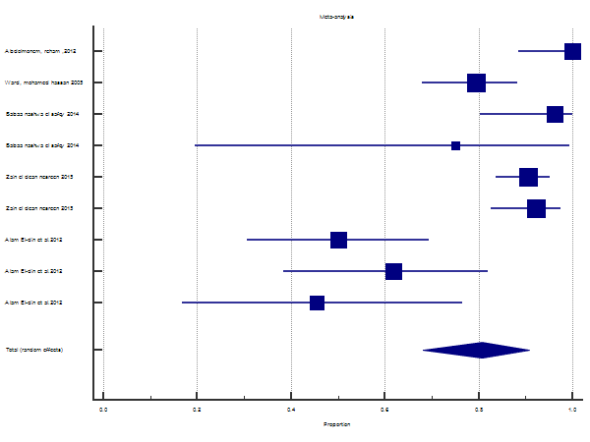

Fig.(1) Meta-analysis: proportion of protected cases of measles vaccine

According to guidelines by (PRISMA) statement, the researcher reviewed theEgyptian theses, papers, journals, in English language focusing on immune response of mumps vaccine. The pool of 2 main studies involves a total sample of 240 children.
Table (2) and fig.(2) show the protected cases with mumps antibodies, in the present meta-analysis, 5 studies are analysed with total number of 240. Total random effects (proportion % =45.060%, 95% CI=17.258 to 74.672). The test of heterogeneity shows the following: Q=79.6821, P<0.0001, I² = 94.98%% (95% CI=90.97 to 97.21). Proportion is45.06%.

Table (2) Meta-analysis: proportion protected cases of Mumps
Variable for number of positive cases |  | Protective Mumpsl
Study | Sample size | Proportion (%) | 95% CI | Weight (%)
 |  |  |  | Fixed | Random
Selim, lamya hassan a2015 | 116 | 75.000 | 66.108 to 82.574 | 47.76 | 21.18
Selim, lamya hassan b2015 | 64 | 82.812 | 71.325 to 91.095 | 26.53 | 20.88
Alam el din, hm et al a2012 | 28 | 7.143 | 0.877 to 23.503 | 11.84 | 20.06
Alam el din, hm et al b2012 | 21 | 38.095 | 18.107 to 61.565 | 8.98 | 19.63
Alam el din, hm et al c2012 | 11 | 18.182 | 2.283 to 51.776 | 4.90 | 18.25
Total (fixed effects) | 240 | 63.198 | 56.824 to 69.248 | 100.00 | 100.00
Total (random effects) | 240 | 45.060 | 17.258 to 74.672 | 100.00 | 100.00

Test for heterogeneity
Q | 79.6821
DF | 4
Significance level | P < 0.0001
I² (inconsistency) | 94.98%
95% CI for I² | 90.97 to 97.21

Meta-analysis: proportion
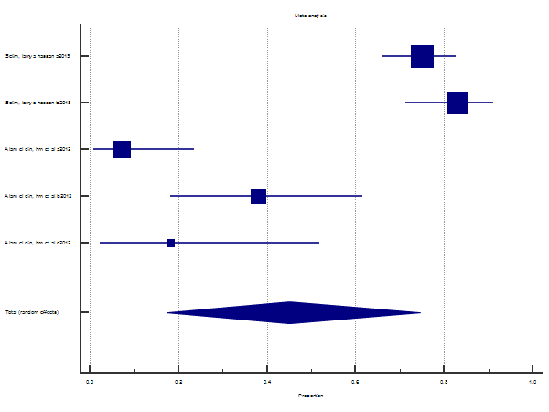

Fig. (2) Meta-analysis: proportion protected cases of Mumps

According to guidelines by (PRISMA) statement, the researcher reviewed the Egyptian theses, papers, journals, in English language focusing on immune response of rubella vaccine. The pool of 3 main studies involves a total sample of 533 children.
Table (3) and figure (3) show the protected cases with Rubella antibodies, in the present meta-analysis, 4 studies are analysed with total number of 533. Total random effects (proportion % =90.21%, 95% CI=82.03 to 96.10). The test of heterogeneity shows the following: Q=17.21, P<0.0006, I² = 82.57% (95% CI=55.24 to 93.21). Proportion is90.21%.

Table (3) Meta-analysis: proportion protected cases of Rubella vaccine
Variable for number of positive cases | Protective Rubella

Study | Sample size | Proportion (%) | 95% CI | Weight (%)
 |  |  |  | Fixed | Random
Zain el dean, nesreen a2015 | 116 | 93.103 | 86.863 to 96.976 | 21.79 | 27.04
Zain el dean, nesreen b2015 | 64 | 82.812 | 71.325 to 91.095 | 12.10 | 24.05
Abdolmonem, reham 2012 | 30 | 100.000 | 88.430 to 100.000 | 5.77 | 18.89
HashemM et al 2010 | 323 | 84.211 | 79.768 to 88.012 | 60.34 | 30.03
Total (fixed effects) | 533 | 87.285 | 84.168 to 89.984 | 100.00 | 100.00
Total (random effects) | 533 | 90.205 | 82.030 to 96.096 | 100.00 | 100.00

Test for heterogeneity
Q | 17.2088
DF | 3
Significance level | P = 0.0006
I² (inconsistency) | 82.57%
95% CI for I² | 55.24 to 93.21

Meta-analysis: proportion
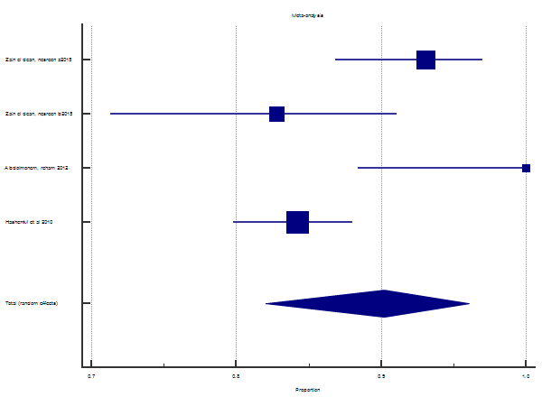

Fig. (3) Meta-analysis: proportion protected cases of Rubella vaccine

Discussion:
In the present meta-analysis, regarding Measles vaccine, 5 main studies were analysed with total number of 368 healthy vaccinated children with age ranging from 3 to more than 18 years, the proportion of vaccinated children who showed non sero-protected level of antibodies was 19.26% while the proportion of sero-protected children was 80.74%.
A meta-analytic study in China, which involved 24 studies with more than 23000 healthy children aged from 9-24 months, found that the seroconversion rates for measles were more than 93.2% (Ma SJ, et al, 2015).
Also, A meta-analysis done by Nic et al in 2015, the overall pooled estimate for seroprotection following measles vaccine was 92% at 9-11 months. (95% CI= 58-78).
While, two other meta-analyses done by Low et al in 2008 andLeung et al in 2015 reported the same pooled seroconversion rate 97.1% .
Another meta-analysis done in 2012 by Demicheli et al reported thatone MMR vaccine dose is at least 95% effective in preventing measles in children aged up to 15 years old.
In India, 97% tested positive for measles antibodies according to Malayan J & Menon T. in 2014. While, Yadav et al, 2003 found that among 102 infants who came for post vaccination sampling, 92 % were seropositive for measles at 9 and 15 months of age.
As for Finland, Kontio et al, in 2016, studied 78 healthy vaccinated children aged 3 years old, reported that 100% had protective level of measles antibodies
In the present meta-analysis, regarding Mumps vaccine, 2 main studies were analysed with total number of 240 healthy vaccinated children with age ranging from 3 to more than 18 years, the proportion of non protected cases was 54.94% while the proportion of protected cases was 45.06%.
Some meta-analyses reported higher rates of protection than our meta-analysis. A meta-analysis in China by Ma SJet al in 2005 reported a seroconversion rates for mumps ranged from 84.7% to 100%.
Also, a meta-analysis done in 2012 by Demicheli et al effectiveness of MMR in preventing mumps cases in children and adolescents was estimated to be between 83% to 88% .
While a meta-analysis in 2015 done by Leung et al found that the seroconversion rates of mumps were 96.1% in healthy children aged from 9 months to 15 years.
In India, Yadav et al, 2003 reported that100 % seroprotection for mumps amongst the children who were followed up after completing the vaccination schedule at 9 and 15 months of age. While, another study in India, done by Malayan J & Menon T. (2014) only 15% were seroprotected by mumps antibodies.
The lower seroconversion proportion found in the present study for mumps compared to other meta-analysesneeds further studies.
In the present meta-analysis, regarding Rubella vaccine, 3 main studies were analysed with total number of 533 healthy vaccinated children with age ranging from 5 to more than 18 years, the proportion of non protected cases was 9.80%.while the proportion of protected cases was 90.21%.
Ma SJ et al, 2015metanalysisfound that seroconversion rate for rubella rates were all above 95.1% (Shu-Juan Ma, et al, 2015)
While, another meta-analysis done by Leung et al in 2015 reported higher seroconversion rates, the seroconversion rates of rubella vaccines were almost 98.8% .

In India, 100% tested positive for rubella specific antibodies in a study by Malayan & Menon, 2014.As for, Yadav et al, 2003 found that,following MMR vaccination, 98% of infants who came for post vaccination sampling were seropositive for rubella at 9 and 15 months of age.
Conclusion:
The seroprevalence survey studies have important implications on updating the vaccine programs and prevention of disease transmission.In this meta-analysis, The proportionsof seroprotected Egyptian children against measles, mumps and rubella respectively are 80.74%, 45.06%and 90.21%.
Recommendations:
Further studies need to be done to study the immune response of children in Egypt against measles, mumps and rubella vaccine. Also, we recommend that the MMR second dose at the age of 4-6years old that is recommended by the CDC, center of disease control would be obligatory.
References:
- Demicheli V, Rivetti A, Debalini MG, Di Pietrantonj C.(2012): Vaccines for measles, mumps and rubella in children. Cochrane Database of Systematic Reviews 2012, Issue 2. Art. No.: CD004407. DOI: 10.1002/14651858.CD004407.pub3.
- Kontio, M., Palmu, A. A., Syrjänen, R. K., Lahdenkari, M., Ruokokoski, E., Davidkin, I., Melin, M. (2016): Similar Antibody Levels in 3-Year-Old Children Vaccinated Against Measles, Mumps, and Rubella at the Age of 12 Months or 18 Months. Journal of Infectious Diseases, 213(12), 2005–2013.doi:10.1093/infdis/jiw058
- Leung JH, Hirai HW, Tsoi KK., (2015): Immunogenicity and reactogenicity of tetravalent vaccine for measles, mumps, rubella and varicella (MMRV) in healthy children: a meta-analysis of randomized controlled trials. Expert Rev Vaccines. 2015;14(8):1149-57. doi: 10.1586/14760584.2015.1057572. Epub 2015 Jun 16.
- Low N, Kraemer S, Schneider M, Restrepo AM. 2008:Immunogenicity and safety of aerosolized measles vaccine: systematic review and meta-analysis. Vaccine. 2008 Jan 17;26(3):383-98. Epub 2007 Nov 26.
- Ma SJ, Li X, Xiong YQ, Yao AL, Chen Q. (2015): Combination measles-mumps rubella-varicella vaccine in healthy children: a systematic review and meta-analysis of immunogenicity and safety. Medicine 2015; 94: e1721
- Malayan J & Menon T. (2014). Low vaccine efficacy of mumps component among MMR vaccine recipients in Chennai, India. The Indian journal of medical research. 139. 773 - 775.
- Marlow R, Kuriyakose S, Mesaros N, Han HH, Tomlinson R, Faust SN, Snape MD, Pollard AJ, Finn AA, (2018): phase III, open-label, randomised multicentre study to evaluate the immunogenicity and safety of a booster dose of two different reduced antigen diphtheria-tetanus-acellular pertussis-polio vaccines, when co-administered with measles-mumps-rubella vaccine in 3 and 4-year-old healthy children in the UK. Vaccine. 2018 Apr 19;36(17):2300-2306. doi: 10.1016/j.vaccine.2018.03.021. Epub 2018 Mar 22.
- MedCalc Statistical Software version 12.7.7.0 (MedCalc Software bvba, Ostend, Belgium; https://www.medcalc.org; 2012)
- Nic L, Laura , Gier B , Maas N , Rots N , van Binnendijk R , de Melker H & Hahné S. (2015): Measles vaccination below 9 months of age: Systematic literature review and meta-analyses of effects and safety.
- WHO. World Health Organization. Central plan of action for Measles-Rubella campaign among persons aged 1-20 in Egypt. Phase I. Geneva 2008, WHO.
- Yadav S, Thukral R, Chakarvarti (2003): A Comparative evaluation of measles, mumps & rubella vaccine at 9 & 15 months of age,Indian J Med Res. 2003 Nov;118:183-6.

