Sphingosin 1 phosphate (S1P) and dietary protein intake in a group of children with attention deficit hyperactivity disorder
Olweya Mohammed Abd El Baaki1, Enas Raafat Abd El Hamid 2, Safaa Taha Zaki 2, Amani Salah El Din Alwakkad 3, Rania Nabil Sabry 2, Eman Mohamed Elsheikh 2
1Department of Medical Studies, Faculty of Postgraduate Childhood Studies, 2 Department of Child Health, National research centre 3Department of physiology, National Research Centre
ABSTRACT:
Background: ADHD is a neurodevelopmental disorder. There is increased prevalence of ADHD in children and adolescents in many countries and in Egypt. The specific causes for ADHD are unknown but there are several factors contribute or exacerbate ADHD as food. Sphingosin 1 phosphate (S1P) is a sphingolipid that is involved in inflammatory cell action and neuronal proliferation and differentiation and neurotransmitter release. S1P is involved in disease pathogenesis of psychiatric disorders including neurodevelopmental disorders. Aim: to measure serum S1P level in a group of ADHD children before and after (gluten elimination and dietary protein restriction) and its relation to ADHD outcome
Subjects and Methods: That interventional study was executed in behavioral and psychological assessment clinic of national research center from June 2014 to June 2017. The study was applied on 47 children newly diagnosed with ADHD not received pharmacological or behavioral therapy, their ages are from 6 to 9 years. Sphingosin1 phosphate (S1P) was measured before and after (diet dietary protein restriction and gluten elimination from food) for 5 weeks with the follow up with Conner’s parent rating scale-revised short (CPR-RS).
Results:
Sphingosin 1phosphate (S1P) decreased statistically significantly after diet protein intake restriction and gluten elimination. This decrease was accompanied by improvement in the behavior of children as confirmed by CPR.
Conclusion: Decrease of serum S1P level after dietary protein intake restriction in ADHD children with concomitant improvement in behavioral symptoms indicating the role of dietary proteins and S1P in the pathogenesis of ADHD.
Key Words: ADHD-Conner’s parent rating scale- diet protein intake.
سفينجوسين 1 فوسفات و المتناول الغذائى من البروتين لدى مجموعة من الأطفال المصابين باضطراب نقص الانتباه و فرط الحركة
مقدمة: إضطراب فرط الحركة ونقص الانتباه هو اضطراب عصبي نمائي. هناك زيادة في انتشار اضطراب فرط الحركة ونقص الانتباه لدى الأطفال والمراهقين في العديد من البلدان وفي مصر. الأسباب المحددة لاضطراب فرط الحركة ونقص الانتباه غير معروفة ولكن هناك العديد من العوامل التي تساهم أو تفاقم اضطراب فرط الحركة ونقص الانتباه كما الطعام. سفينجوسين 1 فوسفات هو شحمي سفينغوليبيد الذي يشارك في عمل الخلايا الالتهابية وانتشار الخلايا العصبية والتمايز والإفراز العصبي كما ان سفينجوسين 1 فوسفات له دور فى تطور الاضطرابات النفسيه و التى تشمل الاضطرابات العصبية النمائية
الهدف: قياس مستوى سفينجوسين 1 فوسفات بالمصل فى مجموعة من الاطفال المصابين باضطراب فرط الحركة و نقص الانتباه قبل و بعد (تقييد البروتين الغذائى و إزالة الجلوتين) و علاقته بنتيجة الاضطراب.
طرق إجراء البحث: أجريت هذه الدراسة التدخليه بعيادة التقييم السلوكى و النفسى بالمركز القومى للبحوث خلال الفترة من يونيو 2014 حتى يونيو 2017 و إشتملت على 47 طفل حديثى التشخيص باضطراب فرط الحركه و تشتت الانتباه لم يتلقوا علاج دوائى أو سلوكى تتراوح اعمارهم من 6-9سنوات . تم قياس سفينجوسين 1 فوسفات فى مصل الدم قبل و بعد تقليص المتناول الغذائى من البروتين و إزالة الجلوتين من الطعام لمدة خمسة أسابيع مع المتابعة بمقياس كونورز- تصنيف الوالدين.
النتائج: أوضحت الدراسة انخفاض مستوى سفينجوسين 1 فوسفات فى مصل الاطفال المصابين باضطراب فرط الحركة و نقص الانتباه بعد (تقليص المتناول الغذائى من البروتين و إزالة الجلوتين) عن مستواه قبل ذلك و كان هذا الانخفاض مصحوب بتحسن فى سلوك الاطفال كما هو مؤكد بانخفاض درجات المقاييس الفرعيه من مقياس تصنيف الوالدين من اختبار كونورز.
الخلاصة:. انخفاض مستوى سفينجوسين 1 فوسفات بالمصل بعدتقليص المتناول الغذائى من البروتين و إزالة الجلوتين في الأطفال الذين يعانون من اضطراب فرط الحركه و نقص الانتباه مع تحسن مصاحب فى الاعراض السلوكيه مبينا دور سفينجوسين 1 فوسفات و بروتينات الطعام فى تطور اضطراب نقص الانتباه و فرط الحركه.
الكلمات االمفتاحية:- اضطراب فرط الحركه و تشتت الانتباه-مقياس كونورز للوالدين- المتناول الغذائى من البروتين
Introduction:
Attention-deficit hyperactivity disorder (ADHD) is a neurodevelopmental disorder that affects 5% of children worldwide and is characterized by excessive and impairing inattentive, hyperactive, and impulsive behavior (DSM 5th ed. 2013). The pathophysiology of ADHD is unclear. Research on children with ADHD has shown a general reduction of brain volume especially in the volume of the left-sided prefrontal cortex (Krain et al., 2006). Abnormalities in dopaminergic system either hypo- or hyperfunctioning are implicated (Congenit , 2003). Also abnormalities in the functioning of adrenergic, serotoninergic and cholinergic or nicotinergic pathways can be present and contribute to the pathophysiology of ADHD (Sikström & Söderlund, 2007). ADHD incidence and prevalence showed progressive increase over a period of 18 years worldwide. Several studies discussed the role of food as a precipitating and one of the risk factors for ADHD that could be targeted for intervention (Hill & Taylor, 2001). The effect of gluten intake on ADHD symptomatology was an era of research (Czaja-Bulsa et al., 2015). Sphingosin-1-phosphate (S1P) is a pleiotropic, bioactive, product of sphingomyelin metabolism; S1P signaling occurs via S1P receptors (S1PRs) and is involved in various aspects of inflammatory cell function. T and B lymphocytes as well as endothelial cells express distinctive profiles of S1PRs (Rosen & Goetzl 2004). Also, sphingolipids are highly abundant in nervous tissues; affect neuronal and glial proliferation, differentiation and apoptosis as well as membrane permeability to Ca and K relevant to the generation and propagation of nervous impulse and neurotransmitter release (Chaves & Sipione 2010).Emerging role of sphingolipids in disease pathogenesis in psychiatric disorders, including schizophrenia, bipolar, neurodevelopmental and major depression have been studied (Narayan et al., 2017).
Aim of the study: was to measure S1P level in a group of ADHD children before and after (dietary protein restriction and gluten elimination) and its relation to ADHD outcome
Sample: the study included 47 children newly diagnosed with ADHD. Their ages ranged from 6 to9 years. They were recruited from behavioral and psychological assessment clinic of, national research center. Parents are motivated and capable to follow 5- weeks’ provided diet while not receiving any pharmacological or behavioral therapy. Any child with medical or metabolic condition interfering with the study (e.g. metabolic disorders, Diabetes mellitus, etc.) was excluded, also the desire to discontinue the study or refusing to participate ,receiving drugs, behavioral therapy or already following diet. Patients with Intelligence quotient (IQ) below 70 or comorbid psychiatric diseases other than oppositional defiant disorder (ODD) or conduct disorder (CD) were excluded.
Ethical aspect of the study:
Written informed consent was obtained from the parents after explanation of the aim of the study, its benefits and expected risks for their children if they participate in the study. Informed verbal assent was taken also from all the patients as their age exceeds eight years after a simplified explanation of the aim and benefits of the study for them. Approval was taken to conduct this research from the Ethical Committee of faculty of Postgraduate Childhood Studies Ain Shams University and the Ethical Committee of the National Research Centre (NRC).
METHODS 1-Full history taking. Laying stress on
Sociodemografic Data; name, age, sex and socio-economic class.
Medical history of any medical condition interferes with dietary protein restriction (e.g. Diabetes mellitus or metabolic disorders).
2-Complete psychiatric examination: physical appearance ,separation, manner of rating, orientation, soft neurological signs, reading difficulties, language and speech, self-esteem, affect, judgment and insight, problems solving.
3-Auxiological examination: assessment of weight, height and body mass index (BMI) (CDC 2000).
4-They were diagnosed by DSM 5 (DSM5th ed. 2013)
Six or more of the inattentive symptoms, hyperactivity/impulsivity symptoms or both have persisted for at least 6 months to a degree that is inconsistent with developmental level and that negatively impacts directly on social and academic/occupational activities
In addition, the following conditions must be met:
*Several symptoms are present in two or more setting, (e.g., at home, school or work; with friends or relatives; in other activities)
*There is clear evidence that the symptoms interfere with, or reduce the quality of, social, school, or work functioning.
*The symptoms do not happen only during the course of schizophrenia or another psychotic disorder.
*The symptoms are not explained by another mental disorder (e.g. Mood Disorder, Anxiety Disorder, Dissociative Disorder, or a Personality Disorder). 5- Diet history (previous 24 hour recall and food records): by asking the caregiver to remember in detail all the food and drink the child consumed during the previous 24 hours. That was done for 3 days (1 day of weekend and 2 workdays) with clarification of the description and preparation methods of foods and food portion sizes using household dishes and measures (e.g., cups, bowls, glasses, and spoons), geometric shapes (e.g., circles, triangles, rectangles) and food labels. 6-Diet analysis was done using food composition tables of nutrition institute, Egypt (National Nutrition Institute, 2006).
8-Conner’s parent rating scale-revised short form (CPR-RS) (Goyette & Conner , 1978). The Arabic form was used (Elbehery & Aglan , 2009). It consists of six subscales (conduct problems, learning problems, anxiety, and hyperactive-impulsive, psychosomatic, ADHD index).
9-Dietary protein restriction:
The expected energy requirements (EER) were adjusted according to EER tables (USDA , 2002). Protein intakes were calculated according to acceptable macronutrient distribution range (AMDR) so protein intake was 25-35 % of EER with exclusion of gluten and any gluten containing food from the diet.
10- Measuring serum S1P before and after dietary protein restriction by ELIZA technique using kit supplied from Bioassay technology laboratory Cat.No：MBS163661. This kit used enzyme-linked immune sorbent assay (ELISA) based on the biotin double antibody sandwich technology to assay the human sphingosine 1phosphate (S1P).
RESULTS: The study included 47 children; they were 34 (72.3%) males and 13 (27.7%) females, their ages ranged between (6-9) years. 40.5% of children were normal weight, 40.5% were overweight and 19% were obese. Diet analysis after following the provided diet showed statistically significant reduction of protein intake with concomitant decrease in all scores of Conner’s test subscales (improvement of behavioral symptoms).
Table (1): Distribution of children according to their BMI
BMI | No. of children | Percentage
Normal weight (within 5th-85th)percentile | 19 | 40.5%
Overweight(within 85th-95th)percentile | 19 | 40.5%
Obese (above 95th percentile) | 9 | 19%
This table shows that more than half of the patients are overweight and obese.
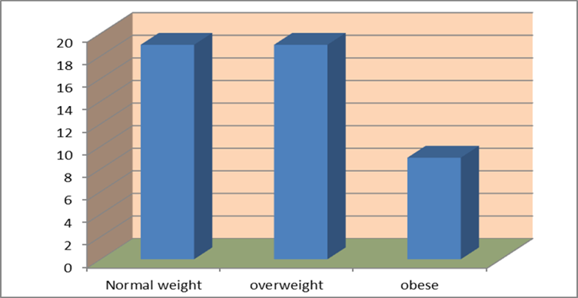
Figure (1): Distribution of children according to their BMI
This figure shows that 19 patients are normal weight, 19 are overweight and 9 patients are obese.
Table (2): protein intakes before and after dietary protein restriction
 | Protein intake before diet protein restriction | Protein intake after following the provided diet | t-test | P value
Mean ±SD | 60±21.3 g | 39.2±7.8 g | 0.000  HS | 4.1
Min. – max. | 38.7-81.2 | 30.8-47
T-test: paired t-test HS: highly significant
Table 2 shows that protein intake of patients decreased significantly after following the diet
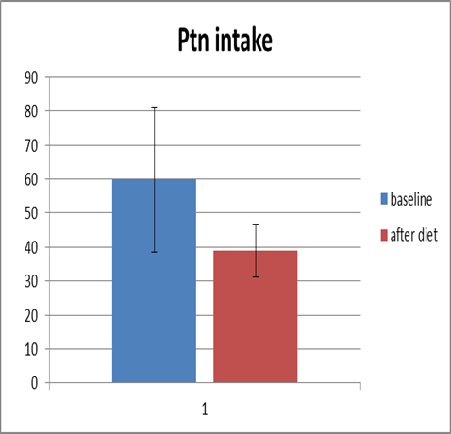
Figure (2): Protein intake before and after diet modification
Table (3) : CPR-RS scores before and after diet protein restriction.
Conner’s subscales |  | Mean ±SD | Min. | Max. | P value | Z value⃰
Hyperactivity index | Before diet | 69.38±14.19 | 83.57 |  | .000  HS | -4.650
 | After diet | 64±11.99 | 76 | 52
Impulsive hyperactive | Before diet | 65.94±7.36 | 58.58 | 73.3 | .000  HS | -4.340
 | After diet | 64.31±6.93 | 57.38 | 71.24
Learning | Before diet | 71.85±12.58 | 59.27 | 84.43 | .000  HS | -3.517
 | After diet | 70.15±11.83 | 58.32 | 81.98
*Wilcoxon test CPR-RS: Conner’s parent rating scale-revised short form HS: highly significant
Table 3 shows improvement in behavioral symptoms as there is statistically significant reduction in CPR scores especially hyperactivity index.

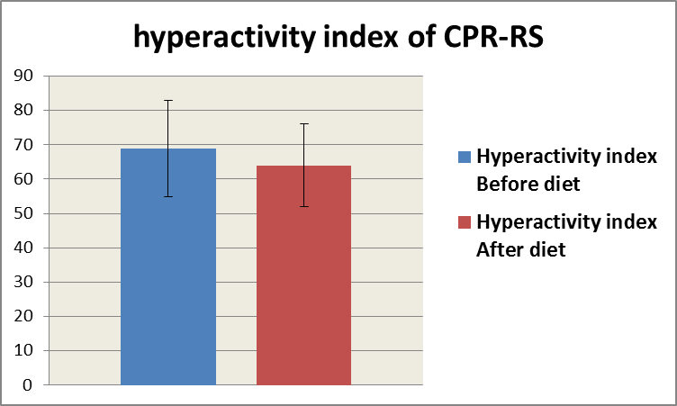  Figure (3):hyperactivity index score before and after diet protein restriction | 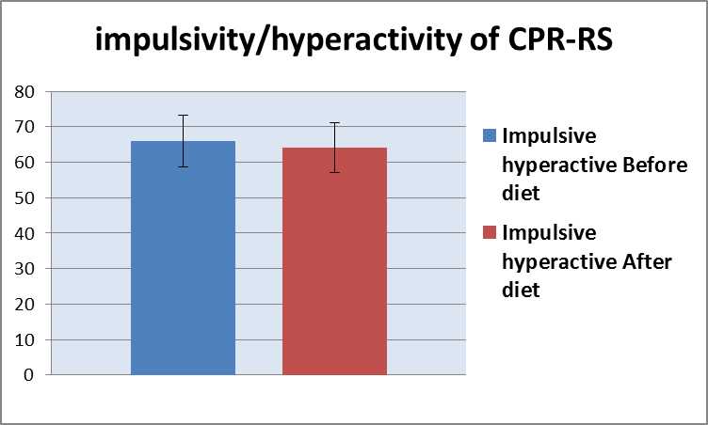  Figure (4):impulsivity/hyperactivity score before and after diet protein restriction
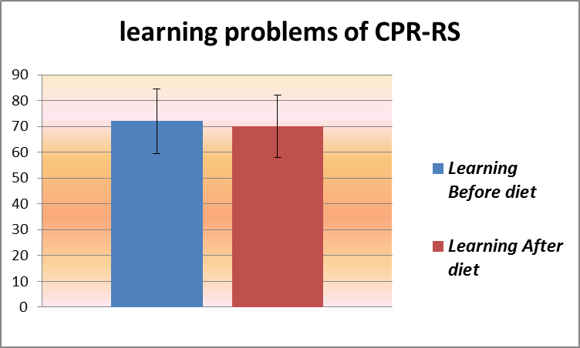
Figure (5):learning problem score before and after diet protein restriction

Table (4):S1P serum levels before and after diet protein restriction
 | S1P levels before diet modification | S1P levels after diet modification | Z⃰ | P value
Number of cases | 46 | 46 | -3.737 | .000  HS
Median(IQR) | 200(90-485) ng/L | 65(45-140) ng/L
range | (45-1536) | (25-2280)
Z: Wilcoxon test ng/ l:nanogram per liter HS: highly significant
That table shows statistically significant reduction in serum S1P after following diet protein restriction and gluten elimination from foods.
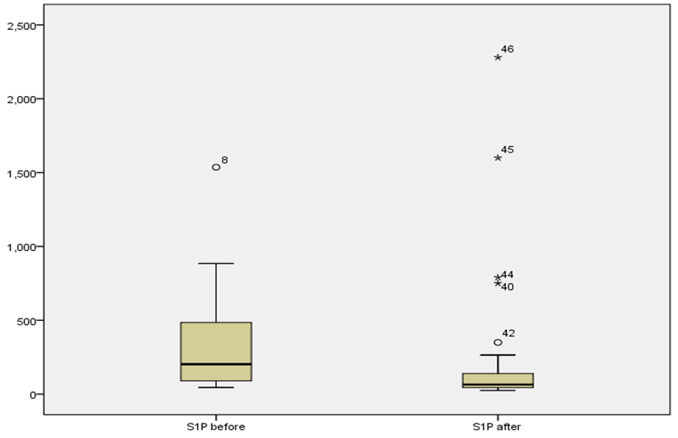
Figure (6): S1P serum level before and after diet protein restriction
Table (5): Correlation between serum S1P level and protein intake before diet protein restriction
 |  | S1P serum level before diet modification | Protein intake before diet modification
Sphingosin-1-phosphate | r | 1 | .665**
 | P value |  | .000
 | N | 47 | 47
⃰ ⃰ strong positive correlation r: Pearson correlation
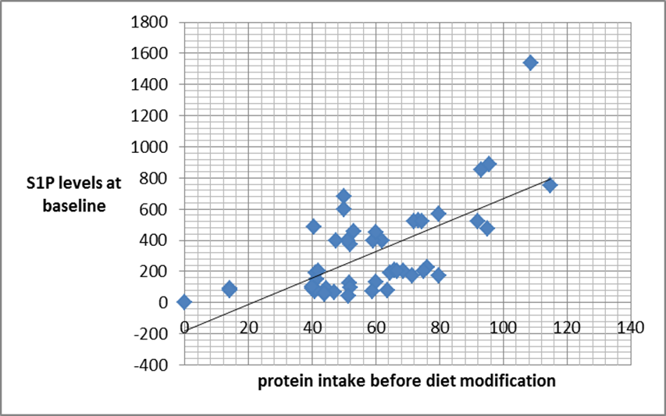
Figure (7): Correlation between hyperactivity index scores of CPR scale and protein intake before following the diet.
Table 5 and figure 7 show significant strong positive correlation between diet protein intake and serum S1P level.
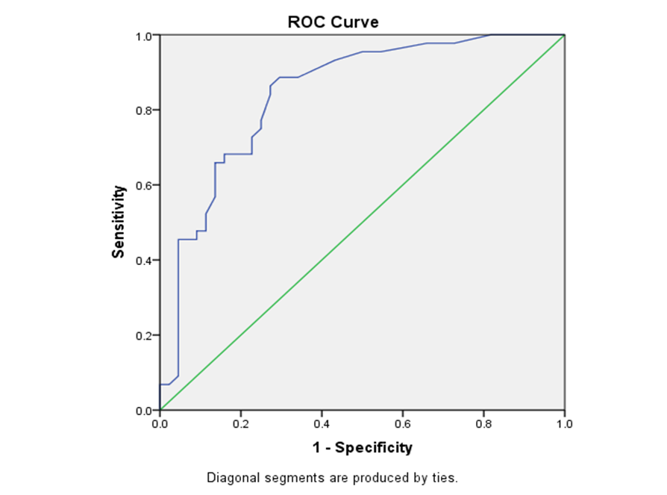Figure (8): ROC curve for S1P serum level before and after diet protein restriction
Table (6): Diagnostic accuracy (Area under the curve AUC), sensitivity, specificity, and cut-off value of S1P before and after diet protein restriction
Cut-off point | AUC | sensitivity | specificity
47.5/l | .842 | .977 | .727
The previous receiver operating characteristic curve (ROC) shows that serum S1P level of 47.5 ng /l was found as the best cut off point with sensitivity 84.2% and specificity 72.7% and area under the curve (AUC) 0.842%. Increased serum S1P level above this cut-off point associated with worsening of behavioral symptoms as measured with CPR.
The prognostic ability of S1P for detecting worsening in symptoms of ADHD was reliable. So increased serum S1P above this cut off value could be considered as a potentially marker of worsening symptoms.
DISCUSSION
Patients of the study were between the ages of 6-9 years with a mean of 7.5. Number of males were 34 (72.3%) and females were 13 (27.7%) going with the male sex predilection in ADHD in a study of Biederman et al., (2002).
In this study, 40.5% of children were normal weight, 40.5% were overweight and 19% were obese. That means that more than half of patients are either overweight or obese.
That is going with the systematic review and meta-analysis by Cortese and Vincenzi (2012), and Corteases and Tessari (2016) showed a clear association between attention deficit hyperactivity disorder (ADHD) and obesity in more than 700,000 children and adults, of whom 48,161 had ADHD. The explanation is that excess eating is one of impulsivity manifestations, also difficult planning as a result of inattention leads to skipping breakfast and lunch resulting in obesity as fitted with Kooij (2016).
In comparison to Tong et al., (2017) who concluded that there was no significant relationship between ADHD and BMI.
In this study, we measured serum S1P levels in ADHD patients before and after following diet (protein restriction and gluten elimination). The median serum level of S1P before diet was 200 ng/l and after diet protein restriction 65 ng/l. There was statistically significant decrease after diet protein restriction (Z=-3.737 p=.000). Also, improvement in behavior as shown by statistically significant reduction CPR-RS subscales scores as hyperactivity index scores (p≤0.001), impulsivity/hyperactivity scores (p≤0.001) and learning scores (p≤0.001) occurred after following the diet.
That comes in agreement with Henríquez-Henríquez et al., (2015) who measured S1P in ADHD children and their unaffected relatives and found that serum S1P in ADHD patients (1.55±0.38 μM) was higher than their unaffected relatives (1.44 ± 0.38 μM). Also, Wu et al., (2018) found that pharmacological decrease of S1P level associated with improvement of learning problems and memory impairment.
In this study, there was strong positive significant correlation between protein intake before diet modification and serum S1P level during baseline period (r=0.665, p≤0.001). In accordance, Kunisawa and Kiyono (2016) found that high level of dietary proteins and thermally processed high protein food impaired S1P lyase activity that analyse sphingosine 1 phosphate to ethanolamine phosphate and hexadecenal leading to increase of S1P.
Narayan et al., (2011) and Schnider et al., (2017) found that emerging role of sphingolipids in disease pathogenesis in psychiatric disorders including neurodevelopmental disorders.
Asherson et al., (2007) and Rommelse et al., (2008) showed that regions containing genes encoding key enzymes in the sphingolipid metabolism i.e., serine-palmitoyl transferase and sphingomyelinases have been mapped in association with ADHD.
Another hypothesis that that S1P is involved in the development of intestinal immune diseases including food allergies and intestinal inflammation as it is involved in various aspects of inflammatory cell function (T and B lymphocytes, as well as endothelial cells) that express distinctive profiles of sphingosin 1 phosphate receptors (S1PRs) as reported by Goetzl and Rosen (2005), Rivera, et al., (2008) and Gohda, et al., (2008) so gluten restriction was associated with decrease serum S1P.
A study of Naviaux et al., (2014) revealed that cell danger response (CDR) encountered with chemical, physical, or biological threats produces a cascade of changes in cellular electron flow, oxygen consumption, whole body metabolism and the gut microbiome are disturbed, behavior is changed, and chronic disease results as ADHD, asthma, atopy, gluten and many other food and chemical sensitivity syndromes, with stimulation of sphingosin 1 phosphate synthesis.
That can be the explanation for why serum sphingosin 1 phosphate levels decreases after diet protein and gluten restriction with the decrease of serum S1P level led to improvement of behavioral symptoms as assessed by CPR, so there is relation between ADHD, diet protein intake and serum S1P.
CONCLUSION
The study revealed that serum S1P decreased significantly after diet protein restriction in ADHD patients with concomitant improvement in behavior.
RECOMENDATIONS
Further studies on larger samples to emphasis the conclusion
Clarification of diet planning importance for ADHD patients.
Encouraging gluten free products industry and advising patients to use it.
REFERENCES:
American Psychiatric Association. Diagnostic and statistical manual of mental disorders, 5th edition, text revision (2013).Washington, DC: American Psychiatric Association.
Asherson P., Zhou K., Anney R. J., Franke B., Buitelaar J., Ebstein R., et al. . (2008). A high-density SNP linkage scan with 142 combined subtype ADHD sib pairs identifies linkage regions on chromosomes 9 and 16. Mol. Psychiatry 13, 514–521.
Biederman J, Petty R, Evans M, Small J, Faraone V (2010). How persistent is ADHD? A controlled 10-year follow-up study of boys with ADHD. Psychiatry Res. 177(3): 299–304.
Center for disease control and prevention (2000) CDC growth charts for the United States: methods and development.
Chaves E P, Sipione S (2010). Sphingolipids and gangliosides of the nervous system in membrane function and dysfunction; FEBS letters 584(9):1748-59
Congenit Kyoto (2003). The dopaminergic system in attention deficit/ hyperactivity disorder. ; 43 (2): 114-22.
Cortese S, Tessari L (2017) Attention-Deficit/Hyperactivity Disorder (ADHD) and Obesity: Update 2016Curr Psychiatry Rep. 2017; 19(1): 4.
Cortese S, Vincenzi B. (2012) Obesity and ADHD: clinical and neurobiological implications.Curr Top Behav Neurosci. 2012;9:199-218.
Czaja-Bulsa G (2015) Non coeliac gluten sensitivity - A new disease with gluten intolerance. Clin Nutr. Apr;34(2):189-94
Elbehery A. A., Aglan A. (2009). Conner's Rating Scales, Arabic version of psychological health center. Faculty of Art, Asiut
Gohda M, Kunisawa J, Miura F, Kagiyama Y, Kurashima Y, Higuchi M, Ishikawa I, Ogahara I, Kiyono H (2008). Sphingosine 1-phosphate regulates the egress of IgA plasmablasts from Peyer's patches for intestinal IgA responses. J Immunol. 2008 Apr 15;180(8):5335-43.
Goyette H, Conners K, Ulrich F (1978). Normative data on Revised Conners Parent and Teacher Rating Scales Journal of Abnormal Child Psychology .6, (2): 221–236.
Henríquez-Henríquez P, Sandra Solari S, Quiroga, T, Kim B, Deckelbaum R, Worgall T,(2015) Low serum sphingolipids in children with attention deficit-hyperactivity disorderFront Neurosci.; 9: 300.
Hill P, Taylor E. (2001). An auditable protocol for treating attention deficit / hyperactivity disorder. Arch Dis Child; 84: 404–09.
J. J. Sandra Kooij (2016) ADHD and Obesity.The American journal of psychiatry
K Naviaux (2014). Metabolic features of the cell danger response. Mitochondrion Volume 16, Pages 7-17
Krain AL, Castellanos FX. (2006). Brain development and ADHD. Clin Psychol Rev. 2006 Aug; 26(4):433-44.
Kunisawa J, Kiyono H (2016) Sphingolipids and Epoxidized Lipid Metabolites in the Control of Gut Immunosurveillance and Allergy Front. Nutr., 27
Tong L ,Huijing Shi, Xiaoru Li (2017). Associations among ADHD, Abnormal Eating and Overweight in a non-clinical sample of Asian children, Sci Rep.; 7: 2844
Ministry of Health and Population, National Nutrition Institute (2006). Egypt. Food Composition Tables.
Narayan S, Thomas E (2011). Sphingolipid abnormalities in psychiatric disorders: A missing link in pathology? Frontiers in Bioscience16(1):1797-810
Sikström S, Söderlund G. (2007). Stimulus-dependent dopamine release in attention-deficit/ hyperactivity disorder". Psychol Rev;114 (4): 1047–75.
Rivera J, Proia RL, Olivera A (2008) The alliance of sphingosine-1-phosphate and its receptors in immunity. Nat Rev Immunol. 2008 Oct;8(10):753-63.
Rommelse N. N., Arias-Vásquez A., Altink M. E., Buschgens C. J., Fliers E., Asherson P (2008). Neuropsychological endophenotype approach to genome-wide linkage analysis identifies susceptibility loci for ADHD on 2q21.1 and 13q12.11. Am. J. Hum. Genet. 83, 99–105
Rosen H, Goetzl EJ (2005). Sphingosine 1-phosphate and its receptors: an autocrine and paracrine network. Nat Rev Immunol. Jul;5(7):560-70.
Schneider G., Bryndza E., Abdel-Latif A., (2013). Bioactive lipids S1P and C1P are prometastatic factors in human rhabdomyosarcoma, and their tissue levels increase in response to radio/chemotherapy. Molecular Cancer Research. ;11:793–807
USDA/HHS (U.S. Department of Agriculture/ U.S. Department of Health and Human Services). 2000. Nutrition and Your Health: Dietary Guidelines for Americans.
Wu H, Zhang Q, Gao J, Wu L (2018). Modulation of sphingosine 1-phosphate (S1P) attenuates spatial learning and memory impairments in the valproic acid rat model of autism Psychopharmacology

