Assessment of vitamin D binding protein in Egyptian cystic fibrosis children and its relation to serum immunoglobulin G.
Dr. Mona Moustafa El Falaki, Professor of Pediatrics, Cairo University
Dr. Rehab Abdel Kader Mahmoud, Professor of Pediatrics – Institute of Postgraduate Childhood Studies
Dr. Sahr Abdel Atty Sharaf, Professor of Clinical Pathology, Cairo University
Dr. Walaa Aboulkasem Shain, Lecturer of Pediatrics, Cairo University
Dr Dina Hossam El Dine Hamed, Lecturer of Pediatrics, Cairo University
Nivine Mohamed Abdel Monem El Enbaby
Abstract
BACKGROUND: Vitamin D binding protein DBP is a multifunctional transport protein. The aim of the present study is to measure the level of DBP and serum 25-hydroxyvitamin D 25OHD in order to assess its role as a nutritional marker in CF. In the context of the recently described immunomodulatory functions of vitamin D, the relationship between vitamin DBP and immunoglobulin G IgG levels was assessed.
METHODS: This is a cross sectional case controlled observational study recruiting 50 patients diagnosed as CF (cystic fibrosis). They were referred to Allergy and Pulmonology Unit, Aboreesh Children’s Hospital, Cairo University. Their age ranged from 18 months to 13 years. DBP and 25OHD were measured using Elisa technique and IgG was measured using nephelometer method.
RESULTS: CF group had significant lower serum concentrations of DBP p<0.012 and 25OHD p<0.001 while IgG levels were within normal values p<0.216 compared to the control group. Significant positive correlations were observed between IgG and age r=0.528, p<0.01 weight r=0.480, p<0.001 and height r=0.509, p<0.001. Significant positive relations were observed between failure to thrive and DBP p=0.023 and 25OHD p=0.003. A significant positive relation between DBP and pancreatic insufficiency p=0.039.No significant correlations were observed between DBP and 25OHD r=-0.224, p=0.118, between DBP and IgG r=0.195, p =0.176, between DBP and sweat chloride test r=0.201, p=0.162, between 25OHD and IgG r=0.195, p=0.176.No significant relations were observed between pancreatic insufficiency, and 25OHD p=0.944 and IgG p=0.332, between failure to thrive and IgG p=0.898.
CONCLUSIONS: DBP and 25OHD levels were decreased in CF patients; and IgG levels were within normal values and positively correlated with age, weight and height. Significant relations of DBP with failure to thrive and pancreatic insufficiency emphasizing its role as a marker for the nutritional status in CF patients.
Keywords: Cystic fibrosis, vitamin D binding protein, 25-hydroxyvitamin D, immunoglobulin G
Introduction
Cystic fibrosis (CF) is the most common inherited disorder in childhood being caused by mutations of the cystic fibrosis transmembrane conductance regulator (CFTR gene) (Kraemer, et al, 2006).
It is a chronic condition involving several organ systems that results in life-long morbidity and premature mortality. Lung disease in CF is the major cause of death through a complex process involving impairment of mucociliary clearance, infection, inflammation, and structural injury (Flume, et al, 2009).
Environmental, nutritional, and socioeconomic factors as well as modifier genes may affect the clinical manifestations of the disorder. (O'Sullivan and Flume, 2009).
CF patients have decreased vitamin D synthesis.CF patients who are exposed to the sun may have little body fat and may store less vitamin D, further exacerbating the problem. In children, severe vitamin D deficiency results in rickets, but its clinical presentation in CF is more subtle (Khazai, et al, 2009).
Vitamin D binding protein (DBP) or group-specific component (Gc) is a serum Alpha 2 globulin, with a molecular weight of 52-59 kDa and belongs with albumin, Alpha fetoprotein and Alpha albumin /afamin to the albumin superfamily of binding proteins. Two predominant DBP alleles, known as DBP 1and DBP 2, determine the DBP polymorphism. Besides its transport of vitamin D metabolites, this multifunctional glycoprotein contributes to the sequestration of actin, stimulation of osteoclast acivity, bone resorption by Gc-macrophage and osteoclast-activating factor, transport of fatty acids and endotoxin, inhibition of actin-induced platelet aggregation, chemotaxis of complement factor 5 derived peptides and macrophage modulation (Meier, et al, 2006).
Systemic levels of inflammation are important in CF for their impact on both pulmonary inflammation and other CF comorbidities (Flume, et al, 2009).
Chronic inflammation has a negative impact on bone metabolism and has been linked to impaired linear growth and bone mineral accrual (Heaney, et al, 2011).
Vitamin D does modulate the immune response and has been shown to have anti-inflammatory effects (Smolders, et al, 2009).Given the growing understanding of the importance of this vitamin in the regulation of multiple biological functions beyond skeletal health and the importance of vitamin D in relation to severity of lung disease which is closely correlated with total immunoglobulin G (IgG) levels in children, the aim of the study was to investigate the levels of vitamin D-binding protein (DBP), circulating 25-OHD vitamin D (25OHD) and total immunoglobulin G (IgG) in CF patients and their correlation to different parameters measured and clinical data presented.
PATIENTS AND METHODS
Patients:
This is a cross sectional case controlled observational study recruiting 50 patients diagnosed as CF, based on clinical manifestations, examination and confirmed by a positive sweat chloride test. They were referred to the Allergy and Pulmonology Unit, Aboreesh Children’s Hospital, Cairo University, throughout a period of one year starting from May 2012 till May 2013 for diagnosis, management and follow up. Both genders were included with age range from 18 months till 13 years. Twenty age and sex matched healthy children were included as a control group.
Methodology:
The patients were subjected to a full medical history and thorough clinical evaluation with special stress on respiratory and GIT systems. All patients were subjected to routine investigations done in follow up visits guided by the clinical profile and severity of each individual case.
Laboratory investigations were done by collection of blood by venipuncture which was allowed to clot, and serum was separated by centrifugation at room temperature and was frozen at -20 °C. The analysis of all samples was carried out at the laboratory of the department of clinical pathology, Kasr el Eini Hospital, Cairo University. Serum level of vitamin D Binding Protein (DBP) was measured using the Quantikine Human Vitamin D Binding Protein immunoassay ELISA from R&D Systems; USA which is a 3.5 hour solid phase ELISA designed to measure DBP in cell culture supernates, serum. It contains natural human DBP Standard. The Quantikine Human Vitamin D Binding Protein kit is used to determine mass values for naturally occurring human DBP.
Serum level of 25-OH Vitamin D(25OHD) was measured using an enzyme immunoassay ELISA from DRG International, Germany for measurement of total 25-OH vitamin D.Serum level of immunoglobulin G (IgG) was measured using antisera to human immunoglobulins (NAS IGG) (Nephelometry) from Siemens Healthcare Diagnostics Inc, Germany.
Statistical Analysis
Data management and analysis were performed using Statistical Package for Social Sciences (SPSS) vs. 17. Numerical data were summarized using medians & ranges. Categorical data were summarized as percentages. Comparisons between the two groups were done the Mann-Whitney test, a nonparametric test equivalent to the t-test, to use in non normally distributed variables. The chi-square test or the Fisher’s exact test for small sample size was used to compare between the groups with respect to categorical data. To measure the strength of the association between the numeric variables, Spearman’s correlation coefficients were calculated (Dawson and Trapp, 2001). All p-values are two-sided. P-values ≤ 0.05 were considered significant.
Results
Demographic data of the study population and clinical presentation of CF patients are shown in (table 1, 2) respectively.
Table 1: Demographic data of the study population.
Characteristic | N=50 | %
Age in years
Median | 3
Range | 1.5-13
1.5years-<3years | 20 | 40
3years-<7years | 24 | 48
7years-13years | 6 | 12
Gender
Female | 15 | 30
Male | 35 | 70
Positive Consanguinity | 30 | 60
Family history of CF | 11 | 22
Age of patient at diagnosis
<1year | 31 | 62
1year-2years | 9 | 18
>2years | 10 | 20

Table 2: Clinical presentation of CF patients.

Clinical presentation | N=50 | %
Cough | 47 | 94
Hospital admission | 47 | 94
Recurrent Pneumonia | 38 | 76
Recurrent wheezing | 32 | 68
Steatorrhea | 32 | 64
Failure to thrive (Weight and Height below 3rd percentile) | 20 | 40
Hepatomegaly | 15 | 30
Hemoptysis | 5 | 10
Rickets | 3 | 6
Cholestatic Jaundice | 0 | 0
Meconium ileus | 0 | 0

Nearly all patients presented with chronic cough, recurrent wheezing, recurrent pneumonia, and steatorrhea. The most common signs were failure to thrive, clubbing and abnormal chest examination.
The median serum concentration of DBP of the CF group (273.6 ug/ml, range (80.6-633.4ug/ml) was significantly lower than the control group(median 320.6ug/ml, range 240.6-495.8ug/ml) (p=0.012)(Figure 1). .
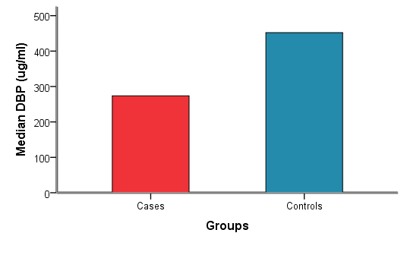
p=0.012
P-values ≤ 0.05 are considered significant
Figure 1: Comparison between median serum concentrations of DBP
levels in cases and controls (p=0.012).
The median serum concentration of 25OHD of the CF group (20.4ng/ml equivalent to 64.8 nmol/l) range (0.2-130.0 ng/ml) was significantly lower than the control group (median 48.34ng/ml, equivalent to 153.5 nmol/l, range 16.2-120.0 ng/ml) (p<0.001) (Figure 2).
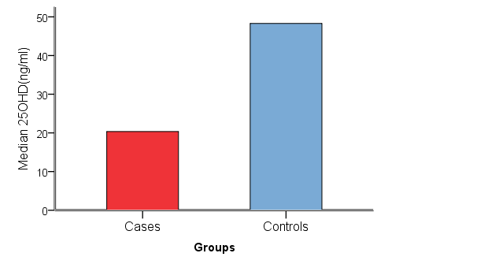
p<0.001
P-values ≤ 0.05 are considered significant
Figure 2: Comparison between median serum concentrations of 25OHD
levels in cases and controls (p<0.001).
The median serum concentration of IgG of the CF group was 10.0 g/l, range 3.7-20.3 g/l and the median concentration of the IgG of the control group was 8.2 g/l, range 4.6-15.2 g/l with no significant difference between the two groups (p=0.216) (Figure 3).74% of CF patients had normal IgG levels while 4% had low IgG levels and 22% had high IgG levels (normal range 4.2-16(g/l).
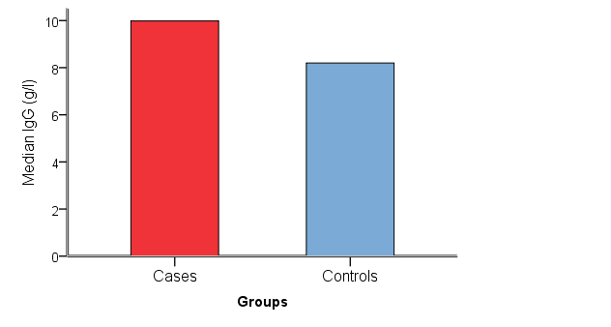 p=0.216
P-values ≤ 0.05 are considered significant
Figure 3: Comparison between median serum concentrations of IgG
levels in cases and controls (p=0.216).
Correlations between age, weight, height, and DBP, 25OHD and IgG
are shown in (table 3) and (Figure 4,5,6) respectively. Correlations between DBP, 25OHD and IgG are shown in (table 4).
Table 3: Correlations between age, weight, height and DBP, 25OHD
and IgG.
 | Spearman's rho
 | DBP (ug/ml) |  | 25OHD(ng/ml) |  | IgG (g/l)
 | r | p-value | R | p-value | r | p-value
AGE (1.5-13y) | 0.030 | 0.836 | 0.126 | 0.301 | 0.528 | <0.01
Weight | -0.045 | 0.758 | -0.099 | 0.493 | 0.480 | <0.001
Height | -0.040 | 0.785 | -0.033 | 0.821 | 0.509 | <0.001
P-values ≤ 0.05 are considered significant
No significant correlations were observed between DBP and age (r= 0.030), (p= 0.836), weight (r=-0.045), (p=0.758) and height (r=-0.040), (p=0.785). No significant correlations were observed between 25OHD and age (r=0.126), (p=0.301), weight (r=-0.099), (p=0.493) and height (r=-0.033), (p=0. 821).Significant positive correlations were observed between IgG and age (r =0.528), (p<0.01), weight (r =0.480), (p<0.001) and height (r= 0.509), (p<0.001).
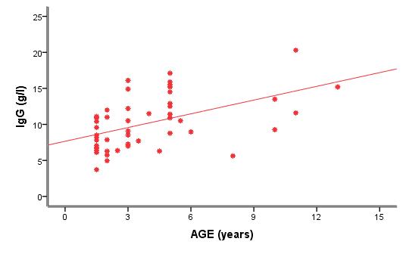
p<0.01
P-values ≤ 0.05 are considered significant
Figure 4: Correlation between IgG and age (r =0.528), (p<0.01).
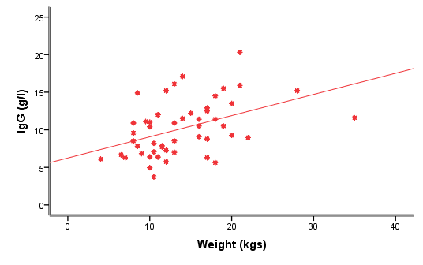
p<0.001
P-values ≤ 0.05 are considered significant
Figure 5: Correlation between IgG and weight (r =0.480), (p<0.001).
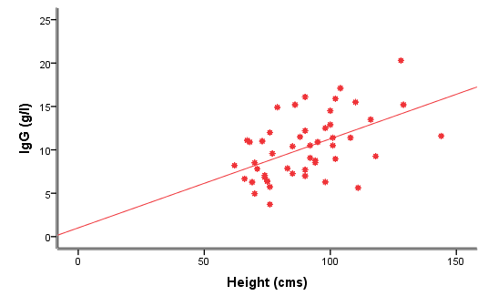
p<0.001
P-values ≤ 0.05 are considered significant
Figure 6: Correlation between IgG and height (r= 0.509) (p<0.001).
Table 4: Correlations between DBP, 25OHD and IgG.
 | 25OHD(ng/ml) |  | IgG (g/l)
 | R | p-value | R | p-value
IgG (g/l) | 0.035 | 0.811
DBP (ug/ml) | -0.224 | 0.118 | 0.195 | 0.176
P-values ≤ 0.05 are considered significant
No significant correlations were observed between DBP and 25OHD (r=-0.224) (p=0.118), between DBP and IgG (r= 0.195), (p=0.176) and between 25OHD and IgG (r= 0.035), (p=0.811).
Relation between failure to thrive, pancreatic insufficiency and DBP, 25OH vit D and IgG are shown in (table 5,6) and (Figure 7,8,9) respectively.
Table 5: Relations between failure to thrive and DBP, 25OH vit D and IgG
Correlations | Failure to thrive
 | NO (n=30) |  |  | YES (n=20)
 | Median | Minimum | Maximum | Median | Minimum | Maximum | p-value
25OHViD(ng/ml) | 31.7 | 4.2 | 81.8 | 9.9 | 0.2 | 130.0 | 0.003
IgG (g/l) | 9.8 | 3.7 | 20.3 | 10.0 | 5.6 | 17.1 | 0.898
DBP (ug/ml) | 238.0 | 80.6 | 633.4 | 306.7 | 149.2 | 468.0 | 0.023
P-values ≤ 0.05 are considered significant
Table 6: Relation between pancreatic insufficiency and DBP, 25OH vit
D and IgG
 | Pancreatic insufficiency
 | yes(n=32) |  |  | no (n=18)
 | Median | Minimum | Maximum | Median | Minimum | Maximum | p-value
25OHViD(ng/ml) | 20.4 | 0.2 | 130.0 | 20.8 | 3.7 | 54.7 | 0.944
IgG (g/l) | 8.9 | 5.0 | 20.3 | 10.7 | 3.7 | 16.1 | 0.332
VDBP (ug/ml) | 306.7 | 82.2 | 633.4 | 237.0 | 80.6 | 461.0 | 0.039
P-values ≤ 0.05 are considered significant
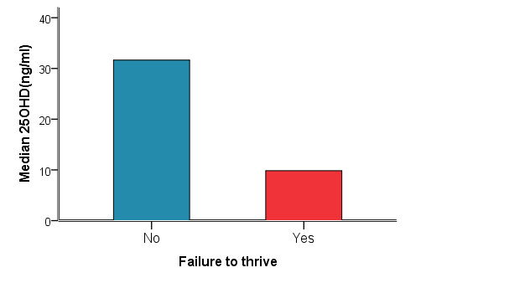
p=0.003
P-values ≤ 0.05 are considered significant
Figure 7: Relation between 25OHD and failure to thrive (p=0.003).
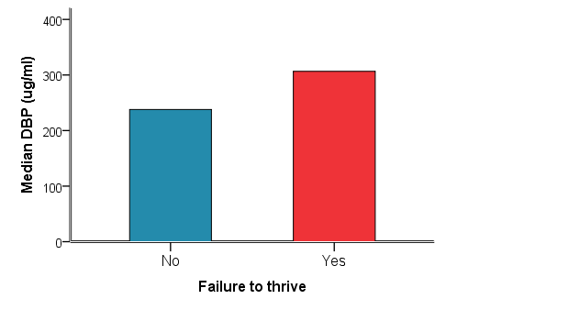
p=0.023
P-values ≤ 0.05 are considered significant
Figure 8: Relation between DBP and failure to thrive (p=0.023).
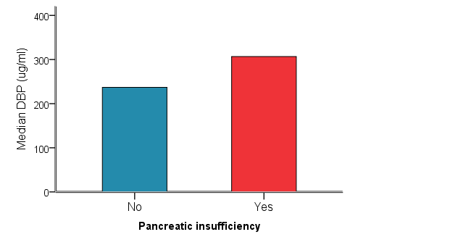
p=0.039
P-values ≤ 0.05 are considered significant
Figure 9: Relation between DBP and pancreatic insufficiency (p=0.039)
Discussion
In the present study the median DBP serum concentration of the CF group was significantly lower than the median DBP concentration of the control group (p=0.012).
This was in accordance with a study done in Belgium that investigated the importance of DBP and its role as an alternative nutritional marker in CF (Speeckaert, et al, 2008).
No significant correlations were observed between DBP levels and age (r= 0.030), (p= 0.836), weight (r=-0.045), (p=0.758) and height (r=-0.040), (p=0.785).
Similar results were obtained from a cross-sectional study done in Belgium (Speeckaert, et al, 2006) and in New Zealand (Bolland, et al 2007) which observed that DBP levels was not correlated to age or to age and weight respectively.
In the study the serum concentration of DBP was not correlated with the serum concentration of 25OHD (r=-0.224), (p=0.118).
Similar results were obtained from studies done in the United Kingdom (Prytuła, et al, 2012), in New Zealand (Bolland, et al, 2007), in Belgium on 116 CF patients (Speeckaert, et al, 2008) and in another cohort study done in Belgium (Taes, et al, 2006).
On the contrary to the results, a large cohort study done in USA for infants and children observed that circulating DBP was significantly correlated with 25OH (Carpenter, et al, 2013).
In the present study no significant correlation between DBP and IgG was observed (r=0.195), (p =0.176).
A statistically significant relation was noted between DBP and failure to thrive (p=0.023) and between DBP and pancreatic insufficiency (p=0.039).
In the present study no significant correlation was observed between DBP and sweat chloride test (r=0.201), (p=0.162).
Also the median serum concentration of 25OHD for the CF group was 20.4ng/ml equivalent to 64.8 nmol/l was significantly lower than the median 25OHD concentration of the control group (p<0.001) which emphasize the continued inadequate supplementation despite increased awareness.
Similar results were obtained in studies from large CF centers, and showed that >90% of patients have 25OHD levels < 75 nmol/L (30ng/mL) (Neville &Ranganathan, 2009) (Speeckaert, et al, and Wolfenden, et al, 2008) (Fewtrell, et al, 2008) (Gordon, et al, Rovner, et al and Stephenson, et al, 2007). (Chavasse, et al, 2004), (Grey, et al, 2000), (Mortensen, et al, 2000) and (Henderson& Madsen, 1997).
Similarly eight hundred and ninety-six CF patients (0.53–65.9 years) from seven centers in Denmark were included in a cross-sectional study and showed that 84% had suboptimal 25OHD level (< 75 nmol/l). (Pincikova, et al, 2010).
No significant correlation was observed between 25OHD and age (r=0.126), (p=0.301), weight (r=-0.099), (p=0.493) and height (r=-0.033), (p=0.821).
In concordance with our results, a study done by (Henderson & Lester, 1997), observed no correlations between 25OHD and weight and height in CF patients.
In concordance with our results, a systematic review in non CF infants and children concluded no significant associations between 25OHD concentrations and weight or height in a six randomized controlled trials, one non-randomized comparative intervention study, and two observational studies (Tufts Evidence-based Practice Center , 2009).
In the present study no correlation was observed between 25OHD and serum total IgG (r= 0.035), (p=0.811).
In concordance with our results, a recent study, observed no significant correlation between the IgG and 25OHD levels (Holmoy, et al, 2011).
In contrast, a Scandinavian study showed inverse relation between 25OHD and serum total immunoglobulin G in cystic fibrosis nutritional study (Pincikova, et al, 2010). This study supported the proposed role of vitD in the immune system infection.
Also a study done on 2052 non CF children and adults patients showed a highly significant positive correlation between the concentrations of the circulating form of 25OHD, and IgG levels in the overall population (Sedrani, 1988).
On the contrary to our results a study done by Yener, et al, 1995, observed a significant correlation between the decrease in 25OHD ,the decrease in total T lymphocytes and the increase in B lymphocytes expressing surface IgG molecules in non CF patients. These results suggest that vitamin D plays an important role in the impaired functions of T lymphocytes which may lead to frequent infectious episodes.
In the present study no relation was observed between 25OHD and pancreatic insufficiency (p=0.944).
This is in agreement with a retrospective chart review of patients followed in a single CF center (Simoneau, et al, 2013) ,in a study done in UK population on 290 children attending a specialist pediatric CF clinic for annual assessment (Chavasse et al, 2004) and in Australian population on infants diagnosed with CF by newborn screening over a 5-year period (Neville& Ranganathan, 2009).
Our study demonstrated a statistically significant relation between 25OHD and failure to thrive (p=0.003).
This is in accordance with a recent retrospective study which included a review of medical reports of 543 patients (aged between 1-17 years) reporting symptoms related to vitamin D deficiency or insufficiency and observed a major complaint of failure to thrive in (89%) of children aged from1-3 years and in (68%) of children aged from 7-11years (Torun, et al, 2013) concluding that great risk for developing clinically and biochemically findings is proved by vitamin D deficiency.
In the present study there was no significant difference between median serum concentrations of IgG in the CF and control groups (p=0.216).
Similar results were obtained from a recent study done in Brazil comparing the immunologic state of CF children aged 3 to 12 years with a control group (Bernadi, et al, 2013).

In the present study, IgG levels increased with age (r =0.528) (p<0.01), weight(r =0.480), (p<0.001) and height(r= 0.509), (p<0.001) suggesting that progression of lung disease may be due in part to a hyper-immune response (Metthews, et al, 1980).
Similarly, a cohort study done in Belgium to explore IgG level as a possible outcome parameter for lung disease severity in pediatric CF patients treated according to current standards of care, concluded that IgG increases with age (Proesmans et al, 2011).
In concordance to our results a study done by (Metthews, et al, 1980), where serum immunoglobulins in 419 CF patients were measured. Twenty-two percent less than 10 years old had hypogammaglobulinemia-G, whereas the older patients had normal or elevated serum immunoglobulins indicating that the patients with hypogammaglobulinemia had significantly less severe lung disease than did age-matched patients with cystic fibrosis and normal or elevated IgG levels concluding that progression of lung disease may be due in part to a hyper-immune response.
In the present study serum level of IgG of CF group was low in 2 patients, normal in 37 patients and high in 11 patients.
In accordance to our results a study done in UK by Garside, et al, 2005 to report total immunoglobulin levels and IgG subclass levels in a large pediatric population with CF. Total immunoglobulin levels were measured in 154 patients, and IgG subclass levels were measured in 136 patients and compared to age-related normal population data and to levels reported in previously published studies of children with CF. The results showed that 7.8% had hypergammaglobulinemia compared with 0-69% and that 1.9% had hypogammaglobulinemia compared with 0-10.8% ,in the published literature. The study suggested that the low percentage of patients with abnormally high immunoglobulin levels probably reflected the improved respiratory status of today's children with CF.
In the present study no significant relation was observed between IgG and pancreatic insufficiency (p=0.332) and failure to thrive (p=0.898).
In conclusion we have demonstrated that DBP, 25OHD levels were decreased in CF patients and that IgG levels were within normal values and positively correlated with age, weight and height. In addition, the present study investigated the importance of DBP on nutritional status as it showed its association with failure to thrive and pancreatic insufficiency. Addressing the presence of low 25OHD emphasizes the continued inadequate supplementation despite increased awareness. Vitamin D is a valuable component of CF therapy as it boosts the innate response yet limit excess inflammation. Understanding the mechanisms by which vitamin D benefits individuals with CF is still in its initial phases. Hence, these characteristics emphasize the value of vitamin D as an essential component of CF therapy.

- Bernardi DM, Ribeiro AF, Mazzola TN, Vilela MM, Sgarbieri VC (2013): The impact of cystic fibrosis on the immunologic profile of pediatric patients. J Pediatr (Rio J).Jan-Feb; 89(1):40-7. doi: 10.1016/j.jped02.007.
- Carpenter TO, Zhang JH, Parra E, Ellis BK, Simpson C, Lee WM, Balko J, Fu L, Wong BY, Cole DE (2013): Vitamin D binding protein is a key determinant of 25-hydroxyvitamin D levels in infants and toddlers.J Bone Miner Res.Jan;28(1):213-21.
- Chavasse RJ, Francis J, Balfour-Lynn I, Rosenthal M, and BushA (2004): “Serum vitamin D levels in children with cystic fibrosis,” Pediatric Pulmonology, vol. 38, no. 2, pp. 119–122.
- Dawson B and Trapp RG (2001): Basic and Clinical Biostatistics (3rd ed.) McGraw-Hill International Editions: Lange
- Flume PA, Robinson KA, O'Sullivan BP, et al (2009): Cystic fibrosis pulmonary guidelines: airway clearance therapies. Respir Care.; 54:522-537.
- Garside JP, Kerrin DP, Brownlee KG, Gooi HC, Taylor JM, Conway SP (2005): Immunoglobulin and IgG subclass levels in a regional pediatric cystic fibrosis clinic. Pediatr Pulmonol. Feb; 39(2):135-40.
- Gordon C M, Anderson EJ, Herlyn K, et al (2007): “Nutrient status of adults with cystic fibrosis,” Journal of the American Dietetic Association, vol. 107, no. 12, pp. 2114–2119.
- Heaney RP, Recker RR, Grote J, Horst RL, Armas LAG (2011): Vitamin D(3).Is More Potent Than Vitamin D(2) in Humans. Journal of Clinical Endocrinology& Metabolism 96:E447-E452.
- Holmøy T, Lossius A, Gundersen TE, Moen SM, Castellazzi M, Fainardi E and Casetta I (2011): intrathecal levels of vitamin D and IgG in multiple sclerosis. Article first published online: 23 JUL
- Kambouris M, Banjar H, Moggari I, et al (2000): Identification of novel mutations in Arabs with cystic fibrosis and their impact on the cystic fibrosis transmembrane regultator mutation detection rate in Arab population. Eur J Pediatr; 159:303-309.
- Khazai NB, Judd S, Jeng L, et al (2009): “Treatment and prevention of vitamin D insufficiency in cystic fibrosis Patients: comparative efficacy of ergocalciferol, cholecalciferol and UV light,” The Journal of Clinical Endocrinology & Metabolism, vol. 94, no. 6, pp. 2037–2043.
- Koch C, Rainisio M, Madessani U, Harms HK, Hodson ME, Mastella G, McKenzie SG, Navarro J, Strandvik B.( 2001) : Investigators of the European Epidemiologic Registry of Cystic Fibrosis.Pediatr Pulmonol Nov;32(5):343-50.
- Kraemer R. Baldwin D, Ammann R, et al (2006): Progression of pulmonary hyperinflation and trapped gas associated with genetic and environmental factors in children with cystic fibrosis. Respire Res.; 7(1): 138.
- Matthews WJ Jr, Williams M, Oliphint B, Geha R, Colten HR(1980): Hypogammaglobulinemia in patients with cystic fibrosis. N Engl J Med.; 302:245-9.
- Meier U, Gressner O, Lammert F, Gressner AM (2006): Gc-globulin: roles in response to infury. Clin Chem; 52:1247-53.
- Neville LA and Ranganathan SC (2009): Vitamin D in infants with cysticfibrosis diagnosed by newborn screening. J Paediatr Child Health45, 36–41.
- O'Sullivan BP and Flume P (2009): “The clinical approach to lung disease in patients with cystic fibrosis,” Seminars in Respiratory and Critical Care Medicine, vol. 30, no. 5, pp. 505–513.
- Pincikova T, Nilsson K, Moen IE, Karpati F, Fluge G, Hollsing A, Knudsen PK, Lindblad A, Mared L, Pressler T, Hjelte L (2010): Inverse relation between vitamin D and serum total immunoglobulin G in the Scandinavian Cystic Fibrosis Nutritional Study. Eur JClin Nutr. Jan;65(1):102-9. Epub Sep 22.
- Proesmans M, Els C, Vermeulen F, De Boeck K (2011): Change in IgG and evolution of lung function in children with cystic fibrosis. J Cyst Fibros. Mar;10(2):128-31. doi: 10.1016/j.jcf.2010.12.004. Epub Jan 8.
- Prytuła A, Wells D, McLean T, Balona F, Gullett A, Knott C, Cantwell M, Hassen K, Ledermann S, Rees L, Shroff R (2012): Urinary and dialysate losses of vitamin D-binding protein in children on chronic peritoneal dialysis. Pediatr Nephrol. 2012 Apr; 27(4):643-9. doi: 10.1007/s00467-011-2045-0.Epub Nov 15.
- Rovner AJ, Stallings VA, Schall JI, Leonard MB, Zemel BS (2007): Vitamin D insufficiency in children, adolescents, and young adults with cystic fibrosis despite routine oral supplementation. Am J Clin Nutr 86, 1694–1699.
- Simoneau Tregony, Albazzaz Omar, Sawicki Gregory, Gordon Catherine (2013): Vitamin D Insufficiency In Young Children With Cystic Fibrosis: Associations With Inflammatory Markers And Bacterial Colonization.
- Smolders J, Thewissen M, Peelen E, Menheere P, Cohen JW, Damoiseaux J, et al (2009): Vitamin D status is positively correlated with regulatory T cell function in patients with multiple sclerosis. PLoS ONE, 4:e6635.
- Speeckaert M, Hunang G, Delanghe JR, Teaes YE (2006): Biological and clinical aspecs of the vitmin D binding protein (Gc-globulin) and its polymorphism. Clin Chim acta, 372: 33-42.
- Speeckaert M, Wehlou C, Vandewalle S, Taes Y. E, Robberecht E, and. Delanghe JR (2008): “Vitamin D binding protein, a new nutritional marker in cystic fibrosis patients,” Clinical Chemistry and Laboratory Medicine, vol. 46, no. 3, pp. 365–370.
- Stephenson A, Brotherwood M, Robert R, Atenafu E, Corey M, and Tullis E (2007): “Cholecalciferol significantly increases 25-hydroxyvitamin D concentrations in adults with cystic fibrosis,”American Journal of Clinical Nutrition, vol. 85, no. 5, pp. 1307–1311.
- Taes, Y E, Goemaere, S, Huang, G, Van Pottelbergh, I, De Bacquer, D, Verhasselt, B, Van den Broeke, C, Delanghe, JR and Kaufman, JM (2006): Vitamin D binding protein, bone status and body composition in community-dwelling elderly men. Bone 38(5): 701-707.
- Torun E, Genç H, Gönüllü E, Akovalı B, Ozgen IT(2013): The clinical and biochemical presentation of vitamin D deficiency and insufficiency in children and adolescents. J Pediatr Endocrinol Metab.;26(5-6):469-75. doi: 10.1515 /jpem-2012-0245.
- Tufts Evidence-based Practice Center (2009): Vitamin D and Calcium: A Systematic Review of Health Outcomes . Prepared for: Agency for Healthcare Research and Quality.
- Sedrani SH (1988): Correlation between concentrations of humoral antibodies and vitamin D nutritional status: a survey studyEur J Clin Nutr. 1988 Mar; 42(3):243-8.
- Wolfenden LL, Judd SE, Shah R, Sanyal R, Ziegler TR, Tangpricha V (2008): Vitamin D and bone health in adults with cystic fibrosis.Clin Endocrinol (Oxf) 69, 374–381.
- Yener E, Coker C, Cura A, Keskinoğlu A, Mir S (1995): Lymphocyte subpopulations in children with vitamin D deficient rickets. Acta Paediatr Jpn. Aug; 37(4):500-2.
- تقييم علاقة البروتين الحامل لفيتامين د فى الاطفال المصريين المصابين بمرض التليف الحويصلى و علاقته بمستوى أجسام المناعه ج
مقدمـــــــــة:
مرض التليف الحويصلى CF من الامراض الوراثية الاكثر شيوعا فى الاطفال و هو مرض مزمن. انخفاض تخزين فيتامين د قد يكون راجعا إلى انخفاض مستويات البروتين الحامل لفيتامين د. ونقصه في مرضى التليف الحويصلى ياثر على الحالة الاكلينكية ولذلك استوجب دراسة تاثير نقص فيتامين د على هؤلاء المرضى. ان هناك العديد من الابحاث حول تاثير فيتامين د على المناعية وبما ان السمة المميزة فى مرضى التليف الحويصلى هو التهاب الرئة المزمن الذى يرتبط ارتباطا وثيقا مع ارتفاع فى مستوى اجسام المناعه ج من ثم كانت هذه الدراسة.
أهمية هذه الدراسة: هو تحديد دور البروتين الحامل لفيتامين د كمؤشر غذائي جديد في التليف الحويصلى وعلاقته بمستوى أجسام المناعه ج.
.الحالات والأساليب:
فى هذه الدراسة قمنا بتقييم 50 مريضا من الاناث و الذكور من عمر18شهرا حتى13سنه المصابيين بمرض التليف الحويصلى والمحولين إلى وحدة امراض الصدر والحساسية بمستشفى الأطفال الجامعى ابو الريش، جامعة القاهرة، مع تقييم 20 من الأطفال الأصحاء من نفس العمر كمجموعة للمقارنة. وبعد الفجص الشامل للاطفال وتحاليل النتائج المعملية وهى البروتين الحامل لفيتامين د وفيتامين د. وأجسام المناعه ج
النتائج: اوضحت النتائج انخفاض فى مستوى البروتين الحامل لفيتامين د و انخفاض ايضا فى مستوى فيتامين د مع معدلات طبيعية لاجسام المناعه ج بالمقارنه بلاطفال الاصحاء.كما اوضحت الدراسة ارتفاع فى مستوى اجسام المناعه ج مع ازدياد السن والوزن والطول ووجود علاقة بين مستوى البروتين الحامل لفيتامين د,وفيتامين د مع سوء التغذية فى هؤلاء المرضى ووجود علاقة بين مستوى البروتين الحامل لفيتامين د والمرضى المصابين بعدم كفائة البنكرياس مع عدم وجود علاقة بين البروتين الحامل لفيتامين دٍ و أجسام المناعه ج. هذه الدراسة توضح ان البروتين الحامل لفيتامين دٍ مؤشر غذائي جديد فى مرضى التليف الحويصلى. وان احتياج المرضى لفيتامين د عنصرا هاما في علاج في المستقبل نظرا لانخفاض فى مستوى فيتامين د عند هؤلاء المرضى مع اهمية التوصل الى الجرعة المناسبة حتى تؤدي إلى تحسين النتائج في السنوات المقبلة.
تقييم علاقة البروتين الحامل لفيتامين د فى الاطفال المصريين المصابين بمرض التليف الحويصلى و علاقته بمستوى أجسام المناعه ج
تحت إشراف
ا.د/منى مصطفى الفلكى أستاذ طب الأطفال ـ جامعة القاهرة
ا.د/رحاب عبد القادر محمود أستاذ طب الأطفال ـ معهد الدراسات العليا للطفولة ـ جامعة عين شمس
ا.د/سحر عبد العاطى شرف أستاذ الباثولوجيا الإكلينيكية ـ جامعة القاهرة
د./ولاء أبو القاسم شاهين مدرس طب الأطفال ـ جامعة القاهرة
د./دينا حسام الدين حامد مدرس طب الأطفال ـ جامعة القاهرة

