The Impact of Antenatal Zinc Supplementation
on Infantile Diarrhea
Prof. Dr. Magdy K. EL Deen, Dr. Nabeel T. Helmy MD, Dr. Mohamed I. Elmohandes MD and Dr. Samir A. Al Naggar

Abstract
Objective: To show whether zinc supplementation during pregnancy would reduce diarrhea in infants offspring. Study design: An intervention study of antenatal zinc supplementation conducted during 2011-2012 in low income areas in Cairo, Egypt. Participating ladies were randomly assigned to receive daily supplementation with 20 mg zinc during second and/or third trimester of pregnancy. Infants of mothers supplemented and non supplemented with zinc (control) were assessed regarding diarrheal morbidity, dietary intake and anthropometric measures from birth through age 12 months.
Results: The incidence of diarrhea was reduced among infants of mothers prenatally supplemented with zinc compared with control group. Mean number of diarrheal episodes in infants of supplemented mothers was 0.84/ infant(SD 0.44) compared to 1.11 episodes/ infant(SD0.50} during first 6 months of age (p. 0.01), the mean duration of diarrheal episode was 2.64 days(SD1.77) in supplemented group compared to 3.36 days(SD2.21) in the control group (p. 0.01) in this age group. The differences in the age group 6-12 months are statistically not significant. The main birth weight was 3.320 kg (SD 0.32) in the supplemented group compared to 3.139 kg (SD 0.38) in the control group (p.0.004).
Conclusion: Prenatal zinc intake protects against diarrheal morbidity in infants offspring.
Introduction
Zinc is a trace element that is essential for normal growth and development of infants and children. Total body zinc is 2.3 gm with high levels found in choroids of the eyes, prostrate, kidneys, liver, muscles and bones ¹. Zinc deficiency was identified to be associated with reduced growth and development, impaired immunity and increased morbidity and mortality from infectious diseases ². Zinc deficiency increases the risk of death due to diarrhea and infectious diseases. Past studies have shown that giving zinc supplements to young children with diarrhea helps clear up the problem faster ³. Zinc acts through inhibition of c AMP-induced chloride secretion through inhibiting basolateral potassium (K) channels ⁴. Studies showed that zinc content of breast milk of well nourished lactating women decline with time to be below recommended daily allowance in spite of fairly constant serum level. However, no manifestation of zinc deficiency appeared among infants of these women ⁵. In developing countries, only few studies were done to evaluate the role of antenatal zinc supplementation in reducing infantile morbidity including diarrheal morbidity ⁶. Multiple micronutrient supplementation in pregnant women may be a promising strategy for reducing adverse pregnancy outcomes ⁷.
Subjects and Methods
The study was conducted during 2011-2012 in Al Galaa Teaching Hospital. Cairo, Egypt. Selected pregnant women were supplemented with 20 mg zinc during second and/or third trimesters, their infants offspring and infants of mothers non supplemented with zinc (control) were followed through 12 months age. The study started with 150 pregnant women who were chosen from those attending for antenatal care and meets the inclusion criteria which avoided risk factors of mothers and infants morbidity. During follow up visits of pregnant women medical and obstetric history was taken beside medical and obstetric examination to ensure agreement with inclusion criteria. Infants of these mothers were followed during their first year of age; this follow up was done through monthly visits in outpatient pediatric clinics (also during diarrheal illness) and collecting data through mobile telephone and from health card. The data included anthropometric measures, dietary intake and diarrheal morbidity. The same data were collected for infants of the control group. Hundred infants of each group completed the study analysis using SPSS ⁸. Written informed consent was signed by mothers and their husbands at start of the study.
Results
Majority of pregnant women (67%) were supplemented with zinc for period 5-15 weeks, 26% for 16-25 weeks and 7% for less than 5 weeks. The main duration of antenatal zinc supplementation for 100 pregnant women was 12 weeks.
The mean number of diarrheal episodes in infants during the first 6 months of age was 0.84 episode/ infant (SD 0.44) in those of the supplemented group compared to 1.11 episodes / infant (SD 0.50) in those of non supplemented group (P-value: 0.01). However during the age period 6-12 months it was 1.25 episodes/ infant (SD 0.56) versus 1.22 episodes/ infant (SD 0.50), this difference is not significant (Table:1). Incidence of diarrhea is inversely proportional to the duration of antenatal zinc supplementation
 | Age up to 6 months |  | Age 6 – 12 months
 | Infants of non supplemented mothers | Infants of supplemented mothers | Infants of non supplemented mothers | Infants of supplemented mothers
Number of infants | 100 | 100 | 100 | 100
Number of diarrheal episodes | 111 | 84 | 122 | 125
Mean episode /infant/6 months | 1.11 | 0.84 | 1.22 | 1.25
SD | 0.50 | 0.443 | 0.50 | 0.56
T | 4.09 |  | -0.40
P-value | 0.01 |  | 0.69
Table: 1 (Mean number of diarrheal episodes in infants of supplemented and non supplemented mothers)
In the age group (0-6 months) the mean duration of diarrheal episodes in infants of the supplemented mothers was 2.64 days(SD 1.77) compared to 3.36 days(SD 2.21) in the infants of the non supplemented mothers (p-value:0.01). However as regards age group (6-12 months) the mean duration was 4.21 days (SD 2.42) versus 4.29 days (SD 2.28), this is not significant. Data analysis showed that the mean duration of diarrheal episodes is inversely proportional to the duration of antenatal zinc supplementation.
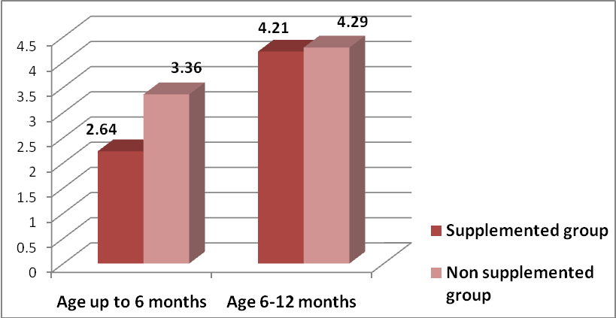
Figure: 1 Mean duration of diarrheal episodes in infants of both supplemented and non supplemented mothers (P value0.01 for age group 0-6 months).
The percentage of some dehydration is more in diarrheal episodes in infants of the non supplemented mothers compared to those of supplemented mothers in both age groups; 3.6% versus 2.5% in the age group 0-6 months and 3.3% versus 2.4% in the age group 6-12months (Figure 2), the differences are not significant (Figure 2).
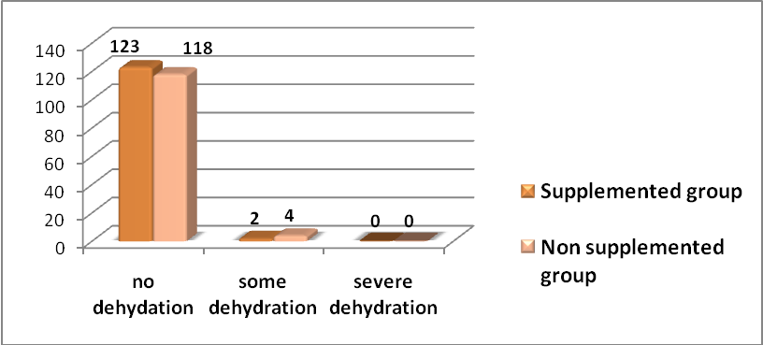
Figure: 2 Degree of dehydration in diarrheal infants
(Age group 6-12 months) P value 1.0
Percentage of presence of blood and mucous (dysentery) in diarrheal cases is more in infants of non supplemented mothers of both age groups; 1.8% versus 1.2% in the age group (0-6 months) and 2.6% versus 1.6% in the age group (6-12 months), the differences are not significant.

The mean birth weight is higher in supplemented group was 3.320 Kg (SD 0.32) compared to 3.139 Kg(SD 0.38) in non supplemented group (P= 0.004). Birth weight it is directly proportional to the duration of antenatal zinc supplementation (Figure 3).

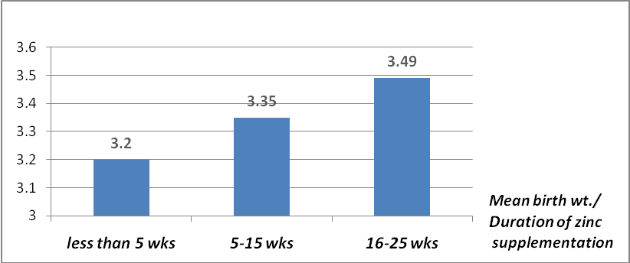
Figure: 3 Relation of between the duration of zinc supplementation and mean birth weight (p value 0.004)

Conclusion
Antenatal zinc supplementation has a beneficial role in the reducing number of diarrheal episode and duration of diarrheal illness in infants offspring, the effect is more evident with longer duration of supplementation and in younger age group.
References
1. McCall, K. A., Huang, C. & Fierke, C. A. (2000) Function and mechanism of zinc metalloenzymes. J. Nutr. 130:1437S-1446S. [Abstract/Free Full Text] 7.
2. Brown, K. H., Peerson, J. M. & Allen, L. H. (2002) Effect of zinc supplementation on the growth and serum zinc concentrations of prepubertal children: a meta-analysis of randomized controlled trials. Am. J. Clin. Nutr. 75:1062-071.[Abstract/Free Full Text].
3. Black, R. E. & Sazawal, S. (2001) Zinc and childhood infectious diseases: morbidity and mortality. Br. J. Nutr. 85(suppl. 2):S125-S129. 57.
4. Hoque KM, Rajendran VM, Binder HJ. Zinc inhibits cAMP-stimulated Cl secretion via basolateral K-channel blockade in rat ileum. Am J Physiol Gastrointest Liver Physiol.2005;288 (5):G956– G963.
5. Ezechukwu CC., ubum G., and Aircede KI. Zinc and cupper level in mature breast milk of the healthy lactating mothers in the first 6 months of lactation. Journal of biomedical investigation, 2004; 2(1):10-16.
6. Lora L. Iannotti, PhD, Nelly Zavaleta, MD, MSb, Zulema León, Anuraj H. Maternal Zinc Supplementation Reduces Diarrheal Morbidity in Peruvian Infants. J. of Pediatrics vol 156, 2009.
7. Bhutta ZA, Ahmed T, Black RE, Cousens S, et al., Interventions for maternal and child undernutrition and survival. Lancet 2008; 371: 417.
8. SPSS Corporation, Chicago, Illinois, USA 2004

الملخص العربي
أثر اعطاء الزنك للسيدات الحوامل علي تقليل الاسهال عند الأطفال الرضع
يعتبر الزنك من العناصرالدقيقة والضرورية لنمو جسم الإنسان حيث يدخل في تكوين الإنزيمات الضرورية لكثير من الوظائف الحيوية ,هذا وقد أثبتت بعض الدراسات فائدة تناول الزنك في سرعة الشفاء من الإسهال والتهابت الجهاز التنفسي وكذلك الوقاية من تلك الامراض.
هذا وقد أجريت تلك الدراسة في مسنشفي الجلاء التعليمي بالقاهرة علي 100 سيدة حامل تناولن 20 مج من الزنك يوميا لمدة تتراوح بين 3-25 أسبوع وتم متابعة أطفالهن خلال السنة الأولي من العمر بالأضافة لعدد مماثل من أطفال لأمهات لم يتناولن الزنك أثناء الحمل, وقد شملت البيانات تلك الخاصة بالاسهال والتغذية ومشورة الامهات عن الممارسات الصحيحة للرضاعة الطبيعية والنظافة.
هذا وقد تم تجميع البيانات وادخالها علي برنامج اكسيل لعمل الجداول والرسومات واستخدم برنامجSPSS لعمل التحليلات الاحصائية.
وقد أشارت نتائج تلك الدراسة الي أثر تعاطي الزنك أثناءالحمل علي تقليل عدد مرات الأصابة بالأسهال وتقليل مدة الأسهال عند أطفال الأمهات اللائي تناولن الزنك خاصة خلال الستة أشهرالأولي من العمر ومع زيادة فترة تناول الزنك ،وأشارت النتائج أيضا الي زيادة وزن هؤلاء الأطفال عند الولادة وأن هذا الوزن يزيد بزيادة فترة تناول الزنك أثناء الحمل.
. المستخلص
اعطاء الزنك للسيدات الحوامل يقلل نسبة الاصبة بالاسهال لدي أطفال هؤلاء السيدات كما يقلل مدة الاسهال خاصة لدي الاطفال عمر أقل من ستة أشهر

