Effectiveness Of Carbamazepine In Treatment Of ADHD In Children with EEG abnormalities
Olweya Mohamed Abdel Baky
Professor of child psychiatry institute of post graduate childhood studies Ain shams University
Safeya Mahmoud Effat
Professor of child psychiatry faculty of medicine Ain shams University
Sara Ali Galal
Abstract:
Background: Attention deficit/hyperactivity disorder is a common neurodevelopmental disorder in children. Abnormal electrophysiological findings with no clinical epilepsy is a common finding in ADHD as compared to normal children. The aim of this study was to assess the efficacy and tolerability of carbamazepine (CBZ) in ADHD children who have abnormal EEG findings.
Methods: fifteen drug naïve ADHD children (13 boys, 2 girls; mean age, 6.62 years; range 4-10) with EEG abnormalities but no clinical seizures were included. Cases with comorbid developmental or mental disturbances other than specific learning disability were excluded. All were treated with carbamazepine (mean dose 5 mg/kg/day). They were followed up through a period of 8 weeks for symptom improvement and occurrence of side effects. Improvement was measured using the parents form ADHD rating scale 4; before and after CBZ treatment. Complete blood count and liver enzyme assessment were performed before and after carbamazepine treatment.
Results: there was statistically significant improvement in mean ADHD rating scale scores specifically in the domains of inattention and combined symptoms while there was no improvement in hyperactivity scores. Reported side effects were mild abdominal discomfort in 2 cases and sedation in 3 cases. No dermatological, hematological or hepatic side effects were reported and no cases had elevated liver enzymes.
Conclusion: low dose carbamazepine can be a well tolerated and effective treatment in some cases of ADHD associated with abnormal EEG findings.
Key words:
Attention deficit hyperactivity disorder, carbamazepine, electroencephalography, ADHD rating scale
دراسة فاعلية عقار الكاربامازيبين في علاج الأطفال المصابين باضطراب فرط الحركة ونقص الانتباه
مـقـــــدمـــــــــــــــــة:
اضطراب فرط الحركة ونقص الانتباه هو اضطراب عصبي نمائي يتميز بنقص في الانتباه 1, اندفاعية و فرط في الحركة. ومن الشائع لدى هؤلاء الأطفال وجود اضطرابات في رسم المخ على الرغم من عدم وجود أعراض الصرع أو التشنجات.
الغرض من البحث:
قياس فاعلية عقار الكاربامازيبين في علاج الاطفال المصابين بفرط الحركة ونقص الانتباه المصحوب باضطرابات في رسم المخ
خطوات البحث:
اجريت هذه الدراسة على 15 طفلا مصابا باضطراب فرط الحركة ونقص الانتباه المصحوب باضطرابات في رسم المخ- لم يتلقوا علاجا لهذا الاضطراب من قبل ولا يعانون من الصرع أو أي أمراض عضوية أو نفسية أخرى. تراوحت أعمارهم بين 4 الى 15 عاما، 13 من الذكور و2 من الاناث. خضع جميع الاطفال المشاركين في البحث لاختبار الذكاء باستخدام مقياس بينيه الصورة الخامسة وقياس أعراض اضطراب فرط الحركة وتشتت الانتباه باستخدام مقياس فرط الحركة ونقص الانتباه كما تم قياس انزيمات الكبد والاطلاع على رسم دم كامل قبل بدء العلاج الدوائي بالكاربامازيبين.
تم اعطاء الكاربامازيبين للأطفال لمدة 8 اسابيع بمتوسط جرعة 5 ملجم لكل كجم من وزن الطفل يوميا مع متابعة المرضى اكلينيكيا في نهاية الأسبوع الثاني والرابع ثم اعادة تطبيق مقياس فرط الحركة ونقص الانتباه بواسطة ولي أمر الطفل في الاسبوع الثامن مع اعادة فحص انزيمات الكبد ورسم الدم.
نتائج الدراسة:
خلصت الدراسة الى فعالية عقار الكاربامازيبين في تحسين أعراض تشتت الانتباه لدى الأطفال المصابين باضطراب فرط الحركة وتشتت الانتباه. بينما لم يكن هناك فرق ذو دلالة احصائية في درجة فرط الحركة لدى هؤلاء الأطفال.
فيما يخص الأعراض الجانبية لعقار الكاربامازيبين؛ كانت اكثر الأعراض الجانبية شيوعا في عينة الدراسة النعاس و آلام طفيفة بالمعدة.
الخلاصة:
يعد استخدام جرعات قليلة من عقار الكاربامازيبين فعالا في بعض حالات اضطراب فرط الحركة وتشتت الانتباه لدى الأطفال وخاصة عندما يكون مصحوبا باضطراب في رسم المخ
Introduction:
Attention deficit/hyperactivity disorder (ADHD) is a neurodevelopmental disorder defined by impairing levels of inattention, disorganization, and / or hyperactivity-impulsivity. ADHD is a common neuropsychiatric disorder in children affecting 6-6.9% of Egyptian children and adolescents (Anbar 2014). Studies agree that this disorder is more common in males than in females of Egyptian population. (Soliman et al, 2010)
Several rating scales consistent with the DSM-IV conceptualization of ADHD are now available for use in both home and school settings. The ADHD Rating Scale-IV (ADHD RS-IV) is a commonly used ADHD rating scale, updated for and directly derived from DSM-IV symptom criteria, applied to children 4–18 years old. It can be completed by either parents (home form) or teachers (school form). The ADHD RS-IV has shown sensitivity to medication effects in several studies. It has high utility for multiple applications due to its quick completion (5–10 minutes), easy scoring, and sensitivity to treatment. (Collett et al, 2003.)
Children with ADHD have relatively consistent EEG abnormalities: increased posterior absolute delta activity, globally elevated absolute and relative theta activity dominant frontally and reduced relative alpha and relative beta activity. A larger theta/beta ratio has also been found consistently in AD/HD children, compared with healthy controls. (Dupuy et al, 2013)
Studies show that carbamazepine (CBZ) is a safe and effective treatment for children with features of ADHD when compared to placebo. However, these studies are scanty and were conducted on patients with some symptoms of ADHD that were not fulfilling the diagnostic criteria of ADHD (Silva et al, 1996). A later case study by Laporte and colleagues reported CBZ to cause significant improvement of ADHD symptoms and cognitive abilities in a patient suffering ADHD associated with EEG abnormalities. The improvement on CBZ was temporally associated to normalization of EEG findings (Laporte et al, 2002).In ADHD with comorbid epilepsy, CBZ is preferable to other antiepileptic drugs for its beneficial effect on attention as well as effective control of epilepsy (Schubert 2005). CBZ is also used as non-FDA approved off label medication for ADHD (Kattimani&Mahadevan 2011). Additionally, in pediatric bipolar disorder cases, CBZ use as a maintenance therapy is beneficial in improving associated ADHD symptoms as well as depressive and psychotic symptoms (Deiana et al, 2011).
Methods:
Fifteen newly diagnosed ADHD children aged 4- 10 years old were enrolled in the study. All patients were diagnosed according to the fifth edition of the Diagnostic and Statistical Manual of Mental Disorders. All cases with comorbid neurological or psychiatric diagnoses were excluded from the study but only cases with comorbid specific learning disability were included. Patients with any contraindication to carbamazepine were also excluded from the study. All included patients had abnormal EEG findings.
Prior to start of carbamazepine, all cases had complete blood count, liver enzymes assessment, IQ assessment using 5th edition of Stanford–Binet Intelligence Scale, ADHD Rating Scale 4th edition and EEG.
All patients administered carbamazepine (Tegretol®) in mean starting dose 2.5 mg/kg body weight daily with gradual increase till mean maintenance dose 5 mg/kg/day. During the 1st 3 weeks of the study, 2 patients dropped out. The other 13 patients completed the 8 weeks period of the study.
Cases were followed up through a period of 8 weeks for improvement of ADHD symptoms and appearance of drug adverse effects. At the end of 8th week, complete blood count and liver enzymes were re-assessed. ADHD RS was also repeated for all cases and was the main tool for evaluation of improvement.
ADHD Rating Scale IV:
The main assessment tool used in this study was the ADHD Rating Scale-IV; home form, The Arabic version, (Desouky, 2004) completed by the care giver of each child before and 8 weeks after initiation of treatment. It includes 18 items; 9 for inattention symptoms and 9 items for symptoms of hyperactivity and impulsivity. It measures 3 symptom domains in ADHD; inattention, hyperactivity and combined symptom domains. In each domain, corrected scores above 69 mean high symptoms, between 60-69 moderate symptoms and below 60 mean low symptoms (Collett et al, 2003).
Statistical analysis:
Data were analyzed using SPSS (Statistical Package for Social Science) Program version 18. Quantitative data e.g. age were presented as minimum, maximum, mean and standard deviation. Qualitative data e.g. sex, were presented as count and percentage.
Paired t test was used to compare ADHD scores for patients before and after treatment and P value < 0.05 was considered statistically significant.
Results:
In the current study, 15 ADHD children (mean age; 6.62 years; range 4-10 years) were enrolled. Demographic data, risk factors and developmental history are demonstrated in table 1. No cases had developmental delays at time of study.
Table 1: Demographic data, risk factors and developmental history:
 |  | N | Minimum | Maximum | Mean | SD
Age in years |  | 15 | 4.00 | 10.00 | 6.62 | 1.79
 |  |  | N |  | %
Sex | Male |  | 13 |  | 86.7
 | Female |  | 2 |  | 13.3
Family history | Negative |  | 13 |  | 86.7
 | ADHD |  | 1 |  | 6.7
 | Intellectual disability |  | 1 |  | 6.7
Prenatal smoking | passive smoking |  | 4 |  | 26.7
Prenatal drugs | positive |  | 1 |  | 6.7
Prenatal stress | positive |  | 4 |  | 26.7
Others | Oligohydramnios |  | 2 |  | 13.3
 | Anemia |  | 1 |  | 6.7
 | Urticaria |  | 1 |  | 6.7
Motor Development | Normal |  | 12 |  | 80.0
 | Delay |  | 3 |  | 20.0
language development | Normal |  | 10 |  | 66.7
 | Delay |  | 5 |  | 33.3
The mean IQ score was 100.25. Main complaint was hyperactivity and the most common ADHD type was the combined type. 6 patients had comorbid specific learning disability (Table 2).
Table 2: Clinical data of study sample:
 | N | Minimum | Maximum | Mean | SD
IQ | 15 | 91.00 | 117.00 | 100.25 | 6.96
 |  | N |  | %
Complaint | hyperactivity | 10 |  | 66.7
 | Inattention | 2 |  | 13.3
 | poor academic performance | 3 |  | 20.0
ADHD type | Combined | 12 |  | 80.0
 | hyperactive impulsive | 2 |  | 13.3
 | Inattentive | 1 |  | 6.7
Specific learning disorder | No | 9 |  | 60.0
 | Yes | 6 |  | 40.0
Before start of Carbamazepine treatment, ADHD scale IV was applied to all the cases. In each of the measured symptom domains (combined, inattention and hyperactivity) scores above 69 are considered high, 60-69 moderate and scores below 60 are considered low.
During the first week of treatment, 2 cases dropped out for the side effect of sedation. After the end of 8th week, ADHD scale was repeated for the remaining 13 cases (Table 3).
After exclusion of drop outs, 2 cases with high scores changed into moderate and 1 moderate changed into low score in the combined score. In the inattention scores; 2 cases changed from sever to moderate and 1 from sever to low symptoms. In the hyperactivity scores; 1 case changed from moderate to low symptoms.
There was significant improvement of mean ADHD RS scores in the combined and inattention domains while improvement in the hyperactivity domain was not significant. (Table 4, Figures 1,2,3)
Table 3: Scores of ADHD rating scale before and after Carbamazepine treatment
 |  | Before |  | After
 |  | N | % | N | %
Combined | Low | 1 | 6.7% | 1 | 7.7%
 | moderate | 3 | 20.0% | 4 | 30.8%
 | High | 11 | 73.3% | 8 | 61.5%
Inattention | low | 2 | 13.3% | 2 | 15.4%
 | moderate | 5 | 33.3% | 7 | 53.8%
 | high | 8 | 53.3% | 4 | 30.8%
Hyperactivity | low | 1 | 6.7% | 2 | 15.4%
 | moderate | 3 | 20.0% | 1 | 7.7%
 | high | 11 | 73.3% | 10 | 76.9%
Total number | 15 |  |  | 13

Table 4: mean ADHD scores before and after treatment with carbamazepine
 | Mean | SD | Paired t test | P value
ADHD scale before | 71.92 | 4.21 | 3.15 | 0.008
ADHD scale after | 68.85 | 5.97
Difference | 3.08 | 3.52
Inattentive score before | 69.85 | 8.21 | 2.20 | 0.048
Inattentive score after | 65.31 | 8.47
Difference | 4.54 | 7.42
Hyperactive score before | 72.92 | 7.33 | 1.61 | 0.134
Hyperactive score after | 71.38 | 8.74
Difference | 1.54 | 3.45
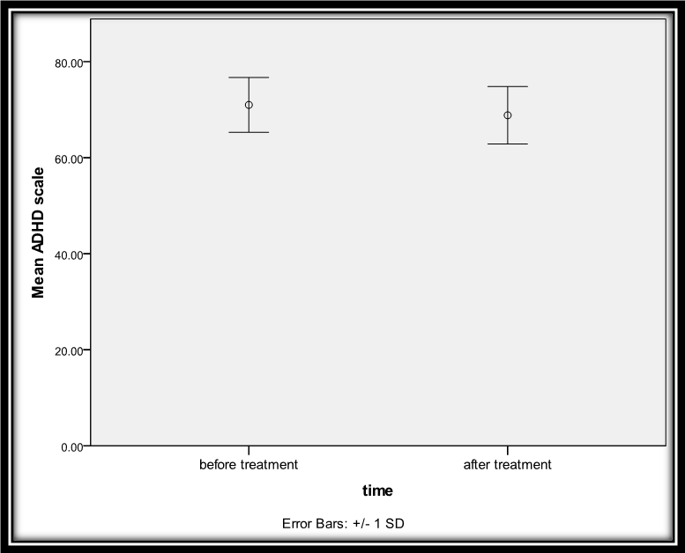
Figure 1: ADHD scale before and after treatment
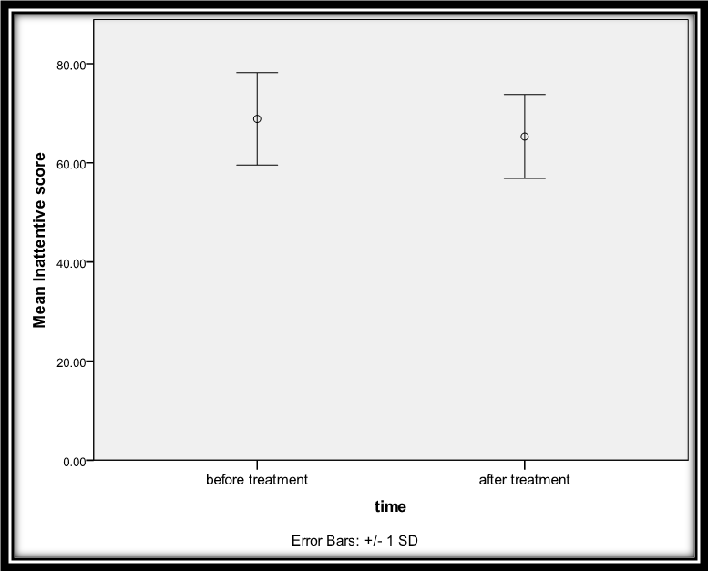
Figure 2: Mean inattentive score before and after treatment
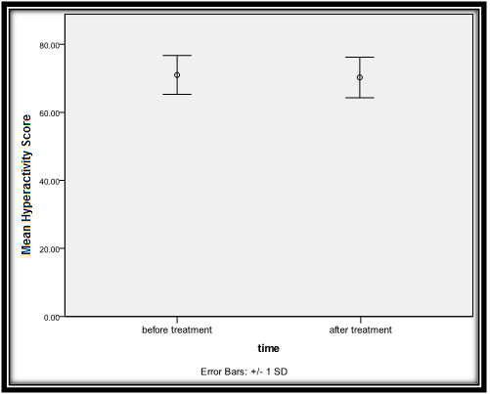
Figure 3: Mean hyperactivity score before and after treatment
Carbamazepine was tolerable in most of the cases. Gastric upset was recorded in 3 cases and sedation in 3 cases; 2 of them dropped out for this side effect; while 9 cases had no recorded side effects. Liver enzymes of all patients were within normal levels before as well as after treatment. No cases had dermatologic, hematologic or hepatic side effects (Table 5).
Table 5: side effects of CBZ (no. 15)
 | N | %
No | 9 | 60.0
GIT distress | 3 | 20.0
sedation | 3 | 20.0
Dermatological reactions | 0 | 0
Hematological reaction | 0 | 0

Discussion:
The results of this study show that low dose carbamazepine appears to be an effective and well tolerated drug in selected cases of pediatric ADHD; namely those with EEG abnormalities and predominant inattentive symptoms. Adverse effects reported in this study are fewer and less severe than those reported in higher doses used in cases of epilepsy. Reported side effects were sedation and abdominal discomfort which was tolerated by all the patients.
The efficacy of CBZ in ADHD children included in this study can be explained by its antiepileptic activity. Electrophysiological abnormality is a common and well studied finding in EEG of ADHD patients (Quintanaa et al 2007, Socanski et al, 2010). The relation between abnormal EEG findings and behavioral or cognitive disturbances in children is an area of debate. Some studies suggest positive relation between EEG findings and behavioral disinhibition and poor concentration in children. This hypothesis is supported by the fact that children with epilepsy have higher rates of externalizing behaviors and aggression as compared to normal peers (Guidetti et al, 2015) and that they also have cognitive difficulties. Both cognitive and behavioral disturbances in epileptic children improve with good epilepsy control using antiepileptic drugs (Powell et al, 2015).
On the other hand, some studies hypothesize that both EEG abnormalities and misbehavior have the same etiological bases rather than having a causal relation (Tarullo et al, 2011, Niv et al, 2015).
Based on the assumption that cognitive and behavioral symptoms of ADHD may be related to abnormal electrophysiological activity, many clinical trials used different modalities to improve ADHD symptoms through normalization of EEG power in non epileptic ADHD children using antiepileptic drugs (Laporte et al, 2002, Eun et al, 2012).
In the current study, there was significant improvement in the mean ADHD scale scores yet, the degree of improvement was not so evident as the scores remained in the moderate to high severity category after treatment.
Studies that assess the efficacy of CBZ in non epileptic ADHD patients are few and outdated. The results of current study are in concordance with an old metaanalysis that included data from 10 clinical trials of CBZ in cases of ADHD. Authors concluded that CBZ can be an effective alternative treatment in cases of ADHD (Silva et al, 1996).
Other studies found similar effect of CBZ on ADHD symptoms in epileptic children. A multicenter, randomized, open-label, observer blinded 28 weeks clinical trial held by Kang and colleagues to compare the cognitive and behavioral effects of CBZ (n. 43) and topiramate (n. 45) on children with benign Rolandic epilepsy. They found that attention and concentration improved with both drugs (Kang et al, 2007).
However, results of CBZ effect on attention are conflicting, which may be due to selection bias or dosing (Ijff and Aldenkamp 2012). A large double blind study to compare the cognitive effects of 200-600 mg/day CBZ (n.= 288) and remacemide (n. 282) on newly diagnosed epileptic patients 12- 75 years old found a deterioration in attention of CBZ treated patients when measured 80 weeks after initiation (Wesnes et al, 2009). Another recent large retrospective study of 258 epileptic adults under CBZ treatment found intolerable cognitive side effects in 5% of cases. Most of them (2.6%) had impairment in memory while 1.6% had decreased concentration (Javed et al, 2015).
Other studies of CBZ in epileptic cases found no effect on attention. Äikiä and colleagues used pooled analysis of two long term follow up studies to compare cognitive effects of CBZ, tiagabine and untreated no drug on patients (12-52 years old) with single epileptic fit for 52 weeks. They found improvement in attention of both CBZ (400-800 mg/day) and tiagabine treated groups but it was similar to no drug group. They concluded that both drugs do not hinder the normal cognitive development of treated patients (Äikiä et al, 2006). Another study comparing the cognitive effects of oxcarbazepine, carbamazepine and valproate for 6 month duration in a sample of children 6-17 years with partial epilepsy found no impairment in cognitive abilities under any of studied drugs (Donati et al, 2007). Similarly, Bozinovska and colleagues investigated the effect of CBZ on attention and reaction time after 1 month of treatment. They included 15 adult patients with epilepsy and 15 healthy controls. No difference in attention was found (Bozinovska et al, 2006).
These differences in findings can be explained by selection bias. Most studies addressing the cognitive effects of CBZ on children use newly diagnosed epileptic children as a study sample. For ethical issues, those patients can’t be studied under placebo to be compared to CBZ. Thus, the deterioration of cognitive function observed in these studies can be either the effect of the drug or the burden of epilepsy itself. Another explanation can be the difference of CBZ dose in various studies as the neuropsychological side effects can be dose-dependent (Meador, 2005).
None of previous studies investigated the relation between cognitive effects of CBZ and its serum level.
The results of the current study should be viewed in light of its methodological limitations.
First; The small number of study sample included and the short duration of study.
Second; all the included cases were newly diagnosed children, the effect of parent psycho-education and counseling cannot be excluded. Comparative studies are needed to overcome this limitation.
Further, accurate interpretation of specific EEG findings and its correlation to symptoms and drug effect were not available in current study.
Finally, serum level was obtained in only 5 cases so, it could not be correlated to clinical improvement.
These results couldn’t be taken as granted because the sample was very small.
However, these results reflect the efficacy of carbamazepine in a group of ADHD children with EEG changes and this should be taken in consideration in the management of these patients.
Moreover, the response of this sector of ADHD patients (with EEG changes) to CBZ should be compared to the classical treatment of ADHD to validate the specialties and the use of antiepileptic drugs notably CBZ in this group of patients.
Conclusion:
From this study it has been concluded that low dose carbamazepine can be a well tolerated and effective treatment in some cases of attention deficit hyperactivity disorder associated with abnormal electrophysiological findings. Taking in consideration the limitations of this study, further studies on larger samples are needed to generalize the results of the study.
References:
- Äikiä, M., Jutila, L., Salmenperä, T., Mervaala, E., &Kälviäinen, R. (2006). Comparison of the Cognitive Effects of Tiagabine and Carbamazepine as Monotherapy in Newly Diagnosed Adult Patients with Partial Epilepsy: Pooled Analysis of Two Long‐term, Randomized, Follow‐up Studies. Epilepsia, 47(7), 1121-1127.‏
- Anbar, RedaFathy (2014). Attention Deficit Hyperactive Disorder among School Age Children in Minoufyia Governorate. thesis(ph.d) - Menofiya University. Faculty of Medicine. Family Medicine Department.
- Bozinovska, L., Mancevska, S., Naumovski, R., Pluncevic, J. H., &Sivevska, E. P. (2006, September). The effect of carbamazepine on reaction time and attention in patients with epilepsy. In International Journal Of Psychophysiology, 61(3), pp. 342-342
- Collett, B. R., Ohan, J. L., & Myers, K. M. (2003). Ten-year review of rating scales. V: scales assessing attention-deficit/hyperactivity disorder. Journal of the American Academy of Child & Adolescent Psychiatry, 42(9), 1015-1037.‏
- Deiana, V., Chillotti, C., Manchia, M., Pinna, M., Ardau, R., Del Zompo, M., &Severino, G. (2011). A Retrospective Case Series of Bipolar Patients With Adjunctive Carbamazepine in Long-Term Lithium Treatment: Evaluation of the Effectiveness. Journal of clinical psychopharmacology, 31(4), 538-540.‏
- Desouky, Mohamed (2004) Attention Deficit Hyperactivity Rating Scale guide, Anglo, Cairo, Egypt
- Donati, F., Gobbi, G., Campistol, J., Rapatz, G., Daehler, M., Sturm, Y., &Aldenkamp, A. P. (2007). The cognitive effects of oxcarbazepine versus carbamazepine or valproate in newly diagnosed children with partial seizures. Seizure, 16(8), 670-679.‏
- Dupuy, Franca, Clarke, Adam R., Barry, Robert J., McCarthy, Rory and Selikowitz, Mark;. (2013). EEG Differences Between the Combined and Inattentive Types of Attention-Deficit/Hyperactivity Disorder in Girls. Clinical EEG and Neuroscience .
- Eun, S. H., Eun, B. L., Lee, J. S., Hwang, Y. S., Kim, K. J., Lee, Y. M., ... &Eom, S. (2012). Effects of lamotrigine on cognition and behavior compared to carbamazepine as monotherapy for children with partial epilepsy. Brain and Development, 34(10), 818-823.
- Guidetti, V., Antonelli, A., Donazzan, S., Faedda, N., Natalucci, G., &Simeoni, S. (2015). P015. Externalizing behaviours in children with headache and epilepsy: a case-control study. The Journal of Headache and Pain, 16(S1), 1-1.‏
- Ijff, D. M., &Aldenkamp, A. P. (2012). Cognitive side-effects of antiepileptic drugs in children. Handbook of clinical neurology, 111, 707-718.‏
- Javed, A., Cohen, B., Detyniecki, K., Hirsch, L. J., Legge, A., Chen, B., ...& Choi, H. (2015). Rates and predictors of patient-reported cognitive side effects of antiepileptic drugs: an extended follow-up. Seizure, 29, 34-40.‏
- Kang, H. C., Eun, B. L., Lee, C. W., Moon, H. K., Kim, J. S., Kim, D. W., ... & Park, J. C. (2007). The effects on cognitive function and behavioral problems of topiramate compared to carbamazepine as monotherapy for children with benign rolandic epilepsy. Epilepsia, 48(9), 1716-1723.‏
- Kattimani, S., &Mahadevan, S. (2011). Treating children with attention-deficit/hyperactivity disorder and comorbid epilepsy. Annals of Indian Academy of Neurology, 14(1), 9.‏
- Laporte, N., Sébire, G., Gillerot, Y., Guerrini, R., &Ghariani, S. (2002). Cognitive epilepsy: ADHD related to focal EEG discharges. Pediatric neurology, 27(4), 307-311.
- Meador KJ, Loring DW, Vahle VJ et al. (2005), Cognitive and behavioral effects of lamotrigine and topiramate in healthy volunteers. Neurology 64(12):2108-2114.
- Mikati, Mohamad A. (2011): Treatment of Seizures and Epilepsy. In R. M. Kliegman (Editor), Nelson Textbook of Pediatrics. 19th ed. (pp.2025-2033)
- Niv, S., Ashrafulla, S., Tuvblad, C., Joshi, A., Raine, A., Leahy, R., & Baker, L. A. (2015). Childhood EEG frontal alpha power as a predictor of adolescent antisocial behavior: A twin heritability study. Biological psychology, 105, 72-76.‏
- Powell, K., Walker, R. W., Rogathe, J., Gray, W. K., Hunter, E., Newton, C. R., & Burton, K. (2015). Cognition and behavior in a prevalent cohort of children with epilepsy in rural northern Tanzania: A three-year follow-up study. Epilepsy & Behavior, 51, 117-123.‏
- Quintana, H., Snyder, S. M., Purnell, W., Aponte, C., &Sita, J. (2007). Comparison of a standard psychiatric evaluation to rating scales and EEG in the differential diagnosis of attention-deficit/hyperactivity disorder. Psychiatry Research, 152(2), 211-222.‏
- Sadock, B. J., &Sadock, V. A. (2015). Kaplan and Sadock's synopsis of psychiatry: Behavioral sciences/clinical psychiatry. Lippincott Williams & Wilkins.‏
- Schubert R (2005).: Attention deficit disorder and epilepsy. Pediatr Neurol. ;32:1–10
- Silva, R. R., Munoz, D. M., & Alpert, M. (1996). Carbamazepine use in children and adolescents with features of attention-deficit hyperactivity disorder: a meta-analysis. Journal of the American Academy of Child & Adolescent Psychiatry, 35(3), 352-358
- Sobanski, E., Banaschewski, T., Asherson, P., Buitelaar, J., Chen, W., Franke, B., ...&Stringaris, A. (2010). Emotional lability in children and adolescents with attention deficit/hyperactivity disorder (ADHD): clinical correlates and familial prevalence. Journal of Child Psychology and Psychiatry, 51(8), 915-923.‏
- Soliman, Gamal T.; Afify, Mohamed F.; Yehia, Mohamed A.; Abdel-Naem, Emad A. and AbdAlkarim, Samir M. (2010). Attention deficit hyperactivity disorders an epidemiological study of preschool and primary school children in minia city. El-minia med., bul., vol. 21(1)
- Tarullo, A. R., Garvin, M. C., & Gunnar, M. R. (2011). Atypical EEG power correlates with indiscriminately friendly behavior in internationally adopted children. Developmental psychology, 47(2), 417-421
- Wesnes, K. A., Edgar, C., Dean, A. D. P., &Wroe, S. J. (2009). The cognitive and psychomotor effects of remacemide and carbamazepine in newly diagnosed epilepsy. Epilepsy & behavior, 14(3), 522-528.

