Diagnostic Biomarkers for Neonatal Sepsis
(Meta-Analysis study)
Salah Mostofa¹, Hanan Abd Allah El Gamal², Salwa Ibrahim Bakr³, Howaida Abou El Ela
1. Professor of Preventive Medicine and Epidemiology, Institute of Postgraduate Childhood Studies, Ain Shams University
2. Professor of Pediatric, Institute of Postgraduate Childhood Studies, Ain Shams University
3. Professor of Clinical Pathology, Faculty of Medicine, Ain Shams University
Background: Neonatal sepsis is the single most important cause of neonatal deaths in the community. It remains a major cause of mortality in newborn and life –threatening disorder in infants.
Aim of the study: To assess the validity of using diagnostic markers in predicting neonatal sepsis.
Methodology: This was a systematic review and meta-analysis. More than 200 potentially relevant studies were collected in 2 years standing from 2012 to 2014 but only 42 of them met the inclusion criteria. A standard method for meta-analysis of diagnostic markers evaluation was performed using Biostat, Comprehensive Meta-analysis version 3.0
Results: Meta-analysis was performed on 2722 neonates divided into 2 groups according to their clinical manifestations of neonatal sepsis and laboratory findings. PROM was the commonest risk factor predisposing to sepsis. Klebsiella and staphylococcus aureus were the most common isolated organism. Based on the results from included studies in this review, 6 predominant markers were used to evaluate early diagnosis of neonatal sepsis, PCT, IL-6, TNF-α, CD64, sICAM and Eselectin.
Procalcitonin was highly significantly elevated with sensitivity (0.93) whereas specificity was (0.87) and it had the most diagnostic accuracy (0.95). SICAM was the most sensitive marker (0.95) its diagnostic accuracy and specificity were (0.93) and (0.90), TNF-α had diagnostic accuracy (0.92) sensitivity and specificity were (0.86), the sensitivity of Eselectin was (0.92), its diagnostic accuracy and specificity were (0.91) and (0.82). IL6 had diagnostic accuracy (0.93); the specificity and sensitivity were (0.90) and (0.88). CD64 was the most specific biomarker for predicting neonatal sepsis (0.91), sensitivity (0.87) accuracy (0.92).
Conclusion: Based on results from the studies included in this review, it was clear that serum sICAM had a high sensitivity for diagnosis of neonatal sepsis; CD64 had a high specificity and serum procalcitonin had the most diagnostic accuracy.
Key words: Neonatal sepsis, Noanatal markers, Meta-analysis, procalcitonin, SICAM
INTRODUCTION
Neonatal sepsis is defined as a clinical syndrome of bacteremia with systemic signs and symptoms of infection in the first 4 weeks of life. It is estimated that up to 20% of all live births develop an infection easily, because their immune system is not adequately developed, approximately 4 million deaths occur annually, attributable mostly to infection, birth asphyxia, and consequence of premature birth and low birth weight (Bernhard et al., 2014).
A variety of factors contributed to this serious disease including maternal risk factors as premature rupture of membrane and others, besides neonatal risk factors as prematurity and invasive procedures. Clinical diagnosis of sepsis in newborn infants is not easy because symptoms and signs are nonspecific. There is no laboratory test with 100% specificity and sensitivity. The current practice of starting empirical antibiotic therapy in all neonates showing infection-like symptoms results in their exposure to adverse drug effects, nosocomial complications, and in the emergence of resistant strains (Alireza et al., 2012).
Accurate and quick diagnosis is therefore essential for both protecting the infant from the consequences of the bacterial invasion and preventing damages deriving from the unnecessary use of antibiotics (Lutsar et al., 2014). Clinical judgment and laboratory tests such as complete blood cell count and the ratio between immature to total neutrophils (I/T ratio) showed to be useful in the early diagnosis of neonatal septic infection (PrabhuDas et al., 2011). The microbiological cultures are the gold standard for diagnosis of neonatal sepsis but they are not available until at least up to 72h and do not identify most infected infants. During the last decades efforts have been made to improve the laboratory diagnosis of neonatal sepsis by studying a large variety of inflammatory markers with diverse success (Bhat et al., 2016).
In view of such data, the aim of this study was designed to elucidate the use of multiple analyses as a tool to amalgamate the results of several Egyptians studies concerning markers of neonatal sepsis.
Materials and Methods:
The present study is based on collection of the target studies from several faculties of medicine across the country through attending the central libraries of Ain Shams, Cairo and Al Azhar Universities.
Raw data were collected while focusing on the results of previous Egyptian studies evaluating diagnostic markers of neonatal sepsis in the last 10 years (2000-2010). More than 200 potentially relevant studies were collected in 2 years standing from 2012 to 2014 but only 42 met the inclusion criteria.
Sources of data:
The online search was done using the site of the Egyptian Universities Libraries Consortium (EULC) other than the three main universities. The search terms were “Neonates”, “Sepsis”, “Septicemia”, “Biomarker”, and “Meta-analysis”.
a) All studies concerning diagnostic markers of neonatal sepsis in Egyptian studies in both full term and preterm in the first month of life were included. .
b) Studies concerning sepsis with multiple congenital anomalies and metabolic disorders or evaluating sepsis after the first month of life, or didn’t have enough data for calculating sensitivity and specificity were excluded.
Data extraction:
The information was extracted from the selected studies include:
- The first author, publication year, title of the study, Type of the study design, Size and characteristics of the study population, number and specific characteristics of the patients in the septic and non-septic groups.
- Laboratory tests (e.g. complete blood cell count, the ratio between immature to total neutrophils (I/T) and C - reactive protein (CRP).
- Microbiological culture results (the gold standard for neonatal sepsis diagnosis.
- Types of markers used for diagnosis of neonatal sepsis.
- Sensitivity, specificity, diagnostic accuracy for neonatal sepsis diagnosis were extracted.
Total number of screened studies
N=200
Studies excluded according to the first screening of titles and abstracts
N=158
Studies met all inclusion and exclusion criteria
N=42
Twenty studies were excluded because of insufficient data for sensitivity or specificity and or accuracy of markers
Studies with outcome data useful in meta-analysis markers were included .N=22 markers.

N=22
N=200
Investigators select the top 6 of accuracy score from the 22 markers
- Procalcitonin
- SICAM-1
- TNF-α.
- CD4.
- Interleukin 6.
- E selection.

Fig (1): Flow diagram of the detailed process of selection of studies.
Statistical analysis:
Data was analyzed using (SPSS) version 12.0, SPSS version 12, 2004. Descriptive statistics in the form of mean (x bar) and standard deviation (SD) were performed for all patients. For quantitative data, student t-test was used. For comparing qualitative, Chi square test (χ²) was used. Values of P ≤ 0.05 were considered significant, values were highly significant if ≤ 0.01.
A standard method for meta-analysis of diagnostic markers evaluation was performed using Biostat, Comprehensive Meta-analysis version 3.0 (Biostat, 2015).
Results:
This meta-analysis study included 2722 neonates. They were divided into 2 groups according to clinical manifestations of neonatal sepsis and laboratory findings. Comparative statistics between case and control group as regards, gestational age and birth weight are present in table (1). There was highly significance difference between case and control groups which is lower in case group when compared to control group (p=0.001). Moreover, PROM was the commonest predisposing factor to sepsis (45%), followed by maternal fever (20%). As regards results of blood culture, klebsiella was the most common gram negative microorganism 292cases (44%), followed by E. coli 72 cases (10%), On the other hand Staphylococcus aureus was the most common gram positive microorganism 137 cases (37.3%), followed by GBS 29 cases (8%).
Comparison between cases and control groups as regards laboratory data of neonatal sepsis were shown in table (2) there was a highly significant difference in hematological parameters (Hb level, Platelet count, I/T ratio) between cases and control groups. All septic neonates had a positive C - reactive protein with a range of 55.9±27.9mg/dl which is highly significance as compared to the control group 2.2±1.5mg/dl.
Analysis of diagnostic markers of neonatal sepsis revealed 6 predominant markers, as determined by number of publications: PCT, IL-6, TNF-α, CD64, sICAM and Eselectin. Results of sensitivity, specificity and diagnostic accuracy of biomarkers in reviewed studies were demonstrated in table (3) fig (2) fig (3) fig (4) were the sICAM is the most sensitive marker for prediction of neonatal sepsis (0.95), CD64 is the most specific marker (0.91) and serum procalcitonin had the most diagnostic accuracy (0.95).
Table (1): Comparative statistics between case and control groups as regards gestational age and birth weight
Items | Case group (n=1783)Mean±SD | Control group  (n=939) Mean±SD | t test | P value
Gestational age (wks) | 34.9±2.2 | 36.7±1.5 | 506.1 | 0.001**
Birth weight (kg) | 2.5±0.7 | 3.0±0.7 | 313.8 | 0.001**

Table (2): Comparison between cases and control groups as regards laboratory data of neonatal sepsis
Laboratory data | Case group  (n=1029)  Mean±SD | Control group  (n=939)  Mean±SD | t- test | P value
Hb level (gm/dl) | 12.8±2.8 | 15.2±1.5 | 600.14 | 0.000**
Platelets (10⁹/L) | 159.0±62.9 | 233.9±63.2 | 869.29 | 0.000**
I/T ratio | 1.8±1.0 | 0.5±0.3 | 1514.87 | 0.000**
CRP (mg/dl) | 55.9±27.9 | 2.2±1.5 | 3472.2 | 0.000**

Table (3): Sensitivity, specificity and diagnostic accuracy of biomarkers in reviewed studies
Name of marker | Sensitivity % | Specificity % | Accuracy%
Procalcitonin | 0.93 | 0.87 | 0.95
TNF | 0.86 | 0.86 | 0.92
SICAM-1- | 0.95 | 0.90 | 0.93
E selectin | 0.94 | 0.82 | 0.91
CD64 | 0.87 | 0.91 | 0.92
IL-6- | 0.88 | 0.90 | 0.93

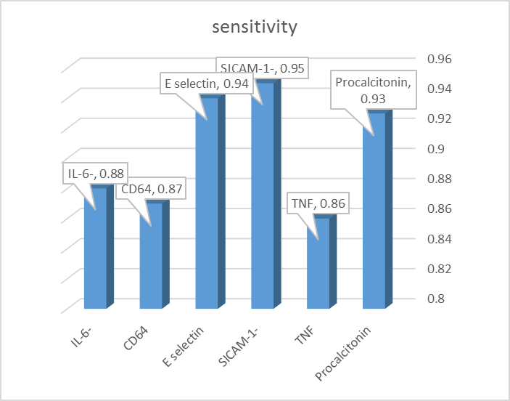
.
Fig (2): sICAM is the most sensitive marker in predicting neonatal sepsis
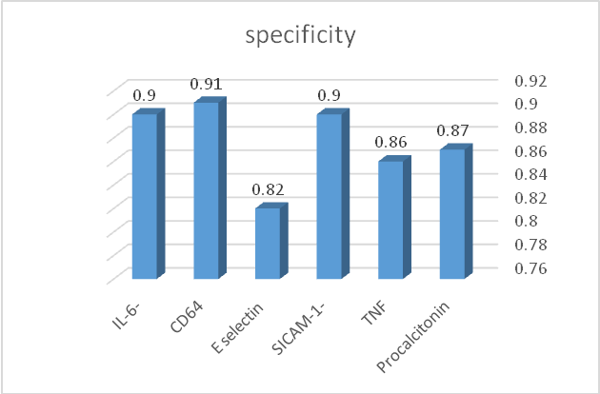
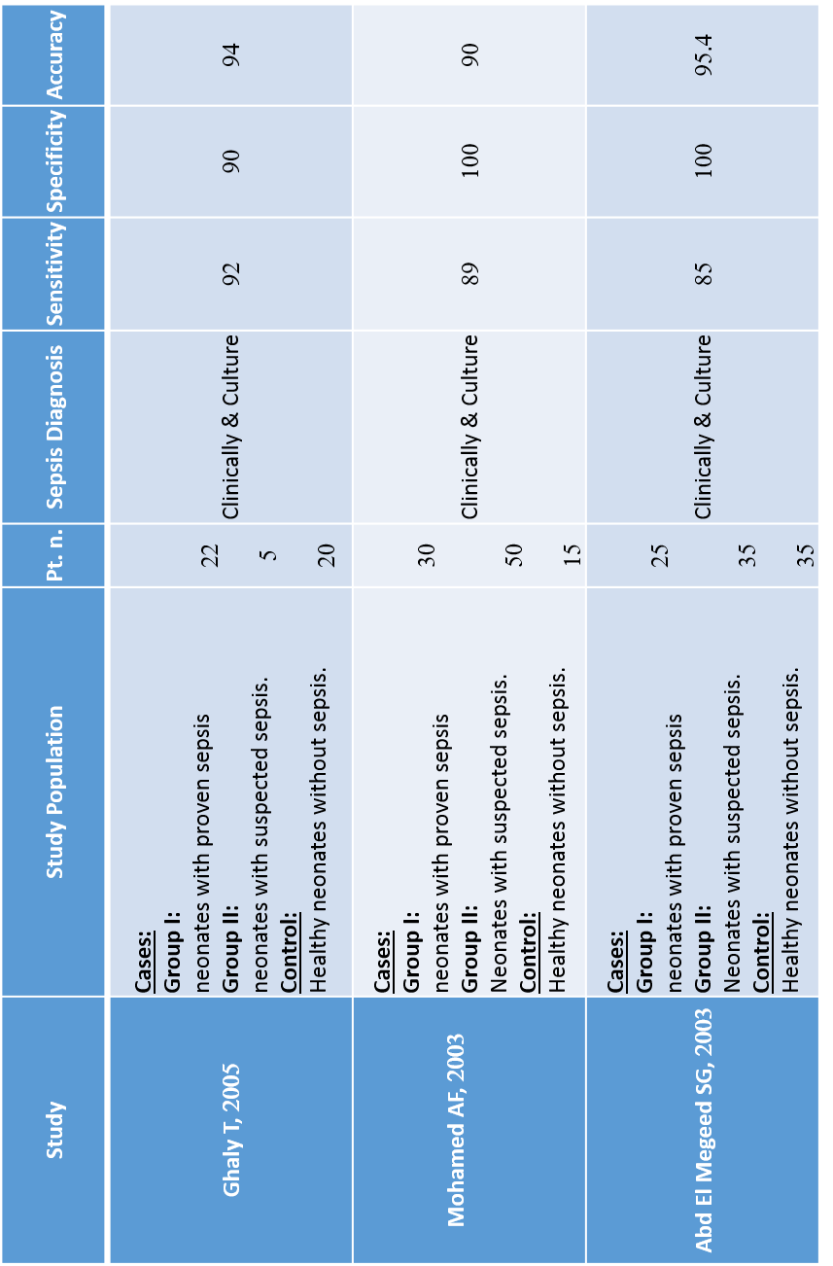Fig (3): CD64 is the most specific marker in diagnosis of neonatal sepsis.
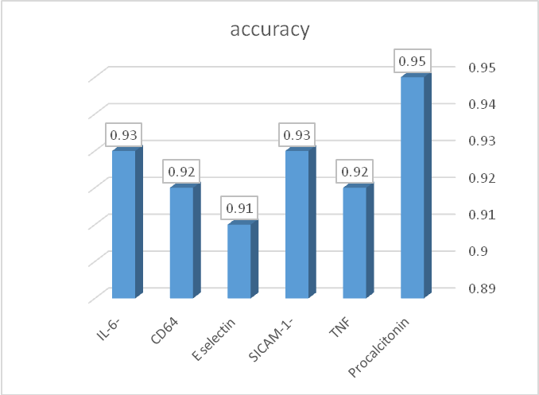
Fig (4): serum procalcitonin is the most diagnostic accurate marker for diagnosis of neonatal sepsis.
Characteristics of studies using procalcitonin for predicting neonatal sepsis are presented in table (4), 5 analyzed studies regarding the value of serum PCT with the total number of cases (n=198) and control (n=110).
Fig (5) shows that serum PCT was highly significantly elevated in septic groups in comparison to the control group. Its pooled sensitivity 0.93 ranged from (0.86 to 0.96) with z value= 6.6, whereas pooled specificity 0.87 ranged from (0.83 to 0.91) z value = 10.5 and the accuracy 0.95 ranged from (0.91 to 0.97) z value = 8.9.
Table (4): characteristics of studies using procalcitonin for neonatal sepsis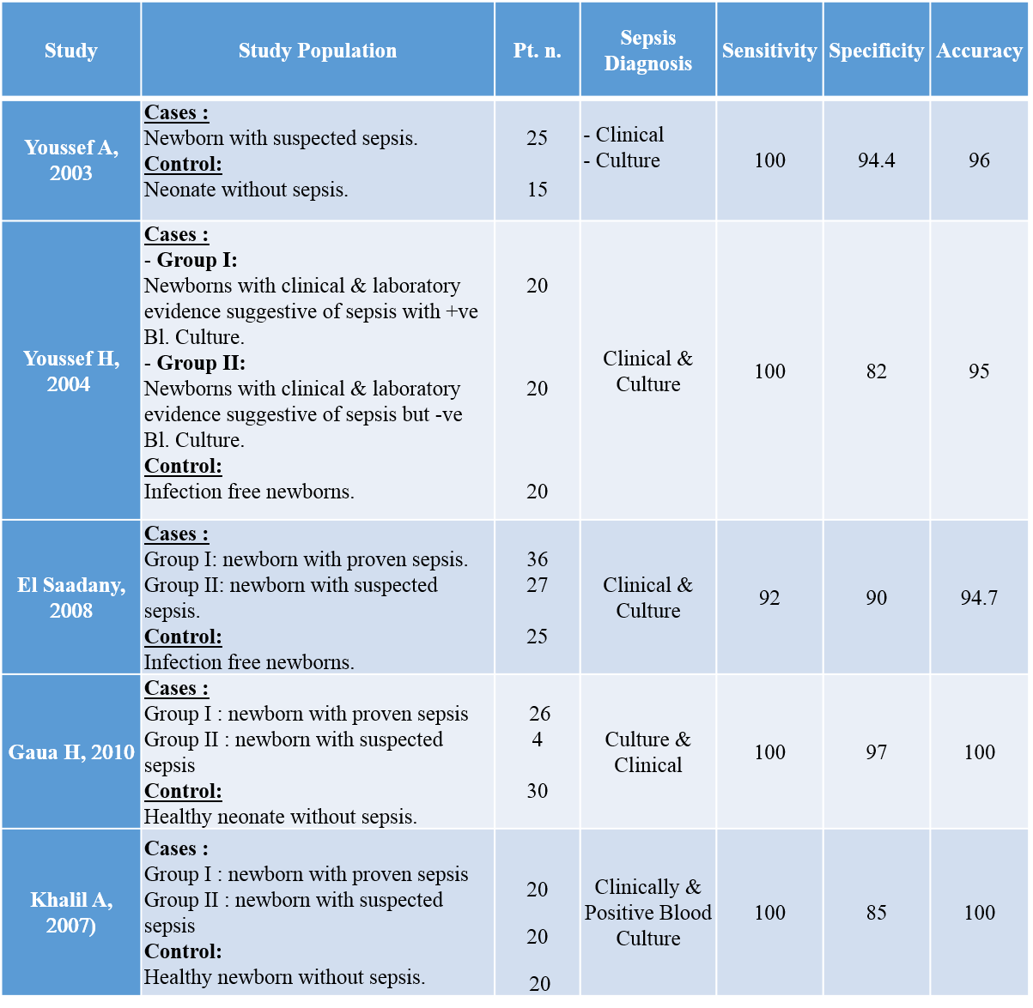
Fig (5): sensitivity, specificity and diagnostic accuracy of serum procalcitonin
Sensitivity of Procalcitonin
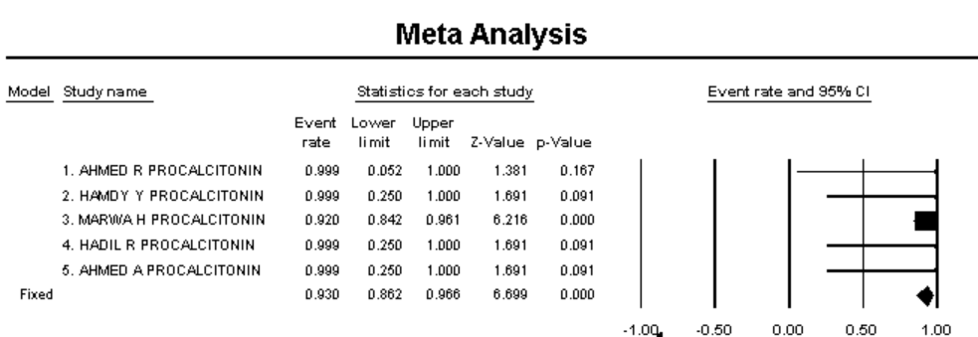
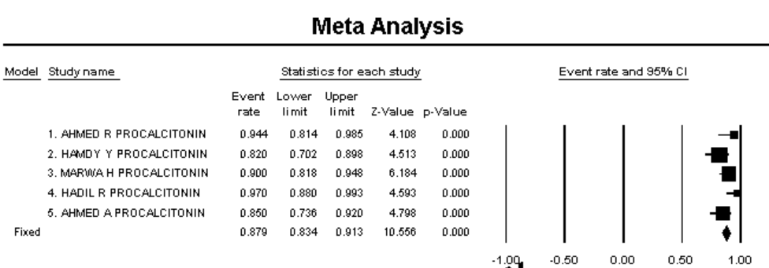 Specificity of Procalcitonin
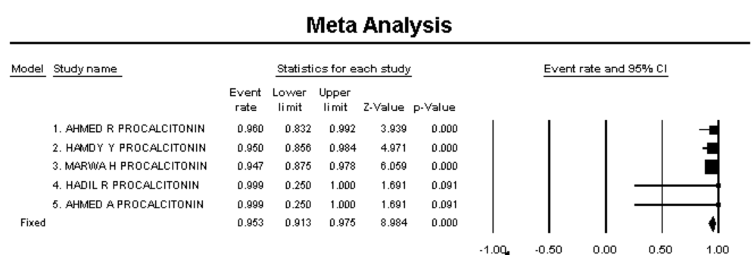 Accuracy of Procalcitonin
Studies using sICAM as a marker are summarized in table (5). Fig (6), the total number of cases (n=166) and the number of control (n=60). Studies revealed that sICAM was the most sensitive marker with pooled sensitivity 0.95 ranged from (0.90 to 0.97) z value = 8.1. The specificity0.90 ranged from (0.85 to 0.93) z value = 9.2and the accuracy0.93 ranged from (0.89 to 0.96) z value = 9.
Table (5): Characteristics of studies dealing with the role of (SICAM-1) for predicting NS
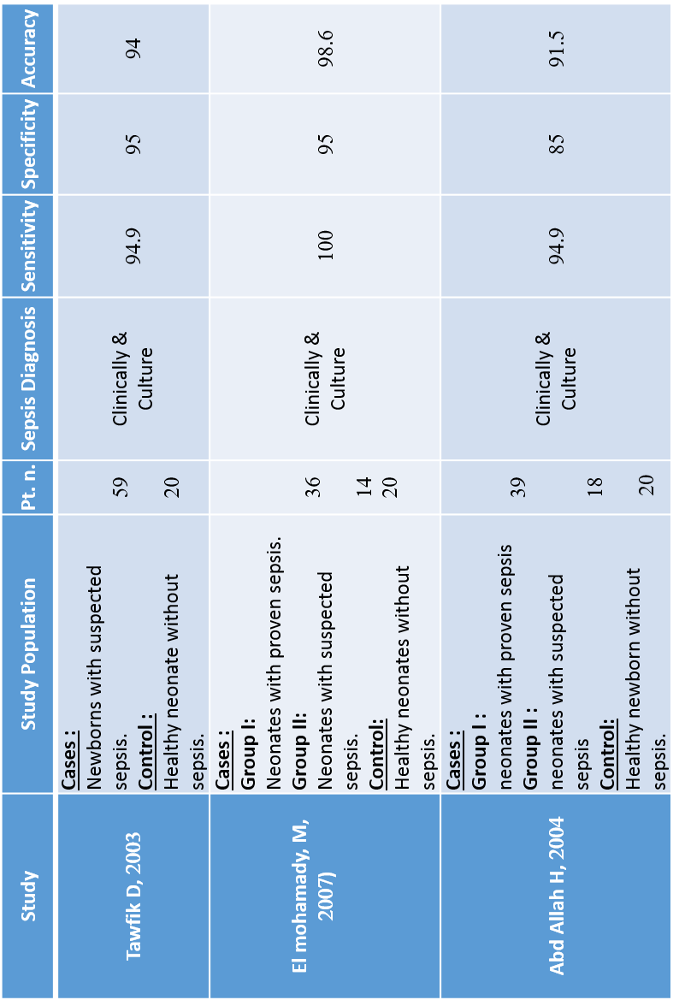
Fig (6): sensitivity, specificity and diagnostic accuracy of surface intracellular adhesion molecule (sICAM)
Sensitivity of (sICAM)
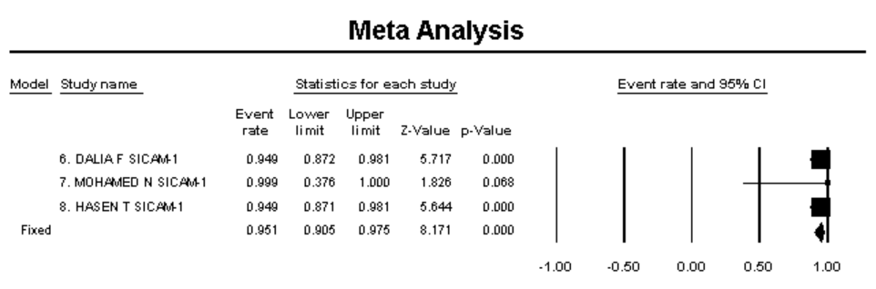
Specificity of (sICAM)
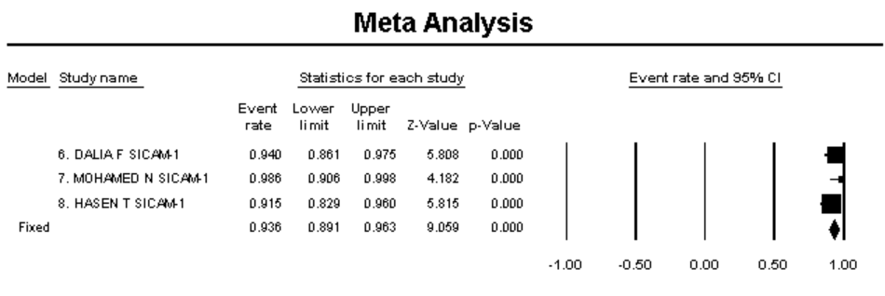
Accuracy of (sICAM)
Table (6), Fig (7) presents the detailed data of the studies using CD4 as a marker of neonatal sepsis. The total number of cases were (n=167) and the number of control patient were (n=70). CD64 was evaluated in three studies with high statistical significance difference comparing septic and control group.CD64 was the most specific biomarker with pooled specificity 0.91 ranged from (0.81 to 0.96) z value = 5.01 and the accuracy 0.92 ranged from (0.88 to 0.95) z value = 9.6, pooled sensitivity 0.87 ranged from (0.82 to 0.91) z value = 9.6.
Table (6): Characteristics of studies dealing with CD4 role for predicting NS
Fig (7): sensitivity, specificity and diagnostic accuracy of CD64
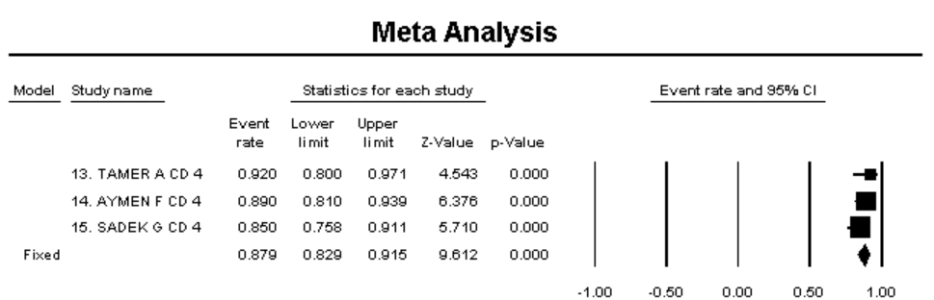 Sensitivity of CD 64
Specificity for CD6 4
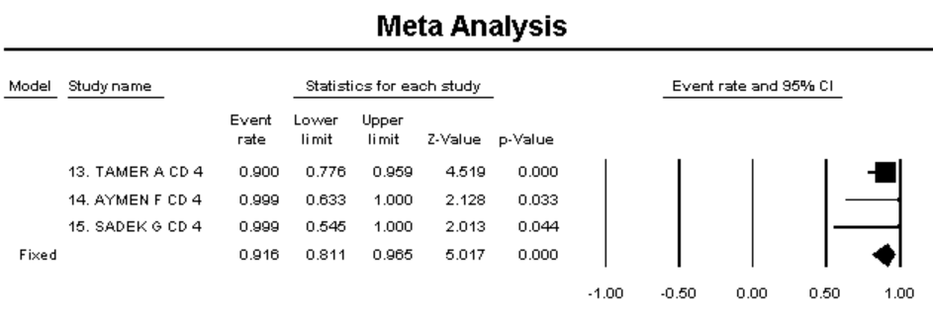
Accuracy for CD64
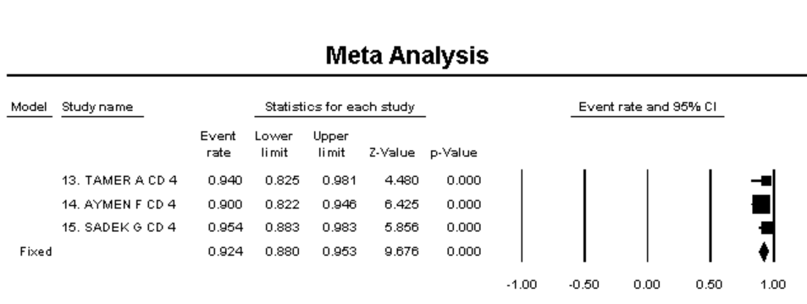
Discussion:
Neonatal sepsis is the single most important cause of neonatal deaths in the community. Despite the advances in perinatal and neonatal care and the use of very potent antibiotics, neonatal sepsis remains a major cause of admission to neonatal intensive care unit with a mortality rate ranging from 1.5% in term of almost 40% in very low birth weight infants (Benitz et al., 2015 and Lutsar et al., 2014).
Clinical diagnosis of sepsis in newborn infants is not easy because symptoms and signs are nonspecific. There is no laboratory test with 100% specificity and sensitivity. The current practice of starting empirical antibiotic therapy in all neonates showing infection-like symptoms results in their exposure to adverse drug effects, nosocomial complications, and in the emergence of resistant strains (Bernhard et al., 2014 and Cuna et al., 2014).
Clinical judgment and laboratory tests such as complete blood cell count and the ratio between immature to total neutrophils (I/T ratio) showed to be useful in the early diagnosis of neonatal septic infection. The microbiological cultures are the gold standard for diagnosis of neonatal sepsis but they are not available until at least up to 72h and do not identify most infected infants. During the last decades efforts have been made to improve the laboratory diagnosis of neonatal sepsis by studying a large variety of inflammatory markers with diverse success (Berardi et al., 2014).
In view of such data, the aim of this study was designed to elucidate the use of multiple analyses as a tool to amalgamate the results of several Egyptians studies concerning markers of neonatal sepsis.
More than 200 potentially relevant studies from several faculties of medicine across the country were collected in 2 years standing from 2012 to 2014 focusing on results of previous Egyptian studies evaluating diagnostic markers of neonatal sepsis in the last 10 years (2000-2010) but only 42 met our inclusion criteria.
This meta-analysis study included 2722 neonates. They were grouped into 2 groups according to clinical manifestations of neonatal sepsis and laboratory findings. The first group (proved and suspected or clinical septic group) included 1783 (65.5%), The second group included 939 (34.5%) healthy neonates acting as a control group.
In the present study comparison of birth weight and gestational age between septic groups (proved + suspected sepsis) with mean gestational age 34.9±2.2 week, birth weight 2.5±0.7 kg and the control group with mean gestational age 36.7±1.5 week, birth weight (3.0±0.7 kg) revealed a highly significant difference. This was in agreement with Dulcimar et al., (2010), Khnichi et al., (2010) and Vusitalo et al., (2011) who stated that there is high statistical significance association existed between septic and control group as regard birth weight and gestational age.
In the present study PROM as the commonest risk factor predisposing to neonatal sepsis (45%) followed by maternal fever (20%).This results agreed with Kayange et al., (2010) who found that the duration of ROM of more than 18 hours before delivery rather than the ROM itself as longer duration was significantly associated with increased risk of NS. Sagori and Karen, (2012) added that risk of EONS increases with increasing maternal fever, 1.9% of evaluated infants were infected if maternal fever was < 99.5°F but 6.4% of evaluated infants were infected when maternal fever > 102°F.
The present study showed that there was highly significant difference in hematological parameters (Hb level, Platelet count, I/T ratio) between cases and control groups. These results correlated with those of Mannan et al., (2010) and Birju and James, (2014) who reported that I/T ratio could be used as a marker for early detection of newborn septicemia. Giving a range for I/T ratio 0.01-0.13 and the cut off value for sepsis detection was 0.13. Moreover Mally et al., (2014) reported that thrombocytopenia is a common manifestation of bacterial septicemia. They added that predisposing conditions to sepsis such as umbilical line placement, birth asphyxia, and mechanical ventilation have independently caused thrombocytopenia, in the absence of positive blood culture.
In the current study, all septic neonates had a positive C - reactive protein with a range of 55.9±27.9mg/dl which is highly significance compared to the control group 2.2±1.5mg/dl. Nearly similar results were obtained in the study of Hofer et al., (2013) and DuPont et al., (2014).
The current study revealed that klebsiella was the most common gram negative microorganism (44%), followed by E. coli (10%), these results were in agreement with a study done by Sameh, (2013) at Beni Suef University who found that Klebsilla was the predominant causative bacteria followed by E. coli, and also the results are in agreement with a study done by Swarkar et al., (2012) Rania et al., (2014)
On the other hand, Staphylococcus aureus was the most common gram positive microorganism (37.3%), followed by GBS (8%), these results agree with the retrospective study done byDias and Vigneshwaran, (2010) who stated that The most common organism to be isolated was Staphylococcus aureus (42.75%) followed by Klebsiella (18.32%), E. coli (12.21%).
Among the numerous biomarkers in the field of neonatal sepsis diagnosis, this review identified 6predominant markers, as determined by number of publications: PCT, IL-6, TNF-α, CD64, sICAM and Eselectin.
Regarding results of sensitivity, specificity and diagnostic accuracy of the markers, the main findings of this meta-analysis reported that serum PCT was highly significantly elevated in septic groups in comparison to the control group. It had very good diagnostic accuracy for the diagnosis of neonatal sepsis 95%, whereas pooled sensitivity and specificity were 93% and 87% respectively.
This was in agreement with a meta-analysis performed by Yu et al., (2010) to assess the accuracy of PCT test for diagnosis of neonatal sepsis; it was included 22 studies published between 1996 -2009, where they reported that the PCT sensitivity varied between 83% - 100% and specificity varied between 70% - 100% .Ali et al., (2015) reported sensitivity 72%, specificity 90%, Moreover, Chiesa et al., (2015) stated sensitivity 100% specificity 96.5% However, the difference in PCT assay producer, gestational age, different microbes, severity of sepsis may explain the studies heterogeneity.
This results support the findings of studies done by Birju and James, (2014) and Mohsen et al. (2015) who stated that PCT is a good diagnostic measure of early onset neonatal sepsis.
The current study showed that sICAM was highly significantly elevated in septic groups in comparison to the control group. Studies revealed that sICAM was the most sensitive marker, the pooled sensitivity 95%; whereas specificity and diagnostic accuracy was 90% and 93% respectively. This finding was consistent with those of Edgar et al., (2010) a randomized control study done on 149 neonates undergoing sepsis work up in a neonatal intensive care unit. There was a highly significant elevation of sICAM (p < 0.001) in both the infected group, compared with the not infected with sensitivity ranged from 85% to 92% and specificity ranged from 75% - 93%.
These results were in agreement of studies done by Mahmoud et al., (2012) , Dollner et al.,( 2010) and Mahbuba et al., (2011) who reported that serum concentrations of sICAM-1 are a potential marker for diagnosis of neonatal sepsis at its early stage.
CD64 was evaluated in three studies with high statistical significance difference comparing septic and control group.CD64 was the most specific biomarker for predicting neonatal sepsis 91%, sensitivity 87% and accuracy 92%. This support the findings done by Li et al., (2014) a meta-analysis including 3944 patients met the inclusion criteria evaluating the diagnostic precision of neutrophil CD64 expression, which showed a pooled sensitivity of 79% and pooled specificity of 91%. Moreover like our results Chiesa et al., (2015) who stated that CD64 had high sensitivity range (94%-100%), specificity ranged (65%-85%).
This results support the findings of studies done by Mahbuba et al., (2011) Hedegaard et al., (2015) who believe that neutrophil CD 64 should be incorporated as useful marker for excluding the diagnosis of neonatal sepsis.
Conclusion
Based on results from the studies included in this review, it was clear that serum sICAM had a high sensitivity for diagnosis of neonatal sepsis; CD64 had a high specificity and serum procalcitonin had the most diagnostic accuracy.
Recommendations
- More researches focusing on the combination of different biomarkers in different clinical settings are needed to achieve clearer conclusions.
- Several steps are needed to facilitate the uptake of biomarkers as tools to diagnose neonatal infections; a multi-country and multi-site study using a harmonized protocol to detect the most promising biomarkers is initiated to find the most promising biomarkers.
- In addition, the use of multiple markers, in particular, combining an early sensitive marker with a late specific test will further enhance the diagnostic accuracy of these mediators in identifying infected cases
- References:
- Abd Elmagid G S (2003): Serum concentrations of CD64 in neonatal sepsis. M.Sc Thesis, Faculty of medicine, Ain Shams University
- Abd-Allah TH (2004): Levels of Intracellular adhesion molecule (sICAM) &E selectin adhesion molecules in neonatal sepsis. MD Thesis, Faculty of medicine, Ain Shams University
- Ahmed R (2003): Level of procalcitonin and phospholipase A2 in septic newborn.M.Sc Thesis, Faculty of medicine, Ain Shams University
- Ali ZA, Ghonaim MM and Hussein YM (2015): Evaluation of recent methods versus conventional methods for diagnosis of early- onset neonatal sepsis. J. Infect. Dev. C tries; 9 (4): 388-393.
- Alireza A, Saeed S and Fatemeh N (2012): Diagnostic Value of simultaneous measurement of procalcitonin, interleukin-6 and hs-CRP in prediction of early-onset neonatal sepsis. Meditre. J. Hematol. Infect. Dis; 4 (1): e 2012028.
- Benitz WE, Wynn JL, and Polin RA (2015): Reappraisal of guidelines for management of neonates with suspected early-onset sepsis. J Pediatr. Apr;166(4):1070-4
- Berardi A, Fornaciari S, and Rossi C (2014): Safety of physical examination alone for managing well-appearing neonates ≥ 35 weeks’ gestation at risk for early-onset sepsis. J Matern Fetal Neonatal Med. 2014 Sep 10:1-5.
- Bernhard N, Hoofer N and Muller W (2014): Challenges in the diagnosis of sepsis of the neonate (http://creative commons .org/licenses/by/3.0).
- Bhat AA, Shamim A, Gul S, Akther R and Bhat I (2016): neonatal sepsis- Early detection comparing Procalcitonin and CRP as markers and newer tools. Int J Med and Dent Sci 2016; (1): 1048-1055
- Birju AS and James FP (2014): Neonatal sepsis: An old problem with new insights. Virulence; 5(1): 170-178.
- Biostat, Comprehensive Met analysis, Englewood ,NJ 07631,USA,2015.
- Chiesa C, pacific L and Osbarn JF (2015): Early-onset neonatal sepsis: still room for improvement in procalcitonin diagnostic accuracy studies. Medicine (Baltirmore); 94 (30): e 1230.
- Cuna A, Hakima Land Tseng YA (2014): Clinical dilemma of positive histologic chorioamnionitis in term newborn. Front Pediatr. 2014 Apr 4; 2:27.
- Doollner H, Vatten l and Austgulen R (2010): Early diagnostic markers of neonatal sepsis. Comparing soluble adhesion molecule, IL6, tumor necrosis factor and C-reactive protein. Journal of clinical epidemiology. 54:12(1251-1257).
- Du Pont-Thibodeau G, Joyal JS and Lacroix J (2014): Management of neonatal sepsis in term newborns. F1000Prime Rep. Aug 1; 6:67.
- Ducliman P, Marcos V and Juliana R; (2010): Early-onset neonatal sepsis: Blood cytokine levels at diagnosis and during treatment. J. Pediatr (Rio. J); 86(6); 509-514.
- El-Mohamedy NM (2007): Surface Intracellular adhesion molecule (sICAM) in neonatal sepsis. M. Sc Thesis, Faculty of medicine, Cairo University.
- El-Saadany AM (2008): Serum procalcitonin as an early marker in neonatal sepsis. M.Sc Thesis, Faculty of medicine, Ain Shams University.
- Ghaly AT (2005): Diagnostic and prognostic value of CD64 in neonatal sepsis. M.Sc Thesis, Faculty of medicine, Ain Shams University.
- Gouda RH (2010): Procalcitonin as diagnostic and prognostic tool in diagnosis 0f neonatal sepsis. M.Sc Thesis, Faculty of medicine, Ain Shams University
- Hansen AB, Verder H, Olsen PS; (2005): Soluble intercellular adhesion molecule and C-reactive protein as early markers of infection in newborns. Journal of Perinatal Medicine. (28):2, 97-103
- Hedegaard SS, Wisborg K,and Hvas A (2014): Diagnostic utility of biomarkers for neonatal spesis –Asystematic review. Scandinavian Journal of Infectious Diseases, 1-8.
- Hofer N, Muller W and Bernhard (2013): The role of C- reactive protein in the diagnosis of neonatal sepsis in "Neonatal Bacterial Infection" Book, IBSN 978-935-11245 in INTECH.
- Kayange N, Kamugisha E and Mwisamholya D (2010): Predictors of positive blood culture and deaths among neonates with suspected neonatal sepsis in tertiary hospital, Mwanza, Tanzania. BMC Pediatr; 10 (39): 12-17.
- Khalil AA (2007): Early prediction of neonatal sepsis by using serum procalcitonin. M.Sc Thesis, Faculty of medicine, Ain Shams University.
- Khinchi YR, Anit K and Satish Y (2010): Profile of neonatal sepsis. Journal of College of Medical Science-Nepal; 6(2):1-6.
- Li S, Xiamei H, Zhipingehen N and Yan Deng H (2014): Neutrophil CD64 expression as a biomarker in the early diagnosis of bacterial infection. A meta-analysis. International Journal of Infectious Disease. (17):12-23.
- Lutsar I, Chazallon C and Carducci FI (2014): Current management of late onset neonatal Bacterial sepsis in five European countries. Eur J Pediatr 2014, 173: [Epub ahead of print].
- Mahbaba M, Joyanta KM and Roman M (2011): Biomarkers for diagnosis of neonatal infections: A systemic analysis of their potential as a point-care diagnostics. J. Glob. Health; 1 (2): 201-209.
- Mahmoud S, Maklad S and Abo Elmaged EK (2012): Soluble Intercellular adhesion molecule for early diagnosis of neonatal infections. Egypt J immunol.16 (2):83-94.
- Mally P, Xu J and Hendricks M (2014): Biomarkers for neonatal sepsis: Recent developments. Dove press 4: 157-168.
- Mannan MA, Shahidullah M, Noor MK, Islam F, Alo D and Begum NA (2010): Utility of C-reactive protein and hematological parameters in the detection of neonatal sepsis. Mymensingh Med J: 19(2): 259-263.
- Mohamed FA (2003): Diagnostic and prognostic value of CD64, CD16 in neonatal sepsis. MD Thesis, Faculty of medicine.Cairo University.
- Mohsen AH and Bothina A (2015): Predictive value for procalcitonin in the diagnosis of neonatal sepsis. Journal List, Electron Phsician; 7 (4); 1190-1195.
- Rania MK, Mohamed FM and Rasha MF (2014): Pattern of blood stream infections within neonatal intensive care unit. Suez Canal University Hospital, Ismailia, Egypt. Journal of Microbiology value; Article ID 276873, 6 pages.
- Sagori M and Karen MP (2012): Risk assessment in neonatal early onset sepsis. Semin Perinatal; 36 (6): 408-415.
- Sameh SF (2013): Early – on set sepsis in a neonatal intensive care unit in Beni Suef, Egypt: Bacterial isolates and antibiotic resistance Pattern. Korean. J. Pediatr; 56(8): 332-337.
- SPSS, Cooperation, Version 12, 2004 Chicago, IL, USA
- Swarnkar K and Swarnkar M (2012): A study of early onset neonatal sepsis with special reference to sepsis screening parameters in Tertiary care centre of rural India. The Internet Journal of infectious Diseases; 10 (1):21-28.
- Tawfik DF (2003): Clinical significance of serum sICAM level in neonatal infection. MD Thesis, Faculty of medicine, Ain Shams University
- Vusitalo SR, Koskinen P and Lieno A (2011): Early detection of severe sepsis in the emergency room: Diagnostic value of plasma C - reactive protein, Procalcitonin and Interleukin-6. Scand J. Infect. Dis; 34: 883-900.
- Wynn JL,and Wong HR (2010): Pathophysiology and treatment of septic shock in neonates. Clin Perinatol; 37(2):439–479. [PubMed: 20569817].
- Youssef H (2004): Procalcitonin as marker of neonatal sepsis.M.Sc Thesis, Faculty of medicine, Ain Shams University.
- Yu Z, Liu J and Sun Q (2010): The accuracy of procalcitonin test for the diagnosis of neonatal sepsis: A meta-analysis. Scand J. Infect. Dis; 42: 723-733.
تحليل ميتا لدلائل تشخيص التسمم الدموي في الأطفال حديثي الولادة
المقدمة:
التسمم الوليدي هو أحد أهم أسباب وفيات الأطفال حديثي الولادة في المجتمع، ويبقى السبب الرئيسي للوفيات واضطراب الوظائف الحيوية لدى الرضع.
الهدف من الدراسة: تقييم علامات ودلائل التشخيص واستخدامها في التنبؤ المبكر للانتان الوليدي باستخدام التحليل المتعدد (تحليل ميتا البعدى).
تصميم الدراسة: تم تصميم الدراسة على استخدام تحليلات بعدية متعددة كأداة لدمج نتائج دراسات عدة تمت على الأطفال المصريين بشأن علامات التسمم الوليدي، وقد استغرق البحث مدة سنتين من 2012 إلى 2014.
النتائج: شملت هذه الدراسة 2722 وليد تم تصنيفهم في مجموعتين وفقاً للأعراض والمظاهرالسريرية للمرض وكذلك نتائج التحاليل الميكروبيولوجية. وقد وجد إلى السبب الأكثر شيوعًا لحدوث المرض هو تسرب ماء حول الجنين السابق لأوانه، أما فيما يتعلق بنتائج المزارع البكتيرية فقد كانت كليبسيلا والمكورات العنقودية الذهبية هما النسب الأعلى في النتائج.
وقد اظهرت النتائج أن بروكالسيتونين يتمتع بدقة نوعية 87% ودقة حساسية 93% ودقة التشخيص95%، وهي نسب ذات دلالة احصائية عالية، بينما اظهر تي إلى اف –الفا- دقة في التشخيص تصل إلى 92%، في حين إدقة حساسية المؤشر ونوعيته تصل إلى 86%.
وكشفت الدراسات أن sICAM هو المؤشر الأكثر دقة الحساسية في التشخيص بنسبه 95%، وأن دقة النوعية ودقة التشخيص 90% و93% على التوالي، وكانتدقة حساسية اختيار سليكتين فى الدراسات 94% ومن حيث دقة النوعية 82% بينما مستوى الدقة يصل إلى 91%.
كما تبين إلى س د 64 يتمتع بخصوصية عالية في التشخيص المبكرللتسمم الدموي بنسبة 91%، 87% نسبة الحساسية، ومدى الدقة 91%.
اختبار انترلوكين 6 نسبته مرتفعة بشكل ملحوظ فى مجموعات العدوى مقارنة بمجموعات التحكم، وكانت حساسية المؤشرتقارب 88%، بينما دقة النوعية ودقة التشخيص تصل إلى 90%، و93% بالتتابع.
الخلاصة: بناء على نتائج التحليل البعدى للدراسات المشمولة كان واضحًا إلى سى كام sICAM ذو دقة حساسية عالية لتشخيص اللتسمم الوليدي، بينما س د 64 لديه دقة نوعية عالية، وكان بروكالسيتونين المصل الأكثر دقة في التشخيص.

