Blackberry Broadcast role in Bahrain’s Crisis
Amira O. Karam El Din
Lecturer University College of Bahrain
Abstract:
Because of the crisis that Bahrain is facing, many have wondered what the sources of the problems, strife, and rivals between the people are. If we had to relate this issue to media, it is clear that the spread of Blackberry smart phones in every household in Bahrain changes the entire concept of what is sent? Who it’s sent by? How it is sent? And many unanswered questions. To have a wider understanding of this issue, a survey was distributed to a group of people ages 18-28 to come up with an accurate percentage of how Blackberry broadcast messages have in fact been one of the major sources of the crisis and the later support of the king.
In this research, a survey was distributed to 100 people who were supporters of the government to use the statistics as a support for our discussion. Our questionnaire reveals how the use of blackberry might have affected each person during this event.
The broadcast feature in the Blackberry helped make events such as Al Fateh gathering -King supporters gathering- a success in Bahrain regardless whether receivers believed the information or not, this was in fact a process of keeping people up to date and also giving each and every man, woman, child, in Bahrain the courage to converse and the voice to speak.

Table of Contents
Introducation: 4

Research Aims 5

Hypothesis…………………………………………………………………………….5
Literature Review……………………………………………………........................6
Methodology………………………………………………………………………….9
Research……………………………………………..………………………………10
Discussion and Analysis…………………………………………………………….10
Observation………………………………………………………………………….17
Conclusion and Evaluation……………………………………………………...….18
Sample Survey……………………………………………………………………....19
Reference…………..……………………………………………...…………………20

Introduction:
Without a doubt, Facebook, Twitter, and Blackberry are social networks that have emerged as a key technique in modern communication. Facebook and Twitter have given a chance for amateur documents, news, and videos to be published online for the world to see.
Social networking became ironical in its name when it became the source of the revolutionary wave of demonstrations and protests occurring in the Arab world. Besides their strikes, marches, and rallies, Arab protests used social media to organize, communicate, and raise awareness of the protests without control of the publishing of or access to information on the Internet.
Bahrain became the first country where the government has become a victim of its own citizens. Unlike the countries of Northern Africa, the strife between the government, anti-government, and pro-government in Bahrain was a result of rumors spread through smart phones, particularly Blackberries.

The February 14th revolution in Bahrain; also referred to as “The Day of Rage”, might have started through Facebook organization, but unquestionably spread rapidly between people of all genders, ages, and statuses with the use of Blackberry. It started out as the source of hatred and anger toward the Bahrain government, and managed to promptly be the reason the government obtained more love and support from the citizens.

Blackberry messenger has the ability to spread documents quicker than any other smart phone for its use of broadcasts. In this research, we will go deeper into how Blackberry broadcasting played a role in the support of Bahrain’s government and King.
Research Aims:

This research aims to:
- Empirically whether blackberry broadcasting played a major role within the awareness of supporting the King.

- Identify the role blackberry broadcasting played in the crisis Bahrain was facing.

Research Hypothesis
The specific research hypothesis that work towards the aims of this study are:
- There are relation between blackberry broadcast and awareness of events?
- There are relation between blackberry broadcast and increasing sense of belonging?
- There is relation between blackberry broadcast and supporters contributions?
Literature Review:
History of Blackberry
The Blackberry Smartphone was originally introduced in 1999 to be used as a two-way pager by the Canadian company Research In Motion, otherwise known as RIM.B BlackBerry was launched in January 19,1999, webcast featuring RIM executives as well as industry analyst Andy Seybold and representatives from Rogers and BellSouth. McQueen, 2010.
Blackberry is able to send and receive information over the wireless data networks used by mobile phone service companies. Blackberry really stood out into the market with its email services, which allowed corporate employees as well as regular consumers the ability to access their email anytime, anywhere, offing them a range of freedom that was much appreciated.
Development of BlackBerry
The first Blackberry devices had only one color displays, but they have expanded their technology in order to provide customers with color-rich displays that seem to get better with every new release. The devices include all regular personal digital assistant (PDA) functions, such as address books, calendars, and to-do lists, as well as regular phone capabilities
In 2002, the Blackberry Smartphone offered features such as push email, text messaging, web browsing, internet faxing, mobile telephone, and many other wireless informational services all on a multi touch interface. The company has even expanded its Blackberry email service in order to make it compatible with non-blackberry devices.
The modern Blackberry devices develop an ARM 7 or 9 processor, while older models make use of Intel 80386 processors. The very latest GSM models including the 8100, 8300, and 8700 models have an included Intel PXA901 312 MHz processor, around 64 MB of flash memory, and usually 16 MB of SDRAM.
RIM provides their customers with a proprietary multi tasking operational system for the Blackberry devices, and third party software developers are allowed to write software for the devices. Yahoo has an application called Yahoo!
In recent years it seems that Blackberry devices have focused more on the visual aspect, working to make Blackberry devices available in a wide range of colors, and also working to make the devices smaller and more compact. The release of the Blackberry Pearl was a turning point for the company, as it was offering customers a brand new style with a brand u app called BlackBerry Messenger that was instantly accepted by Blackberry users. http://www.webhostingreport.com/learn/blackberry.html
One of the top applications for BlackBerry’s is BlackBerry Messenger it’s an instant messaging application just for BlackBerry Smartphone owners. With a chat style layout, and unlimited characters. BBM has many features that allows users to communicate easier one of the main features is Broadcast messages. Users can send a broadcast message to all contacts. http://us.blackberry.com/apps-software/blackberrymessenger/
BlackBerry Messenger (BBM) is an Instant Messenger application included on BlackBerry devices. Messages sent via Blackberry Messenger are sent over the BlackBerry PIN system; thus, communication is only possible between two BlackBerry devices. Exchanging messages is also possible via dedicated discussion or chat groups, which allow multiple BlackBerry devices to communicate in a single session. In addition to offering text-based instant messages, BlackBerry Messenger also allows users to broadcasts; send pictures, voice notes (audio recordings), files, location on a map, and a wide selection of emoticons (also known as "smiley’s") over the Blackberry network.

Advantages and Disadvantages of BlackBerry Messenger :

Advantages :
Blackberry messenger is a multi-use yet simple device of communication. It has many different ways to send one’s message to the world:
- Send a Broadcast
- Carry on several conversations simultaneously.
- Chat with a group.
- Send and receive messages worldwide for free with no per-message charge.
- Know whether a your friends are available, online or busy.
- Other software’s will be still working while using BBM. (Emails, SMS)
- Invite someone to join your conversations and start communicating.

Disadvantage:
- You can't send an instant message to someone unless you know there PIN code. Each Blackberry device has its own PIN conde that contains, eight-digit letter-and-number code.
- Another disadvantage of BlackBerry Messenger may be that it only allows you to exchange instant messages with other BlackBerry users.
- With blackberry Messenger you cant go offline or close it. It’s always on, your contacts could chat with you at anytime even if you status is busy.
http://communication.howstuffworks.com/blackberry-messenger1.htm
Broadcast Message:

Broadcast messaging is one of the features in Blackbery messenger that is very useful. This allows you to send a single message to multiple blackberry messenger contacts at the same time. Messenger broadcasts is beneficial for invites, latest news, and anything to keep the contacts up to date with any information you would like to share.

Methodology
Population:
The main target for this research was the group of people who attended the assemblage at Al-Fateh mosque. With the positive usage of the Blackberry broadcasting feature, anonymous people were capable of organizing a gathering of pro-government Bahraini citizens to show their love and support toward their government and leaders. Thanks to the rapid spread of the Al-Fateh assemblage invitation, it was estimated that 400,000 out of 500,000 Bahraini citizens have attended the grouping.
Data Collection:
In this research, a survey was distributed to 100 people who were supporters of the government to use the statistics as a support for our discussion. Our questionnaire reveals how the use of blackberry might have affected each person during this event.
Research
In order to receive profound information for this research, a survey was conducted and given out to people of a range age of 18-28 who are hypothetically the ages of active social network users. Distributing a survey at the second gathering at Al-Fateh mosque was a method to easily interact with each of the 100 supporters of the government while coming up with a specific and accurate percentage of the use of Blackberry.
Discussion and Analysis
Aside references such as books, articles, and internet, our main focus in obtaining accurate information about the use of Blackberry broadcasting was through surveys and questionnaires. We considered this technique as an easy way to receive personal information from anonymous people who can easily relate to the issue due to the fact that they each are Blackberry owners.
After calculating the results of the survey, we found out the following:

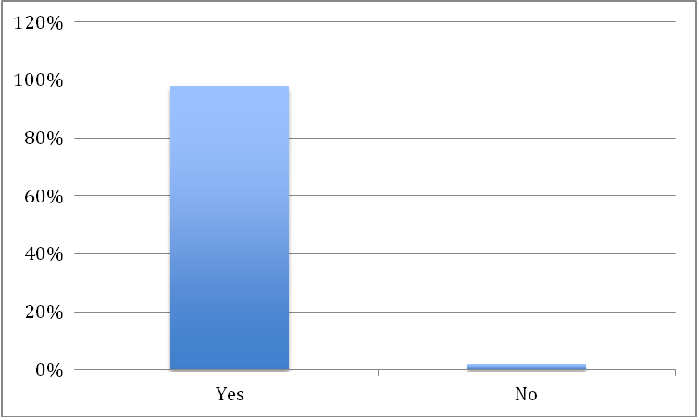

Chart 1. Owning a Blackberry.
The first and most important question asked in the survey was if in fact the supporters owned a Blackberry. As shown in the chart above, 98 out of 100 answered “yes”, leaving only 2 remaining. This clearly reveals how this smart phone has become a “must have” device in every household.
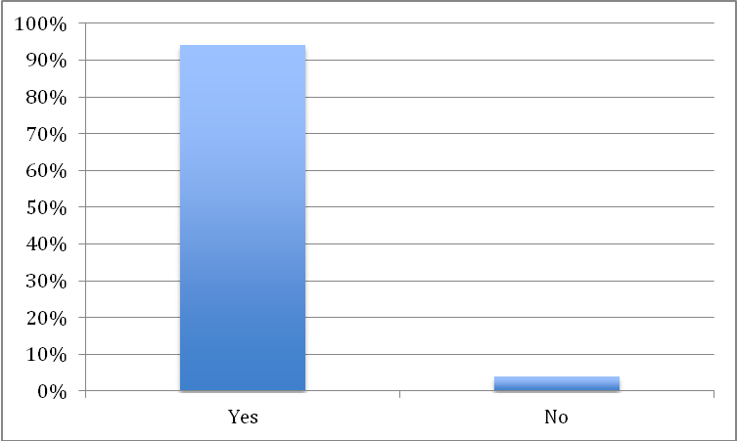

Chart 2. Receiving Broadcasts through Blackberry
Out of 98 Blackberry users, 94 of them stated that they do receive broadcasts, leaving only for. 94/98 people sending and receiving broadcasts simply shows how much broadcasts have been sent between the citizens of Bahrain during this event and how it played a big role.
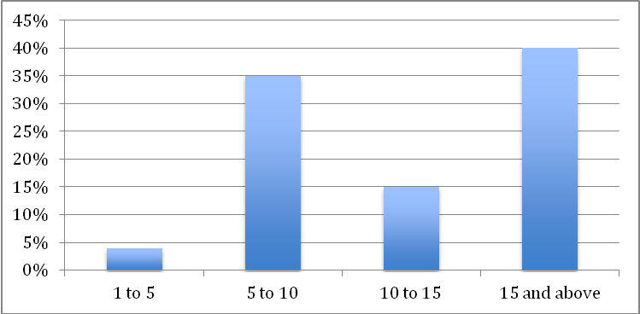

Chart 3. Amount of broadcast per day
It is clear that the majority of the users who deal with messenger broadcasts receive over 15 broadcasts per day. If we predict the 50% of these broadcasts carry information about the crisis, it is easy to understand how quickly information spread whether it was true or false.
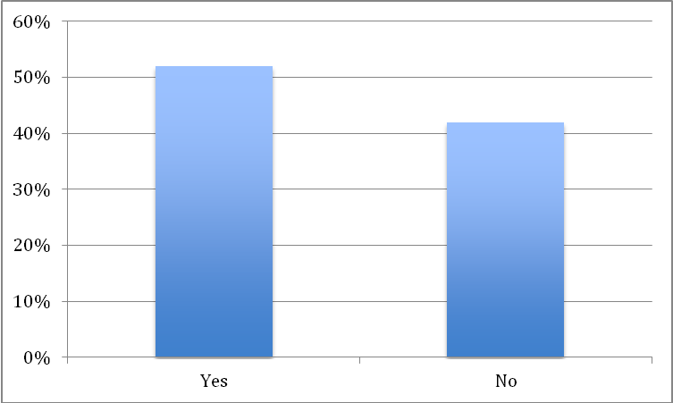

Chart 4. Are broadcast trustworthy
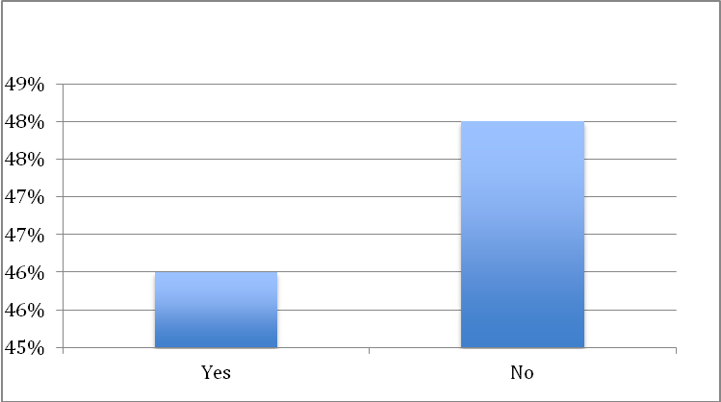
Due to the amount of rumors that we know have been spread about Bahrain through broadcast messages, we decided to see whether the receiver do in fact trust the information sent in the message. More than 50% said that they trust those broadcasts, while around 43% said that they don’t trust those broadcasts.

Chart 5. Forwarding of broadcasts.
The difference of forwarding those broadcasts is very close 46% said they do forward and 48% said that they don’t forward those broadcasts. Even though previously the greater percentage was they do trust those broadcast but yet they don’t forward them.

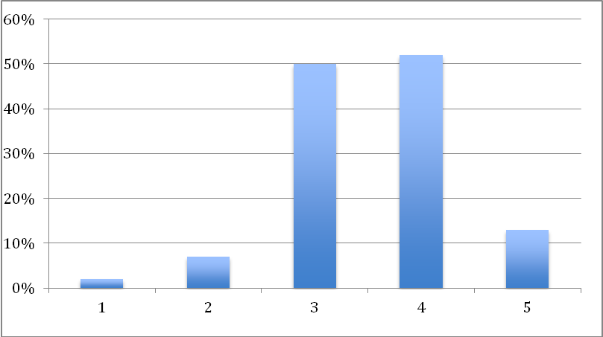

Chart 6. Amount of forwards through broadcasting.
Even though that the question above shows only 46% forward those broadcast here we see that an average of 3 to 4 broadcast are forwarded with around 50% of people forwarding that average.
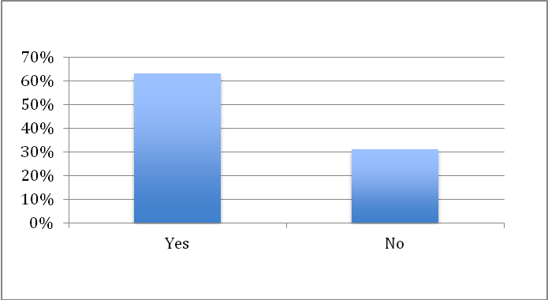

Chart 7. Broadcast about Kings supporters.
63% proved that the broadcasts that they receive are messages that support the King with having a small percentage of 31% saying no. This again proves that even though with only 63% said that they receive supporting messages its still the major role blackberry broadcasting played in crisis Bahrain was facing.

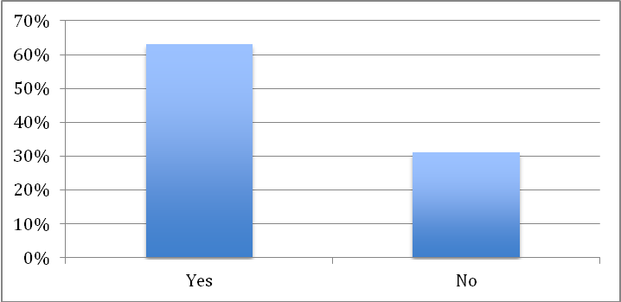

Chart 8. Relying on broadcast to keep you updated
Whether or not the broadcasts are supporting the King, Most of the people that do receive broadcasts about Bahrain rely on broadcast to keep them updated about matters of Bahrain, with a percentage 63% saying yes. And only 31% said no.

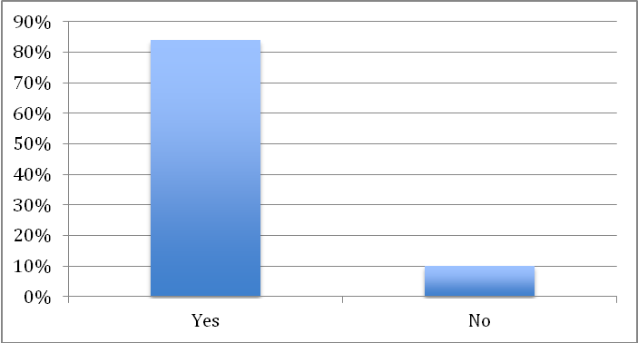

Chart 9. Attending events due to broadcasts
Again relying to broadcasting, 84% attends the events due to broadcasts they received. Where as only 10% said no. Proving the role of broadcasts on matters about Bahrain.

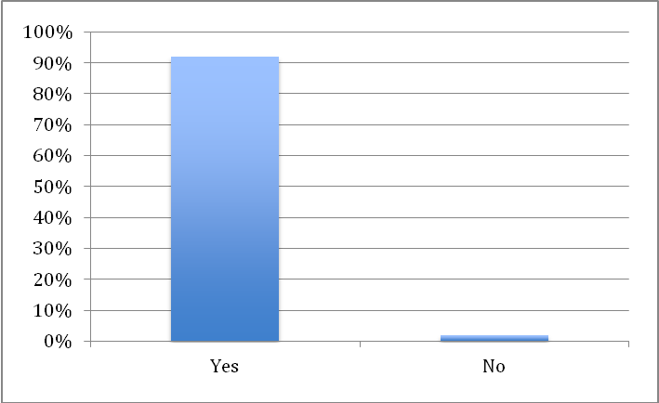

Chart 10. Hearing about AlFateh mosque through broadcast
With only 2 % saying no that they didn’t hear about AlFateh mosque, the majority voted yes with a percentage of 92 %, that due to broadcasts they’ve received that they heard about AlFatah mosque.
Observed:
There are relation between blackberry broadcast and awareness of events?
 | Yes | No | Total
Blackberry | 94 | 4 | 98
No Blackberry | 0 | 2 | 2
 | 94 | 6 | 100

Expected:
 | Yes | No | Total
Blackberry | 98 x 94  100  = 92.12 | 98 x 6  100  = 5.88 | 98
 | 0 x 2  100  = 0 | 2 x 6  100  = 0.12 | 0.12
Total: | 92.12 | 6

∫ o | ∫ e | ∫ o - ∫ e | (∫ o - ∫ e)2 | (∫ o - ∫ e)2  ∫ e
94 | 92.12 | 1.88 | 3.5344 | 0.0383
4 | 5.88 | - 1.88 | 3.5344 | 0.601
0 | 0 | 0 | 0 | 0
2 | 0.12 | 1.88 | 3.5344 | 29.45
∑ 30.092
Calc.

d∫ = (c-1) (r-1)
= (2-1) (2-1)
= 1

At 5% significant level critical = 3.84
Calc = 30.092
Calc > critical

Its Dependent between Blackberry broadcast and awareness.

Observation:
According to the results of the above survey, we cannot deny that a little less than 50% of Blackberry users who receive broadcast don’t necessarily rely on or believe the information sent. Regardless whether they believed the detailed information or not, it did in fact lead many to support the government and the king. Some might have believed the information included in messages about the anti-government, and other might have not, but despite the rival between the two, message broadcasts gave the motivation and push for each and every Bahraini who was once silenced by the terrifying events to stand up for not only the king, but for the land.
Al-Fateh National Unity gathering was a successful turn-out, especially after weeks of corruption in Bahrain. Most people lived that moment, and other watched, but after this success, we ask ourselves what or who was the source of this organization? If we go back in time and dig deeper, we will discover that 400,000 Bahraini citizens of all genders, ages, and statuses gathered up at one of the largest place for Islamic worshippers as a result of one single invitation from an anonymous person, broadcasted and forwarded by different people right before the night of the big event. Surprisingly, just around 3:00 PM, people from all around the kingdom started heading to the mosque where the event started after Isha Prayers.
After this massive crowd and successful event, the record was once again broken on March 2, 2011 where another gathering took part at Al-Fateh mosque in support of Bahrain, the government, and the king. At this gathering, the survey was distributed where we collected information on how this could have been a result of messenger broadcasts.
The broadcast feature in the Blackberry helped make these events a success in Bahrain, as I mentioned earlier, regardless whether receivers believed the information or not, this was in fact a process of keeping people up to date and also giving each and every man, women, child, in Bahrain the courage to converse and the voice to speak.
Without a doubt, the results prove our hypothesis to be true, and illustrate that there is a clear link between Blackberry messenger and the series of events that occurred in Bahrain. In particular, a clear link between the broadcasts and the awareness of political events which lead everyone to be a part of.
Conclusion:
With our results, we once again imply that they have proven our hypothesis to be correct, and that the broadcasts on Blackberry messenger definitely played a role in the awakening of the political interpretations that each citizen has, whether they were anti-government or pro-government. Our charts also reveal the sense of belonging in the country and loyalty that most Bahraini citizens have towards the ruling family. This takes us to whether or not there was a relationship between the broadcasts and the government supporters, and again, our results prove that the majority of the supporters were motivated by the messages sent through the broadcasts whether they believed them or not. Maybe not all messages were completely accurate, but the general idea of showing one’s support to the king pushed people to read, forward, and attend. With knowing this, we can conclude that both assemblages at Al-Fateh and the gathering of over 450,000 Bahraini flag carriers were easily organized through Blackberry broadcast messages.
References:
Books:
- Rod McQueen, Blackberry: The Inside Story Of Research In Motion (Canada, 2010).
- Roger D. Wimmer and Joseph R. Dominick, Mass Media Research (Wadsorth Cengage learning: Boston, 2006).

Websites:
  - "The History Of BlackBerry," acquired Macromedia in 2005,
http://www.webhostingreport.com/learn/blackberry.html.

  - " BlackBerry messenger",http://us.blackberry.com/apps-software/blackberrymessenger/

"Advantages and Disadvantages of BlackBerry Messenger," founded in 1998,
http://communication.howstuffworks.com/blackberry- messenger1.htm.

  - "National Unity Gathering In Bahrain," March 2, 2011,
http://wn.com/National_Unity_Gathering_in_Bahrain_March_2,_2011.

Survey:
1. Do you own a blackberry?
Yes. No
2. Do you receive blackberry broadcasts?
Yes. No
3. How many broadcast messages do you receive per day about Bahrain?
1-5. 5-10
10 - 15. 15 - above
4. Do you consider those broadcast trustworthy?
Yes. No
5.Do you forward those broadcasts?
Yes. No
6.On a scale 1 to 5 (5 Is the highest) how many time do you forward those broadcast?
1 2 3 4 5
7. Is most of the broadcast you receive are supporting the King?
Yes. No
8.Do you rely on broadcast to keep you updated about matters in Bahrain?
Yes. No
9. Have you attended any event due to a broadcast you received?
Yes. No
10.Did you hear about AlFatah mosque from a broadcast?
Yes. No
دور رسائل أجهزة البلاك بيري النصية في الأزمة البحرينية

إذا ما نظرنا إلى الأزمة التي تواجه البحرين, وما تشهده الأخيرة من انتشار للفتن والعداء بين الناس، وحاولنا ربط هذه المسألة بأحد صور وسائل الاعلام الحديثة المتمثلة فى هواتف البلاك بيري الذكية والتى انتشرت بشكل ملحوظ فى المملكة فى الآونة الأخيرة, سنجد أن التكنولوجيا الحديثة قد أفرزت وسيلة اعلامية واسعة الانتشار تتكفل بنقل الحدث بصورة فورية، إلا أنها تثير العديد من علامات الاستفهام فيما يتعلق بما قد يرسل، أو من يرسله أو مصداقية المعلومة المرسلة ذاتها. لتكوين مفهوم أوسع عن هذه المسألة, تم توزيع استبيان لمجموعة من الناس تتراوح أعمارهم بين 18- 28 عاماً من أجل التوصل إلى نسبة دقيقة بشأن اعتماد العينة المختارة على الرسائل النصية لأجهزة البلاك بيرى كواحدة من المصادر الرئيسة للتفاعل مع الأزمة، وتم اختيار حدث بعينه لدراسة هذا التفاعل، والمتمثل فى نجاح مجموعات كبيرة من المؤيدين للحكومة البحرينية من التجمع بأعداد غفيرة – مثل تجمع الفاتح – من خلال تنسيق مواقفهم عن طريق تبادل الرسائل النصية لأجهزة البلاك البيرى.
يهدف هذا البحث إلى التعرف على الدور الذي لعبته الرسائل النصية لأجهزة البلاك البيرى في الأزمة البحرينية بشكل عام، وفى التجمعات الموالية للحكومة بشكل خاص، وكذا التحقق في ما إذا لعبت هذه الرسائل دوراً رئيسياً ضمن التوعية لدعم الملك البحرينى خلال أحداث الأزمة.
في هذا البحث, وزعت الاستبيانات على 100 شخص من المؤيدين للحكومة البحرينية فى محاولة للتعرف على كيفية استخدامهم للرسائل النصية لأجهزة البلاك بيري، وكذا للوقوف على تأثيرها المحتمل على كل شخص خلال ذلك الحدث على وجه الخصوص.
في الختام, سواء كانت هذه الرسائل مؤيدة للملك أم لا, غالبية مستقبلين الرسائل عن الشأن البحريني يعتمدون عليها للبقاء على إطلاع دائم عن أحوال البحرين، حيث شكلت نسبة المصدقين لفحوى الرسائل النصية للبلاك بيرى حوالى 63% فى حين لم تتعد نسبة غير المصدقين لهذه الرسائل نسبة 31% .
وفي حقيقة الأمر كانت هذه الرسائل بمثابة سلسلة من العمليات المتواصلة لجعل الناس في اطلاع دائم, بالإضافة إلى إمداد كل رجل, امرأة و طفل في البحرين الشجاعة للتحدث و التعبير عن أرائهم.

