The Fashion Content In Gossip Girl And Its Influence On Young Bahraini Women
Amira O. Karam El Din
Lecturer University College of Bahrain
Abstract
All fashion comes from the historical past and from the traditions of each country, therefore to speak about westernization of Bahrain and the affect of media upon people’s minds is meaningless without understanding this huge constituent, which is current media and its’ influence on teenage girls in Bahrain. Gossip Girl is the most popular and demanding TV show in Bahrain private High Schools. Influences may be positive, but somehow negative if misinterpreted.
Introduction
The show Gossip Girl may have influences on fashion trends in Bahrain and overall westernization of the Bahraini lifestyle. For this purpose we will primarily identify the scope for analysis, as well as draw the picture of what we mean when we speak about fashion and culture. It is obvious that people in Bahrain are divided into two parts: those who appreciate westernization and actively participate in this process and also those, who are more conservative and tend to have more traditional worldviews.
Problem
Fashion can be a gift or a curse. Unlike the modern world, decades ago, fashion was art and a form of identity. Presently, fashion is being misinterpreted due to the western media power. The idea that Gossip Girl is putting in young girl’s heads is basically materialistic; “you cannot be popular and fun unless you’re trendy –with an attitude”. This image is causing discrimination in High Schools, and putting a thicker line between class standards. Gossip Girl also portrays the idea that rich girls should look “fabulous” in school uniform, which is causing distractions and obvious misconceptions.

Research Objectives
The main objective is to measure how the fashion content in the TV show Gossip Girl influence high school girls in Bahrain. Is it positive or negative? We want to know if Bahraini girls manipulated by the clear stereotyped statement that Gossip Girl entitle: Only rich girls can afford designer brands, thus they are the only ones bonded with fashion. Last, how broad is the mentality and culture of Bahrain open to the domination of fashion lifestyle portrayed in Gossip Girl?
Research Questions:
There was a main question which is:
- What is the effect of “Gossip Girl” on Bahraini teenagers?

From this main question there were sub-questions which are:
- Are girls taking the main character as their role model?
- Is “Gossip Girl” as a series changing the fashion acceptance in Bahrain?
- Are girls obsessed of fashion because they want to look like “Gossip girl”?

Background
Gossip Girl is an American production by 17th Production Company. The airing premier was year 2007-till modern day. The show revolves around wealthy teenagers from the Upper East Side in New York. Through out the series, there is non-stop drama and struggle of friends, drugs, and family disparity (La Ferla, Ruth, 2008).
Overall, Gossip Girl is a window to fashion forward trends. Journalists, and fashion critics watch the show for insights. Several runaways took place in the show promoting actual young designers.
The winning show of 11 awards gained extreme popularity in the Middle East as soon as it aired in the US. Recently, the bars went higher when it started showing in MBC4.

Fashion in media
Fashion has always been a significant factor in making television figures appear more appealing. Western cultures designates that their celebrities be admirable, and that they in some way have characteristics that the public can sympathize with, envy, or relate, but most importantly these celebrities represent the height of one’s own personal expectations. It is this very reason that celebrities, in the form of athletes, actors, political figures, and musical artists, must be fashionable to represent the glamorous lifestyle they are presumed to be living.
The dawn of fashion and it’s invasion of the media can be seen with the popularity of hit television shows like Clueless, Beverly Hills 2010, Sex and the City, and The Hills. Likewise celebrity magazines and tabloid media have played a dramatic role in the craze that has enforced the manipulation of teenage anxiety to be fashionable, thin, and glamorous. No television series more greatly exploits this ideal than the latest teen craze Gossip Girl. The show depicts fashionable young elite of the Manhattan scene partying every night and wearing the best in high-end garments and attending the most exclusive parties. It is the epitome of the decadence that comes with Western capitalism and its mass marketing and distribution is a prime example of how foreign cultures are being ever more westernized by America and Europe’s capitalist influence.
The draw of fashion psychologically is much deeper than just style itself. In John O. Summer’s article “The Identity of Women’s Clothing Fashion Opinion Leaders, he points out the psychology behind what draw women to certain brands of fashion and makes them avoid others. He says, “Central to the study of interpersonal communication has been the concept of opinion leadership, which proposes that some individuals exert a disproportionate amount of influence on the behavior of others in some given topic area (Summers, 1970).” Here he uses fashion as a particular topic of discussion. He notes that the opinion leaders, those identified as the authorities on a subject are put on a pedestal. What they say is the hot brand to wear is held in such high regard that it’s then mentioned in brief dialogue on shows like Gossip Girl, or it’s seen worn by the characters on screen, or even off-screen on the cover of magazines. Summer goes on to note that the appeal of this process the key factor that incites the audience member to in turn become a consumer of the brand name items the show promotes is the desire to be associated with the positive feelings that come along with association to the opinion leader, when he says, “Studies on social participation or gregariousness have shown a strong positive association with opinion leader-ship across topic contexts (Summers, 1970).” Here we see that the driving factor behind what makes fashion fashionable is not the desire to appear beautiful but the desire to be associated with those who dictate what defines beauty.
U.S. Weekly is a celebrity magazine. The majority the advertisements, as well as the articles target women. Founded in 1977 and acquired by Werner Media in 1986, the magazine currently has a circulation of 1.7 million, and a website that has approximately 2 million unique hits per month. First read through of an average U.S. Weekly magazine, the reader is bombarded with images of stereotypical beauty, fashion and often-current scandals in the entertainment world. It is completely compatible with the theme of Gossip Girl. Glamorous ideals promoting the everyday lives of the wealthy, and advertisements centered on makeup, lingerie, acne medication, and ads for television shows that are marketed to woman as well, represent virtually all of the sponsors.
On the cover of Us Weekly issue 629 March 5, 2007, there are three cover pictures. One was of Brad Pitt and Angelina Jolie dressed to in very expensive, and stylish clothing designed to look casual, as they walk children in dual strollers through the streets; below this was a picture of a very glamorous and happy looking newly coupled Owen Wilson and Kate Moss, both with shiny white teeth and bright blond hair, blues eyes. The promotion of beauty and glamour is highly apparent and it pops off the page. Next to these two small photos, was a huge leading photograph of Britney Spears with a partly shaved head and a lead title statement saying, Help Me. This cover page gives perfect insight into the magazines ideology, in that it shows what ideals the editors promote as well as what goes against their values.
Spear’s image is exploited to denounce her fashion decision and in turn promote the idealistic image of beauty promoted by the magazine and most importantly the Western world. In this way is a combination of exploitative scandal, and the magazines way of taking a finite stance against her fashion decision, but it takes it even further. The fact that she cuts her hair is not treated as just a fashion mistake, but as a sign that she needs psychological analyses. Her personal and family life is put in question and she is virtually crucified by the magazine for simply cutting her hair. Of course, the hair she cut was the key representation of the American dream. Britney Spears first came on to the American scene as a catholic schoolgirl; her promiscuous and seductive personality image can be likened to that of Marilyn Monroe and Madonna. These are icons that have had the power to dictate fashion and influence young women all over the world. One would think that they have the power to make whatever fashion decisions they decide, U.S. Weekly proves that they operate within misogynistic and stereotypical expectations that can be tested, but never abruptly crossed. When Britney Spears cut her hair she crossed this line, and U.S. Weekly signified their publication as a defender of this status quo.
In her articles “15 Going on 50: How Gossip Girl is Killing Youth Culture” style editor for the Huffington Post Lesly M.M. Blume takes time to asses the popular series and “After five hours of shrieking, conniving, attempted suicides and attempted dates rapes, pouting, clotted eye make-up, staid buffets, and absentee mothers, I sat back and ruminated. Yes, there was rampant immoral teenage behavior, but frankly, it wasn't anything that hasn't been dished up in spades elsewhere” (Blume, 2007). Blume acknowledges that most of the imagery and themes used to make the series so addictive are merely byproducts of what has come before, and surely a sign of what is to come in the future. She goes on to note that, “On a certain level, I simply felt bad for this generation of young girls, that this subpar soap opera was their guilty, voyeuristic pleasure. After all, I had cult classic Heathers, and then Clueless (Blume, 2007).” She identifies the show with previous bodies of work that exploited the same ideals but managed to depict women in a more intellectual way.” Her views of Gossip Girl denotes that the show is one of many signs that media is gradually more and more taking advantage of the anxieties of young women with no regard for their mental or emotional wellbeing. Blume goes on to say that, “At least both of these films, which similarly profile the hilariously angst-ridden inner lives of popular, minted adolescents, were intelligently-conceived satires. The characters might have been nasty little beasts, but they were also witty as hell (Blume, 2007).” She further voices her belief that the show is a new low in gender exploitation and fashion marketing.
Teenagers and fashion:
Popular culture is the most dynamic driving force behind the human interpretation of society and its influence in individual decision making is significant, but it is most prevalent during one’s teenage years. Through it, people develop social expectations and then project those expectations on to others. In western society, one of the more ironic factors is the source of popular culture. French Sociologist Pierre Bourdieu notes that “public opinion doesn’t exist, and that it is just a farce formulated by the economically elite of society to further the long lasting capitalist hold they have on the workings of western civilization .” He recognizes popular culture as being a product of the financially superior, which he refers to as cultural capital (Bourdieu, 1987). In his theory these heads of capitalism dictate popular culture to mold people into more efficient valuable consumers. This author will asses examples from society to test this theory and find whether individuals dictate their identities, or it’s done by popular culture. Popular culture’s interpretation of American cities, members of particular social classes, cultures, and historical events all have been heavily influenced by the media, specifically film.
One major problem in society that is mentally affecting our women is this culture of thinness. There is an immense amount of pressure placed on women to be attractive and thin through the media and the stick-thin models regularly gracing magazine covers. As a result, women are more likely to develop eating disorders. Anorexia, an eating disorder that involves drastic fasting, and Bulimia, which consists of binge eating, followed by any compensatory behavior, are virtually nonexistent in men (Summers, John O, 1970). Both of these disorders lead to serious health problems but anorexia ultimately leads to death by starvation. It is thought that these disorders are caused by a perceived lack of control in their lives; which do these women having complete control over their looks balance. Discrimination against unattractive or overweight women is an unspoken prejudice. This epidemic of attaining physical perfection is actually an unnecessary and harmful setback for women.
Women are more likely to seek therapy (Noor Mohamed, Nadia, 2008). There is an over-diagnosis of women and an under-diagnosis of men. General discrimination towards women is that communal traits aren’t as valued as physical strength, which can lead to depression. Housework creates sense of never having leisure time; it provides no emotional reward and an isolation factor. Emphasis on physical appearance, body image eating disorders, and lack of control over appearance leads to depression. Gender roles, since women are expected to be communal their relationships can lead to depression because there is more pressure on them to have good relationships, so when the relationships are unsuccessful, they tend to blame themselves.
Social studies:
Blume’s analysis of Gossip girl involved her discussion of the popular teen film Clueless. The most noted and obsessively received film depicting California life is the film Clueless. The film can very easily be proclaimed as a contemporary version of Jane Austen’s novel Emma. Both of the main characters are high-class snobs who pride themselves in their matchmaking abilities. Emma Woodhouse is a member of an upscale society in nineteenth century England, while Cher Horowitz lives in wealthy, upscale Beverly Hills U.S.A. Both Cher and Emma are among the culturally elite in their societies. Cher’s father is a litigation lawyer in Los Angeles the most affluent city in America, and Cher is arguably the most popular girl in her school. Just like Jane Austen’s novel was a depiction of upscale elitists life in London during the Victorian era, Clueless depicts the same socioeconomic class only with regards to Beverly Hills in the 90’s. This can directly be connected to Austen’s description of Emma in which she describes Emma as, handsome, clever, and rich, with a comfortable home and happy disposition. The film’s reception was so popular it inadvertently resulted in further establishing the archetype of the valley girl (which is most synonymous with snobby, wealthy, Barbie-like California teenagers) as an American stereotype. America’s historical infatuation with this stereotypical image can most prevalently be seen with the notorious popularity of women like Marilyn Monroe, Paris Hilton, Anna Nicole Smith, and Britney Spears.
Arabs and fashion:
In addition to displaying an invested interest in the elites of society, news networks attempt to maintain the public’s faith in these elites and their reign within the status quo by employing supposed experts to deliver their message. Globalization at its most core and basic form is most commonly described as the process by which societies, regional economies, and cultures have become integrated through the globe spanning network of trades and communication systems. Economist, sometimes refer to it as the integration of national economies into international economy through trade, capital flows, migration, and direct investment. On a more broad scale Globalization is understood to involve economic, communal, political, and biological factors. The controversy that surround the term stems from the significant effects it has on nations as how they are run and in how they interact with one another (Pink, Johanna., 2009). The decadence and desire for abundant wealth that is the driving force of capitalism, is the fuel that empower globalization and the expansion of western ideals. By this ideal expanding they are in turn being imposed on the Arab world and the traditional standards, might be considered fashionable in the Arab world becomes intertwined with western themes. Many members of the Muslim faith consider this to be a tainting of their traditions and what they identify as Halal in measuring the quality and standards of their commodities.
In his article “Halal, Haram, or What? Creating Muslim Space In London” Johan Fischer talks about the transformation of the understanding of Halal, a Muslim standard of lawfulness that is occurring with the westernization of Muslim culture. He notes that, “the nature (intrinsic qualities), processing (production method and context), and manner of acquisition (the morality or immorality of handling and origin) of commodities all determine whether they are classified as halal, haram, or indeterminable.” In this context, the very handling of Muslim fabrics, foods, and other consumer goods of the like is a contamination and said to be ‘haram.’ Westernization itself, in terms of global commerce is seen as a contamination in the Arab world (Davis, Philip, 2002).
All of the themes identified in shows like Gossip Girl are products of Western Capitalism and the underlying message of the show depicts how these beliefs are it influencing the youth in the western world. The irony, is that mainstream media has managed to mold the show in a way that best benefit the distribution of its commodities both nationally and worldwide. Fischer notes, “In the course of the 20th century, mass consumption—characterized by the availability and affordability of a broad spectrum of differentiated and ever-changing commodities far exceeding the consumers’ basic needs both in substance and in variety—has spread across the world. (Fischer, ” Here Fischer denitrifies the same decadence that is depicted in shows like Gossip girl as the core cause of westernization
Conclusion
In sum, the popular television series “Gossip Girl” has been manipulated by mainstream media to portray certain ideals that enforce the dominance of Western Culture and westernization throughout the globe. This influence can be seen contrasted by Muslim culture in the understanding of Halal and how they set standards on their distributed commodities, but also in how westernization is now influencing Muslim culture and the concept of Halal.

Population
The population of the sample used is various Private High School girls in Bahrain. Not necessarily Bahraini, nevertheless the High School is not specified.
Sample
Random sampling is chosen for this research. The questionnaire was distributed by http://www.surveymonkey.com since it is an Internet era, teenagers are more likely to answer surveys through the Internet. The team distributed the survey, and made sure it is for the correct sample. Sources used: Facebook, email, and BBM broadcasts.

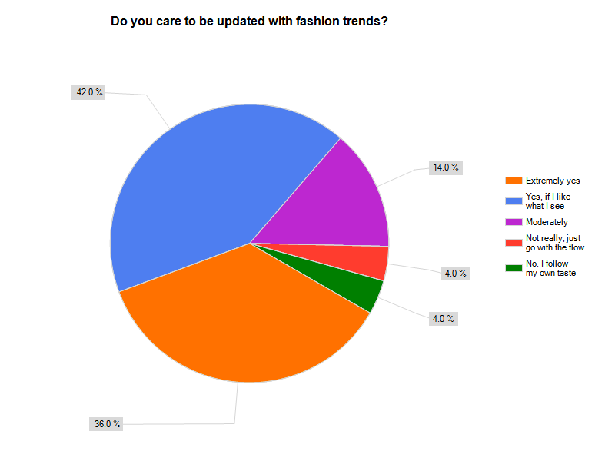
Table 1 Percentage of Female teenagers’ awareness of fashion trends

There was a close call between “extremely yes” and “yes”. Yet that doesn’t really make a difference. The mass of the sample does care about fashion trends.

Table 2 Percentage of female teenagers watching Gossip Girl


Clearly, the majority of High school girls in Bahrain do watch Gossip Girl. From this point on, this research is valid.

Table 3 Percentage of Gossip Girl influence in teenagers taste of fashion


Slightly more than half of the sample is influenced fashion wise by Gossip Girl.

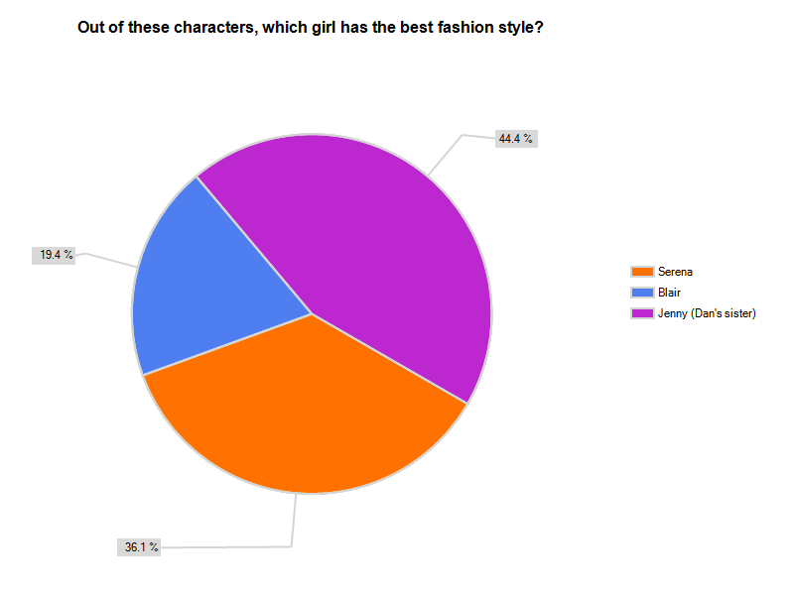
Table 4 Percentage of the favorite character in Gossip Girl

As expected, the most loved style is Jenny. We believe it is due to the fact that Serena’s style it too revealing, while Blair’s is too formal. Jenny’s style is hip, young and suitable for teenagers (most of the time).

Table 5 Percentage of teenagers’ acceptance of Gossip Girl fashion in the light of Bahrain Culture

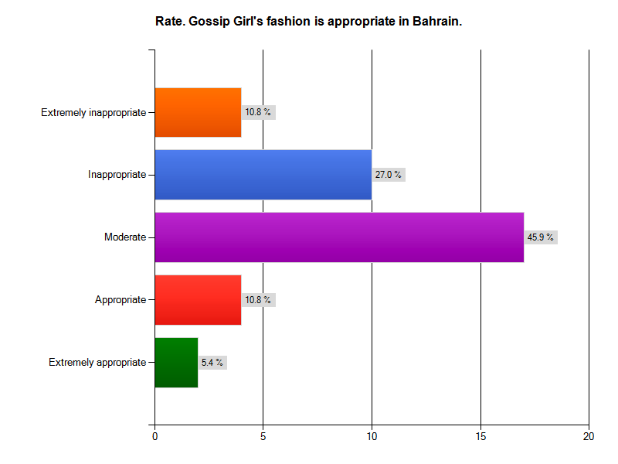
lilight of Bahrain culture

Almost 50% stated that the fashion content in Gossip Girl is moderately appropriate. The majority of the other 50% stated is inappropriate.

References

1. Blume, Lesley M. M. “15 Going on 50: How Gossip Girl is Killing Youth Culture” Huffington Post (October 24, 2007)

2. La Ferla, Ruth. “Forget Gossip, Girl; the Buzz Is About the Clothes” The New York Times (July 8, 2008)

3. Bordwell, D. and Thompson, K. Film Art: An Introduction, London: McGraw Hill. (2004).

4. Bourdieu, Pierre,“Distinction”, Cambridge, MA: Harvard University Press, (1984).

5. Pink, Johanna. “Muslim Societies in the Age of Mass Consumption” Cambridge Scholars Publishing (2009).

6. Noor Mohamed, Nadia A. “Muslim Women – Adapting Culture To The Modern Western World” Journals of Diversity Management First Quarter (2008).
7. Davis, Philip. "The Effect of the Web on Undergraduate Citation Behavior: A 2000 Update." College & Research Libraries 63 (January 2002).

8. Summers, John O. “The Identity of Women’s Clothing Fashion Opinion Leaders” Journal of Marketing Research (1970)

الموضة في المسلسل الدرامي " فتاة النميمة Gossip Girl" و تأثيرها على الفتاة البحرينية.
ملخص البحث:
يتناول هذا البحث تأثير مسلسل درامى أمريكى يسمى " فتاة النميمة Gossip Girl"، والذى يتناول نمط حياة مجموعة من الفتيات الأثرياء سواء خلال يومهن الدراسى أو فى حياتهن الشخصية، على الفتيات البحرينات الدارسات فى المرحلة الثانوية.
يمكن للموضة أن تكون نعمة أو نقمة. فمنذ عقود مضت كانت الموضة عبارة عن فن وهوية, على العكس مما يحدث في الوقت الراهن, والذي أدى إلى إساءة تفسير مفهوم الموضة بسبب تأثير الإعلام الغربي. الصورة التي يقدمها المسلسل للفتيات الصغيرات هي عبارة عن نظرة مادية محضة. "فلا يمكن أن تكون محبوباً ذو شعبية عالية إلا إذا كنت عصري تواكب الموضة - متخذ سلوك وموقف معين". هذه الصورة تسبب التمييز في المدارس الثانوية وتضع حدود فاصلة بين الطبقات المختلفة. فتاة النميمة يصور فكرة أن الفتيات الغنيات يجب أن يظهرن رائعات في زيهن المدرسي, مما يتسبب في تكوين صورة فجة من المفاهيم خاطئة.
الهدف الرئيسي من البحث هو قياس كيفية تأثير الموضة في المسلسل التلفزيوني فتاة النميمة على فتيات المدارس الثانوية في البحرين. هل هو إيجابي أم سلبي؟ نريد معرفة إذا كانت الفتيات البحرينيات متأثرات من الصورة النمطية الواضحة التي يقدمها المسلسل: فقط الفتيات الغنيات يمكنهن شراء تصاميم لماركات عالمية, فبالتالي هن الوحيدات المعنيات بالموضة. أخيرا, ما هو مدى تقبل النظرة و الثقافة البحرينية لهيمنة الموضة المصورة في فتيات النميمة؟
مجتمع البحث هو فتيات مدارس ثانوية خاصة في البحرين. وحرصاً من الباحث على الوصول إلى العينة المناسبة، تم اختيار عينة عشوائية من خلال توزيع الاستبيان عن طريق موقع الكترونى يسمى http://www.surveymonkey.com , فى ضوء تفضيل المراهقين الإجابة على الاستبيان عن طريق الانترنت.
هذا، وقد أظهرت النتائج أن أكثر من نصف العينة متأثرة بالموضة المصورة في مسلسل فتاة النميمة.

