Impact of Sensory Integration Program Therapy on Development of Hard of Hearing Children
El Din M., Aziz S., **Khouessah H. **
Abstract:
Background: Deprivation of sensory input affects neurological development. Deafness whether treated by cochlear implants or not, results in a delay in development of complex motor sequence and balance and is associated with lower but non-pathological visual guso-praxic tasks and sustained attention .Sensology describes a functional, operational, sensory education; it embraces the importance of the theory of early learning, through sensory stimulation, sensory experiences and multi-sensory environment .
Sensology is a new educational term used to specifically describe a particular area of education or learning. It is used to describe the first sensory steps in early learning for everyone, including those with special educational needs and very special learners (Hirstwood, 2005).
A multi-sensory room is extremely therapeutic for both children and adults with sensory processing disorders, from mild to severe. The room must be tailed to one’s specific sensory needs; the reason for this is because it will become therapeutic depending on how, when and why the equipment or activities are used.
Aim: To evaluate the effect of the sensory activities on the development of hearing impaired children; and compare between the roles of sensory activity on children with severe to profound auditory loss and wearing auditory aids, as well as, children having auditory neuropathy.
Key words: sensory integration, hard of hearing, auditory neuropathy
Methodology
The prospective (Intervention study) included 24 children with hearing impairment (13 children with hearing loss and wearing hearing aids and 11 children with auditory neuropathy and wearing hearing aids). Their age range was from 3-7 years and the study included both males and females.
The study was held in Nedaa center for deaf and auditory impairment children. Children were selected from 300 children, who were attending in Nedaa center in a period of a year according to inclusion and exclusion criteria, and after discussing the dropouts.
Inclusion criteria were:
- Children aged from 3-7 years old, both genders (males and females)
- 13 children with severe to profound hearing loss and wearing hearing aid.
- 11 children with auditory neuropathy.
- Children suffering from different levels hearing loss.
Exclusion criteria:
- Children less than 3 years or above 7 years.
- Children with other types of disabilities, mental, physical or visual.
Tools
All children were subjected to full history taking (i.e. name, age & gender), general medical examination, hearing loss evaluation (audiometry, advanced auditory brain stem response, testing the adjustment of the hearing aid individually), and a determination of type of hearing impairment to classify whether the cases are either simple hearing loss or auditory neuropathy.
- Stanford – Binet IV test (SBT) Arabic version (Meleika 1996).
- Evaluation of child in the different fields of development (social, cognitive, self-help, motor & linguistic) using Portage Checklist (Marlows and Avon, 2003).
- Sensory Integration Test (SIT) (Young, 2000).
Subjects and Methods
Study design:
The study was a prospective intervention study.
Site of the study:
The intervention program was done in Nedaa center for deaf and auditory impaired children.
Time of the study:
April 2009 until April 2010.
Program
    - A written questionnaire was given to the parents before the assessment.
    - The Sensory Integration Test assessment was done for each child individually in the multisensory room affiliated to Nedaa center. The assessment was done by the researcher, an occupational therapist and a psychomotor trainer.
    - The ‘Assessment Directory’ is subdivided into the following categories:
            - Motor skills
            - Communication
            - Interaction
            - Intellectual development
            - Sensory
    - Video photos of assessment were done for each child.
    - After reviewing the video tapes and reading all remarks written during the assessment time and after reading carefully the answers of the parents’ questionnaire. An individual tailored program was designed for each child based on the strengths, weakness & the sensory deficits of the child according to (SIT) was done.
    - The program included twice a week sessions, each session lasting from 20-30 minutes in addition to: Home based activities performed by the care giver.
All children were full-time schedule students in Nedaa center. This helped a lot in having a complete evaluation of the children. IQ evaluation using Stanford-Binet IV was completed by every one of them upon admission.
Stanford-Binet Intellectual Scale
Ethical Issues:
Prior to initiation, all steps of the procedures were fully explained to the parents, then an informed written consent was collected from the parents prior to starting the study.
Statistics:
The IBM SPSS statistics (v.19.0 IBM Corp., USA, 2010) 90 was used for data analysis. Data were expressed as Mean = SD for quantitative parametric measures in addition to Median Percentiles for quantitative non-parametric measure and both numbers and percentage for categorized data.
Results
The present study was designed as a prospective (intervention) study including both male and female children with age range 3-7 with mean 5.21+/-1.8 (+/- SD), total study group were 24 children, 17 males (70.8%) and 7 females (29.2%).
The study subjects were divided into 2 groups, 1st group (HL) the hearing loss group including 13 children (9 males and 4 females) and the 2nd group (AN) auditory neuropathy group including 11 children (8 males and 3 females), classification was done by performing audiometric study and advanced auditory brain stem response (ABR), and all children were enrolled to the center in full time schedule.
The results of this study revealed that the IQ level was 79.846 +/- 8.484 (mean +/- SD) in the 1st group (HL group) and was 87.182 +/- 11.232 (mean +/- SD) in the 2nd group (AN group) at the baseline, with no statistically significant difference between the two groups before intervention (Table 1). The current study revealed that there was a marked I.Q. level improvement in both group after intervention. In the 1st group (HL group) there was a statistically significant improvement of the total IQ level after intervention 99.231 +/- 14.967 (mean +/- SD) with p = 0.001* (Fig 1).
Table (1) Descriptive data at baseline
AN group | HL group
8 (72.7%)  3 (27.3%) | 9 (69.3%)  4 ( 30.7%) | Sex  Male (%)  Female (%)
3-7  5.6 +/- 1.4 | 3-7  4.5 +/- 1.9 | Age  Range  Mean =/- SD
87.182 +/- 11.232 | 79.846 +/- 8.484 | IQ mean +/- SD

Fig (1): Comparison of IQ level between hearing loss group and auditory neuropathy group (before and after intervention)
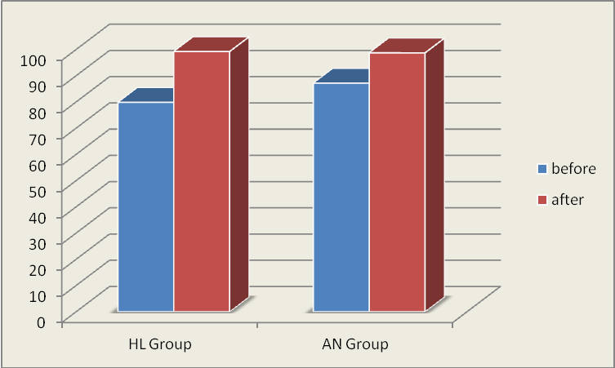
Also the communicative skills (core area) in the assessment directory of sensory integration test in the auditory neuropathy group study, the statistical significant difference was in 3 key components “move closer” (p=0.02^{*)}, ask for objects” (p=0.05*) and “laugh” (p=0.001*), these finding revealed that child with auditory neuropathy when exposed to regular organized sensory stimulation react positively and be fully communicated (fig 2).
Figure (2): Comparison between the before and after intervention of the communication skills of the auditory neuropathy group.
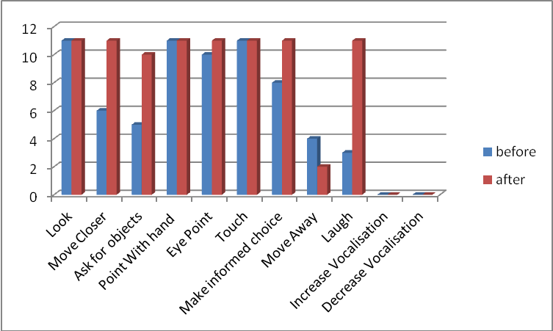
When comparing the “motor skills” in the hearing loss group before and after intervention the key component of “equilibrium controlled movement” p= 0.003 was the only positive highly significant after intervention. Also when comparing the “motor skills” in the auditory neuropathy group before and after intervention the key component of “equilibrium controlled movement” p= 0.006 was the only highly positive statistically significant after intervention (fig3).
Fig (3): Comparison in the Equilibrium Control Movement between the Hearing loss & the Auditory Neuropathy groups.
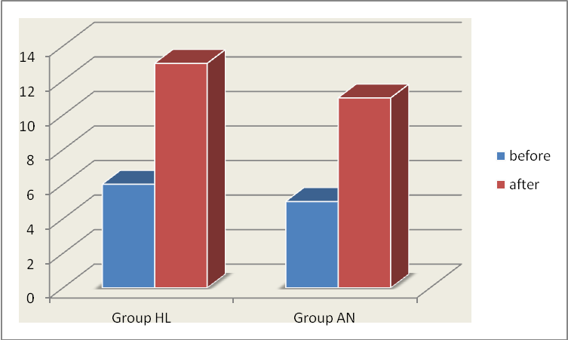
Discussion:
The longer the brain is deprived of auditory input, the greater the resulting sensory deprivation, causing a lack of sensory stimulation to the brain. Not only does sensory deprivation prevent auditory learning, deprivation also prevents growth. In the absence of normal stimulation, there is a sensitive period of about 3.5 years during which the human central auditory system remains maximally plastic; after age 7, plasticity is greatly reduced. The longer the deprivation, the more “stunted” the auditory brain in growth. In fact, not only do the auditory centers not grow, existing pre-wired auditory tracts can also degenerate (Flexer C. et al 2005).
Sensology is a new educational term used to specifically describe a particular area of education or learning. It is used to describe the first sensory steps in early learning for everyone, including those with special educational needs and very special learners (Hirstwood, 2005).
The present study was designed to evaluate the effect of sensory activities on the development of hearing impaired children in Nedaa center for deaf and hearing impaired children which is NGO (non-governmental organization). This was performed through studying the effect of sensory activation using the multi-sensory environment room (MSE) as sessions, two per week for one year period.
The results of this study revealed that the IQ level was 79.846 +/- 8.484 (mean +/- SD) in the 1st group (HL group) and was 87.182 +/- 11.232 (mean +/- SD) in the 2nd group (AN group) at the baseline, with no statistically significant difference between the two groups before intervention.
This goes with (Strong et al., 1997) who stated that hearing loss per se doesn’t imply or cause any cognitive impairment. Specific delay in communicative and linguistic abilities may lead to impairment in one aspect of cognitive abilities later in life.
The current study revealed that there was a marked I.Q. level improvement in both group after intervention. In the 1st group (HL group) there was a statistically significant improvement of the total IQ level after intervention 99.231 +/- 14.967 (mean +/- SD) with p = 0.001*.
Also there was a statically significant improvement in the total IQ level in the 2nd group (AN group) after intervention, 98.727 +/- 10.845 with p=0.001*. When comparing both groups there was no statically significant difference between them before or after intervention.
Also the communicative skills (core area) in the assessment directory of sensory integration test in the auditory neuropathy group study, the statistical significant difference was in 3 key components “move closer” (p=0.02^{*)}, ask for objects” (p=0.05*) and “laugh” (p=0.001*), these finding revealed that child with auditory neuropathy when exposed to regular organized sensory stimulation react positively and be fully communicated.
Bailly et al., (2003) stated that the ability to communicate effectively depends on both sensory and non-sensory factors. General communication skills, acceptance or denial of the hearing loss, overall emotional adjustment, and the behavior and attitude of friends, family, and co-workers all can have an impact on communication.
In this study we found significant improvement in the “equilibrium control movement” which is one of the main key components of the motor skills for both groups study, with p value =0.003 & 0.006 in the hearing loss group & auditory neuropathy group respectively. Lucky enough all children before intervention were having an appropriate motor skill conditions they can walk, sit, lay, run but the degree of equilibrium controlled movement was variable accordingly from one child to another, they were having a sort of unbalance in getting up the stairs or down or getting up from the ground and in jumping as in a trampoline.
The children’s vestibular-related improvement in equilibrium and in postural control making them more efficient and having a positive effect on playground and sports activities as well as they lead them to be more efficiently concentrate on academic material without the distraction of frequents loss of sitting balance. The maintenance of upright equilibrium is essentially a sensor motor integration task. The central nervous system (CNS) has to generate appropriate and complex motor responses based on the selective and rapid integration of sensory information from multiple sources. Since each sensory system has its own coordinate framework, specific time delay and reliability, sensory conflicts may arise and represent situations in which the CNS has to recalibrate the weight attributed to each particular sensory input (Bugnariu & Fung 2007).
Conclusion:
The results of this study supported the importance of multisensory integration therapy in both hearing loss and Auditory Neuropathy children in improving their quality of life as regard the five core areas of the assessment directory. It showed significant improvement of intellectual, communication, sensory and Equilibrium.
When children with sensory integrative problems experience positive changes during intervention, their lives and the lives of other family members be enhanced. One possible by-product of intervention based on sensory integrative principles is that parents gain a better understanding of their children’s behavior and begin to generate own strategies for organizing family routines in a way that is supportive of the entire family system (Talsma, 2007).
In future trails we will need to identify children who will benefit from multisensory integration therapy and their specific age group and abilities.
References
Fergeson, D.& Young, H (2000). Exploring multi-sensory rooms (www.spacecraft.co.uk).
Hirstwood, Richard & Harris, Carolyn (2007). The Sensology workout- waking up the senses.
Binet, A., & Simon, T. (1905). Methodes nouvelles pour le diagnostic du niveau intellectual des anormaux. L'Anne psychologique, 11,191-336.
Talsma, D., Doty, JJ., &Woldorff, MG. (2007). Selective attention and audiovisual integration: is attending to both modalities a perquisites for early integration? Cereb Cortex 17 (3): 679-690.
Bailly, D. Decharlydelenclane, M.B., & Lauwerier, L. (2003). Hearing Impairment and Psychopathological disorder in children and adolescences. Encephole Jul-Aug 629 (4P11): 329-337.
Flexere, C. (1997). Facilitating Hearing and Listening in Children. 2nd Edition, San Diegeo, CA: Singular Publishing Corp.
Marlows & Avons (2003). Portage Program for Cognitive Skills.
Stephens (1997), D.O. (1997). Audiological rehabilitation. Scott Brown's otolaryngology 2, 1-36.
تأثير برنامج التكامل الحسى على تنمية قدرات الأطفال ضعاف السمع
استهدف البحث مدى تأثير برنامج التكامل الحسى على تنمية قدرات الأطفال ضعاف السمع من أطفال ضعاف السمع فئة شديد إلى عميق ويعتمدون على ميعينات سمعية و أطفال ذوي الأعتلال السمعي.
وقد أجريت الدراسة على عينة مكونة من 24 طفلاً من جمعية نداء لرعاية ضعاف السمع في أطفال الفئة العمرية من 3 – 7 سنوات من الجنسين إناث (29.2%) وذكور(70.8%).
وقد تم تقييم القدرات العقلية للطفل, ذلك عن طريق تطبيق اختبار (ستانفورد – بينيه )– الصورة 4 (مليكة 1996), برنامج بورتج, و برنامج التكامل الحسي يونج (2000).
وتم تطبيق برنامج التكامل الحسى للأطفال بواقع جلستين أسبوعياً مدة الجلسة 20 – 30 دقيقة فى غرفة تنمية الحواس لمدة 12شهر(مارس 2009- فبراير2010).
غرفة العلاج الحسى مصممة بشكل خاص لتحفيز الحواس جميعها, و هى تحتوى على كم كبير من الأدوات و الأجهزة و الألعاب التى تعمل على إثارة عدد من الحواس فى الوقت نفسه مثل المقاعد المصنوعة من مواد و أقمشة خاصة تساعد على الأسترخاء و كذلك انابيب البلاستيك المملوءة بفقاعات الهواء الملونة بألوان زاهية و أسلاك ألياف ضوئية مضاءة بألوان شديدة التنوع لتحفيزحاسة البصر.
وتحتوى هذه الغرفة كذلك على ادوات خاصة تعمل على إخراج البخار والروائح الجميلة والعطور المتنوعة التى تساعد على الأسترخاء وتحفيز حاسة الشم وكذلك أدوات تقوم بتسليط الضوء على السقف والجدران بألوان خاصة وتأثيرات ضوئية خاصة لتحفيز حاسة البصر. بالأضافة إلى أجهزة و ألعاب تصدر أصوات خاصة عند الضغط عليها لتحفيزحاسة السمع.
من المميزات المهمة فى العلاج متعدد الحواس هو عدم اعتماده على التعليمات الشفهية او المكتوبة و بذلك من الممكن استخدامه مع الحالات التى تعانى من اضطراب شديد التواصل و فى فهم التعليمات
حيث يمكن تقديم جلسات علاجية للحالات التى لا يمكن استخدام الطرق و الوسائل الأخرى فى العلاج معها نظرا لشدة الإعاقة التى يعانون منها.
نتائج الفروق كانت ذات دلالة إحصائية بين القياس القبلي والبعدي على مقياس ستانفورد بينيه لقياس نسبة الذكاء لكل من الأطفال ضعاف السمع، وخلل السمع (نيورباثي) كلاً على حدة، ولكن لم يكن هنالك فروق ذات دلالة إحصائية بين الأطفال ضعاف السمع، وخلل السمع (نيورباثي).
و قد أشارت نتائج البحث إلى وجود تحسن ملحوظ للأطفال بعد انتهاء الجلسات فى درجة التفاعل والإدراك والأتزان الحركى للأطفال ضعاف السمع، وخلل السمع (نيورباثي)، كما أن سمات الشعور بالسعادة وزيادة نسبة التركيز والإستيعاب كانت من أهم المظاهر الإيجابية بتحسن حالة الأطفال، وهذا أتاح لهم مواصلة حياتهم العامة بشكل أفضل، وكثير منهم ألتحق بمدارس دمج عادية.
الكلمة الكاشفة: (ستنفارد – بينيه )– الصورة 4, برنامج بورتج, التكامل الحسي, غرفة تنمية الحواس , ضعاف السمع.

