Relationship between Interleukin-1 Receptor Antagonist and C-Peptide in Children with Type 1 Diabetes Mellitus

Magdy K. El-Din¹, Mona H. El-Samahy², Iman A. El-Ashmawy³, ⁴Samar M. Farid, ³Sawsan M. Tawfik, ⁵Nabila AA. Ellithy,
⁵Eman R. Youness and ³Reham F. Fahmy
¹Department of Medical Studies, Institute of Postgraduate Childhood Studies, Ain Shams University
²Department of Pediatrics, Faculty of Medicine, Ain Shams University
³Child Health Department, National Research Centre
⁴Department of Pediatrics, Faculty of Medicine, Ain Shams University
⁵Medical Biochemistry Department, National Research Centre
Abstract
Background: Type 1 diabetes is an immune-mediated disease leading to selective destruction of insulin-producing β-cells in which cytokines play an important role. Cytokines related to the innate immune response, such as interleukin (IL)-1β, IL-1 receptor antagonist (IL-1ra), and tumor necrosis factor (TNF)-α are thought to be associated with β-cell destruction and disease status in humans and in animal models.
Objective: This prospective case-control study was carried out to assess the association of C-peptide as a marker of β-cell function with systemic cytokine IL-1ra concentration during the first 6 months after diagnosis in children with type 1 diabetes.
Methods: Thirty children with newly diagnosed type 1 diabetes with a mean age of 6.5 ± 2.2 years and thirty age and sex matched healthy children included as controls were enrolled in this study. Fasting and stimulated C-peptide and circulating concentration of IL-1ra were determined at time of diagnosis in the serum of patients and controls and 6 months after diagnosis in the serum of the patients only using ELISA technique.
Results: Diabetic patients showed significantly lower mean serum fasting C-peptide (0.5 ± 0.3 ng/mL), lower mean serum stimulated C-peptide (0.7 ± 0.2 ng/mL) and lower mean serum IL-1ra (202.6 ± 55.8 pg/mL) compared to control group (1.4 ± 0.2 ng/mL), (2.2 ± 0.3 ng/mL), and (235.0 ± 29.5 pg/mL) respectively at time of presentation. There was no statistically significant correlation between IL-1ra and fasting C-peptide or stimulated C-peptide neither at time of diagnosis nor 6 months after diagnosis (P>0.05).
Conclusion: The present study concluded there was no significant correlation between C-peptide (as a marker of β-cell function) and IL-1ra (the natural antagonist IL-1) in children with recent onset type 1 diabetes.
Key words: Interleukin (IL)-1ra, C-peptide, pediatric, type 1 diabetes
العلاقة بين مضاد مستقبلة الإنترلوكين-1 وسى ببتيد فى الأطفال الذين يعانون من مرض البول السكرى النوع الأول
الخلفية العلمية: النوع الأول من مرض البول السكرى هو مرض مناعى، الذى ينتج عنه تكسير خلايا بيتا المنتجة للأنسولين، تلعب فيه السيتوكينز دوراً هاماً. إن السيتوكينز المرتبطة بالرد المناعى الفطرى مثل الإنترلوكين-1، مضاد مستقبلة الانترلوكين-1، ومعامل الورم الميت- ألفا يعتقد أنها مرتبطة بتكسير خلايا بيتا وبالحالة المرضية فى الإنسان والنماذج الحيوانية.
الهدف من البحث: استهدف البحث إلى دراسة العلاقة بين سى ببتيد كدلالة لوظيفة خلايا بيتا وبين تركيز السيتوكين البدنى مضاد مستقبلة الإنترلوكين-1 خلال 6 شهور الأولى من تشخيص الأطفال الذين يعانون من النوع الأول من مرض البول السكرى
خطة البحث: شمل البحث 30 طفل ممن تم تشخيصهم حديثاً بمرض البول السكرى النوع الأول بمتوسط عمر حوالى 2.2 ± 6.5 سنة وقد تمت مقارنتهم بـ 30 من الأطفال الأصحاء من نفس العمر والجنس كمجموعة ضابطة . سى ببتيد الصائم والمحفز وتركيز مضاد مستقبلة الانترلوكين-1 تم قياسهم فى مصل المرضى والمجموعة الضابطة وقت التشخيص وتم قياسهم مرة أخرى 6 شهور بعد التشخيص فى مصل الأطفال المرضى فقط باستخدام طريقة الإليزا.
النتائج: إن مرضى السكر وجد فى المصل لديهم متوسط سى ببتيد الصائم (0.3 ± 0.5 نانوجرام/مل)، ومتوسط سى ببتيد المحفز (0.2 ± 0.7 نانوجرام/مل) ومتوسط مضاد مستقبلة الانترلوكين-1 (55.8 ± 202.6 بيكوجرام/مل) أقل منه مقارنة بالمجموعة الضابطة (0.2 ± 1.4 نانوجرام/مل)، (0.3 ± 2.2 نانوجرام/مل) و (29.5 ± 235 بيكوجرام/مل) بالترتيب كما تم التوصل إلى عدم وجود علاقة بين مضاد مستقبلة الانترلوكين-1 وسى بيت الصائم أو المحفز سواء وقت التشخيص أو 6 شهور بعد التشخيص.
الإستنتاج: استخلص هذا البحث إلى عدم وجود علاقة بين سى ببتيد (كدلالة لوظيفة خلايا بيتا) وبين مضاد مستقبلة الانترلوكين-1 (المضاد الطبيعى للإنترلوكين-1) فى الأطفال حديثى التشخيص بالنوع الأول من مرض البول السكرى.
الكلمات الدالة: مضاد مستقبلة الانترلوكين-1، سى ببتيد، الأطفال، النوع الأول من مرض البول السكرى.

INTRODUCTION
Diabetes mellitus is a group of metabolic diseases characterized by hyperglycemia resulting from defect in insulin secretion, insulin action, or both (ADA, 2010).
Type 1 diabetes (T1D) is the most common metabolic disease in childhood with an increasing incidence of about 3 to 5% per year, particularly in preschool children. Despite substantial progresses in diabetes research concerning its pathogenesis and etiology in the last decades, there is no strategy for primary prevention in subjects with subclinical signs of diabetes (Kordonouri et al., 2008).
Type 1 diabetes is a chronic autoimmune disease mediated by autoreactive T-cells (Seyfert-Margolis et al., 2006). However, there are still some processes in its pathogenesis to be elucidated (Luczyński et al., 2009).
The auto-immune response leading to type 1 diabetes is closely associated with the overproduction of T helper-1 (Th1) cytokines which activate macrophage production of inflammatory mediators such as interleukin-1 beta (IL-1β) (Aribi et al., 2007).
Pro-inflammatory IL-1β induces apoptosis in insulin-producing β-cells, whereas the anti-inflammatory interleukin (IL)-1 receptor antagonist (IL-1ra) as the specific receptor antagonist of IL-1β preserves β-cells (Larsen et al., 2007). IL-1ra is a cytokine which displays anti-inflammatory and insulin-sensitizing effects (Berg et al., 2001). There are mounting evidences to suggest that anti-inflammatory IL-1ra reduces the inflammatory effects of IL-1 and preserves cell function in both types of diabetes (Volarevic et al., 2010).
C-peptide level (cleavage product of pro-insulin) is the most reliable factor evaluating the endogenous insulin secretion in patients with type 1 diabetes (Zmyslowska et al., 2004).
So far, no association of this cytokine (IL-1ra) with endogenous C-peptide secretion and metabolic status has been demonstrated in patients with type 1 diabetes. The first comprehensive study relating β-cell secretion capacity, metabolic control, and remission status with circulating concentrations of cytokines in pediatric patients was carried out by Pfleger and colleagues (2008).
As IL-1ra improved glycemia and β-cell function in patients with type 1 diabetes, in whom locally produced IL-1 is associated with progressive β-cell destruction, this finding strongly support the rationale for trials of IL-1 antagonists in patients with T1D (Mandrup-Poulsen et al., 2010).
Aim of the study: The current study was carried out to assess the association of C-peptide as a marker of β-cell function with systemic cytokine IL-1ra concentration during the first 6 months after diagnosis in children with type 1 diabetes.
Research Design and Methods:
This a prospective case-control study was conducted on 30 children who were newly diagnosed patients with type 1 diabetes (11 females and 19 males, mean age of 6.5±2.2 years, range 2.1 to 9.4 years at time of diagnosis).
They were recruited from Pediatric Diabetes Clinic, Children's Hospital, Ain Shams University, during the period from April 2011 to December 2012. All patients fulfilling the inclusion criteria were included in the study: a-age of patients from 6 months to prepuberty. b-newly diagnosed patients with type 1 diabetes according to the diagnostic criteria of the American Diabetes Association (ADA, 2009).
Exclusion criteria were patients with type 2 diabetes and presence of other concomitant chronic conditions. The control group consisted of equal number of healthy children matched in age and gender with the patients. A written informed consent was obtained from parents after explanation of the aim of the study. All participants in the current study were subjected to, full history taking, thorough physical examination and laboratory investigations including serum fasting and stimulated C-peptide and serum circulating concentration of IL-1ra using ELISA technique. Fasting serum C-peptide was measured after 8-10 hours of fasting for both patients and controls. Stimulated serum C-peptide was measured 90 minutes after ingestion of 125 mL of milk + ½ white cheese baladi sandwich for both patients and controls. Serum C-peptide was determined using the DRG C-peptide kit. Serum IL-1ra was measured simultaneously with stimulated C-peptide for both patients and controls. Serum IL-1ra was determined using quantikine human IL-1ra Immunoassay kit (R and D systems).
The patients were evaluated again 6 months after diagnosis for C-peptide and IL-1ra, each patient on his day of follow-up at Pediatric Diabetic Clinic, Ain Shams University.
Serum samples were labeled and frozen at -20°C until time of analysis.

Statistical Methods:
The collected data were coded, tabulated, and statistically analyzed using SPSS program (Statistical Package for Social Sciences) software vesion18.
Descriptive statistics were done for numerical parametric data as Inferential analyses were done for quantitative variables using independent t-test in cases of two independent groups with parametric data and paired t-test in cases of two dependent groups with parametric data.
While correlations were done using Pearson Correlation for numerical parametric data.
The level of significance was taken at P value < 0.05 is significant, otherwise is non significant. The p-value is a statistical measure for the probability that the results observed in a study could have occurred by chance.
RESULTS
Comparison of serum fasting and stimulated C-peptide and IL-1ra between diabetic patients and control group: Diabetic patients showed significantly lower serum fasting C-peptide (0.5±0.3 ng/mL), lower serum stimulated C-peptide (0.7±0.2 ng/mL) (P<0.001) and lower serum IL-1ra (202.6±55.8 pg/mL) (P=0.007) compared to the control group (1.4±0.2 ng/mL), (2.2±0.3 ng/mL), and (235.0±29.5 pg/mL) respectively (table 1).
Association of circulating cytokine IL-1ra with C-peptide: There was no statistically significant correlation between IL-1ra and neither fasting C-peptide (Pearson correlation coefficients(r) =0.126, P=0.507) nor stimulated C-peptide (r=0.035, P=0.856) at time of presentation .
Also, we couldn't detect significant correlation between IL-1ra and neither fasting C-peptide (r=0.172, P=0.363) nor stimulated C-peptide (r=0.132, P=0.487) 6 months after diagnosis(table 2,3).
Longitudinal analysis of circulating cytokine concentration: IL-1ra did not statistically differ during follow-up in diabetic patients (P=0.504)(table 4).
Table (1): Comparison between diabetic patients and control group as regards fasting C-peptide (FC-P),stimulated C-peptide( SC-P), and interleukin1-receptor antagonist(IL1-ra) at time of presentation
Parameter |  | Measure | Patients  (N=30) | Control  (N=30) | t_{i} | p
Fasting C-peptide  (ng/mL) |  | Mean ±SD | 0.5±0.3 | 1.4±0.2 | 13.754 | <0.001*
 |  | Range | 0.1–0.9 | 1.0–1.9 | 13.754 | <0.001*
Stimulated C-peptide  (ng/mL) |  | Mean ±SD | 0.7±0.2 | 2.2±0.3 | 25.340 | <0.001*
 |  | Range | 0.3–1.0 | 1.9–3.0 | 25.340 | <0.001*
IL-1ra  (pg/mL) | Mean ±SD |  | 202.6±55.8 | 235.0±29.5 | -2.817 | 0.007*
IL-1ra  (pg/mL) | Range |  | 110.8–293.9 | 190.0–287.7 | -2.817 | 0.007*
t_{i}: Independent t-test, *Significant
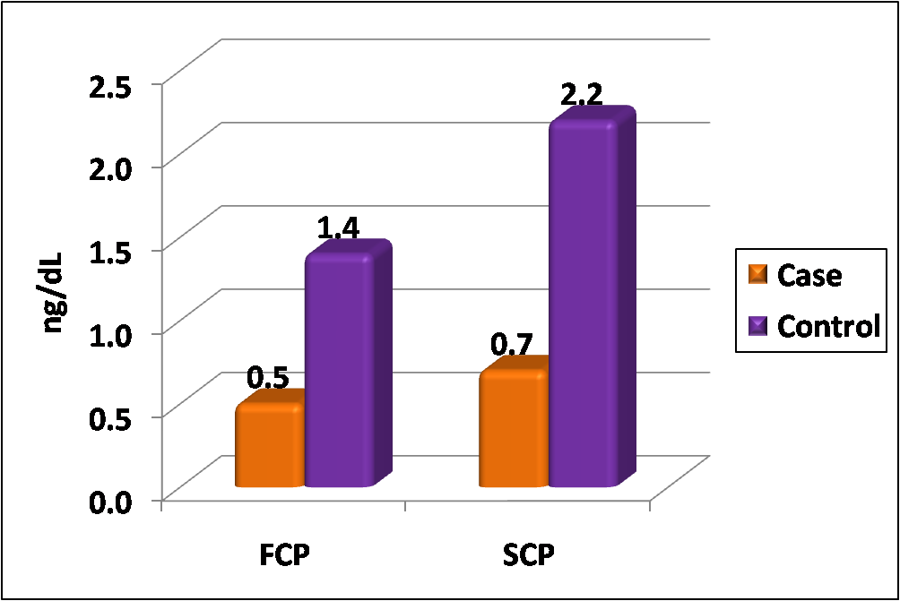
Figure (1): Comparison between diabetic patients and control group as regards fasting C-peptide (FC-P) and stimulated C-peptide ( SC-P)
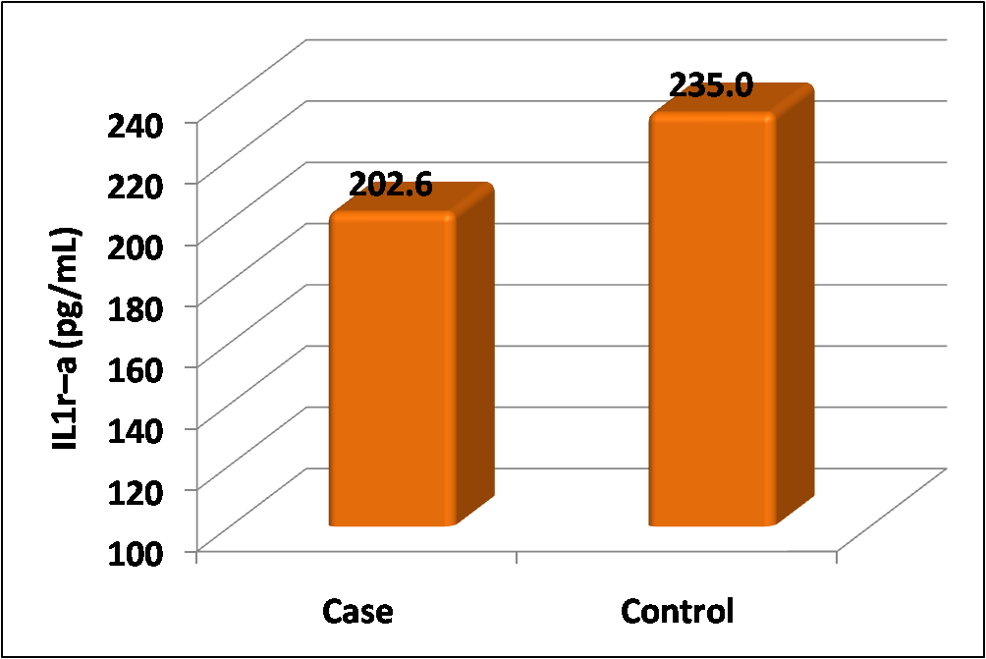
Figure (2): Comparison between diabetic patients and control group as regards interleukin1-receptor antagonist(IL1-ra) at admission.
Table(2): Pearson's correlation coefficients( r) between fasting C-peptide (FC-P), Stimulated C-peptide (SC-P), and interleukin1- receptor antagonist (IL-1ra) in diabetic patients at admission .
 | IL-1ra
 | r | p
Fasting C-peptide | 0.126 | 0.507
Stimulated C-peptide | 0.035 | 0.856

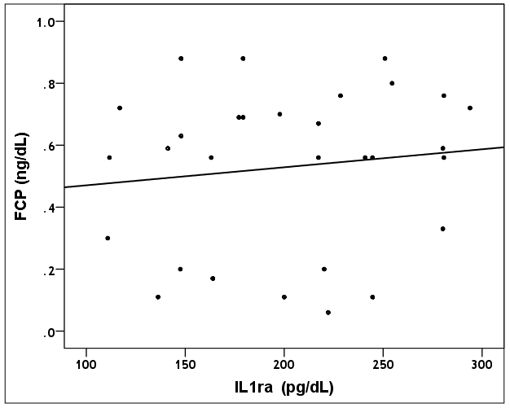
Figure (3): Correlation between fasting C- peptide and IL1-ra in diabetic patients at admission

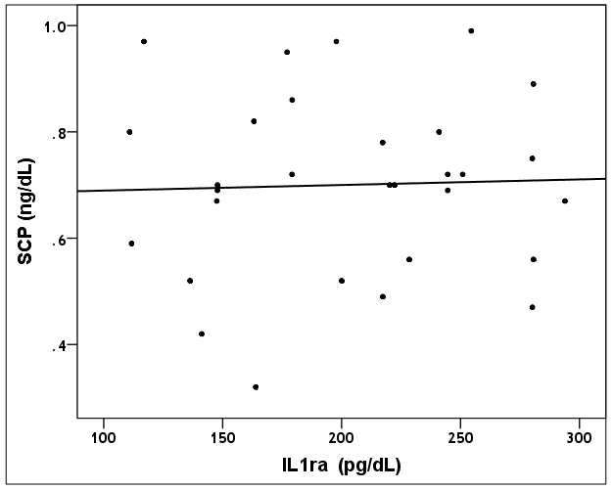
Figure (4): Correlation between stimulated C- peptide and IL1-ra in diabetic patients at admission
Table (3): Pearson's correlation coefficients ( r) between fasting C-peptide, StimulatedC-peptide, and interleukin1- receptor antagonist (IL-1ra) in diabetic patients at follow up.
 | IL-1ra
 | r | p
Fasting C-peptide | 0.172 | 0.363
Stimulated C-peptide | 0.132 | 0.487

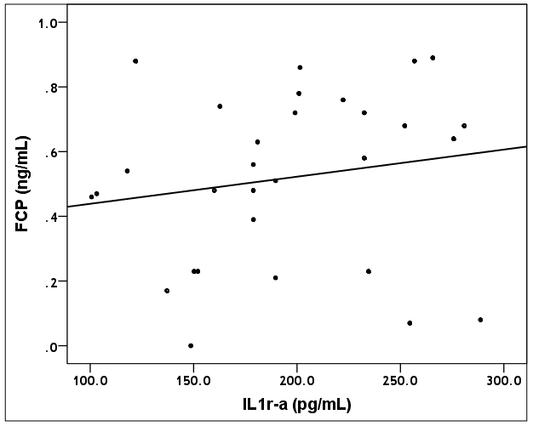
Figure (5): Correlation between fasting C- peptide and IL1-ra in diabetic patients at follow up.
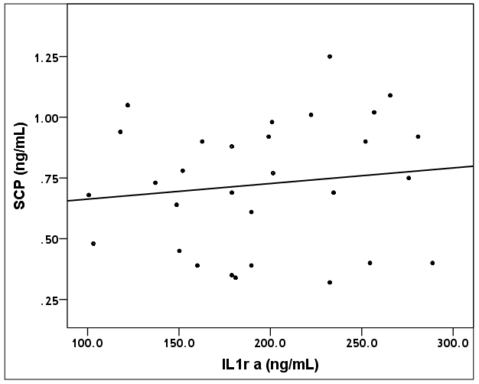
Figure (6): Correlation between stimulated C- peptide and IL1-ra in diabetic patients at follow up.
Table (4): Comparison between diabetic patients at admission and 6 months after diagnosis as regards interleukin1-receptor antagonist( IL1-ra).
 | Mean±SD | Range | t_{p} | p
Admission | 202.6±55.8 (pg/mL) | 110.8–293.9(pg/mL) | 0.677 | 0.504
Follow up | 194.9±54.1 (pg/mL) | 100.6–288.7(pg/mL) | 0.677 | 0.504
Change | -7.6±61.6 | -180.0–98.3 | 0.677 | 0.504
 | N | % | 0.677 | 0.504
Reduction# | 19 | 63.3% | 0.677 | 0.504
t_{p}: Paired t-test, #Negative values indicate reduction
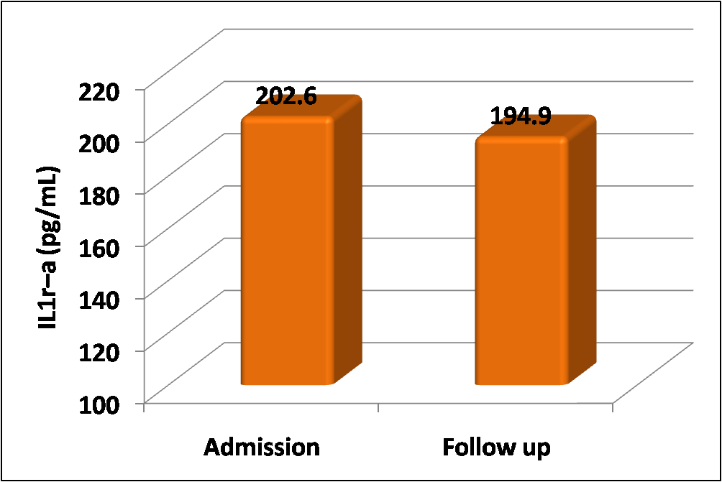
Figure (7):Comparison between diabetic patients at admission and 6 months after diagnosis as regards interleukin1-receptor antagonist (IL1-ra) (pg/mL)

DISCUSSION:
Cell-mediated immunity and pro-inflammatory cytokines are implicated in the pathogenesis of type 1 diabetes (Antonelli et al., 2008). One of these cytokines is interleukin (IL)-1β. This cytokine is involved in the cytotoxicity and apoptotic death of the insulin-secreting cells in T1D patients (Amrani et al., 2000). So, IL-1β seems to be associated with T1D inflammatory process (Aribi et al., 2007).
Interleukin-1 receptor antagonist (IL-1ra) is the natural antagonist to IL-1β (Rotondi et al., 2007). IL-1ra is able to counteract inflammatory effects of IL-1 implicated in insulin resistance and diabetes (Perrier et al., 2006).
C-peptide provides a surrogate measure of endogenous insulin production (Klinke, 2011).
Connecting peptide (C-peptide) of pro-insulin is important for the biosynthesis of insulin (Tsimaratos, 2005).
In the present study, the mean serum fasting and stimulated C-peptide levels in diabetic patients are significantly lower compared to control group .Previous studies reported that type 1 diabetic patients typically lack C-peptide (Haidet et al., 2009).
Type 1 diabetes is characterized by loss of virtually all endogenous insulin secretion (Ludvigsson, 2009).
Previous studies that in patients with T1D, C-peptide is decreased or absent (Kamiya et al., 2006).
Also, results of the present study showed that the mean serum IL-1ra level in diabetic patients was significantly lower compared to control group. This result is in contrast with Pham and colleagues (2011) who reported that patients with type 1 diabetes had higher median concentration of IL-1ra compared with healthy participants. This could be explained as we had studied IL-1ra concentration in newly diagnosed children with type 1 diabetes within the first 6 months of diagnosis while Pham and colleagues (2011) had studied IL-1ra concentration in type 1 diabetic patients who had been diagnosed with diabetes within 5 years before the study. In some studies performed on newly diagnosed patients with type 1 diabetes, the production of IL-1 was found to be increased significantly when compared with long-standing type 1 diabetes and healthy controls. IL-1ra/IL-1 ratio deceased in patients with newly diagnosed type 1 diabetes and returned to normal in long-standing type 1 diabetes group. In a study done by Netea et al., 1997, circulating concentrations of IL-1ra in long-standing type 1 diabetes patients have increased. A decrease in IL-1β levels in long-standing diabetic subjects may be beneficial as it has been demonstrated that antagonism of the mechanism of action of IL-1β may exert a protective effect on pancreatic beta cells against apoptosis (Giannoukakis et al., 1999). These data suggest a pro-inflammatory imbalance and an activation of systemic inflammatory process during early phases of type 1 diabetes which may be indicative of an ongoing β-cell destruction (Dogan et al., 2006).
This study showed no significant correlation between fasting or stimulated C-peptide with IL-1ra in diabetic patients neither at time of diagnosis for 6 months after diagnosis.
Conversely, Pfleger and colleagues (2008) reported that IL-1ra concentrations had significant positive association with C-peptide (as a marker of β-cell function) at 6 and 12 months after diagnosis. Pro-inflammatory IL-1β induces apoptosis in insulin-producing β-cells, whereas the anti-inflammatory IL-1ra as the specific receptor antagonist of IL-1β preserves β-cells (Dinarello, 1996).
Meanwhile, Pham and colleagues (2013) reported that increased IL-1ra concentrations were associated with lower fasting and stimulated C-peptide levels in patients with longer term type 1 diabetes. The discrepancy of the results of these two studies could be explained as the first study had compared the concentrations of IL-1ra and C-peptide in newly diagnosed diabetic children during the first year of diagnosis of diabetes (Pfleger et al., 2008). It is noteworthy that residual beta cell function in patients with recent onset type 1 diabetes is associated with systemic concentrations of an inhibitor of pro-inflammatory or aggressive immune reactivity. IL-1ra suppress central pathways of inflammatory and destructive immunity via blockade of the IL-1 receptor (Dinarello et al., 2012). So, IL-1ra may have an influence on disease activity shortly after diagnosis, where most of the patients still have a preserved beta cell mass (Kaas et al., 2010).
On the other hand, the second study had compared the concentrations of IL-1ra and C-peptide in diabetic patients with longer term type 1 diabetes with diabetes duration of 0.75-4.97 years (Pham et al., 2013), where the association between beta cell function and circulating immune mediators appears to change with the progression of type 1 diabetes. There is substantial loss of beta cell function and probably of beta cell mass in the years following diagnosis (Atkinson and Gianani, 2009), and a regression of the insulitis process (Foulis and Farquharson, 1986).
Islet inflammation was found to persist when there was still substantial beta cell mass present (Atkinson and Gianani, 2009). These data are suggestive of ongoing inflammatory disease activity during the late stages of diabetes that might be perpetuated by the remaining beta cells (Pham et al., 2013). The absence of significant correlation whether negative or positive between fasting and stimulated C-peptide levels and IL-1ra concentration in this work could be attributed to the small number of diabetic patients included in this study compared with the larger number of diabetic patients in other studies.
In the present work, there was no statistically significant difference between diabetic patients at time of diagnosis and at follow-up regarding IL-1ra concentrations. This result is in agreement with that reported by Pfleger and colleagues (2008) who found that IL-1ra did not statistically differ at 6 months of diabetes diagnosis in newly diagnosed type 1 diabetic patients demonstrating that there is no general up-regulation of all cytokines measured 1 month after diagnosis of type 1 diabetes.
Conclusion:
The present study concluded that there was no significant correlation between C-peptide (as a marker of β-cell function) and IL-1ra (the natural antagonist of IL-1).
It is recommended that further studies using larger sample sizes are needed to clarify clearly the association between C-peptide and interleukin-1 receptor antagonist (IL-1ra) in children with type 1 diabetes.
REFERENCES:
- American Diabetes Association (2009): Diagnosis and classification of diabetes mellitus. Diabetes Care; 32:S62-S67.
- American Diabetes Association (2010): Diagnosis and classification of diabetes mellitus. Diabetes; 29:S43-S48.
- Amrani A, Verdaguer J, Thiessen S, et al (2000): IL-1α, IL-1β, and INF-γ mark β cells for Fas-dependent destruction by diabetogenic CD4+ T lymphocytes. J Clin Invest; 105:459-68.
- Antonelli A, Fallahi P, Ferrari SM, et al (2008): Serum Th1 (CXCL10) and Th2 (CCL2) chemokine levels in children with newly diagnosed type 1 diabetes: a longitudinal study. Diabetic Med; 25(11):1349-53.
- Aribi M, Moulessehoul S, Kendouci-Tani M, et al (2007): Relationship between interleukin-1 beta and lipids in type 1 diabetic patients. Med Sci Monit; 13(8):CR372-378.
- Atkinson MA and Gianani R (2009): The pancreas in human type 1 diabetes: providing new answers to age-old questions. Curr. Opin .Endocrinol. Diabetes Obes; 16:279-285.
- Berg AH, Combs TP, Du X, et al (2001): The adipocyte-secreted protein Acrp30 enhances hepatic insulin action. Nat Med; 7:947-953.
- Dinarello CA (1996): Biologic basis for interleukin-1 in disease. Blood; 87:2095-2147.
- Dinarello CA, Simon A and van der Meer JW (2012): Treating inflammation by blocking interleukin-1 in a broad spectrum of diseases. Nat Rev Drug Discov; 11:633-652.
- Dogan X, Akarsu S, Ustundag B, et al (2006): Serum IL-1β, IL-2, and IL-6 in insulin-dependent diabetic children. Mediators of Inflammation; 2006(1):59206.
- Foulis AK and Farquharson MA (1986): Aberrant expression of HLA-DR antigens by insulin-containing beta-cells in recent-onset type 1 diabetes mellitus. Diabetes; 35:1215-1224.
- Giannoukakis N, Rudert WA, Ghivizzani SC, et al (1999): Adenoviral gene transfer of the interleukin-1 receptor antagonist protein to human islets prevents IL-1 beta-induced beta-cell impairment and activation of islet cell apoptosis in vitro. Diabetes; 48:1730-36.
- Haidet J, Cifarelli V, Trucco M, et al (2009): Anti-inflammatory properties of C-peptide. Rev Diabet Stud; 6(3):168-79.
- Kaas A, Pfleger C, Hansen L, et al (2010): Association of adiponectin, interleukin (IL)-1ra, inducible protein 10, IL-6 and number of islet autoantibodies with progression patterns of type 1 diabetes the first year after diagnosis. Clin Exp Immunol; 161(3):444-52.
- Kamiya H, Zhang W, Ekberg K, et al (2006): C-peptide reverses nociceptive neuropathy in type 1 diabetes. Diabetes; 55(12):3581-3587.
- Klink DJ (2011): Age-corrected beta cell mass following onset of type 1 diabetes mellitus correlates with plasma C-peptide in humans. PLOSONE; 6(11):e26873.
- Kordonouri O, von Schütz, Meyer N, et al (2008): Type 1 diabetes in children and adolescents-new strategies management and treatment. Med Monatsschr Pharm; 31(6):200-6; quiz 207-8.
- Larsen CM, Faulenbach M, Vaag A, et al (2007): Interleukin-1 receptor antagonist in type 2 diabetes mellitus. N Engl J Med; 356:1517-1526.
- Luczyński W, Stasiak-Barmuta A, Urban R, et al (2009): Lower percentages of T regulatory cells in children with type 1 diabetes-preliminary report. Pediatr Endocrinol Diabetes Metab; 15(1):34-8.
- Ludvigsson J (2009): The role of immunomodulation therapy in autoimmune diabetes. J Diabetes Sci Technol; 3(2):320-30.
- Mandrup-Poulsen T, Pckersgill L and Donath MY (2010): Blockade of interleukin-1 in type 1 diabetes mellitus. Nat Rev Endocrinol; 6:158-166.
- Netea MG, Hancu N, Blok WL, et al (1997): Interleukin-1 beta, tumour necrosis factor-alpha and interleukin-1 receptor antagonist in newly diagnosed insulin-dependent diabetes mellitus: comparison to long-standing diabetes and healthy individuals. Cytokine; 9(4):284-287.
- Perrier S, Darakhshan F and Hajduch E (2006): IL-1 receptor antagonist in metabolic diseases: Dr Jekyll or Mr Hyde? FEBS Lett; 580(27):6289-94.
- Pfleger C, Mortensen HB, Hansen L, et al (2008): Association of IL-1ra and adiponectin with C-peptide and remission in patients with type 1 diabetes. Diabetes; 57(4):929-37.
- Pham MN, Hawa MI, Pfleger C, et al (2011): Pro- and anti-inflammatory cytokines in latent autoimmune diabetes in adults, type 1 and type 2 diabetes patients: Action LADA 4. Diabetologia; 54(7):1630-8.
- Pham MN, Kolb H, Battelino T, et al (2013): Fasting and meal-stimulated residual beta cell function is positively associated with serum concentrations of pro-inflammatory cytokines and negatively associated with anti-inflammatory and regulatory cytokines in patients with longer term type 1 diabetes. Diabetologia; 56:1356-1363.
- Rotondi M, Chiovato L, Romagnani S, et al (2007): Role of chemokines in endocrine autoimmune diseases. Endocr Rev; 28:492-520.
- Seyfert-Margolis V, Gisler TD, Asare AL, et al (2006): Analysis of T-cell assays to measure autoimmune responses in subjects with type 1 diabetes: results of a blinded controlled study. Diabetes; 55(9):2588-94.
- Tsimaratos M (2005): Physiological effects of the connecting peptide. Arch Pediatr; 12(4):442-8.
- Volarevic V, Al-Qahtani A, Arsenijevic N, et al (2010): Interleukin-1 receptor antagonist (IL-1ra) and IL-1ra producing mesenchymal stem cells as modulators of diabetogenesis. Autoimmunity; 43(4):255-63.
- Zmyslowska A, Szadkowska A, Andrzejewski W, et al (2004): Factors affecting C-peptide level during the first year of type 1 diabetes in children. Endokrynol Diabetol Chor Przemiany Materii Wieku Rozw; 10(2):103-11.

