Evaluation of Inflammatory Markers in Full Term Neonates with Unconjugated Hyperbilirubinemia
Hanan El-Gamal*, Salwa Ibrahim. Bakr**, Mona Sayed Aly Hassan***, Azza Ibrahim Anous
Department of Medical Studies, Institute of Postgraduate Childhood Studies*, Ain Shams University; Department of clinical Pathology**, Faculty of Medicine, Ain Shams University, Pediatric Department, El-Galaa Teaching Hospital***, General Organization for Teaching Hospitals and Institutes
ABSTRACT
Objective: To evaluate inflammatory markers in full term neonates with unconjugated hyper-bilirubinemia. Design: Prospective case control study. This study was done in the department of pediatrics screening clinic, Al-Galaa Teaching Hospital, in Cairo, Egypt from October 2012 to June 2014. Subjects and Methods: The study was done on seventy five full term neonates their age ranged from 3 to 6 days after birth, fifty with unconjugated hyperbilirubinemia compaired to twinty five normal neonates as control group with matched age and sex. All neonates were subjected to history taking (including gestational age, postnatal age) and clinical examination, anthropometric data, and laboratory investigations including complete blood count, CRP and inflammatory markers TNF-α and ILIβ concentration by ELISA. Results: Regarding total bilirubin level in unconjugated hyperbilirubinemia neonates, there was statistically significant to inflammatory markers TNF-α and IL-Iβ (p-value was <0.001). The same finding were also it was found that both inflammatory markers IL-1β and TNF-α showed statistically significant positive correlation with breast feeding p-value was 0.021 for IL-1β and 0.003 for TNF-α respectively. Inflammatory markers IL-1β and TNF-α increasing levels showed positive correlation with neurological examination (Lethargy or irritability, p-value were 0.011 for IL-β and 0.046 for TNF-α respectively. Conclusion: Inflammatory markers IL-1β and TNF-α levels increased in neonatal unconjugated hyperbilirubinemia. Inflammatory markers IL-1β and TNF-α was found correlation between neurological examination. Recommendations: Further studies on larger sample size (are advised to verify the diagnostic and prognostic value of inflammatory markers in neonatal unconjugated hyperbilirubinemia which may help also in treatment. Key words: Inflammatory markers, IL-1β and TNF-α, neonatal unconjugated hyperbilirubinemia, Bilirubin and neurological dysfunction.
تقييم علامات الالتهاب فى الأطفال حديثى الولادة كاملى النمو مع ارتفاع البليروبين الغير مقترن فى الدم
مقدمة: يعتبر مرض الصفراء واحداً من أهم المشكلات الصحية فى الأطفال الخدج والبليروبين غير مقترن هو أهم ناتج نهائى استقلاب الهيموجلوبين فى الدم وزيادة البليروبين الغير مقترن هو المسئول عن العلامات الطبية لصفراء. والبليروبين الغير مقترن يتلف الخلايا العصبية ويؤدى لإفراز الكينات الخلوية الالتهابية ومنها عامل نخر الورم ألفا وانتيرليوكين 1 بيتا ويؤدى إلى خلل وظيفى عصبى قصير الأجل وطويل الأجل حتى عند التركيزات المقبولة سريرياً يحدث استجابة التهابية نموذجية مع اطلاق الكينات الخلوية البروتحريضية ويؤدى إلى عجز فى التعلم والذاكرة؛ الهدف من الدراسة: تقييم مستوى الكينات الخلوية الالتهابية (عامل نخر الورم ألفا وانتيرليوكين 1 بيتا فى الأطفال حديثى الولادة كاملى النمو مع ارتفاع نسبة البليروبين الغير مقترن فى الدم. البحث عن أى ارتباط بين مستوى هذه العلامات الإلتهابية ومستوى البليروبين الغير مقترن. طريقة البحث: تمت دراسة عدد (50) طفل حديثى الولادة مكتمل النمو وعدد (25) حالة طفل حديثى الولادة مكتمل النمو من الأصحاء كمجموعة ضابطه مع تطابق فى العمر. وهؤلاء الأطفال مترددين على قسم الأطفال – وحدة متابعة الأطفال حديثى الولادة فى مستشفى الجلاء التعليمى للولادة والأطفال وأمراض النساء من أكتوبر 2012 حتى يونية 2014. وقد خضعت جميع الحالات لما يلى: أولاً: دراسة تاريخية كاملة للأم. ثانياً: دراسة تاريخية كاملة للطفل. ثالثاً: فحص اكلينكى شامل للطفل خاصة فحص الجهاز العصبى. رابعاً: التحاليل الآتية للأطفال: صورة دم كاملة وتفصيلية. قياس نسبة البروتين التفاعلى سى فى الدم لاستبعاد حالات التعفن البكتيرى فى الدم. قياس نسبة البليروبين فى الدم الإجمالى والغير مباشر. قياس نسبة عامل نخر الورم ألفا وانتيرليوكين 1 بيتا مع مجموعات اليزا . نتائج الدراسة: من الدراسة وجد ارتفاع نسبة البليروبين الغير مقترن عند الأطفال الخدج مكتملى النمو المرضى بالصفراء. ارتفاع نسبة الكينات الخلوية البروتحريضية (عامل نخر الورم ألفا وانترليوكين 1 بيتا مع ارتفاع نسبة البليروبين الغير مقترن بالدم. ووجد أيضاً علاقة بين ارتفاع نسبة عامل نخر الورم ألفا وانتيرليوكين 1 بيتا وارتفاع نسبة البليروبين الغير مقترن مع التأثيرات العصبية بالفحص الإكلينيكى. وكذلك وجدت علاقة بين الرضاعة الطبيعية وزيادة نسبة الكينات الخلوية البروتحريضية "عامل نخر الورم ألفا وانتيرليوكين 1 بيتا"، وتوصى هذه الدراسة بالآتى: بتكرار دراسات مماثلة على أعداد أكبر واثبات أهمية نظام التقييم. متابعة الأطفال المصابين بمرض الصفراء خاصة من الناحية العصبية مما يساعد فى العلاج.
Introduction
Neonatal jaundice or hyperbilirubinemia is one of the most common problems encountered in newborn.
Unconjugated bilirubin (UCB) is the principal and product of hemecatabolism. Increased levels of UCB are responsible for the clinical manifestation of jaundice, common condition in the neonatal period usually referred as physiologic jaundice of the new born infants. Plasma UCB levels can increase dramatically owing to impaired postnatal maturation of hepatic transport or conjugation of UCB, and or enhanced entero-hepatic circulation of UCB, or augmented hemolysis (Brito et al., 2008).
If untreated, and depending on the level of severity, hyperbilirubinemia can lead to minor brain deficits, acute bilirubin encephalopathy, kernicterus, or even death. Unconjugated bilirubin (UCB) injury to glial cells leads to the secretion of glutamate and elicits a typical inflammatory response. Release of pro-inflammatory cytokinis may influence gliogenesis and neurogenesis and lead to deficits in learning and memory and even moderate levels of UCB have been associated with developmental delay, attention deficit disorder and autism (Shapiro, 2010).
Cytokines such as TNF-α, and IL-1β as pleiotropic proteins, play crucial roles in a variety of physiological and pathophysiological processes of the CNS, being considered majour effectors in the nerve cell response to brain injury (Allaman et al., 2011).
Aim of the study:
The current study was carried out to evaluate the level of infllammatory markers IL-1β and TNF-α in jaundiced term neonates with unconjugated hyperbilirubinemia.
Subjects and Methods
This a prospective case control study was conducted on 50 fullterm neonates with unconjugated hyperbilirubinemia their age ranged from 3 to 7 days after birth and compaired to 25 normal neonates as control group with matched age and sex.
The cases were classified into three groups:
Group A: 25 neonates with unconjugated bilirubin range from 12-18 mg/dl.
Group B: 25 neonates with unconjugated bilirubin above 18 mg/dl.
Group C: 25 normal neonates as control group with matched age, sex and number.
They attended to neonatal screening clinic – pediatric department at Al-Galaa Teaching Hospital at Cairo, Egypt during the period from October 2011 to June 2014.
Exclusion criteria:
Neonates with sepsis, jaundiced neonates with direct hyperbilirubinemia and jaundiced neonates with unconjugated hyperbilirubinemia below 12 mg/dl. A written consent was obtained from the patients family who would accept that their neonates to be included in this study after explain to them the study. All participants in the current study were subjected to full medical history for the mothers through physical examination and laboratory investigations including C.B.C, CRP, serum bilirubin total and direct.
Blood level of TNF-α and IL-1β using ELIZA to measure each biomarker in duplicate with specific quantitative ELIZA kits, according to the manufacture's.
Statistical methods:
The collected data were varified, revised, coded, tabulated then edited on computer and statistically analyzed by SPSS/PC softwere, version 20, 2011 (Statistical Packadge of social science) program. The level of significance was taken at p-value <0.05 is significant, otherwise is non significant.
Results:
Statistically significant difference was found between hyperbilirubinemia groups A and B versus control group C as regard to the presence of neurological findings (Lethargy or irritability) in clinical examination, p-value was <0.001 table (1).
Table 1: Comparison of sex and perinatal risk factors between study groups
Studied Groups  Variables | ANOVA test
Studied Groups  Variables | Group A versus B |  | Group B versus C |  | Group A versus C
Studied Groups  Variables | P value | significant | P value | significant | P value | significant
Sex | 0.322 | NS | 0.580 | NS | 0.902 | NS
Consanguinity | 0.370 | NS | 0.824 | NS | 1.000 | NS
Mode of delivery | 0.488 | NS | 0.430 | NS | 0.268 | NS
Perinatal and Maternal History | 0.738 | NS | 0.687 | NS | 0.672 | NS
Breast Feeding | 0.002** | S | 0.513 | NS | 0.775 | NS
Neurologic examination (lethargy or irritability) | 0.882 | NS | 0.000** | S | 0.000** | S
P-value is significant at the ≤ 0.05 or ≤ 0.01 level; NS = non-significant; S = significant.
Statistically significant difference was found between hyperbilirubinemia groups A and B versus control group C as regard to the presence of neurologic finding (lethargy or irritability) in clinical examination, P-value was 0.000.
Table 2: Correlation of IL-1β and TNF-α with different studied variables in group A
Group A  Variables | IL - 1β |  | TNF - α
Group A  Variables | Pearson Correlation | Sig. (2-tailed) | Pearson Correlation | Sig. (2-tailed)
Sex | 0.007 | 0.974 (NS) | 0.081 | 0.702 (NS)
Gestational Age | 0.112 | 0.595 (NS) | 0.268 | 0.196 (NS)
Postnatal Age | 0.300 | 0.144 (NS) | 0.309 | 0.133 (NS)
Body Weight | 0.316 | 0.123 (NS) | 0.194 | 0.354 (NS)
Length | 0.241 | 0.245 (NS) | 0.340 | 0.097 (NS)
Head circumference | 0.011 | 0.958 (NS) | 0.098 | 0.642 (NS)
Consanguinity | - 0.240 | 0.248 (NS) | - 0.287 | 0.164 (NS)
Mode of delivery (NVD) | 0.523** | 0.007 (S) | 0.344 | 0.093 (NS)
Perinatal and Maternal History | 0.161 | 0.443 (NS) | 0.155 | 0.459 (NS)
Breast Feeding | 0.460* | 0.021 (S) | 0.569** | 0.003 (S)
Neurologic finding (lethargy or irritability) | 0.500* | 0.011 (S) | 0.402* | 0.046 (S)
** Correlation is significant at the 0.01 level (2-tailed); * Correlation is significant at the 0.05 level (2-tailed)
NS = non-significant; S = significant
Table 2 showed that relatively increased both inflammatory markers (IL-1β and TNF-α) levels showed statistically significant positive correlation with neurologic examination (lethargy or irritability), P-value were 0.011 for IL-1β and 0.046 for TNF-α respectively. Figure (1,2)
Also we found both inflammatory markers (IL-1β and TNF-β) level showed statistically significant positive correlation with breast feeding p-value was 0.021 in IL-1β and 0.003 for TNF-α respectively in group A in table (2).
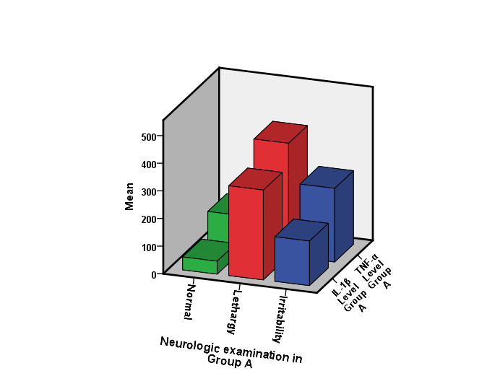
Figure 1: Correlation of mean inflammatory markers IL-1β and TNF-α level with neurologic examination in hyperbilirubinemia group A
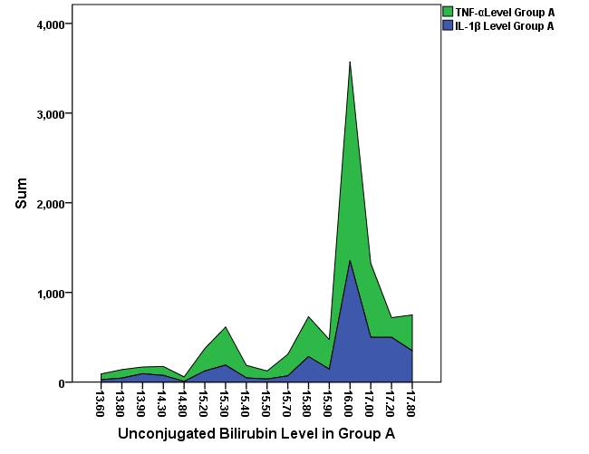
Serum level of inflammatory markers
Figure 2: Correlation of unconjugated bilirubin to level of inflammatory markers IL-1β and TNF-α level in hyperbilirubinemia group A
Also both inflammatory markers (IL-1β and TNF-α) levels showed statistically significant positive correlation with breast feeding; P-value was 0.021 for IL-1β and 0.003 for TNF-α respectively.
Table 3: Comparison of Bilirubin and inflammatory markers IL- β1 and TNF - α between the studied groups.
Studied Groups  Variables | Paired Samples (T test) [Test Sig. (2-tailed)]
Studied Groups  Variables | Group A versus B |  | Group B versus C |  | Group A versus C
Studied Groups  Variables | P value | significant | P value | significant | P value | significant
Total bilirubin | 0.000** | S | 0.000** | S | 0.000** | S
Direct bilirubin | 0.401 | NS | 0.000** | S | 0.000** | S
Unconjugated Bilirubin | 0.000** | S | 0.000** | S | 0.000** | S
IL-1β | 0.423 | NS | 0.000** | S | 0.000** | S
TNF-α | 0.432 | NS | 0.000** | S | 0.000** | S
P-value is significant at the ≤ 0.05 or ≤ 0.01 level (2-tailed); NS = non-significant; S = significant
In table (3) increased total bilirubin level showed statistically significant difference and relatively increased inflammatory markers IL-1β and TNF-α levels (p-value <0.001).
Statistically significant difference was found as regard to inflammatory markers IL- β1 and TNF - α levels between hyperbilirubinemia groups A and B, versus control group C, P-value was 0.000 respectively.
Also relatively increased both inflammatory markers (IL-1β and TNF-α) levels showed statistically significant positive correlation with neurological examination (Lethargy on irritability) p-value were 0.011 for IL-1β and 0.046 for TNF-α respectively table (3) and figure (1).
Table 4: Correlation of IL-1β and TNF-α with studied laboratory tests in group A
Group A  Variables | IL-1β |  | TNF-α
Group A  Variables | Pearson Correlation | Sig. (2-tailed) | Pearson Correlation | Sig. (2-tailed)
Hemoglobin | - 0.042 | 0.843 (NS) | 0.035 | 0.868 (NS)
Hematocrit | 0.190 | 0.364 (NS) | 0.047 | 0.824 (NS)
RBCs | - 0.265 | 0.201 (NS) | - 0.327 | 0.110 (NS)
WBCs | - 0.185 | 0.375 (NS) | 0.087 | 0.680 (NS)
Neutrophil count | - 0.354 | 0.082 (NS) | - 0.072 | 0.733 (NS)
I / T ratio | 0.236 | 0.256 (NS) | 0.186 | 0.373 (NS)
Total bilirubin | 0.713** | 0.000 (S) | 0.678** | 0.000 (S)
Direct bilirubin | - 0.324 | 0.114 (NS) | - 0.118 | 0.575 (NS)
Unconjugated bilirubin | 0.737** | 0.000 (S) | 0.634** | 0.001 (S)
IL-1β | - | - | 0.811** | 0.000 (S)
TNF-α | 0.811** | 0.000 (S) | - | -
** Correlation is significant at the 0.01 level (2-tailed); NS = non-significant; S = significant
In table 4 IL-1β level, showed statistically significant positive correlation with total and unconjugated bilirubin, P-value was 0.000, Figure 3
Also relatively inflammatory markers TNF-α level showed statistically significant positive correlation with total and unconjugated bilirubin p-value <0.001 figure (4).
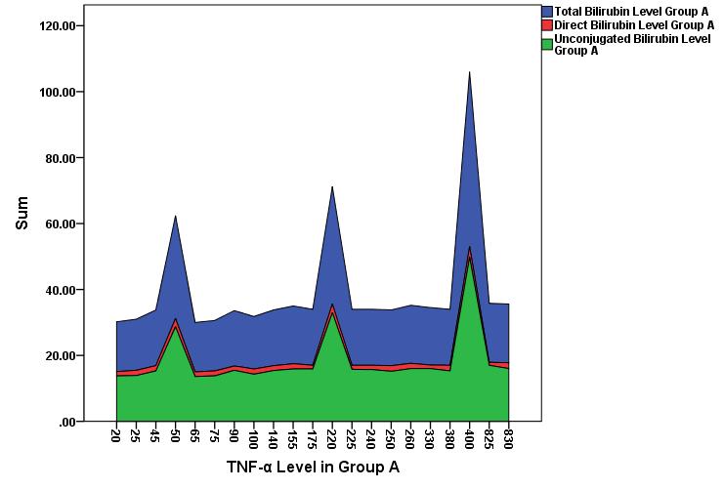
Serum level of inflammatory markers
Figure 3: Correlation of inflammatory markers TNF-α to serum level of total, direct and unconjugated bilirubin levels in hyperbilirubinemia group A
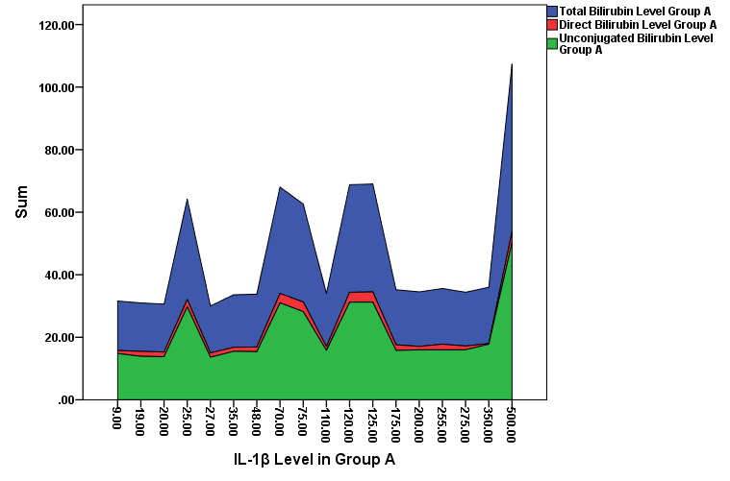
Serum level
Serum level of inflammatory markers
Figure 4: Correlation of inflammatory markers IL-1β to serum level of total, direct and unconjugated bilirubin levels in hyperbilirubinemia group A
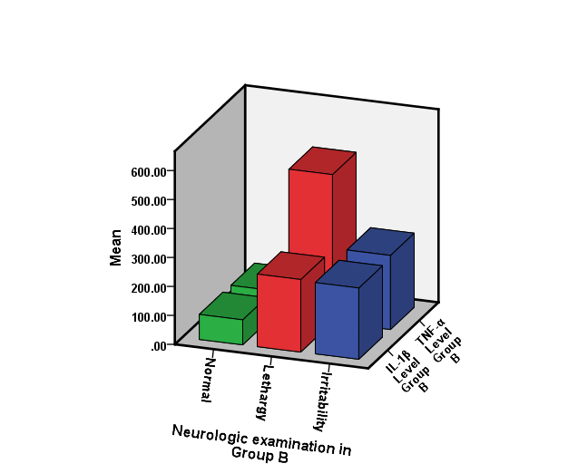
Figure 5: Correlation of mean inflammatory markers IL-1β and TNF-α level with neurologic examination in hyperbilirubinemia group B
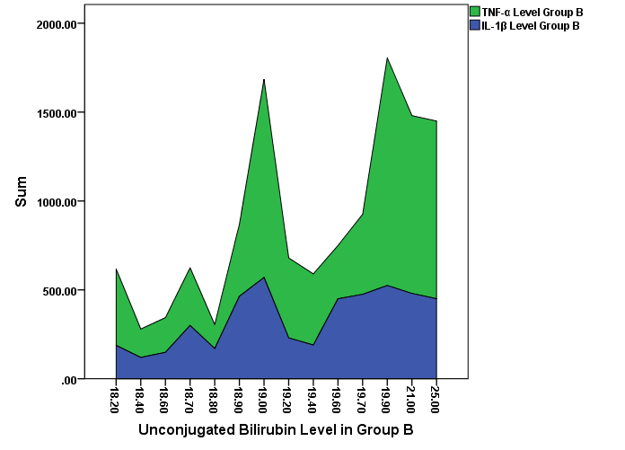
Serum level of inflammatory markers
Figure 6: Correlation of unconjugated bilirubin level to serum level of inflammatory markers IL-1β and TNF-α level in hyperbilirubinemia group B

Discussion:
Unconjugated bilirubin (UCB) injury to glial cells leads to the secretion of glutamate and elicits a typical inflammatory response. Release of pro-inflammatory cytokines (Shapiro, 2010) cytokines such as TNF-α and IL-1β play crucial roles in a variety of physiological and pathophysiological processes of the CNS (Allaman et al., 2011).
However, while TNF-α may be either neurotoxic or neuroprotective injuried brain, IL-1β has been reported as being primarily neurotoxic, although some recent paper's also suggest that it can be have both roles depending on cell-type of cytokine levels (Piaton et al., 2010).
The present study have shown that statistically significant difference was found between group A and B as regard to breast feeding, also statistically significant difference was found between hyperbilirubinemia group A and B versus control group C as regard to the presence of neurologic finding (lethargy or irrtability) in clinical examination, p-value as <0.001 and this findings agree with (Ip S, Chung M, et al., 2004), who found that breast fed infants more likely to develop jaundice with the first week of life and in the newborn baby unconjugated bilirubin can penetrate the blood. Brain barrier and is potentially neurotoxic (lethargy and hypotonia followed by irritability) (Hansen, 2011).
Additionaly of the present study have shown that both inflammatory markers (IL-1β and TNF-α) levels showed statistically significant positive correlation with breast feeding, p-value was 0.021 for IL-1β and 0.003 for TNF-α respectively in group A which agree with (Agurwal et al., 2011), who also mentioned that breast feeding represents the continued exposure of infant to the maternal immune environment may contribute to an infants risk of developing jaundice, especially IL-1β concentrations seems to be increased in milk of mothers whose infants had breast milk jaundice.
Also the present study showed comparison of bilirubin types and inflammatory markers TNF-α and IL-1β statistically significant difference was found between hyperbilirubinemia group A and B versus group C. But no statistically significant difference was found between hyperbilirubinemia group A and B, p-value was 0.0423 for IL-1β and 0.432 for TNF-α respectively agree with (Brites et al., 2009).
As regarding increased total and unconjugated bilirubin showed statistically significanty positive correlation with neurologic examination (Lethargy or irritability) group A and B agree with Palmel et al, 2012, who found that elevated levels of unconjugated bilirubin (UCB) during the neonatal period may be responsible for the occurrence of UCB induced neurological delay function associated to minor brain deficits, or bilirubin encephalopathy (Fernandes et al., 2009).
Also this was agree with Sanjiv et al. (2011), who observed that the level of unconjugated bilirubin control the rate at which bilirubin can escape the blood compartment and presents danger to infant because of it's neurotoxic effect and also this study agree with Silva et al. (2010) study.
As regarding to unconjugated bilirubin, inflammatory markers and neurologic examination our results showed that relatively increased both inflammatory markers (IL-1β and TNF-α) levels showed statistically significant positive correlation with neurologic examination (Lethargy or irritability) group A and B, this agree with the study of Fernandes et al. (2009a), who found that elevated level of unconjugated bilirubin (UCB) may lead to adverse neurologic outcomes, in their review was mentioned that exposure of astrocytes and microglia to UCB initiates an inflammatory response with release of cytokines such as TNF-α, IL-1β, it is not agree with Sargsyan et al. (2011), which found that UCB stimulated astrocytes and neurons dampen microglial inflmmatory response triggered by UCB in isolated cells, since the release of pro-inflammatory mediators such as IL-1β and TNF-α is down regulated (Loddick et al., 1998).
Conclusion:
The present study we found that inflammatory markers (IL-1β and TNF-α) in unconjugated hyperbilirubinemia in full term neonates showed highly significantly elevation, our study revealed also that increased total and unconjugated bilirubin and inflammatory markers (IL-1β and TNF-α) showed statistically significant positive correlation with neurological examination even at clinically relevant concentrations they are neurotoxic.
Also we found that both inflammatory markers (IL-1β and TNF-α) levels showed statistically significant positive correlation with breast feeding.
This study suggests that the evaluation of inflammatory markers (IL-1β and TNF-α) may improve the neurological complain which is important in treatment, prognosis and follow up.
References
- Allaman, I., Belanger, M., and Magistretti, P. J. (2011): Astrocyte-neuron metabolic relationships: for better and for worse. Trends Neurosci. 34, 76–87.
- Brites D, Fernandes A, Falcao AS, Gordo AC, Silva RF, Brito MA (2009): Biological risks for neurological abnormalities associated with hyperbilirubinemia. J Perinatol. 29 Suppl 1:S8–13.
- Brito, M. A., Rosa, A. I., Falcão, A. S., Fernandes, A., Silva, R. F., Butterfield, D. A., and Brites, D. (2008): Unconjugated bilirubin differentially affects the redox status of neuronal and astroglial cells. Neurobiol. Dis. 29, 30–40.
- Fernandes, A., Falcão, A. S., Abranches, E., Bekman, E., Henrique, D., Lanier, L. M., and Brites, D. (2009): Bilirubin as a determinant for altered neurogenesis, neuritogenesis, and synaptogenesis. Dev. Neurobiol. 69, 568–582.
- Hansen, T. W. (2011). Prevention of neurodevelopmental sequelae of jaundice in the newborn. Dev. Med. Child Neurol. 53(Suppl. 4), 24–28.
- Ip S, Chung M, Kulig J, O’Brien R, Sege R, et al. (2004): An evidence-based review of important issues concerning neonatal hyperbilirubinemia. Pediatrics 114: e130–153.
- Loddick S. A., Turnbull A. V. and Rothwell N. J. (1998) Cerebral interleukin-6 is neuroprotective during permanent focal cerebral ischemia in the rat. J. Cereb. Blood Flow Metab. 18, 176–179.
- Palmela I, Hiroyuki Sasaki, Filipa L.Cardoso, Miguel Moutinho, Kwang S.Kim, Dora Brites and Maria A. Brito (2012): Time-dependent dual effects of high levels of unconjugated bilirubin on the human blood-brain barrier lining. Front. Cell. Neurosci. 6:22. doi: 10.3389/fncel. 2012. 00022
- Piaton, G., Gould, R. M., and Lubetzki, C. (2010). Axon-oligodendrocyte interactions during developmental myelination, demyelination and repair. J. Neurochem. 114, 1243–1260.
- Sanjiv B. Amin and Angelo A. Lamola (2011): Newborn Jaundice Technologies: Unbound Bilirubin and Bilirubin Binding Capacity In Neonates. Semin Perinatol. June; 35(3): 134–140.
- Sargsyan, S. A., Blackburn, D. J., Barber, S. C., Grosskreutz, J., De Vos, K. J., Monk, P. N., and Shaw, P. J. (2011). A comparison of in vitro properties of resting SOD1 transgenic microglia reveals evidence of reduced neuroprotective function. BMC Neurosci. 12, 91.
- Shapiro, S. M. (2010). Chronic bilirubin encephalopathy: diagnosis and outcome. Semin. Fetal Neonatal Med. 15, 157–163.
- Silva, S. L., Vaz, A. R., Barateiro, A., Falcão, A. S., Fernandes, A., Brito, M. A., Silva, R. F., and Brites, D. (2010). Features of bilirubin-induced reactive microglia: from phagocytosis to inflammation. Neurobiol. Dis. 40, 663–675.

