Evaluation of Diagnostic Markers of Early Onset Neonatal Sepsis
Hanan Abd-Allah El Gamal, Salwa Ibrahim Bakr*, Manal Esmat Abou Ghareeb
Pediatric Department of medical studies for children, Institute of postgraduate childhood study and *Clinical Pathology Department, Faculty of Medicine, Ain Shams University, Cairo, Egypt
Abstract
Background: Early diagnosis of neonatal sepsis decreases morbidity and mortality in neonates. Recently, serum procalcitonin (PCT) has been investigated as a new marker for the detection of bacterial infection. Objectives: to evaluate procalcitonin (PCT) as an early marker of neonatal infections, and to compare procalcitonin with interleukin-6 (IL-6), C-reactive protein (CRP), hematological scoring systems (HSS). Methods: This cross sectional study included 90 neonates divided into three groups: 30 neonates as proved septic group, 30 neonates as suspected septic group and 30 healthy control neonates. All studied neonates were investigated at age of 1-2 days of life for serum PCT, IL-6, CRP, hematological score by using HSS. Results: Serum PCT, IL-6, CRP were significantly elevated in septic groups in comparison to the control group. The area under the ROC curve for PCT was 0.97, with specificity of 96.7%, sensitivity of 93.3%. Negative predictive value of 93.5% positive predictive value of 96.6%, diagnostic efficacy of 95%, which is significantly higher than that of IL-6 and CRP. No correlation was found between PCT, IL-6, CRP. HSS was not an early tool for diagnosing of neonatal sepsis.
Conclusion: PCT is superior to IL-6 and CRP in diagnosis of early onset neonatal sepsis
Kew words: C-reactive protein, Hematological scoring system, Interleukin-6, Procalcitonin.
Introduction
Neonatal infection represents one of the most common causes of morbidity and mortality in neonatal intensive care units (NICU). The disease is classified into early-onset sepsis (within 72 hours of age) and late –onset sepsis (after 72 hours of age) (Stoll et al., 2011). Early diagnosis of neonatal sepsis is challenging problem because of its non specific clinical picture. The symptoms may be seen in other neonatal diseases as: respiratory distress syndrome, metabolic diseases, and intracranial hemorrhages (Gomella et al., 2009).
Moreover, the signs of sepsis may be absent or minimal and hard to detect, thus fatal septicemia may occur with little warning. Hence the time of diagnosis of sepsis in neonates is critical, as the illness can be rapidly progressive and fatal (Sgro et al., 2011).
Efforts have been made to develop new biomarkers that accurately predict and evaluate sepsis in neonatal patient. Procalcitonin (PCT) marker has been discovered, it is proved to be a useful, early, sensitive, and independent biomarker of neonatal sepsis. PCT is a 116-aminoacid peptide and one of the precursors of calcitonin (Naher et al., 2011). Most microbial infections induce an increase in CALC 1 gene expression and a subsequent release of PCT from all tissues and cell types throughout the body (Yadolla et al., 2009).
PCT is released into the circulation within 3-4 hours after endotoxin injection, plateau at 6 hours and remains elevated for 24-30 hours (Zahed Pasha et al., 2009).
In several countries, the recent adult intensive care guidelines have been altered to the extent that PCT has displaced CRP in the recommendations (O'Grady et al., 2008). In some cases of proved and suspected sepsis the level of PCT were high in spite of negative results for other sepsis screening tests as CRP, HSS and IL-6 (Yadolla et al., 2009).
The aim of the present study was to evaluate the utility of procalcitonin as an early, fast independent marker of neonatal infections, and to compare procalcitonin with hematological scoring system and traditional markers, such as interleukin-6 and CRP.
Patients and Methods
1-Study population
This cross sectioned study( Mostafa & Shorubagy,2015) was conducted on 90 neonates admitted to NICUs of EL-Galaa and Ghamra military hospitals, from August 2013 till February 2015.The included neonates had a gestational age ≥34weeks, only the first 1-2 days of life. The cases were classified into 3 groups on the basis of their clinical and laboratory data:
Group I (proved sepsis): (30 cases) with risk factors of sepsis, clinical picture of sepsis and positive blood culture.
Group II (suspected or clinical sepsis): (30cases), with risk factors of sepsis, clinical features of sepsis, non specific laboratory markers of sepsis and negative blood culture.
Group III (control): It included 30 healthy neonates, age and sex matched.
1.1. Inclusion criteria
This study included any suspected case of neonatal sepsis with maternal risk factors of sepsis, e.g. premature rupture of membranes ≥18 hours, maternal intrapartum fever, chorioamnionitis, urinary tract infection, meconium stained amniotic fluid and any clinical picture suggestive of sepsis e.g. apnea, tachypnea, cyanosis, respiratory distress , bradycardia, hypotenion, poor skin perfusion irritability, lethargy, hypotonia, poor Moro's reflex, poor suckling reflex or seizures, feeding intolerance, abdominal distension, vomiting or hepato-splenomegly hypothermia or hyperthermia.
1.2. Exclusion criteria
Neonates received antibiotics, perinatal asphyxia, congenital anomalies laboratory finding suggestive of metabolic disorders, congenital infections, cardiac arrest, pneumothorax, surgery.
2- Methods
2.1 Sampling
Before antibiotics therapy, 3 milliliters of blood were collected from each neonate of the present study each sample was divided into two tubes: The first tube was EDTA tube for complete blood count. The second tube was a plain tube into which blood was left to clot and serum was separated and divided into two parts, one was used for CRP determination, while the other was stored at – 20 C till assay of serum procalcitonin (PCT) and interleukin -6 (IL-6). For blood culture another 3 ml of venous blood was taken from septic groups (group I, II).
2.2. Laboratory testing
After an informed consent, all neonate included in this study were subjected to the following:
- Complete blood count using automated blood counter cell-dyn 3700 (USA).
- Blood culture: was done for group Iand II using neonatal bottles.
- Quantitative C-reactive protein using OLYMPUS analyzer (USA)
- Serum Procacitonin using quantitative ELISA kit (wuhan Elabb Science co, LTD, China).
- Serum Interlukin-6 using quantitative ELISA kit (AviBion), Finland.
2.3. Statistical Methods:
IBM SPSS statistics (V. 20.0, IBM Corp., USA, 2011) was used for data analysis. Data were expressed using median, 25th and 75th percentiles. Comparison between two independent mean groups for non-parametric data were done using Wilcoxon Rank Sum test. Chi-square test was done to study the association between 2 independent groups as regards the categorized data. The correlation between each two variables were calculated with Spearman’s rank correlation test. Receiver operator characteristic (ROC) procedures identified optimal cut-off values for both markers to differentiate between neonate with and without sepsis P-value <0.05 was considered significant and P-value < 0.001 was highly significant.
Results
There were significant difference between septic groups (proved septic group, suspected septic group) and control group regarding procalcitonin (PCT), interleukin-6 (IL-6), c-reactive protein (CRP) and platelet count (Table 1, 2, figure 1).
Table (1): Comparison between control group and proved septic group regarding hematological indices and laboratory markers
Group  Parameter | Control group  N=30  Median  (25-75 percentile) | Proved Septic groups  N=30  Median  (25-75 percentile) | Z | P | Sig
PCT (ng/ml) | 7(4-9) | 88(75.7-104.3) | -6.33 | 0 | HS
IL-6 (pg/ml) | 35(28-39.5) | 55(38-91.3 | -4.04 | 0 | HS
CRP (mg/l) | 18(16-21) | 31(19-38) | -2.08 | 0.03 | S
WBCs (×10⁹/L) | 10.8(7.9-12.7) | 10.9(8.9-12.9) | -0.50 | 0.6 | NS
PMN (×10⁹/L) | 4.2(2.4-5.7) | 4.2(2.8-6.1) | 0 | 0.99 | NS
Immature PMN (×10⁹/L) | 0.65(0.48-0.9) | 0.8(0.5-0.9) | -1.25 | 0.21 | NS
I/T ratio | 0.14(0.1-0.2) | 0.18(0.13-0.2) | -1.96 | 0.05 | NS
I/M ratio | 0.17(0.1-0.2) | 0.18(0.14-0.2 | -5.68 | 0 | HS
Platelet (×10⁹/L) | 192.5(159.7-214.7) | 10.8(4.8-15.0 | -5.68 | 0 | HS
Pct=Procalcitonin I/T= Immature/ Total PMN
IL-6=Interleukin-6 I/M= Immature/ Mature PMN
CRP=C-reactive protein
Table (2): Comparison between control group and suspected septic group regarding hematological indices and laboratory markers
Group  Parameter | Control group  N=30  Median  (25-75 percentile) | Suspected Septic group  N=30  Median  (25-75 percentile) | Z | P | Sig
PCT (ng/ml) | 7(4-9) | 85(68.7-95.3) | -6.10 | 0 | HS
IL-6 (pg/ml) | 35(28-39.5) | 49.5(35.5-95) | -3.86 | 0 | HS
CRP (mg/l) | 18(16-21) | 32(27-42.5) | -3.65 | 0 | HS
WBCs (×10⁹/L) | 10.8(7.9-12.8) | 10.5(6.6-12.2) | -0.99 | 0.31 | NS
PMN (×10⁹/L) | 4.2(2.4-5.7) | 3.9(3-5.5) | -0.33 | 0.73 | NS
Immature PMN (×10⁹/L) | 0.65(0.48-0.9) | 0.8(0.7-0.9) | -2.3 | 0.02 | S
I/T ratio | 0.14(0.1-0.2) | 0.2(0.13-0.2) | -2.51 | 0.01 | S
I/Mratio | 0.17(0.1-0.2) | 0.29(0.15-0.4) | -2.42 | 0.01 | S
Platelet (×10⁹/L) | 192.5  (159.7-214.7) | 112  (88.8-142) | -5.66 | 0 | HS
Pct=Procalcitonin I/T= Immature/ Total PMN
IL-6=Interleukin-6 I/M= Immature/ Mature PMN
CRP=C-reactive protein
Table (3): Comparison between proved group and suspected septic group regarding hematological indices and laboratory markers
Group  Parameter | Proved Septic groups  N=30  Median  (25-75 percentile) | Suspected sepsis group  N=30  Median  (25-75 percentile) | Z | P | Sig
PCT (ng/ml) | 88(75.7-104.3) | 85(68.7-95.2) | -1.05 | 0.29 | NS
IL-6 (pg/ml) | 55(38-91.3 | 49.5(35.5-95) | -0.25 | 0.80 | NS
CRP (mg/l) | 31(19-38) | 32(27-42.5) | -1.02 | 0.30 | NS
WBCs (×10⁹/L) | 10.9(8.9-12.9) | 10.4(6.6-12.2) | -1.27 | 0.20 | NS
PMN (×10⁹/L) | 4.2(2.8-6.1) | 3.8(3-5.4) | -0.28 | 0.77 | NS
Immature PMN (×10⁹/L) | 0.8(0.5-0.9) | 0.7(0.6-0.9) | -0.73 | 0.46 | NS
I/T ratio | 0.18(0.13-0.2) | 0.2(0.13-0.2) | -0.72 | 0.47 | NS
I/M ratio | 0.18(0.14-0.2 | 0.23(0.15-0.4) | -1.71 | 0.08 | NS
Platelet (×10⁹/L) | 10.8(4.8-15.0) | 112(88.7-142) | -0.24 | 0.80 | NS
Pct=Procalcitonin I/T= immature/ Total PMN
IL-6=Interleukin-6 I/M= Immature/ Mature PMN
CRP=c-reactive protein
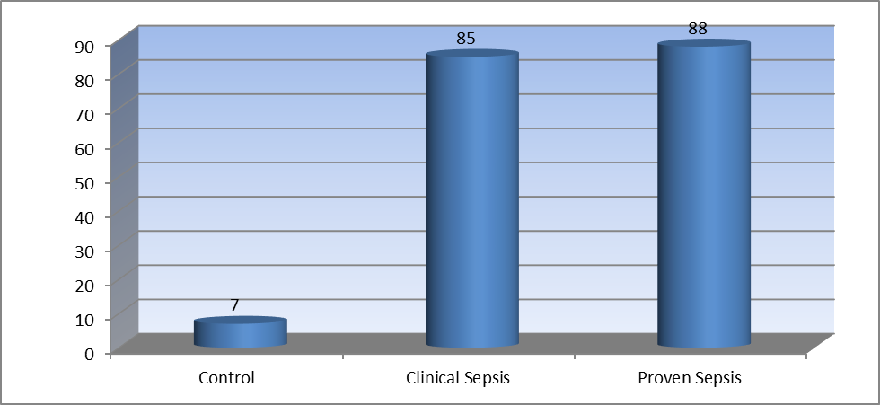
Figure (1): Comparison between median PCT levels of the 3 studied groups.
In the current study as regard haematological scoring system, the majority of cases of proved sepsis group and suspected (clinical) sepsis group were among score 2 (56.7%, 53.5% respectively) and score 5 (16.7%), while majority of control group were score 2 (63.3%). Thus, in our study HSS cannot be considered as an early marker of neonatal sepsis (Table4, 5).
Table (4): Comparison between control group and proved septic group regarding hematological scoring system (H.S.S)
Group  Scoring | Control group  N (%) | Proved septic group  N (%) | Chi-Square  Test X² | P | Sig
0 | 1(3.3) | 0(0) | 15.7 | 0.02 | S
1 | 1(3.3) | 0(0) | 15.7 | 0.02 | S
2 | 19(63.3) | 17(53.7) | 15.7 | 0.02 | S
3 | 7(23.3) | 3(10) | 15.7 | 0.02 | S
4 | 2(6.7) | 0(0) | 15.7 | 0.02 | S
5 | 0(0) | 5(16.7) | 15.7 | 0.02 | S
6 | 0(0) | 3(10) | 15.7 | 0.02 | S
7 | 0(0) | 2(6.7) | 15.7 | 0.02 | S

Table (5): Comparison between control group and suspected septic group regarding hematological scoring system (H.S.S)
Group  Scoring | Control group  N (%) | Suspected septic group  N (%) | Chi-Square  Test  X² | P | Sig
0 | 1(3.3) | 0(0) | 9.08 | 0.17 | NS
1 | 1(3.3) | 1(3.3) | 9.08 | 0.17 | NS
2 | 19(63.3) | 16(53.3) | 9.08 | 0.17 | NS
3 | 7(23.3) | 4(13.3) | 9.08 | 0.17 | NS
4 | 2(6.7) | 2(6.7) | 9.08 | 0.17 | NS
5 | 0(0) | 5(16.7) | 9.08 | 0.17 | NS
6 | 0(0) | 2(6.7) | 9.08 | 0.17 | NS
7 | 0(0) | 0(0) | 9.08 | 0.17 | NS

Regarding sensitivity, specificity and, PCT, had higher sensitivity, higher negative predictive value (NPV) and higher efficacy than CRP.As regard IL-6, PCT had higher specificity, higher sensitivity, higher NPV, higher positive predictive value (PPV), and higher efficacy. IL-6 also higher sensitivity, higher NPV and higher efficacy than CRP (figures 2,3,4)
Figure (2): ROC curve analysis showing the diagnostic performance of PCT for discriminating patients with sepsis from those without.
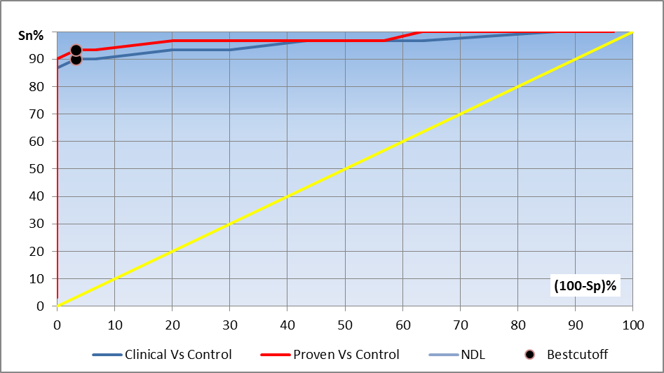
AUC
Suspected Vs Control 0.974
Proved Vs Control 0.986
Figure (3): ROC curve analysis showing the diagnostic performance of IL-6 for discriminating patients with sepsis from those without.
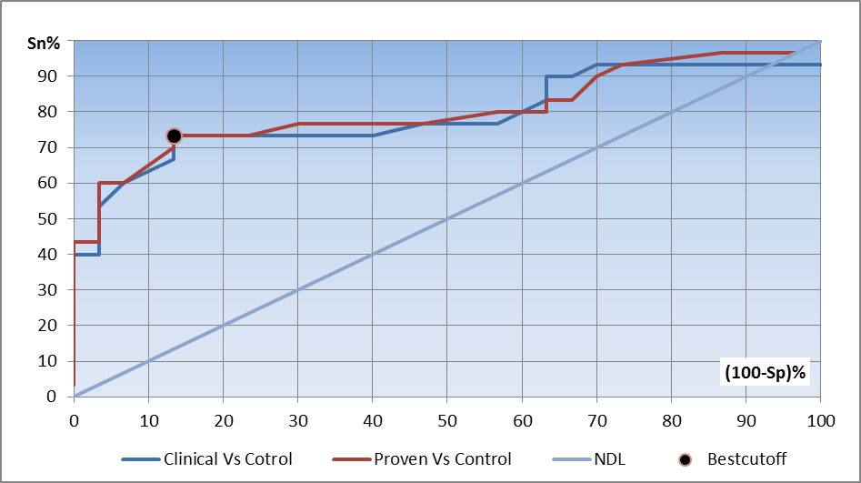
AUC
Suspected Vs Control 0.842
Proved Vs Control 0.848
Figure (4): ROC curve analysis showing the diagnostic performance of CRP for discriminating patients with sepsis from those without sepsis.
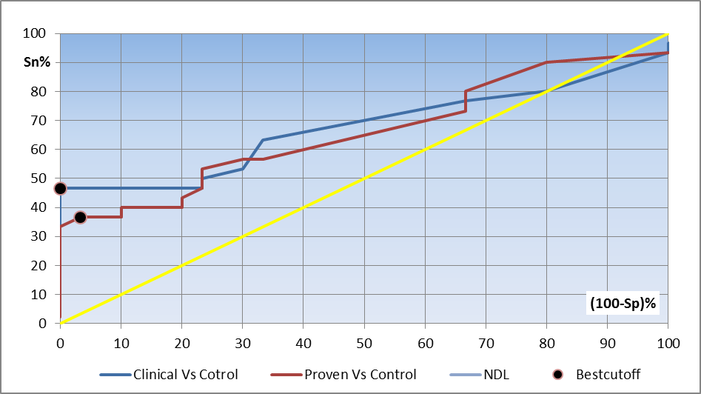
AUC
Suspected Vs Control 0.677
Proved Vs Control 0.672
4- Discussion
Despite the advances in neonatal care, early onset neonatal sepsis remains a serious and potentially life- threatening disease with a mortality rate ranging from 1.5% in term of almost 40% in very low birth weight infants (Weston et al., 2011). The signs and symptoms of neonatal sepsis may be subtle and non specific being clinically indistinguishable from various non infectious conditions as respiratory distress syndrome or maladaptation (Bernhard et al., 2014). During the last decades efforts have been made to improve the laboratory diagnosis of neonatal sepsis by studying a large variety of inflammatory markers with diverse success. Like PCT which has demonstrated its benefit in clinical practice and is more and more implanted in neonatal intensive care unit (Park et al., 2014).
In this study, it was found that serum PCT was highly significantly elevated in septic groups (median PCT 87 ng/ml) in comparison to the control group (median PCT 7 ng/ml). There was also highly statistically significant difference between PCT level in proved septic group (median PCT 88 ng/ml) and PCT level of the control group (median PCT 7 ng/ml). In addition, there was highly significant difference between median of PCT of clinical (suspected) septic group (median PCT 85 ng/ml) and that of the control group (median PCT 7 ng/ml). But there was no significant difference was found between PCT level of proved septic group and PCT of clinical septic group. Cut off level of PCT in our study was 11 ng/ml, specificity and sensitivity of PCT were 96.7% and 90% respectively in clinical (suspected) septic newborns group, 96.7% and 93.3% in proved septic group. This was in agreement with studies done by Yu et al. (2010). The negative predictive value is our study was 90.6%- 93.5% which is in agreement with Guibourdenche et al. (2002) and Daynia et al. (2004). This high NPV can be used to rule out sepsis and limit hospital stay and antibiotic used in neonates.
In our study, the median CRP of the control group was 18 mg/L which was highly significantly less than that of septic groups 31 mg/L, which was in agreement with results of Fathy et al. (2009). Mannan et al. (2010) specificity and sensitivity of CRP at cut off value of 21 mg/L were 100% and 46.7% respectively in suspected septic group, 96.7%, 36.7% in proved septic group. However, it is well known that CRP provides limited sensitivity during the early phase of neonatal sepsis (Kari et al., 2014). In our study, sensitivity of CRP was lower than that of PCT (90%, 93.3% in clinical septic group and proved septic group respectively), also, efficacy of CRP (73.3%, 66.7% in clinical septic group and proved septic group respectively) is lower than that of PCT (93.3%, 95% in clinical septic group and proved septic group respectively). Beside, when we performed ROC curve analysis to determine the accuracy of PCT compared with CRP for detecting EONS, AUC (area under curve) for CRP was (0.67) which is lower than that of PCT (0.97), thus PCT is a more useful biomarker according to Greiner et al. (2000) guide lines based on AUC levels. Our results support the findings of studies done by Naher et al. (2011), Birju and James (2014), Ali et al. (2014), Ali et al. (2015), Mohsen et al. (2015) who stated that compared to CRP, PCT is a good diagnostic measure of early onset neonatal sepsis. This can be explained by the fact that CRP level kept normal for the first 10h after bacterial infection, peak within 2-3 days and its peak plasma level does not indicate severity of sepsis adequately. Hence, CRP level may fail to diagnose early severe sepsis (Michael, 2014).
IL-6 induces the production and release of other markers such as CRP. So IL-6 concentrations rise before CRP in response to bacterial infections in neonates (Adib et al., 2008). However, IL-6 has a very short half life and the concentration falls rapidly to undetectable value after 48 hours so its sensitivity falls rapidly (Rita and Renato, 2012). In our study, the median IL-6 in the control group was 35 pg/ml which was highly significantly less than that of septic groups (53pg/ml). Specificity and sensitivity of IL-6 at cut off value of 42 Pg/ml were 86.7% and 73.3% respectively in clinical (suspected) septic group and proved septic group. Area under curve (AUC) was 0.84. Our results are similar to results of Noor et al. (2008) and Shahkar et al. (2011). In the present study, specificity and sensitivity was lower than that of PCT, also efficacy of IL-6 (80% in both clinical (suspected) septic group and proved septic group) was lower than that of PCT (93.3%, 95% in clinical septic group and proved septic group respectively). Beside, AUC for IL-6 (0.84 moderately accurate) was lower than that of PCT (0.97-highly accurate). Our results were in agreement with studies done by Resch et al. (2003), Abdallahi et al. (2011), Ali et al. (2015) who reported that PCT specificity and sensitivity for bacterial neonatal infection was greater than that for IL-6. The current study showed also that sensitivity of IL-6 to early onset neonatal sepsis is more than that of CRP, this support the studies done by Emine et al. (2007), Jliana et al. (2015)
In the present study, no correlation was found between PCT, IL-6 and CRP in groups of clinical sepsis and proved sepsis, this may be due to the fact that IL-6, although it rises sharply after exposure to bacterial products it falls rapidly as time elapse in contrast to PCT which begins and continues to rise within this period, then coming at last CRP which begins to rise more lately than them. They have different half lives) (Alireza et al., 2012).
As regard hematological scoring system, majority of cases of proved sepsis group and suspected (clinical) sepsis group of the current study were among score 2 (56.7%, 53.5% respectively) and score 5 (16.7%), while majority of control group were score 2 (63.3%). Thus, in our study HSS cannot be considered as an early marker of neonatal sepsis. This agrees with study done by Wang et al. (2013) who reported that HSS should be supplemented by observational evidences collected by physicians (such as body temperature and clinical examination) and by additional diagnostic hematological parameters as CRP and PCT.
In the present study, there was highly significantly decrease in the platelet count in the septic groups in comparison to control group. These results agreed with the study done by Arif et al. (2012) who reported that thrombocytopenia is a common manifestation of bacterial septicemia.
5- Conclusion
Levels of PCT, IL-6 and CRP are significantly increased in neonates with sepsis compared to those without sepsis. But assessment of serum PCT level is superior to serum IL-6 and CRP levels and can be considered as an early, fast, independent marker of early onset neonatal sepsis. Hematological scoring system is not an early tool for diagnosis of neonatal sepsis but, it may be used as a part of sepsis work up.
6- References
Abdollahi A, Morteza A and Nayyeri F (2011): Procalcitonin, interleukin-6 and highly sensitive c-reactive protein in the early predication of neonatal sepsis. Pediatric Research; 70: 426-430.
- Adib M, Navaeo F and Sahbfousul F (2008): Evaluation of interleukin-6 for early diagnosis of neonatal sepsis in comparison with CRP. MED J. Esfahan Univ. Med. Sic; 82:74-75
- Ali AM, Elkhatib WF and Abdelaziz SS (2014): Procalcitonin versus C- reactive protein in neonatal sepsis. Journal of Immunolo and Infect Dis; 1 (1): 103-107.
- Ali ZA, Ghonaim MM and Hussein YM (2015): Evaluation of recent methods versus conventional methods for diagnosis of early- onset neonatal sepsis. J. Infect. Dev. C tries; 9 (4): 388-393.
- Alireza A, Saeed S and Fatemeh N (2012): Diagnostic Value of simultaneous measurement of procalcitonin, interleukin-6 and hs-CRP in prediction of early-onset neonatal sepsis. Meditre. J. Hematol. Infect. Dis; 4 (1): e 2012028.
- Arif SH, Ahmed T and Khan HM (2012): Thrombocytopenia and bacterial sepsis in neonates. Indian. J. Hematol Blood Tranfus; 28 (3); 147-151.
- Bernhard R, Nora H and Wilhelm M (2012): Challenges in diagnosis of sepsis in neonates. In Critical Care and Emergency. Sepsis-an ongoing and significant challenge, book by Luciano A Chapter 11.
- Birju AS and James FP (2014): Neonatal sepsis: An old problem with new insights. Virulence; 5(1): 170-178.
- Chirico G and Loda G (2011): Laboratory aid to the diagnosis and therapy of infection in the neonates. Pediatr Rep; 3(2): 52-60.
- Daynia EB, Olga P and Jacky G (2004): Serum procalcitonin as an early marker of neonatal sepsis. S A M J; 94 (10).
- Emine K, Aysun S and Necmi I (2007): Role of procalcitonin, C - reactive protein, interleukin-6, interleukin -8 and tumor necrosis factor-alpha in the diagnosis of neonatal sepsis. The Turkish Journal of Pediatrics; 49: 7-20.
- Fathy A, Seoud I and Samy G (2009): Serum neopterin level as a marker in early onset neonatal sepsis. PhD. Thesis in childhood studies. Ain Shams University.
- Gomella TL, Cunningham MD and Eyeal FG (2009): Newborn physical examination. Neonatology (Management Procedures, On Call Problems, Diseases and Drugs); 5: 31-42.
- Greiner M, Pfeiffer D and Smith RD (2000): Principles and practical application of the receiver-operating characteristic analysis for diagnostic test. Prev. Vet. Med; 45:23-41.
- Guibourdenche J, Bedu A and Petzold A (2002): Biochemical markers of neonatal sepsis: Value of procalcitonin in the emergency setting- Ann. Clin. Biochem; 39: 130-135.
- Iliana B, Ginzia A and Maria P (2015): Use of early biomarkers in neonatal brain damage and sepsis: State of the art and future perspectives. Bio. Med. Research. International Article ID 253520, 10 Pages.
- Kari AS, Ann LA and Shirley FD (2014): Early – onset neonatal sepsis. Clin. Microbiol. Rev; 27(1): 21-47
- Mannan MA, Shaidullah M and Noor MK (2010): Utility of C- reactive protein and hematological parameters in detection of neonatal sepsis. Mymensingh Med J; 19(2): 259-263.
- Michael M (2014): Update on procalcitonin measurements. Ann. Lab. Med; 34 (4): 263-273.
- Mohsen AH and Bothina A (2015): Predictive value for procalcitonin in the diagnosis of neonatal sepsis. Journal List, Electron Phsician; 7 (4); 1190-1195.
- Mostafa & Shorubagy(2015):Medical Informatics Researches /services project design .Ain Shames University . edition 2015.
- Naher BS, Mannan MA, Noor K, et al. (2011): Role of serum procalcitonin and C-reactive protein in the diagnosis of neonatal sepsis; Bangladesh Med Res Counc Bull; 37(2): 40-46.
- Narasimha A and Harendra ML (2011): Significance of hematological scoring system (HSS) in early diagnosis of neonatal sepsis. Indian. J. Hematol. Blood. Transfus; 27 (1): 14-27.
- Noor MK, Shahidullah M and Rahman H (2008): Interleukin-6: A sensitive parameter for the early detection of neonatal sepsis. Banagabandhu Sheikh Mujib Medical University Journal; 1 (1): 1-5 BSMMU. J.
- O'Grady NB, Barie PS, Barttett JG, et al. (2008): Guidelines for evolution of new fever in critically ill adult patient: 2008 update infectious diseases society of America. Crit Care Med; 36(4): 130-1349.
- Park IH, Seung HL and Seung T (2014): Serum procalcitonin as a diagnostic marker of neonatal sepsis. Korean. J. Pediatr; 57(10): 451-456.
- Resch B, Gusenleitner W and Muller WB (2003): Procalcitonin and interleukin-6 in the diagnosis of early onset sepsis of neonates. Acta. Paediatr; 92 (2): 243-245.
- Rita DC and Renato SP (2012): Immunoinflammatory prognostic markers of early onset neonatal sepsis in critically ill preterm newborns. Revista Brasileira de Tera Pia Intensiva; 24 (1):34-41.
- Sgro M, Yudin MH, Lee S, et al. (2011): Early-onset neonatal sepsis: it is not only group B streptococcus. Paediatr Child Health 16(5): 259-265.
- Shahkar L. Keshtkar A and Mirfazeli A (2011): The role of IL-6 for predicting neonatal sepsis: A systemic review and meta-analysis. Iranian Journal of Pediatrics; 21(4): 411-417.
- Stoll BJ (2007): Infections of neonatal infants. In Behrman RE, Kliegman BM, Jonson HB- Nelson Text book of Pediatrics 18th Ed Philadelphia. WB sounders 2008: 794-811.
- Wang K., Bhandari V and Che pustanova S (2013): Which biomarkers reveal neonatal sepsis? PLOS ONE; 382700.
- Weston EJ, Pondo T and Lewis MM (2011): The burden of invasive early-onset neonatal sepsis in the United States, 2005-2008 Pediatr. Infect. Dis. J; 30(11): 937-94 1.
- Yadolla Z, Mousa A, Mahmoud H (2009): Procalocitonin as a marker of neonatal sepsis. Iran J Pediatr; 19(2): 117-122.
- Zahed Pasha Y, Ahmed PM and Hajiahmadi M (2009): Procalcitonin as a marker of neonatal sepsis. Iran J Pediatr; 19:117-122.
- تقييم علامات التشخيص المبكر للتسمم الدموى لحديثى الولادة
حنان عبد الله ، *سلوى ابراهيم بكر، منال عصمت ابو غريب
استاذ طب الاطفال بقسم الدراسات الطبية للأطفال – معهد الدراسات العليا للطفولة جامعة عين شمس
* استاذ الباثولوجيا الاكلينيكية – كلية الطب – جامعة عين شمس
المستخلص
الخلفية العلمية : يظل التسمم الدموي لحديثي الولادة سبب رئيسي لزيادة معدل الإعتلال والوفيات بين هؤلاء الأطفال ولذلك ظهرت العديد من الوسائل التشخيصية تهدف إلى سرعة تشخيص هذا المرض ولكنها غالباً ما تكون ضعيفة للكشف عن المرض في مراحله المبكرة. وقد أظهرت الدراسات حديثاً بروتين البروكلسيتنين المشتق من هرمون الكلستنين وأوضحت أنه يزداد في الدم مبكراً في حالة الإصابة بالتسمم الدموي البكتيري ولذلك يمكن استخدامه كمؤشر حيوى مبكر لتشخيص التسمم الدموي لحديثي الولادة.
الهدف من هذا البحث: هو تقييم مدى فائدة البروكلسيتنين كمؤشر مبكر ومستقل لإصابة ببداية التسمم الدموي لحديثي الولادة ومقارنته مع نظام التسجيل الدموي والمؤشرات الأخرى مثل انترلوكين 6 وبروتين سي التفاعلي.
المنهجية : اجريت هذه الدراسة على 90 وليدا وقد تم اختيارهم من وحدات العناية المركزة لحديثى الولادة بمستشفيات الجلاء وغمرة العسكرية .
النتائج: وقد أظهر البحث زيادة مستوى البروكلسيتنين والأنترولكين 6 وبروتين سي التفاعلي في الأطفال حديثي الولادة المصابين بالتسمم الدموي سواء المؤكدين أو المشتبه بهم بالمقارنة بحديثي الولادة الأصحاء (مجموعة المقارنة)،وبعد مقارنة البروكلسيتنين بالانترلوكين 6 وبروتين سي التفاعلي وجد البحث أن البروكليستنين يتمتع بخصوصية تصل إلى 96.7% وحساسية تصل إلى 93.3% وقيمة تنبؤية سلبية تصل إلى 93.5% وإيجابية تصل إلى 96.6% وفاعلية 95% .
الخلاصة : اتضح تفوق البروكلسيوتنين على المؤشرات الحيويه الأخرى. وأوضحت الدراسة أيضا تفوق الانترلوكتين 6 على بروتين سي التفاعلي في التشخيص المبكر للتسمم الدموي. وأنه ليس هناك ارتباط بين الثلاث مؤشرات سواء في مجموعتي حديثي الولادة المصابين أو في مجموعة المقارنة.
وأوضحت الدراسة أن نظام التسجيل الدموى لا يعتبر مؤشر مبكر لتشخيص التسمم الدموى
الكلمات الدالة:
مستوى بروتين سي التفاعلي في الدم،التسمم الدموي المبكر لحديثي الولادة،نظام التهديف الدموي،مستوى الانترلوكين 6 في الدم،مستوى البروكلستنين في الدم.

