Pattern of Sleep Disturbance among children with cerebral palsy
Omar El Shourbagy, Magdy Karam Eldeen, Hanan El Gamal and Heba El Shal
Department of Medical Studied for Children, Institute of Postgraduate Childhood Studies, Ain Shams University.
Abstract:
Objective: to describe the pattern of sleep disturbances among children with CP (the age > 3 years) and to evaluate the relationship between sleep disturbances and neurological state.
Methodology: This descriptive study included 124 children with CP; (80 males and 44 females) with an age ranging from 4 to 10 years. Children were randomly recruited from Pediatric Outpatient Clinic (IPGCS (throughout the period from June 2015 till the end of January 2016. All participants were subjected to IQ test (Stanford-Binet Scale V5), EEG, the CSHQ and hemoglobin measurement.
Results: Out of 124 children, 92.7% had spastic CP, 6.5% had dyskinetic CP and 0.8% had hypotonic CP. Topographically spastic CPs were; 55.6% diplegic, while quadriplegia and hemiplegia were found in 28.2% and 8.9% of studied cases, respectively. Degree of intellectual disability among cases was 0.8% low average (89-80), 8.1% were borderline (79-70), 56.5% were mildly impaired, 14.5 % were moderately impaired (54-40), 12.1% were severely impaired (39-25) and 8.1% were profound. Hemoglobin estimation revealed that 8.1% were anemic. Abnormal EEG was found in 70.2% of cases, 81.36% of the epileptic CP children and 60% of the non-epileptics had abnormal EEG findings, 27.4% had focal epileptiform, 18.5% had generalized slow wave, 16.9% had generalized epileptiform and 7.3% had multi-focal epileptiform. Among the epileptic CP children; 52.54% experienced partial seizures and 47.46% experienced generalized seizures. Out of all studied children, 48.38% showed abnormal total CSHQ score indicating a clinically distinct sleep disturbance. There were significant correlation between sleep disturbance score and the degree of intellectual disability and also presence of epilepsy.
Conclusion: sleep disturbance was significantly correlated to several co-morbid conditions including the degree of intellectual disability and the presence of epilepsy.
Keywords: Children, Cerebral Palsy, Sleep Pattern, CSHQ score.
المستخلص
أنماط اضطرابات النوم لدى الأطفال الذين يعانون من الشلل الدماغى
الهدف من الدراسة: هو معرفة أنماط اضطرابات النوم لدى الأطفال المصابين بالشلل الدماغى، بالإضافة إلى تقييم العلاقة بين الحالة العصبية لمرضى الشلل الدماغى و اضطرابات النوم.
المنهجية: هذه دراسة وصفية، أجريت على 124 طفلا مصابا بالشلل الدماغي. و قد تم اختيارهم عشوائيا من العيادات الخارجية بمركز رعاية ذوى الاحتياجات الخاصة، خلال الفترة من يونيو 2015 إلى يناير 2016 . تكونت الدراسه من 80 من الذكور و 44 من الاناث و كانت أعمارهم تتراوح ما بين 4 إلى 10 عاما. ولقد تم تقييم جميع الأطفال المدرجين ضمن الدراسة من خلال أخذ التاريخ المرضي، كما تم إجراء الفحوصات اللازمة واختبار الذكاء ستانفورد بينيه (الصورة الخامسة)، ورسام المخ الكهربائى ومقياس عادات النوم للأطفال.
النتائج: تم التشخيص الإكلينيكي لحالات الشلل الدماغى على النحو التالى: 92.7% من المرضىي يعانون من النوع التيبسي/التشنجي، في حين تم تشخيص النوع الكنعي (الاثيتويدي) في 6.5% و النوع الترنحي (اللاتناسقي الحركي) في 0.8 % من المرضى. وكانت درجة الإعاقة الذهنية بين الحالات 0.8% يقع ضمن الفئة (89-80)، 8.1% يقع ضمن الفئة (79-70)، 56.5% يقع ضمن الفئة (69-50) ، و 14.5% ضمن الفئة (54-40)، وبنسبة 12.1% ضمن ( 39-25) و 8.1% ضمن الفئة أقل من 24. وأظهر قياس نسبة الهوموجلوبين فى الدم وجود نسبة 8.1% من الحالات تعانى من فقر الدم. وأظهرت فحوصات رسم المخ أن 70.2% من الحلات لديهم قياسات غير طبيعية، 81.36% من المرضى الذين يعانون من التشنجات العصبية و 60% من المرضى الذين لا يعانون من التشنجات العصبية. و 27.4% من النوع صرعي البؤري، 18.5% موجة بطيئة عامة، وكان 16.9% موجات صرعية بؤرية عامة، و 7.3% كان صرعي متعددة البؤري. وأظهرت نتائج تطبيق مقياس استخبارات النوم: نسبة 48.38% من اللأطفال يعانون من اضطراب فى النوم. كما أشارت النتائج إلى وجود ارتباط وثيق بين معدل اضطرابات النوم لدى أطفال الشلل الدماغى و بين بعض الحالات المرضية المصحوبة للمرض مثل حدوث التشنجات بالإضافة إلى درجة الإعاقة الفكرية.
الخلاصة: ارتفاع معدل اضطرابات النوم لدى الأطفال المصابين بالشلل الدماغى، ووجود ارتباط ذو دلالة إحصائية بين معدل اضطرابات النوم لدى أطفال الشلل الدماغى و بين بعض الحالات المرضية المصحوبة للمرض مثل حدوث التشنجات بالإضافة إلى درجة الإعاقة الذهنية.
الكلمات الافتتاحية: الأطفال ، الشلل الدماغى ، أنماط النوم ، مقياس عادات النوم للأطفال
Introduction:
The disorder of cerebral palsy (CP) can be considered one of the popular causes of disabilities during childhood period, affecting motor, sensation, perception and cognition. Clinically, CP is heterogeneous; from mild to severe impairment, with mental retardation and limited motor function (Strauss et al., 2008).
Although CP is primarily a disorder of movement, many children with this disorder have also other impairments that can often affect their quality of life and their life expectancy (O'Shea, 2008).
Sleep disturbances are more frequent in children with cerebral palsy compared to normally developing children, and this increased prevalence is related to several factors including epilepsy (Romeo et al., 2014).
Individuals suffering from neuro-developmental delay, including CP, were more liable to develop sleep disturbances, affecting the child and his family. Sleep disturbance is associated with challenging behavior in disabled children (Simard-Tremblay et al., 2011).
Cerebral palsy is considered a lifelong disorder; where approaches to intervention, either at individual or environmental level, should recognize that the quality of life and social participation are important for individuals with cerebral palsy, not only improvement in physical function (Colver et al., 2014).
Objective:
The objective of the current research is describing sleep pattern and disturbances among children suffering from cerebral palsy (age > 3 years) and the relationship with the neurological state.
Methodology:
Subjects:
This is a descriptive study included 124 children with confirmed diagnosis of cerebral palsy were recruited in the study. They were randomly recruited from Pediatric Outpatient Clinic, Institute of Post-graduate Childhood Studies (IPGCS), Ain Shams University. They were 80 males and 44 females with an age range from 4 to 10 years (mean 6.41 ± 1.6 years).
Inclusion criteria:
- Age: 4-12 years old (pre-school and elementary-school children).
- Gender: both sexes.
- Cases: children diagnosed as cerebral palsy.
Exclusion criteria:
- Cases with previously diagnosed severe co-morbid chronic medical conditions (e.g. hepatic, cardiac or renal).
- Cases of specific genetic syndromes.
- Cases with craniofacial abnormalities.
Research Ethical considerations:
The study proposal was approved by the local ethical committee of the Institute of Post-graduate childhood studies and it was conducted according to the guidelines of Helsinki, the guidelines for the Ethical Conduct of Medical Research involving children, revised by the Royal College of Pediatrics and Child Health: Ethics Advisory Committee (IPGCS, 2014). The researcher received an informed consent from parents or the legal guardian of the children enrolled in this study, after plain simple explanation of the nature, aim and procedures of the study and also emphasizing that personal and other data would be used for scientific work only
Methods and Research tools:
- Data sheet:
- Ante-natal and perinatal history including:
- Antenatal history: teratogens, infections (TORCH), drugs and maternal diseases during pregnancy.
Natal history: gestational age, place of delivery, mode of delivery, first cry and birth weight.
Postnatal history: age of 1st convulsion, jaundice, cyanosis and Apgar score.
- Developmental history for evidence of psychomotor retardation or regression including: gross motor, fine motor, communication, language and cognitive skills.
- History of seizure and antiepileptic drugs.
- Family history of similar condition or other neurological illness and history of consanguinity.
- Examination:
Detailed general and neurological examination findings:
  - Mental status, cognition and alertness.
  - Motor examination:
- Muscle tone, muscle state …..
- Reflexes (superficial, deep).
- Gait and posture.
  - Sensory examination: superficial sensations, deep sensations and cortical sensations.
  - Coordination.
  - Cranial nerves examination.
  - Hypothalamic affection; symptoms such as: polyuria, polydipsia, polyphagia and obesity.
  - Vaccination history.
- Assessment:
- Intelligence quotient; IQ test using Stanford-Binet Intelligence Scale V5, the Arabic version (Abu El-Neil, 2011); used in the age range of 2 to 89 years old. It consists of ten subscales, assessing three area; the general cognitive functioning, the verbal and the nonverbal intelligence (Roid, 2003). It was conducted by trained psychologists at the Special Needs Center.
- Electroencephalography; EEG records the electrical activity generated by brain structures through scalp electrodes. It was done in the EEG Unit, at the IPGCS. The child is being prepared before the investigation and a list of instructions was given to parents to ensure child’s safety.
- The Children’s Sleep Habits Questionnaire; the Arabic version; (Abu Taleb, 2010).
- The CSHQ is used to assess the most common sleep domains encompassing the most distinct complaints in this age group (Owens et al., 2000). The CSHQ constitutes 35 items relating to 8 domains that represent clinical sleep complaints: bedtime behavior and sleep onset; sleep duration; anxiety around sleep; behavior occurring during sleep and night waking; sleep-disordered breathing; parasomnias; and morning waking/daytime sleepiness. It was done by the researcher in the outpatient clinic at IPGCS.
- Hemoglobin level, which is considered the most consistent anemia indicator according to World Health Organization (Gwetu et al., 2013). It was done at the laboratory of the IPGCS, using Medonic Coulter.
- Data processing and Statistical analysis
Data was collected, entered and analyzed on personal computer using SPSS software version 12. The mean ± SD researcher used for quantitative variables. The number and percentage researcher used for qualitative variables. Chi square test was used to assess statistical differences between qualitative variables; t-test was used between quantitative variables. The statistical methods were verified, assuming a significance level of P < 0.05 and a highly significant level of P < 0.001 (Mustafa and El-Shourbagy, 2012).
Limitation of the study:
Some children did not give their consent to be enrolled in the study. Some children did not fulfill all the investigations required for the study.
Results:
Table (1): Gender distribution among studied cases:
Gender (N=124) | Number | Percentage%
Male (M) | 80 | 64.5%
Female(F) | 44 | 35.5%
Sex Ratio | M:F= 1.8 : 1

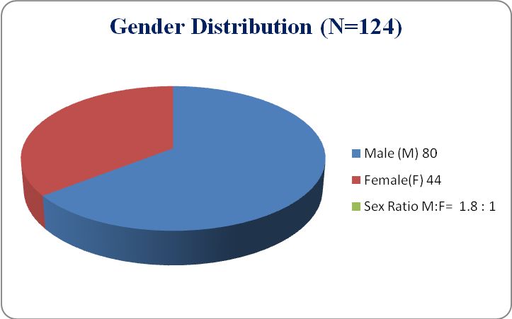
Figure (1): Gender distribution
Table (1) and figure (1) show that there is gender difference among studied cases with M: F ratio = 1.8:1.
Table (2): Clinical Sub-types of CP among studied cases:
Clinical Neurological Diagnosis (N=124) | Number | Percentage%
Spastic (Pyramidal) | 115 | 92.7%
Dyskinetic (Extra-pyramidal) | 8 | 6.5%
Ataxic (Hypotonic) | 1 | 0.8%
 | 124 | 100%

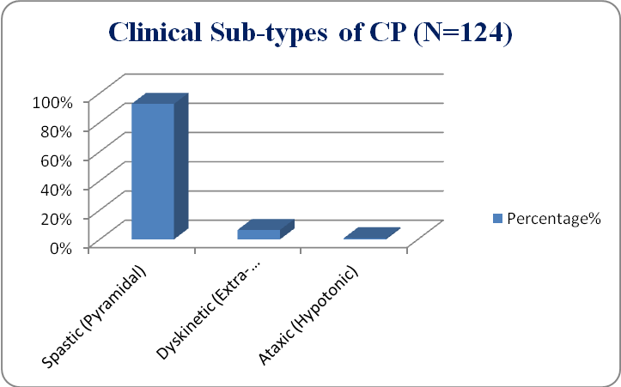
Figure (2): Clinical sub-types of CP
Table (2) and figure (2) show that the most common type of CP is pyramidal (spastic) type in current study population.
Table (3): Topographic diagnosis of CP among studied cases:
Topographic Neurological Diagnosis(N=124) | Number | Percentage%
Diplegia | 69 | 55.2%
Quadriplegia | 35 | 28 %
Hemiplegia | 11 | 8.8%
Athetoid | 8 | 6.4 %
Ataxic | 1 | 0.8 %
 | 124 | 100%

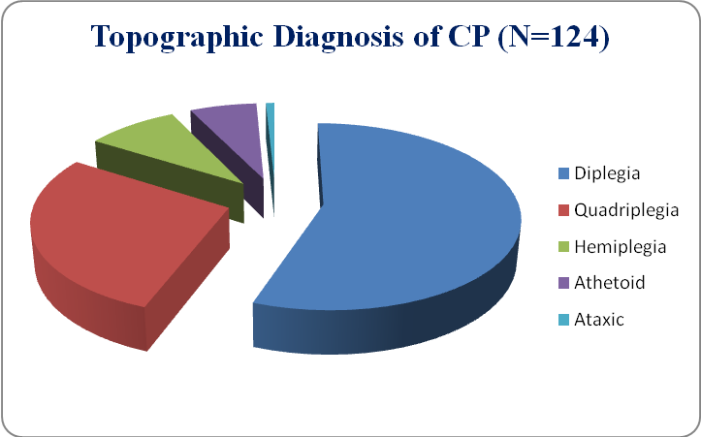
Figure (3): Topographic diagnosis of CP
Table (3) and figure (3) show the most common topographic type of CP is diplegia (55.6%) followed by quadriplegia (28.2%).
Table (4): Intelligent Quotient among studied cases, according to Stanford-Binet Fifth Edition (SB5) Classification (Kaufman and Alan, 2009):
Intelligent Quotient (N=124) | Number of | Percentage%
Low Average (89-80) | 1 | 0.8%
Borderline Impaired (79-70) | 10 | 8.1%
Mildly Impaired (69-55) | 70 | 56.5%
Moderately Impaired (54-40) | 18 | 14.5%
Severely Impaired (39-25) | 15 | 12.1%
Profoundly Impaired (24-10) | 10 | 8.1%
 | 124 | 100%

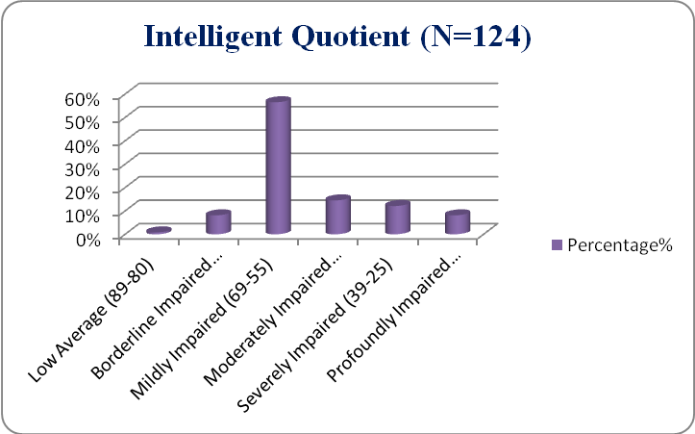
Figure (4): IQ results among studied cases
Table (4) and figure (4) show intelligent quotient results among studied cases, with minimum IQ score 20 and maximum IQ score 84.
Table (5): Hemoglobin (Hb) level among studied cases:
Hemoglobin level (N=124) | Age (4-12) |  | Percentage%
Normal (Hb >11.5g/dl) | 114 |  | 91.9%
Anemic (Hb ≤ 11.5 g/dl) | 10 |  | 8.1%
Mean: 12.68 ±1.08
- Hb range: from 2-6 years mean 12.5 g/dL (-2SD: 11.5 g/dL) and from 6-12 years mean 13.5 g/dL (-2SD: 11.5 g/dL); according to WHO 2011 (Marks and Glader, 2009).
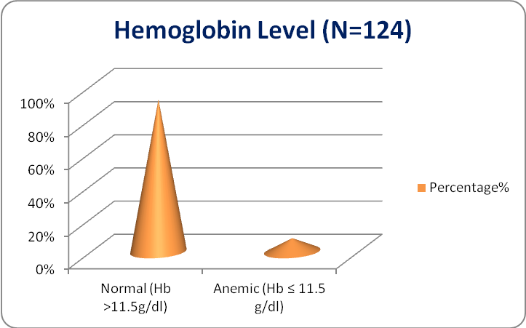
Figure (5): Hemoglobin level
Table (5) and figure (5) show hemoglobin level among studied cases is, where only (8.1%) of our cases were identified as anemic and (91.9%) were normal.
Table (6): EEG findings among studied cases:
EEG findings (N=124) | Number | Percentage%
Normal | 37 | 29.8%
Abnormal | 87 | 70.2%
 | 124 | 100%

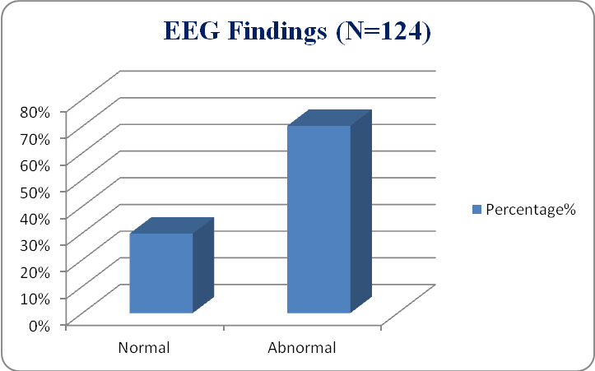
Figure (6): EEG findings
Table (6) and figure (6) show that 70.2% of studied cases had abnormal EEG recording, while 29.8% of studied cases had normal EEG recording.
Table (7): Character of EEG abnormality among studied cases:
Character of EEG abnormality (N=87) | Number | Percentage%
Focal epileptiform activity | 34 | 39.1%
Generalized slow wave activity | 23 | 26.44%
Generalized epileptiform activity | 21 | 24.14%
Multi-focal epileptiform activity | 9 | 10.34%
 | 87 | 100%

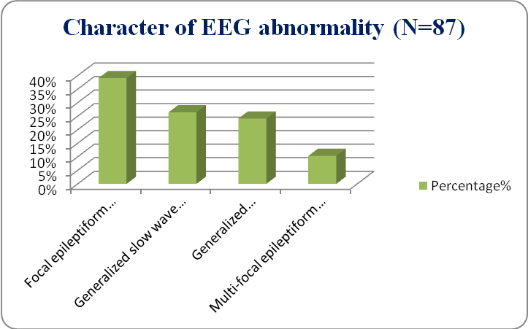
Figure (7): Character of EEG abnormality
Table (7) and figure (7) show that among studied cases; (27.4%) had focal epileptiform activity, (18.5%) had generalized slow wave activity, (16.9%) had generalized epileptiform activity and (7.3%) had multi-focal epileptiform activity.
Table (8): Percentage of EEG abnormal findings among epileptic and non-epileptic sub-groups of CP cases:
EEG findings (N=124) | Epileptic CP cases (N=59) |  | Non-epileptic CP cases (N=65)
EEG findings (N=124) | Number | Percentage% | Number | Percentage%
Normal | 11 | 18.64% | 26 | 40%
Abnormal | 48 | 81.36% | 39 | 60%

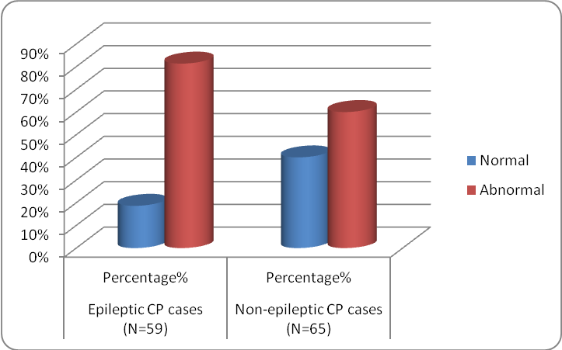
Figure (8): Percentage of EEG abnormal findings among epileptic and non-epileptic CP cases
Table (8) and figure (8) show (81.36%) of the epileptic CP cases had (60%) of the non-epileptic cases had abnormal EEG recording, respectively.
Table (9): Epilepsy among studied cases:
Presence or absence of epilepsy (N=124) | Number | Percentage%
Epileptic | 65 | 52.4%
Non-epileptic | 59 | 47.6%
 | 124 | 100%

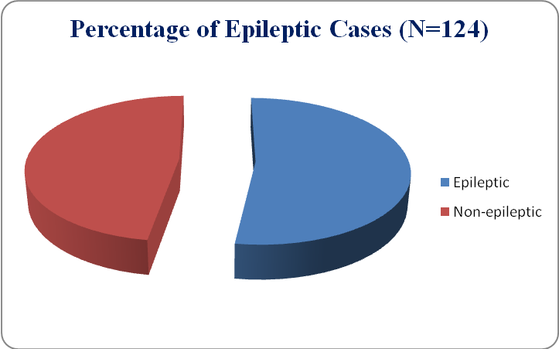
Figure (9): Epilepsy among studied cases
Table (9) and figure (9) show that (47.6%) of studied cases were found to be epileptic, while (52.4%) were not epileptic.
Table (10): Type of epileptic seizures among studied epileptic cases:
Type of epileptic seizures (N=59) | Number | Percentage%
Partial seizures | 31 | 52.54%
Generalized seizures | 28 | 47.46%
 | 59 | 100%

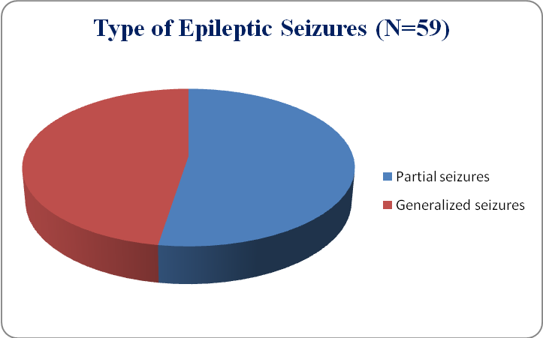
Figure (10): Type of epileptic seizures
Table (10) and figure (10) show that 52.54% of fifty nine cases, who experience seizure activity, had partial seizures, while 47.46% had generalized seizures.
Table (11): CSHQ total and individual sleep variables scores among studied cases
CSHQ score (N=124) | Mean | Standard deviation ±
Bed Time Resistance | 9.26 | ± 2.88
Sleep Onset Delay | 1.56 | ± 0.80
Sleep Duration | 4.04 | ± 1.15
Sleep Anxiety | 5.27 | ± 1.65
Night Waking | 3.48 | ± 0.96
Parasomnias | 8.15 | ± 1.58
Sleep Disordered Breathing | 3.87 | ± 1.30
Daytime Sleepiness | 11.61 | ± 3.2
Total CSHQ score | 44.53 | ± 9.55

Table (11) shows the mean and standard deviation of CSHQ total and individual sleep variables scores among studied cases; bed time resistance: 9.26 ± 2.88, sleep onset delay s: 1.56 ± 0.80, sleep duration: 4.04 ±1.15, sleep anxiety: 5.27 ±1.65, night waking: 3.48 ±0.96, parasomnias: 8.15 ± 1.58, sleep disordered breathing: 3.87 ± 1.30 and daytime sleepiness: 11.61 ± 3.2, respectively.
Table (12): Percentage of sleep disturbance among studied cases as indicated by total CSHQ score ≥ 41:
Total CSHQs score (N=124) | Number | Percentage%
Normal (<41) | 64 | 51.61%
Abnormal (≥ 41) | 60 | 48.38%
 | 124 | 100%

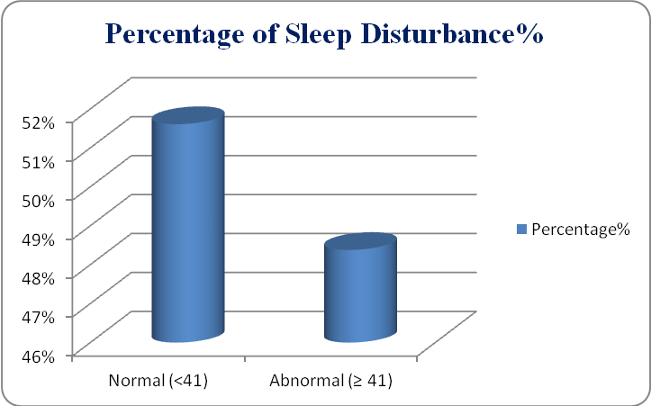
Figure (11): Percentage of Sleep Disturbance
Table (12) and figure (11) show that 51.61% of studied cases had normal total CSHQ score, while 48.38% had abnormal total score.
Table (13): Correlation among sleep disturbance studied cases
Sleep disturbance correlates |  | r | P -value
Gender | Male | - .314 | <0.001
Gender | Female | - .314 | <0.001
Age |  | - .197 | 0.047
Hemoglobin level | Anemic |  | >0.05
Hemoglobin level | Not anemic |  | >0.05
Topographic neurological distribution |  | 0.79 | <0.001
Intelligent Quotient |  | 0.197 | < 0.001
Presence or absence of epilepsy | Epileptic | 8.4 | < 0.001
Presence or absence of epilepsy | Non epileptic | 8.4 | < 0.001
- Significant correlation P < 0.05.
- Table (13) shows that there was a significant correlation between sleep disturbance and the following; male gender, younger age, a more “total” body involvement of impairment, a more degree of intellectual disability and the presence of epilepsy.
- Discussion:
This study was carried out on 124 cases of cerebral palsy (CP), their age ranged from 4 to10 years old with a mean age mean 6.41 ± 1.6 years old. They were 80 males (64.5%) and 44 females (35.5%), with M: F=1.8:1, this means there is male predominance in our study population. Also Wayte et al. (2012) and Atmawidjaja et al. (2014) reported a male preponderance with a sex ratio M: F = 2.03 and 1.27 respectively.
The presence of pyramidal or extrapyramidal signs is considered the characteristic clinical feature among all syndromes of CP. CP does not represent a certain disease, and the term CP does not imply a particular cause (Gupta and Appleton, 2001).
The current study demonstrates that children were categorized into 3 main clinical types according to the tone of the muscle into: spastic hypertonic (pyramidal); 92.7%, dyskinetic (extrapyramidal); 6.45% and ataxic (hypotonia); 0.8%. Similarly, Atmawidjaja et al. (2014) showed parallel results whereby hypertonia accounted for 89% and hypotonia 9%. While another study by Wayte et al. (2012) showed that; 84% were spastic, 8% were athetoid and 8% were ataxic.
In terms of topographic classification in the present study researcher had three categories; the first one is diplegia representing 55.2%, secondly quadriplegia representing 28% and thirdly hemiplegia representing 8.8%. On the contrary, Wayte et al. (2012) showed quite different results from ours where diplegia, quadriplegia and hemiplegia were representing 22%, 35% and 27% respectively. Another study by Atmawidjaja et al. (2014) showed different percentages of diplegia, quadriplegia and hemiplegia; 39%, 41% and 9% respectively. The difference in topography can be attributed to the different etiologies in our studies and others.
In the present study, Stanford Binet test 5th edition revealed the following intelligent quotient scores among our study population; Low Average (89-80): 0.8%%, borderline impaired (79-70): 8.1%, mildly Impaired (69-55): 56.5%, moderately impaired (54-40): 14.5%, severely Impaired (39-25): 12.1%, profoundly impaired (24-10): 8.1%. On the contrary Wayte et al. (2012) reported different results where normal, mild and moderate, severe and profound represented 37.5%, 32.5% and 25% respectively. Another study by Atmawidjaja et al. (2014) showed parallel results; no intellectual disability13%, mild 26%, moderate to severe 61%.
In the present study, 47% of CP children were epileptic, while 52% were not. These findings were close to those reported by Wayte et al. (2012) where 62.5% were epileptic. While Atmawidjaja et al. (2014) reported that only 27.5% had active seizures.
Electroencephalogram results showed abnormal EEG findings was (81.36%) of the epileptic CP children and (60%) of the non-epileptics. These findings were consistent with those reported by Al-Sulaiman (2001); who reported that 92.6% of epileptic CP children had abnormal EEG findings while 76% of the non-epileptics had abnormal findings. Another study by Şenbi et al. (2002) stated that EEG was confirmed abnormal in epileptic CP as 90.3%, and in non-epileptic CP as 39.5%.
Generalized and partial forms were the most co-occurring types; however, other types of epilepsy can also occur. Individuals with quadriplegic CP commonly have generalized epilepsy, but individuals with hemiplegic CP commonly have localization-related epilepsy (Odding, et al., 2006).
In the present study, among 35 quadriplegic children with CP; 27 cases (78.1%) had epilepsy. Şenbi et al. (2002) also reported that tetraplegic/quadriplegic cases of CP had higher incidence of epilepsy (60.5%).
The CSHQ include insomnia-related domains, parasomnia- related domains, domains of excessive sleepiness and sleep breathing disorders (Imran and Praveen, 2014). Regarding sleep disturbances; 48.39% among CP studied children showed abnormal total CSHQ score. This finding was approximately similar to the results of Zuculo et al. (2014), where 60.4% of them present sleep disorders. Both results surpassing the prevalence reported in literature, which estimates that sleep problems affect approximately 33.0% of the population of CP (Galland et al., 2012). This percentage difference may be due to methodological differences such as the use of different scales in the assessment as well as the difference in age ranges.
The high incidence of sleep problems in the study population may still be underestimated, because, in this study, most of the CP children (60%) reported to be on medication that may interfere with sleep. It is also known that convulsive crisis as well as seizures’ spasticity, along with other symptoms of CP, may be treated with medications, which may result in side effects, such as sedation and sleepiness (Leite and Prado, 2004). In some cases, this may induce sleep, without necessarily providing its quality and, consequently, the quality of wake time activities, but it is capable of masking the diagnosis and the actual prevalence of sleep problems (Wiggs and Stores, 2004).
In this study, the CSHQ showed that 24.3% of the participants with CP usually or sometimes wake up in the middle of the night and 38.7%, usually or sometimes snore. It is speculated that these problems may be due to factors such as: motor impairment, chronic pain, respiratory disorders, and alterations in the circadian rhythm by visual impairment, epilepsy as well as alterations in sleep architecture (Galland et al., 2012). It was also observed that 36.3% of the participants with CP showed difficulties in initiating sleep and 75% had daytime sleepiness. In our study 23.4% have teeth grinding, 8% sleep talking, 8.8% and no one showed sleep walking.
Despite using a different questionnaire than ours; the general sleep habits questionnaire and the sleep diary (Lemos, 2005; Wey, 2001) to assess sleep disturbance, a study by Zuculo et al. (2014) showed parallel results; where night wakening and snoring represented 23.2% and 37.2% respectively, while difficulties in initiating sleep and daytime sleepiness represented 48.6% and 57.1%, respectively. The study also showed parallel results to those of our study; teeth grinding 28%, sleep talking 10% and sleep walking 2%.
Sub-scale scores revealed the following results: bed time resistance mean: 9.26, sleep onset delay with mean: 1.56, sleep duration with mean: 4.04, sleep anxiety with mean: 5.27, night waking with mean: 3.48, parasomnias with mean: 8.15, sleep disordered breathing mean: 3.87, and day time sleepiness mean: 11.61. There is no much difference between the mean of each subscale found in our study compared to those reported by Wayte et al. (2012); bed time resistance mean: 7.48, sleep onset delay with mean: 1.73, sleep duration with mean: 4.32, sleep anxiety with mean: 6.00, night waking with mean: 5.25, parasomnias with mean: 10.45, sleep disordered breathing mean: 4.20, and day time sleepiness mean: 11.55.
Researcher studied the correlations of different reported sleep disturbances, which included the following; gender, age, presence or absence of anemia, CP clinical subtypes (extent of body involvement), the degree of intellectual disability and presence or absence of epilepsy. Some studies found that epilepsy was an important factor (Lindblom et al., 2001) causing sleep disturbance, others did not (Wayte et al., 2012; Elsayed et al., 2013).
Some of the reported studies considered epilepsy to be a risk factor (Newman et al., 2006; by Lindblom et al., 2001) causing sleep disturbance, others did not (Wayte et al., 2012; Elsayed et al., 2013).
In the present study, there was significant correlation between presence of epilepsy and total sleep disturbances score; (P< 0.001) and also with individual subscales’ scores, where the presence of epilepsy showed statically significant correlation with all sub-scales except for sleep duration, there was no statistical significance and daytime sleepiness showed the most significant correlation; Bed Time Resistance (r = .336), Sleep onset delay (r = .423), Sleep Anxiety (r = .508), Night Waking (r = .342) ,Parasomnias (r = .352), Sleep disordered breathing (r = .379), and Daytime Sleepiness (r = .767).
The presence of active epilepsy among children was a principal factor associated with sleep disturbance. Those who were seizure-free showed no increased prevalence of either total sleep disturbances or in any specific disorder of sleep. Problems as fragmentation of sleep, reduced efficiency of sleep or repeated arousals, are the most commonly. The interaction between epilepsy and sleep disorders is not yet well understood (Bazil, 2003).
As regard the correlation between clinical subtypes of CP children, there was a significant correlation between quadriplegic cases (more “total” body involvement) and total sleep disturbance score. Children having spastic quadriplegic or dyskinetic CP were at higher risk for developing sleep disturbances, than those having hemiplegic or diplegic CP i.e. a more focal impairment of physical function (Newman et al., 2006).
There was a significant correlation between quadriplegia and presence of epilepsy (P = 0.001). Epilepsy occurs in 15- 60 % of children with CP, depending on CP type and origin (Carlsson et al., 2003).
In the current study researcher have assessed the relationship between the degree of intellectual disability and sleep disturbance; where a significant correlation has been found (r= 0.65, P= 0.001).
Intellectual disability was reported to be significantly correlated to sleep problems (Didden et al., 2002). The more severe degree of intellectual disability was a predictor of increased nighttime sleep (Lindblom et al., 2001).
In few studies, there was a significant correlation between problems of sleep and the co-morbid intellectual disability (Didden et al., 2002). Paradoxically; another study considered the severity of intellectual disability ‘‘protective factor’’ for the occurrence of problems of sleep problems as it may increase the nighttime sleep (Lindblom et al., 2001).
Regarding the age difference in our study population; there has been found a significant correlation between younger ages and total sleep disturbance score (r =0.197, P= 0.047), as well as the following sub-scales’ scores; Sleep onset delay (r= 0.194, P= 0.031), Night Waking (r= 0.238, P= 0.008), Sleep disordered breathing (r= 0.255, P= 0.004) and Daytime Sleepiness (r= 0.229, P= 0.01).
Also the following items were significantly higher among younger ages; “falls asleep in own bed”, “falls asleep in other’s bed” and “afraid of sleeping alone” that were significantly higher in younger ages, where (r= 0.185, P= 0.04), (r= 0.343, P= 0.001) and (r= 0.269, P= 0.003), respectively.
In 2013, Iwadare and his colleages used the CSHQ to assess sleep among Japanese elementary school children (equivalent to the age in our study); who had been sub-divided into 3 sub-groups according to their grades; low, middle and high grade. Some of the obtained results from this study were quite similar to ours; where the Low grade group showed a significantly higher total score on the CSHQ-J vs. the High-grade group. Bedtime resistance encompass some items such as "falls asleep in own bed," "falls asleep in other's bed," and "afraid of sleeping alone", those mentioned items measured in the Low-grade group were found significantly higher vs. the High-grade group. As regard the Sleep anxiety; the item "afraid of sleeping alone" was found to be significantly higher in the Low-grade group vs. the High-grade group.
There was not significant correlation regarding the sleep duration, the night waking, parasomnia, or sleep-disordered breathing, which however was different from our results.
There was a significant correlation between male gender and total sleep disturbance score, (r = 0.314, P= 0.001). As well as the following sub-scale scores; Sleep anxiety (r= 0.186, P= 0.039), Night waking (r=0.232, P= 0.01), Sleep disordered breathing (r= 0.212, P= 0.018) and Daytime sleepiness (r= 0.304, P= 0.001). No significant correlation was found, between gender and the scores of; Bed Time Resistance sub-scale, Sleep onset delay sub-scale, Sleep duration sub-scale or Parasomnia sub-scale.
Iwadare et al., (2013) stated that no significant difference exists, between boys and girls in the following; CSHQ-J total and sub-item scores, the waking up time, the bedtime, or the sleeping time.
This difference in results can be attributed to the male gender predominance in our study (M:F = 1.8:1).
Bruxism is an involuntary act of clenching or grinding one’s teeth, either while awake or asleep, in an occasional to constant manner. Sleep bruxism is more common than awake bruxism (Van Selms et al., 2013). Among children with developmental disabilities, such as cerebral palsy, the prevalence ranges from 25.0% to 69.4% (Abanto et al., 2014).
Gender was independently associated with parent/caregiver-reported bruxism among the children with CP analyzed in the present study. While a number of previous studies have reported no association between bruxism and gender, (Ghafournia et al., 2012; Cheifetz et al., 2005; Seraj et al., 2010; Ghanizadeh et al., 2013; Cortese et al., 2013). A study found such an association and reported that the strength of the association with the male gender diminished with age (Lam et al., 2011). A similar finding was reported in another study in which the authors suggest that girls tend to be less aggressive and agitated than boys and, due to social impositions, boys are unable to express their feelings, whereas girls express their feelings mainly through crying (Renner et al., 2012). All studies cited involved questionnaires administered to parents/caregivers.
Anemia is defined as a low blood hemoglobin concentration, has been shown to be a public health problem that affects low-, middle- and high-income countries and has significant adverse health consequences, as well as adverse impacts on social and economic development (Balarajan et al., 2011).
Measurement of the blood hemoglobin concentration is considered the most reliable indicator of anemia at the population level is, however measurements of this concentration alone do not determine the cause of anemia. Approximately 50% of cases of anemia are considered to be due to iron deficiency, but the proportion probably varies among population groups and in different areas, according to the local conditions (Stevens et al., 2013).
Anemia resulting from iron deficiency adversely affects cognitive and motor development, causes fatigue and low productivity (Horton et al., 2001). In the present study, researcher aimed to screen for the presence of anemia among our CP cases; blood hemoglobin level was measured and results show that only (8.1%) of studied were anemic. It was also noted that there were no statistical significance (P > 0.05) between the presence of anemia and sleep disturbance.
Individuals suffering from neurodevelopmental delay, such as CP, have a risk of developing disturbances of sleep, which have broad consequences that affect both the child and family (Simard-Tremblay et al., 2011).
The functional motor abilities of children suffering from CP, along with insomnia and excessive sleepiness were associated with lower QOL; a finding that highlights the great importance of considering sleep disturbances when addressing the needs of children suffering from CP (Sandella et al., 2011).
Results of the current study indicated that children with CP had high incidence of sleep problem in elementary school age groups. There was association between sleep disturbance and co-morbid epilepsy, thus focusing on such special groups is necessary. All clinical subtypes of CP were found to be associated with disturbed sleep; this was specifically found among children with spastic quadriplegic CP. Questionnaires that are used for sleep assessment among individuals with CP can be considered as a simple screening tool for, with many studies supporting their validity.
Conclusion:
The CSHQ is considered a brief and simple parent-report survey for detecting sleep problems in children. Children with cerebral palsy are at risk of developing sleep problems of different patterns; bed time resistance, sleep onset delay, sleep anxiety, night awakening, teeth grinding, and snoring as well as day time sleepiness. Sleep disturbance was significantly correlated to several co-morbid factors including the degree of intellectual disability and the presence of epilepsy.
Recommendations
- Recognizing and managing disturbances of sleep can favorably result in improvement of sleep and daytime behavior, as well as family functioning.
- Awareness of the co-morbidities of CP may help guiding caregivers for dealing with their children and can help physicians delivering appropriate counseling.
- Primary, secondary and tertiary ways of prevention are important, following the previously mentioned guidelines in the present study.
- Children with CP should be referred to a pediatric neurologist and should be properly followed up for any disturbances that may affect their quality of life.
References:
- Abanto J, Ortega AO, Raggio DP, Bönecker M, Mendes FM and Ciamponi AL (2014): “Impact of oral diseases and disorders on oral health- related quality of life of children with cerebral palsy”. Spec Care Dentist. 2014 Mar; 34(2):56-63.
- Abu El-Niel M (2011): “Stanford Binet Intelligence Scale – version five”. The Arab Association for the preparation and publication of rationing and psychological tests, Cairo, Egypt.
- Abu Taleb M (2010): "Sleep habits in children with attention deficit / hyperactivity disorder compared to children without disabilities in the age group of 7-12 years”. Thesis; under the supervision of Prof Ahmed Mestikawi Ahmed, Prof. Saadia Badawi. Institute of Post-graduate Childhood Studies, Ain Shams University.
- Al-Sulaiman A (2001): “Electroencephalographic findings in children with cerebral palsy: a study of 151 children”. Funct Neurol. 2001 Oct-Dec; 16(4):325-8.
- Atmawidjaja RW, Wong S, Yang WW and Ong LC (2014): “Sleep disturbances in Malaysian children with cerebral palsy”. Developmental Medicine and Child Neurology. Mac Keith Press.
- Balarajan Y, Ramakrishnan U, Ozaltin E, Shankar AH and Subramanian SV (2011): “Anaemia in low-income and middle-income countries”. Lancet. 2011; 378:2123–35.
- Bazil CW (2003): “Epilepsy and sleep disturbance”. Epilepsy Behav. 2003; 4:S39–45.
- Carlsson, M; Hagberg, G. and Olsson I (2003): “Clinical etiological aspects of epilepsy in children with cerebral palsy”. Developmental Medicine and Child Neurology, 45: 371-376.
- Cheifetz AT, Osganian SK, Allred EN and Needleman HL (2005): “Prevalence of bruxism and associated correlates in children a reported by parents”. J Dent Child. 2005 May-Aug; 72(2):67-73.
- Colver A, Fairhurst C and Pharoah PO (2014): “Cerebral palsy”. Lancet. 2014 Apr 5; 383(9924):1240-9.
- Cortese SG, Fridman DE, Farah CL, Bielsa F, Grinberg J and Biondi AM (2013): “Frequency of oral habits, dysfunctions, and personality traits in bruxing and non-bruxing children: a comparative study. Cranio”. 2013 Oct; 31(4):283-90.
- Czeisler CA and Buxton OM (2011): “The human circadian timing system and sleep-wake regulation, in principles and practice of sleep medicine, M.H. Kryger, T. Roth, and W.C. Dement, Editors”. Saunders: St. Louis. p. 402-419.
- Didden R, Korzilius H, Van Aperlo B et al. (2002): “Sleep problems and daytime problems behaviours in children with intellectual disability”. J Intellect Disabil Res. 2002; 46(pt 7):537-547.
- Elsayed RM, Hasanein BM, Sayyah HE, El-Auoty MM, Tharwat N, Belal TM., (2013): “Sleep assessment of children with cerebral palsy: using validated sleep questionnaire”. Ann Indian Acad Neurol 2013; 16: 62–5.
- Galland BC, Elder DE and Taylor BJ. (2012): “Interventions with a sleep outcome for children with cerebral palsy or a post-traumatic brain injury: a systematic review”. Sleep Med Rev. 2012; 16(6):561-73.
- Ghafournia M and Hajenourozali Tehrani M (2012): “Relationship betresearcheren bruxism and malocclusion among preschool children in Isfahan”. J Dent Res Dent Clin Dent Prospects. 2012 Fall; 6(4):138-42.
- Ghosh D, Rajan PV, Das D, Datta P, Rothner AD & Erenberg G (2014): “Sleep disorders in children with Tourette syndrome”. Pediatr Neurol.2014; 51:31---5.32. Halal CS, Nunes.
- Guardiola-Lemaïtre B and Quera-Salva MA(2011): “Melatonin and the regulation of sleep and circadian rhytms, M. Kryger, T. Roth, and C.W. Dement, Editors”. St. Louis. p. 420-430.
- Gupta R and Appleton RE, (2001): “Cerebral palsy: not always what it seems”. Archives of Disease in Childhood. 85: 356-360.
- Gwetu TP, Chhagan MK, Craib M and Kauchali S (2013): “Hemocue Validation for the Diagnosis of Anaemia in Children: A Semi-Systematic Review”. Pediat Therapeut 4:187.
- Horton S and Levin C (2001): “Commentary on “evidence that iron deficiency anemia causes reduced work capacity”. J Nutr. 131:691S–6S.
- Imran M. and Praveen S., (2014): “Study of the Sleep Disturbances in Children with Autism Spectrum Disorder”. EUROPEAN ACADEMIC RESEARCH - Vol. II, Issue 1 / April 2014.
- IPGC (2014): “Ethical Committee of Institute of Post-graduate Childhood Studies”. Ain Shams University 2014.
- Iwadare Y, Kamei Y, Oiji A, Doi Y, Usami M, et al., (2013): “Study of the sleep patterns, sleep habits, and sleep problems in Japanese elementary school children using the CSHQ-J”. Kitasato Med J 2013; 43: 31-37.
- Lam MHB, Zhang J, Li AM and Wing YK (2011): “A community study of sleep bruxism in Hong Kong children: association with co-morbid sleep disorders and neurobehavioral consequences”. Sleep Med. Aug; 12(7):641-5.
- Leach EL, Shevell M & Bowden K (2014): “Treatable inborn errors of metabolism presenting as cerebral palsy mimics: systematic literature review”. Orphanet J Rare Dis. 2014 Nov 30; 9(1):197.
- Leite JMRS and Prado GF (2004): “Paralisia cerebral: aspectos fisioterapêuticos eclínicos”. Rev Neurocienc.; 12(1):41-5.
- Lemos MC (2005): “Incidência de características de hiperatividade /déficit de atenção e qualidade do sono em crianças de 7 a 10 anos de idade que frequentam o Centro Educacional Cavalcanti Lemos [dissertação]. SãoJosé dos Campos: Universidade do Vale do Paraíba.
- Lie KK, Groholt EK & Eskild A (2010): “Association of cerebral palsy with Apgar score in low and normal birth weight”. BMJ; 341:c4990.
- Lindblom N, Heiskala H, Kaski M, et al. (2001): “Neurological impairments and sleep-wake behaviour among the mentally retarded”. J Sleep Res. 2001; 10:309-318.
- Newman CJ, O'Regan M & Hensey O (2006): “Sleep disorders in children with cerebral palsy”. Dev Med Child Neurol, 48(7), 564-568.
- Odding E, Roebroeck ME & Stam HJ (2006):”The epidemiology of cerebral palsy: incidence, impairments and risk factors”. Disabil Rehabil. 28. 2006; 28(4):183–191.
- O'Shea M (2008): “Cerebral palsy”. Semin Perinatol. 2008 Feb; 32(1):35-41.
- Owens JA. Spirito A. & McGuinn M. (2000): “The Children's Sleep Habits Questionnaire (CSHQ): psychometric properties of a survey instrument for school-aged children”. Sleep. 2000; 23: 1043-51.
- Roid G (2003): “Stanford-Binet Intelligence Scales, Technical Manual. (5th edition)”. Itasca.
- Romeo DM, Bronga C, Quintiliani M et al. (2014): “Sleep disorders in children with cerebral palsy: neurodevelopmental and behavioral correlates” ScienceDirect. Sleep Medicine 15 (2014) 213-218
- Reddihough D (2011): “Cerebral palsy in childhood. Aust Fam Physician”. 2011; 40(4): 192-6.
- Şenbi N, Sonel B, Aydin OF, Kemal Y and Gürer Y, (2002): “Epileptic and non-epileptic cerebral palsy: EEG and cranial imaging findings”. Brain & Development. Official Journal of the Japanese Society of Child Neurology. April 2002Volume 24, Issue 3, Pages 166–169.
- Seraj B, Shahrabi M, Ghadimi S et al. (2010): “The prevalence of bruxism and correlated factors in children referred to dental schools of Tehran, based on parents’ report”. Iran J Pediatr. Jun; 20(2):174-80.
- Simard-Tremblay E, Constantin E, Gruber R, Brouillette RT & Shevell M, (2011): “Sleep in children with cerebral palsy: a review”. J Child Neurol. 2011 Oct; 26(10):1303-10.
- Stevens GA, Finucane MM, De-Regil LM et al. (2013): “Global, regional, and national trends in haemoglobin concentration and prevalence of total and severe anaemia in children and pregnant and non-pregnant women for 1995–2011: a systematic analysis of population-representative data”. Lancet Glob Health.
- Strauss D, Brooks J, Rosenbloom L & Shavelle R (2008): “Life expectancy in cerebral palsy: an update”. Dev Med Child Neurol. 2008; 50:487-493.
- Tietze AL, Blankenburg M, Hechler T et al. (2012): “Sleep disturbances in children with multiple disabilities”. Sleep Med Rev. 2012; 16(2):117-27.
- Wayte S, McCaughey E, Holley S & Annaz D (2012): “Sleep problems in children with cerebral palsy and their relationship with maternal sleep and depression”. Acta Paediatr 2012; 101: 618–23.
- Zimmerman RA and Bilaniuk LT (2006): “Neuroimaging evaluation of cerebral palsy”. Clin Perinatol; 33(2):517-44.
- Zuculo GM, Knap CCF and Pinato L (2014): “Correlation betresearcheren sleep and quality of life in cerebral palsy”. Luciana Pinato Avenida Hygino Muzzi Filho, 737, Vila Universitária, Marília (SP), Brasil, CEP: 17525-000. CoDAS; 26(6):447-56.

