Immunological Relation of Atopy with Type1 Diabetes in Children
Hanan Abd Allah El Gamal
From ⃰ Institute of Postgraduate Childhood Studies Ain Shams University
Mohamed Hesham El Hefnawy
Pediatric Clinic National Institute of Diabetes & Endocrinology
Hala Dawood Mohamed EL Gindi
Department of Child Health National Research Center , • Pediatric Clinic, New Cairo hospital .
Eman Ibrahim Mohammed•
ABSTRACT
Objective: assess immunological relation between atopic disease and Type 1 diabetes mellitus.
Subject and method: a cross sectional study was done by written questionnaire adopted from American Academy of Dermatology Journal, (March 2008), from 200 children with Type 1 diabetes mellitus attending pediatric clinic, National Institute of Diabetes , and 200 non diabetic children attending pediatric clinic, New Cairo hospital.
Results: cases had lower frequency of asthma compared to controls with statistically significant difference between both groups, no allergic conjunctivitis among cases was found but was 2 % among controls, cases had lower frequency of allergic rhinitis compared to controls with statistically significant difference between both groups and cases had lower frequency of atopic dermatitis compared to controls with no statistically significant difference between both groups.
This study shows no statistically significant difference between both groups as regard type of lactation, effect of kind of food in presence of atopical symptoms, exposure to tobacco smoke. This study shows that cases had lower frequency of interference with daily activities; lower frequency of family history of atopy. This study indicates that positive atopical cases had higher frequency of positive family history of atopy compared to negative group with statistically significant difference in between. This study shows that insulin dose among positive atopy cases was lower compared to negative atopy cases group with no significant difference.
Conclusion: patients with Type 1 diabetes have a lower prevalence of atopic symptoms, mainly asthma and allergic rhinitis which is consistent with the Th1/Th2 polarization concept.
Additional studies are needed to evaluate the effect of atopy and allergic diseases on glycemic control and long-term complications in patients with Type 1 diabetes and to understand why allergic symptoms among children with Type 1 diabetes have decreased.
Key words: Children, Type 1 diabetes, T helper1, T helper2
العلاقة المناعية لأمراض فرط الحساسية مع السكر من النوع الأول عند الأطفال
أجريت هذه الدراسة للتعرف على العلاقة المناعية بين كلا من الحساسية والسكر من النوع الأول بواسطة التعرف على الإختلاف فى نسبة حدوث الحساسية خلال الأطفال المصابون بالسكر من النوع الأول مقارنة بالأصحاء و ما إذا كان الأطفال المصابون بهذا النوع من السكر تقل بهم الإصابة بأمراض الحساسية و هل الأطفال المصابون بالحساسية أقل عرضة للإصابة بأمراض المناعة الذاتية مثل السكر من النوع الأول. وقد شملت هده الدراسة 200 طفل مصابون بمرض السكر من النوع الأول الذين يترددون على عيادة الأطفال بالمعهد القومي للسكر و200 طفل من الأصحاء المقاربين في السن والنوع.
و قد تم عمل الاستبيان لمعرفة تعرض مريض السكر من النوع الأول لأى نوع من انواع الحساسية مثل الحساسية الصدرية أو الحساسية الأنفية أو الإكزيما.
وقد وجدت الدراسة ان الحالات المصابة بمرض السكر من النوع الاول لديهم معدل اقل للاصابة بالحساسية الصدرية او الاكزيما او حساسية الانف من العينة الضابطة .
و لم توجد حالات مصابة بحساسية العين بين مرضى السكر من النوع الاول و اربعة اطفال فقط مصابون بحساسية العين من العينة الضابطة .
أما بالنسبة للعامل الو راثي وجدت الدراسة دلالة إحصائية بين المجموعتين من حيث وجود تاريخ عائلى للإصابة بالحساسية بين أفراد الأسرة حيث وجدت الاطفال المصابون بمرض السكر من النوع الأول لديهم نسبة اقل من حيث وجود تاريخ عائلى للإصابة بالحساسية وان الاطفال الذين يعانون من الحساسية لديهم نسبة أعلى من حيث وجود تاريخ عائلى للإصابة بالحساسية.
كما وجدت الدراسة ان الأطفال المصابون بمرض السكر من النوع الأول ويعانون من الحساسية يحتاجون لجرعات اقل من الإنسولين من الذين لا يعانون من الحساسية.
الخلاصة: الأطفال المصابون بالسكر من النوع الأول لديهم معدل اقل للاصابة بأمراض الحساسية وخاصة الحساسية الصدرية أو الحساسية الأنفية.
ويوصي البحث بضرورة اجراء المزيد من الأبحاث الموسعة للمساعدة في تقييم تأثير الحساسية على مستوى السكر وحدوث مضاعفات طويلة المدى في الأطفال المصابون بمرض السكر من النوع الأول.
أيضا يوصي بإجراء المزيد من الأبحاث لمعرفة سبب أن الحالات المصابة بمرض السكر من النوع الاول لديهم معدل اقل للاصابة بالحساسية الصدرية او الاكزيما او حساسية الانف اخذة في الاعتبار متابعة العوامل المؤثرة كالعامل البيئي والعامل الوراثي والاستجابة المناعية في الأطفال المصابون بمرض السكر من النوع الأول ويعانون من الحساسية أو الذين لا يعانون من الحساسية.
Introduction:
There has been considerable interest in defining the relationship between the expression of allergic and autoimmune diseases in populations of patients. Does an atopic disease decrease the risk of development of autoimmune diseases? Or patients that have autoimmune diseases is’ protected’ from developing allergic diseases? (1)
Type 1 diabetes, due to an absolute deficiency of insulin secretion and identified by serological evidence of an autoimmune pathologic process occurring in the pancreatic islets and by genetic markers (2)
Atopy is the propensity of an individual to produce IgE antibodies in response to various environmental antigens and to develop strong immediate hypersensitivity (allergic) responses (3). Atopic disease includes atopic dermatitis, allergic conjunctivitis, allergic rhinitis and asthma and appears to be a strong hereditary component. (4).
T-helper 1 (Th1) and T-helper 2 (Th2) cells play a key role in type 1 diabetes and atopic diseases, respectively. Because theTh1 and Th2 cells mutually inhibit each other (5), it has been speculated that patients with Type 1 diabetes have a lower predisposition to atopy. However, the findings have been conflicting (6).
Aim of the study: assessment of immunological relation between atopic disease and Type 1 diabetes mellitus.
Subject and method: a cross sectional study was done by written questionnaire from 200 children with Type 1 diabetes mellitus attending pediatric clinic, National Institute of Diabetes , and 200 non diabetic children attending pediatric clinic, New Cairo hospital.
The questionnaire adopted from American Academy of Dermatology Journal, (March 2008).
CASES REPORT

Across sectional study was done by written questionnaire from 200 children with Type 1 diabetes mellitus attending pediatric clinic, National Institute of Diabetes, and 200 non diabetic children attending pediatric clinic, New Cairo hospital. . Certain questions were added to contain the following topics: Age, sex, residence of the child, history of absolute breast feeding during the 1st six months, Job and level of education of the father and mother, number of rooms and number of family member inside the house, symptoms related to asthma (night cough, chest wheeze, difficult breathing) and symptoms related to severity of asthma (sleep disturbance, speech disturbance, and number of attacks during the last 12 months and hospitalization due to asthma) and medical treatment (controller therapy), symptoms suggesting other atopic diseases (allergic rhinitis, atopic dermatitis, and allergic conjunctivitis), family history of asthma and other atopic diseases, environmental conditions in and outside the house (exposure to tobacco smoke, the presence of nearby air pollution and exposure to family pets or farm animals),full history taking laying stress on age of onset of diabetes and duration of disease, insulin therapy (type, dose and frequency),history of complication as hypoglycemia and diabetic ketoacidosis ,history of atopic symptoms ( difficult respiration , night cough , skin rash ,….etc), family history especially diabetic and atopic history.
Full general and systemic examination was done with stress on signs of atopy or complication of diabetes.
RESULTS

Table (1) Comparison between both groups as regard asthma symptoms
P | Controls  N=200 | Cases  N=200 | Variables
<0.001  HS | 71(35.5%) | 18(9%) | History of respiratory distress
<0.001  HS | 70(35%) | 16(8%) | Sleep disturbance
<0.001  HS | 69(34.5%) | 16(8%) | Night wake
<0.001  HS# | 3+1.2 | 2+0.7 | Time of wake (mean+SD)
# unpaired t-test
This table shows that cases had lower percentage of symptoms compared to controls with statistically significant difference between both groups by using Fisher exact test.
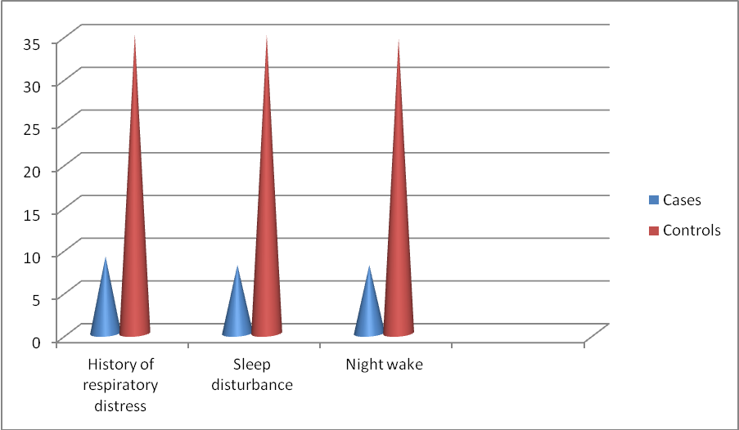
Figure (1): This graph indicates that cases had lower frequency of asthma symptoms compared to controls with significant difference.

Table (2) Comparison between both groups as regard other asthma symptoms
P | Controls  N=200 | Cases  N=200 | Variables
<0.05  S | 14(7%) | 4(2%) | Wheeze after exercise
<0.001  HS | 71(35.5%) | 18(9%) | Wheeze after cold
<0.001  HS | 13(6.5%) | 3(1.5%) | Wheeze limit speech
<0.001  HS | 71(35.5%) | 16(8%) | Dry cough
<0.001  HS | 71(35.5%) | 17(8.5%) | Asthma
<0.05  S | 12(6%) | 3(1.5%) | Previous admission
<0.001  HS# | 4+0.9 | 3+0.7 | Number of attacks
#unpaired t-test
This table shows that cases had lower frequency of symptoms compared to controls with statistically significant difference between both groups by using Fisher exact test.
Figure (2): This graph indicates that cases had lower frequency of qualitative variables like wheeze, dry cough, asthma and previous hospital admission compared to controls with significant difference
Table (3) Comparison between both groups as regard Allergic conjunctivitis, Allergic rhinitis, Atopic dermatitis.
P | Controls  N=200 | Cases  N=200 | Variables
>0.05  NS | 4(2%) | 0 | Allergic conjunctivitis
<0.001  HS | 33(16.5%) | 3(1.5%) | Allergic rhinitis
>0.05  NS | 37(18.5%) | 31(15.5%) | Atopic dermatitis
#unpaired t-test
This table shows that cases had lower frequency of allergic rhinitis compared to controls with statistically significant difference between both groups by using Fisher exact test. No significant difference as regard allergic conjunctivitis or atopic dermatitis.

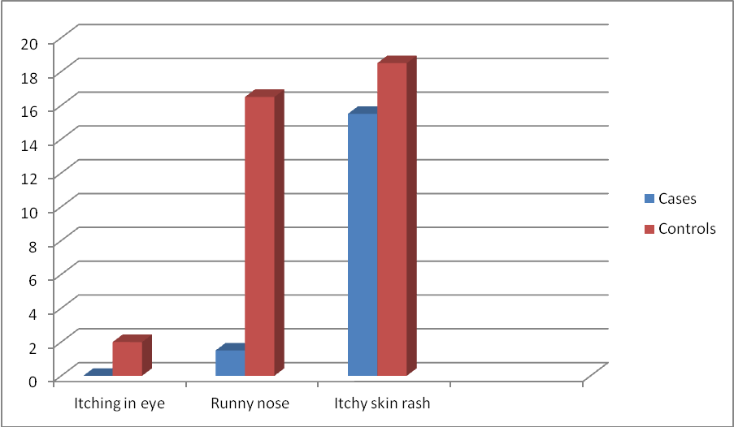
Figure (3): There is a lower frequency of allergic rhinitis among cases compared to controls with statistically significant difference.
Table (4) Comparison between both groups as regard family history of atopy
P | Controls  N=200 | Cases  N=200 | Variables
<0.001  HS | 106(53%) | 56(28%) | Yes
<0.001  HS | 94(47%) | 144(72%) | No

This table shows that cases had a lower % of history of atopy with statistically significant difference between both groups by using Fisher exact test.
Figure (4): This graph shows higher frequency of positive family history of atopy among control group with statistically significant difference.
Relation between atopy versus FH 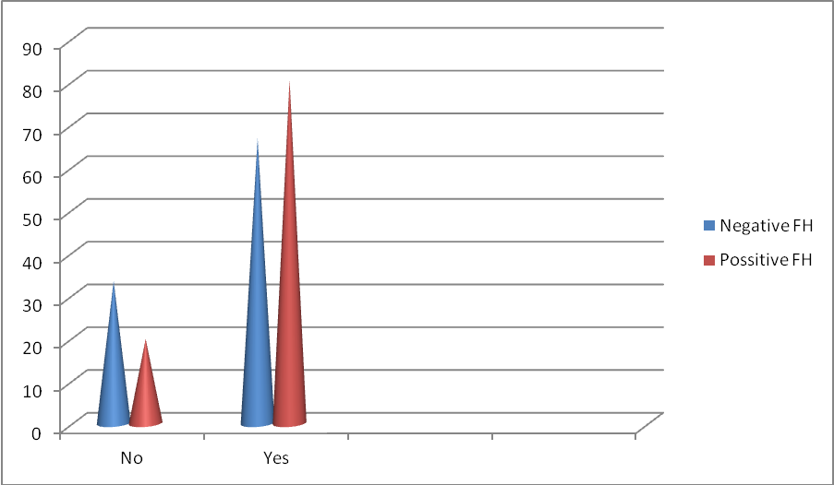
Figure (6) : This graph indicates that positive atopy cases had higher frequency of positive family history of atopy compared to negative group with statistically significant difference in between by using Fisher exact test p<0.05 .

Relation between atopy versus insulin dose

Figure (5) : Box plot indicates that median insulin dose among positive atopy was lower compared to negative atopy group with no significant difference by using unpaired t-test p>0.05
DISCUSSION
T-helper 1 (Th1) and T-helper 2 (Th2) cells play a key role in the pathogenesis of Type 1 diabetes diabetes and atopic diseases, respectively. Th1 and Th2 cells mutually inhibit each other. It has been speculated that patients with Type 1 diabetes have a lower predisposition to atopy.
The present work aimed to identify the immunological relation between atopy and insulin dependent diabetes mellitus diseases by identification the difference in the prevalence of atopy among insulin dependent diabetes mellitus patients as compared to the general population.
Current results showed that prevalence of atopy among 200 diabetic and 200 non diabetic children was: prevalence of bronchial asthma was 8.5% asthmatic among cases but among control children was 35.5% are asthmatic, so cases had lower frequency of asthma compared to controls with statistically significant difference between both groups.
No allergic conjunctivitis among cases was found but was 2 % among controls, allergic rhinitis among cases was 1.5% with statistically significant difference between both groups but among control is 16.5%, no significant difference between both groups.
Skin allergy among cases was 15.5% but among control was 18.5%, so cases had lower frequency of atopic dermatitis compared to controls with no statistically significant difference between both groups.
This is in agreement with study found that that The prevalence of allergic disease and atopy is decreased in Th1-mediated autoimmune disease, Type 1 diabetes DM, and, conversely, is increased in insufficient Th1 response (7)
Similary, another study found patients with Type 1 diabetes have a decreased risk of atopic dermatitis occurrence. (8)
Also, another work reported that Th1 vs Th2 cell dichotomy for type 1 diabetes and atopic dermatitis, and indicates an inverse association between genetic factors for these disorders. (9)
This is in agreement with a report found that asthma, inversely associated with Type 1 diabetes and autoimmune diseases in general. (10)
And an inverse association has been found between atopic diseases and childhood Type 1 diabetes (11)

Also, there is study found an inverse association between Type 1 diabetes and allergic contact dermatitis. (12)
On the other hand, another study found that the prevalence of allergic diseases and sensitization in patients with DM1 was higher than usually expected. (13)
Gazit (14) found that no significant difference in the prevalence of atopic dermatitis, allergic rhinitis, conjunctivitis, food allergy and asthma between the two groups.
This study shows that controls had higher percentage of family history of atopy (53%) than cases (28%) with statistically significant difference between both groups.
Alford et al (15) reported that atopy increases with the number of close relatives suffering from atopic diseases, which suggests polygenetic inheritance. Also Kuyucu et al (16) found that children from parents with asthma or other atopic disorders present an increased risk of developing similar disease. Also, Arruda et al (17) found that the presence of asthma cases aggregation among related individuals may indicate either shared genes or a common household environment.
Having a close relative with an atopic disease is one of the most distinct risk factors for one’s own development of an atopic disease. A child with one atopic parent has a 25% risk of atopy; a child with two atopic parents has a 50% risk of atopy (18)
There are studies found that a maternal history of atopic dermatitis is considread as risk factor for atopic dermatitis in their children, and also become more predictive of eczema in their children more than a paternal history of eczema. (19)
It is logical to postulate that a mother with history of atopy may have specific antibodies against antigens that trigger the atopy, and these antibodies may pass in her breast milk. It is also known that atopic dermatitis is highly hereditary and family history or twins with the atopy is strongly related to presence of atopic dermatitis in infants (20)
In this study box plot indicates that median insulin dose among positive atopy was lower compared to negative atopy group with no significant difference by using unpaired t-test p>0.05
But another study reported that insulin also has anti-inflammatory effect in the context of severe Th1-type inflammation. Insulin has been found to reduce levels of inflammatory cytokines. (21)
It has been subsequently shown that high levels of insulin promote air way smooth muscle (ASM) contraction and enhance contractile responses to methacholine and KCl (22)

Insulin effects on ASM are likely to result in increased airway contractility, cell proliferation, and fibrosis, all of which should lead to a thicker, stiffer, and hyper contractile airway reflective of an asthma phenotype (23).
Conclusion: patients with T1D have a lower prevalence of atopic symptoms, mainly asthma and allergic rhinitis which is consistent with the Th1/Th2 polarization concept. Additional studies are needed to evaluate the effect of atopy and allergic diseases on glycemic control and long-term complications in patients with type 1 DM. It is possible that further research may allow using immunotherapy in Type 1 diabetes.
REFERENCES
1-Martinez FD(2007). Gene–environment interactions in asthma.: with apologies to William of Ockham. Proc Am Thorac Soc;4:26–31. [PMC free article] [PubMed]
2-American Diabetes Association (2015)Diabetes Care 2015;38(Suppl. 1):S1–S2 | DOI: 10.2337/dc15-S001
3-Abbas AK, Lichtman AH(2008),Disorders caused by immune responses:Basic immunology ,Function and Disorders of immune system ,3rd edition,California ch11p205
4-Stromberg L(2004): Diagnostic accuracy of the atopy patch test and the skin-prick test for the diagnosis of food allergy in young children with atopic eczema/dermatitis syndrome. Acta Paediatr, 91:1044–1049.
5-McGeadySJ(2004) .Immunocompetence and allergy . Pediatrics ;113:1107–1113
6-Cardwell CR, Shields MD, Carson DJ,Patterson CC(2003). A meta-analysis of the association between childhood type 1 diabetes and atopic disease. Diabetes Care; 26:2568–257
7-Cakir M, Akcay S, Karakas T, Gedik Y, Okten A, Orhan F(2008) Prevalence of atopy in children with type 1 diabetes mellitus, hepatitis B virus carriers, and healthy children: role of T helper 1 (Th1)-type immune response. Allergy Asthma Proc; 29:166–70.
8-Romanian Journal of Diabetes (2012): Nutrition & Metabolic Diseases/ Vol. 19/ no. 2 /
9-Thomsen SF, Duffy DL, Kyvik KO, Skytthe A, Backer V. (2011) Relationship between type 1 diabetes and atopic diseases in a twin population. Allergy 66, 645647.
10-Tirosh A, Mandel D, Mimouni FB, Zimlichman E, Shochat T, et al. (2006) Autoimmune diseases in asthma. Ann Intern Med 144: 877–883.
11-SteneLC,RonningenKS,BjornvoldM,UndlienDE,JonerG(2010) An inverse association between history of childhood eczema and subsequent risk of type 1 diabetes that is not likely to be explained by HLA-DQ, PTPN22, or CTLA4 polymorphisms. Pediatr Diabetes 11:386–393

12-Cavani A, De PO, Girolomoni G (2007) New aspects of the molecular basis of contact allergy. Curr Opin Allergy Clin Immunol 7: 404–408
13-Villa-Nova H1, Spinola-Castro AM2, Garcia FE2, Solé D Allergol Immunopathol (Madr).(2014) Prevalence of allergic diseases in children and adolescents with type 1 diabetes mellitus. Aug 1. pii: S0301-0546(14)00032-9. doi: 10.1016/j.aller.2013.11.009.
14-Gazit, V., Tasher, D., Hanukoglu, A., Landau, Z., Ben-Yehuda, Y., Somekh, E. and Dalal, I(2008)., Atopy in children and adolescents with insulin-dependent diabetes mellitus. Isr Med Assoc J. 10: 858-861
15-Alford SH, Zoratti E, Peterson EL, et al. (2005): Parental history of atopic disease: disease pattern and risk of pediatric atopy in offspring. J. Allergy Clin. Immunol. Jul;116(1):231-2, author reply 232
16-Kuyucu S, Sarac LY, Tuncer A, et al (2004): Determinants of atopic sensitization in Turkish school children: Effects of pre- and post-natal events and maternal atopy. Pediatr. Allergy Immunol., 15:62–71.
17-Arruda LK, Sole D, Baena-Cagnani CE, Naspitz CK (2005): Risk factors for asthma and atopy. Curr. Opin. Allergy Clin. Immunol 5:153-159
18-Palmer LJ, Cookson WOCM. Atopy and asthma. In: Bishop T, Sham P, eds(2000). Analysis of multifactorial disease. Oxford: BIOS; pp. 215–37.
19-Moore, M.M.; Rifas-Shiman, S.L.; Rich-Edwards, J.W.; Kleinman, K.P.; Camargo, C.A., Jr.; Gold, D.R.; Weiss, S.T.; Gillman, M.W. (2006) Perinatal predictors of atopic dermatitis occurring in the first six months of life. Pediatrics, 113 Pt 1, 468–474.
20-Van, E.P.; Little, R.D.; Dupuis, J.; del Mastro, R.G.; Falls, K.; Simon, J.; Torrey, D.; Pandit, S.; McKenny, J.; Braunschweiger, K.; et al(2008). Association of the ADAM33 gene with asthma and bronchial hyperresponsiveness. Nature, 418, 426–430.
21-Shapiro H ,. Kagan I , Shalita-Chesner M. , Singer J. , and. Singer P, (2010). “Inhaled aerosolized insulin: a “topical” anti-inflammatory treatment for acute lung injury and respiratory
22-Kim H. K, Lee C. H, Kim J. M, Ayush O., Im S.Y., and Lee H.K ,(2013) “Biphasic late airway hyperresponsiveness in a murine model of asthma,” International Archives of Allergy and Immunology, vol. 160, no. 2, pp. 173–183,
23- Dekkers B. G. J , Schaafsma D. , Tran T., Zaagsma J., and Meurs H. ,(2009) “Insulin-induced laminin expression promotes a hypercontractile airway smooth muscle phenotype,” American Journal of Respiratory Cell and Molecular Biology, vol. 41, no. 4, pp. 494–504,. View at Publisher · View at Google Scholar · View at Scopus

