Assessment Of Urinary Cystatin C In Type1 Diabetic Children
Dr. Hayam Kamal Nazif*, Dr. Mohamed Hesham El Hefnawy**,
Dr. Ibrahim Ali Emara***, Abdel Hamid Ezzat Abdel Hamid****
* Prof. of Pediatrics, Dean of the Institute of Postgraduate Childhood Studies
**Prof. & Head of Pediatric Department, Dean of National Institute of Diabetes and Endocrinology.
***Prof. of Biochemistry, National Institute of Diabetes and Endocrinology.
****M.Sc. of Pediatrics – Cairo University
ABSTRACT
Background: Diabetes is the disease of this century; its incidence had progressively increased in the last few years especially in young ages. Cystatin C is a single chain non glycosylated basic protein produced by all nucleated cells at a constant rate freely filtered by the renal glomernli and almost entirely reabsorbed in the proximal tubule and its level in urine increases in cases with renal tubular dysfunction.
Aim of the Work: The aim of the present study was to assess the urinary Cystatin C excretion in diabetic children attending the pediatric department of the National Institute of Diabetes and Endocrinology (NIDE) in comparison with apparently healthy children with comparable age and sex.
Methods: We studied 60 children and adolescents (38 females and 22 males) with type 1 diabetes. They had a mean age of 13.93 ± 2.92 years ranging from 10-18 years and a mean duration of 6.67±3.35 years of diabetes. In addition to 30 healthy children and adolescents included as a control group, fourteen of them were females and 16 were males having a mean age of 14.73±2.13 years with the age range of 10:18 years. All subjects were subjected to full history taking and thorough clinical examination with special emphasis on diabetic details and complications and an investigations including Microalbuminuria detected by measuring the albumin in urine by turbid metric method and urine creatinine by colorimetric measure and represented by [(A/C) ratio] also urinary Cystatin C excretion by ELISA from a morning urine sample was tested.
Results and Conclusion: High urinary Cystatin C levels were present in 41diabetic patients and none of the control group and were positively correlated to HbA1c and microalbuminuria (MA).
Key Words: Urinary Cystatin C in type 1diabetes: assessment, and correlations.
دراسة السيستاتين سي البولي في أطفال السكر من النوع الأول
إن مرض السكري هو مرض العصر فقد زادت نسبة حدوثه بطريقة مطردة خلال السنوات الأخيرة وخاصة في الأعمار الصغيرة.
سيستاتين سي هو سلسلة أحادية من البروتين القاعدى غير النشوى ينتج من كل خلايا الجسم بمعدل ثابت ويتم خروجه من خلايا الكلى بحرية تامة ثم يتم إعادة امتصاصه كاملاً في الأنابيب الكلوية القريبة ويزيد معدل إخراجه في البول في حالات اختلال عمل هذه الأنابيب.
الغرض من الدراسة:
هو بحث زيادة إفراز السيستاتين سي في الأطفال مرضى السكري الذين يترددون على قسم الأطفال بالمعهد القومى لأمراض السكر والغدد الصماء مقارنة بالأطفال الأصحاء المقاربين لهم في السن والجنس.
أسلوب الدراسة:
اشتملت هذه الدراسة على 60 طفلاً ومراهقاً (38 أنثى و22 ذكر) من مرضى داء السكري من النوع الأول والذين تراوحت أعمارهم بين 10- 18 سنة بمتوسط أعمار 13،91سنة + 2،92 ومتوسط مدة حدوث السكري 6،67 سنة + 3،35 بالإضافة إلى 30 طفلاً ومراهقاً من الأصحاء كمجموعة مقارنة (14 أنثى و16 ذكر) والذين تراوحت أعمارهم أيضاً بين 10- 18 سنة بمتوسط أعمار 14،73 سنة + 2،13.
وقد تم أخذ التاريخ المرضى المفصل لهم وعمل الفحص الإكلينيكي مع التركيز على تفاصيل مرض السكري كما تم عمل بعض الفحوصات المعملية والتي اشتملت على الفحص الدقيق في البول عن طريقة قياس الزلال البولي بطريقة قياس معامل التفكير والكرياتينين البولي بطريقة قياس معامل التلوين وتم التعبير عنه بنسبة الزلال إلى الكرياتينين في البول كما تم قياس معامل إخراج السيستاتين في البول بطريقة الأليزا من عينة بول الصباحية.
النتائج المستخلصة:
خلصت النتائج إلى وجود معدلات زائدة للسيستاتين كما في البول في 41 من مرضى داء السكري الخاضعين للدراسة وعدم وجوده في أي من الأطفال الأصحاء في المجموعة المقارنة.
كما تبين ارتباطه طردياً بنسبة السكر التراكمي والزلال الدقيق في هؤلاء الأطفال.
الكلمات المفتاحية
سيستاتين سي في مرضى السكري من النوع الأول بحث وجوده وارتباطه.
INTRODUCTION
Type 1 diabetes is the most common endocrinal and metabolic disease in children and adolescence. Its incidence and prevalence has been increased largely in the last decade (5). It causes great burden on patients and their families either economic or psychological. Diabetes mellitus affects the renal tissues initiating several structural and functional abnormalities of the tubular interstitium up to glomerular changes resulting in higher excretion of tubular injury markers (6).
An increased urinary low molecular weight protein (tubular proteins) indicates proximal tubular injury as N. acetyl B glucosaminidase, retinol binding protein, B2 microglobulin and Cystatin C (8). Cystatin C is a basic protease inhibitor that is produced constantly by all nucleated cells. It's freely filtered by renal glomeruli and primarily catabolized by the tubules. Its level doesn’t depend on age, gender and body mass (3). Increased urinary Cystatin C can detect tubular dysfunction in pure and mixed nephropathies. In this study we assessed the urinary Cystatin C excretion in type 1 diabetic children and adolescents and its correlation to microalbuminuria (9).
AIM OF THE WORK
The aim of this study was to assess the urinary Cystatin C excretion in type 1 diabetic children and adolescents and its correlation with microalbuminuria.
Ethical aspect:
Ethical consent
This study was accepted by the ethical committee of the institute of postgraduate childhood studies and ethical committee of NIDE
Written informed consent was obtained from care givers after explanation of the nature and aims of study, its benefits for their children and for all the community and expected risks for their children in this study.
Verbal assent
Informed verbal assent was being taken from children over 8 years after a simplified explanation of the aim and benefits of the study.
Type of study:
Case control study.
SUBJECTS AND METHODS
Subjects:
Sixty children and adolescents suffering from type 1 diabetes for more than 3 years were included in this prospective study as the patient group. They were attending the pediatric department and outpatient clinic at National Institute of Diabetes & Endocrinology (NIDE) during year 2015 from 1/1/2015 to 31/12/2015. They had a mean age of 13.93 ± 2.92 years ranging from 10-18 years and a mean duration of 6.67±3.35 years of diabetes.
Additionally 30 apparently healthy children and adolescent with comparable sex and age without type1 diabetes were included as a control group. Fourteen of them were females and 16 were males having a mean age of 14.73±2.13 years with the age range of 10:18 years
Inclusion Criteria:
Type I diabetic children and adolescents diagnosed according to American Diabetes Association (ADA) criteria.
Age: 6-18 years old.
Disease duration more than 3 years of diabetes.
For the control group:
Non diabetic children and adolescents.
Age: 6-18 years old.
Exclusion Criteria:
Diabetics with any renal affection other than microalbuminuria (based on past medical data).
Presence of metabolic or any chronic disease other than diabetes (based on past medical data).
Methods:
Each subject was subjected to the following:
Full history taking with emphasis on the important relevant data
Thorough clinical examination including both general and systemic one with special emphasis on the following:
Blood pressure
Growth assessment by performing anthropometric measurements: including height, weight, and comparison of measures with the same age and sex using standard Egyptian charts and pubertal stagging according to Tanner’s White House (1973), body mass index was calculated using the equation: { BMI = wt (kg) / height (m2)}.
Investigations included:
Assessment of glycemic control by assessment of HbA1c using liquid chromatographic assay method (in addition to 2 readings from the medical records of patients).
Assessment of Albuminuria:
Morning urine sample was processed and albumin in urine was measured by turbidimetric measure and creatinine by enzyme colourimetric measure and A/C ratio was calculated. A/C ratio between 30 mg/gm – 300 mg/gm is considered microalbuminuria or positive result and below this range is normoalbuminuria or negative result.
If the microalbuminuria is positive, it is repeated and considered positive if it is positive for 2 times in a period of 3 months with negative urinary culture (1).
Assessment of Urinary Cystatin C by ELISA (Sunredbio.com):
Morning urine sample was collected, centrifugated and frozen at -20 °C till the time of analysis samples were processed after melting by ELISA technique to detect Cystatin C urine sample using Shanghai Sunred Biological Technology Co. Ltd kit.
Statistical Methods:
SPSS version 17.0 was used for data analysis. Mean and standard deviation described quantitative data and median with range when appropriate. Parametric and non-parametric t-test was used for comparing means of independent groups. Pearson correlation analysis was used to show magnitude of association between quantitative variables. P-value is two tailed and significant at 0.05 levels (7).
RESULTS
Table (1): Clinical and laboratory characteristics of the studied groups.
 |  | Control group | Patients group | Independent t-test
 |  | Control group | Patients group | T | p-value
Age | Mean±SD | 14.73 ± 2.13 | 13.93 ± 2.92 | 1.346 | 0.182
Age | Range | 11 – 18 | 10 – 18 | 1.346 | 0.182
W | Mean±SD | 46.23 ± 11.90 | 46.61 ± 15.59 | -0.116 | 0.908
W | Range | 31 – 86 | 25 – 82 | -0.116 | 0.908
H | Mean±SD | 147.07 ± 13.53 | 146.43 ± 15.45 | 0.193 | 0.847
H | Range | 109 – 167 | 106 – 174 | 0.193 | 0.847
BMI | Mean±SD | 21.21 ± 3.61 | 21.05 ± 4.21 | 0.170 | 0.865
BMI | Range | 15.7 – 33.5 | 14.2 – 33.3 | 0.170 | 0.865
Systolic BP | Mean±SD | 109.00 ± 9.23 | 110.50 ± 12.13 | -0.596 | 0.553
Systolic BP | Range | 90 – 130 | 90 – 130 | -0.596 | 0.553
Diastolic BP | Mean±SD | 69.67 ± 8.09 | 72.67 ± 7.56 | -1.734 | 0.086
Diastolic BP | Range | 50 – 80 | 60 – 80 | -1.734 | 0.086
Cystatin C | Mean±SD | 81.66 ± 8.99 | 91.82 ± 22.49 | -2.375 | 0.020
Cystatin C | Range | 65.9 – 102.5 | 3 – 140 | -2.375 | 0.020
HbAIC | Mean±SD | 5.39 ± 0.29 | 11.61 ± 2.70 | -12.537 | 0.000
HbAIC | Range | 4.8 – 5.8 | 4.4 – 16.5 | -12.537 | 0.000
CHOL | Mean±SD | 172.60 ± 37.51 | 187.62 ± 45.27 | -1.567 | 0.121
CHOL | Range | 15 – 224 | 103 – 348 | -1.567 | 0.121
T.G | Mean±SD | 109.70 ± 49.55 | 113.33 ± 64.11 | -0.272 | 0.786
T.G | Range | 43 – 261 | 45 – 279 | -0.272 | 0.786
HDL | Mean±SD | 47.70 ± 8.21 | 47.33 ± 8.86 | 0.190 | 0.850
HDL | Range | 31 – 61 | 35 – 66 | 0.190 | 0.850
LDL | Mean±SD | 107.63 ± 18.72 | 119.33 ± 38.09 | -1.586 | 0.116
LDL | Range | 79 – 147 | 38 – 237 | -1.586 | 0.116
Urea | Mean±SD | 24.37 ± 6.29 | 25.48 ± 6.77 | -0.755 | 0.452
Urea | Range | 13 – 39 | 12 – 40 | -0.755 | 0.452
Creat | Mean±SD | 0.82 ± 0.15 | 0.76 ± 0.12 | 2.103 | 0.038
Creat | Range | 0.5 – 1.2 | 0.5 – 1.1 | 2.103 | 0.038
Micro | Mean±SD | 29.25 ± 66.23 | 43.09 ± 64.69 | -0.950 | 0.345
Micro | Range | 2.36 – 364 | 1.43 – 285 | -0.950 | 0.345
A/c | Mean±SD | 17.51 ± 20.46 | 43.33 ± 48.94 | -2.765 | 0.007
A/c | Range | 1.21 – 116 | 3.61 – 253 | -2.765 | 0.007
ALT | Mean±SD | 16.00 ± 3.69 | 29.52 ± 28.16 | -2.611 | 0.011
ALT | Range | 9 – 22 | 8 – 200 | -2.611 | 0.011
AST | Mean±SD | 17.33 ± 3.18 | 30.90 ± 32.11 | -2.302 | 0.024
AST | Range | 12 – 27 | 9 – 222 | -2.302 | 0.024
*: Independent t-test BMI: Body mass index
P > 0.05: Non significant Wt: weight
P < 0.05: Significant Ht: height
P < 0.01: Highly significant
HbA1C: Glycosylated hemoglobin
Chol: Cholesterol
T.G: Triglycerides
HDL: High density lipoproteins
LDL: Low density lipoproteins
Micro: Microalbuminuric
A/C: Albumin/creatinine ratio
ALT: Alanine Transaminase
AST: Aspartate Transaminase
No significant difference was found between the two groups as regards Age, Sex, BMI, Wt, and Ht.
There was a significant difference between the patient and control groups as regards Cystatin C, HbA1c, A/C ratio, and liver enzymes which were higher in the patient group. Also there was a significant difference in creatinine which was on to be lower in patient group.
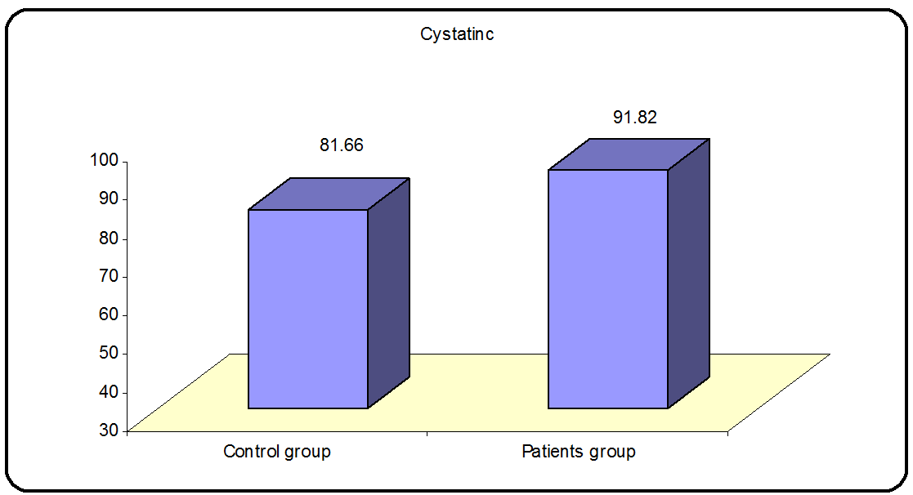
Fig (1): Urinary Cystatin C in patient and control groups.
P value = 0.02 significant difference
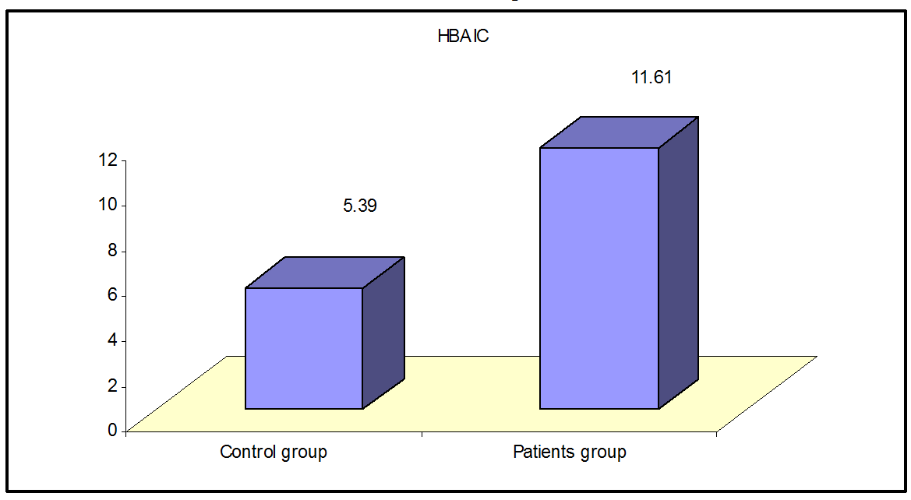
Fig (2): Glycosylated hemoglobin in patient and control groups.
P value = 0.000 significant difference
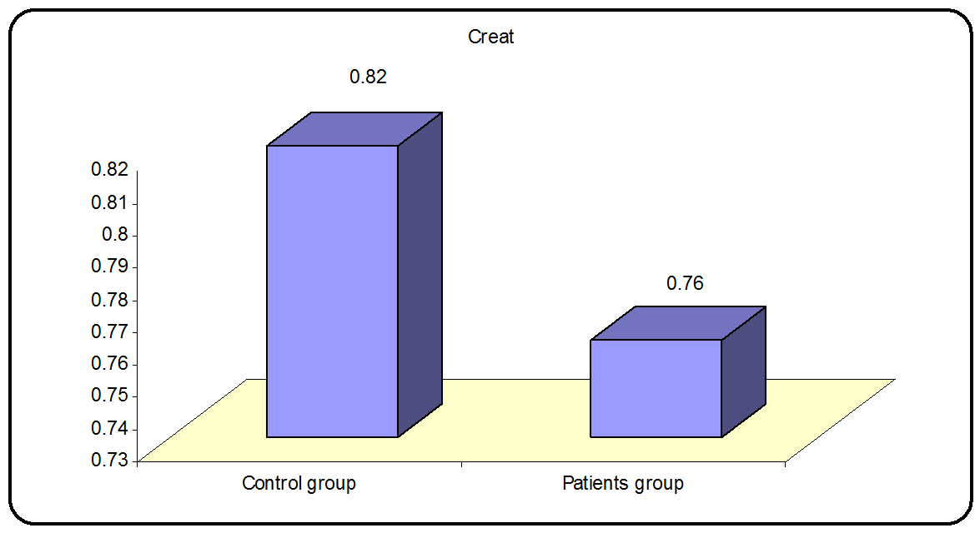
Fig (3): Serum creatinine in patient and control groups.
P value = 0.038 significant difference
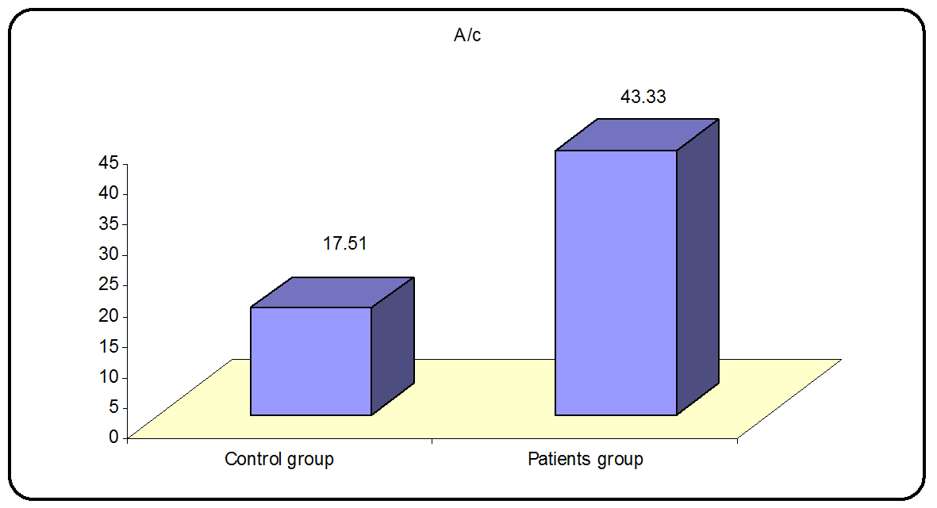
Fig (4): Albumin/creatinine ratio in patient and control groups.
P value = 0.007 significant difference
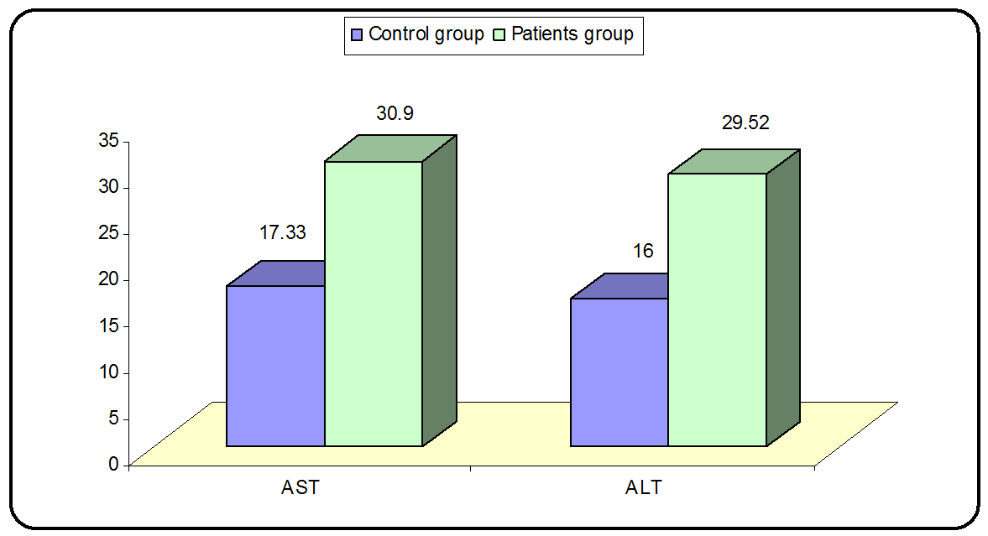
Fig (5): Liver enzymes in patient and control groups.
P value = 0.011 significant difference
P value = 0.024 significant difference
Table (2): Correlation of Cystatin C with the other studied parameters in each group.
 | Cystatinc
 | Control group |  | Patients group
 | R | p-value | r | p-value
A/c | 0.346 | 0.061 | 0.501** | 0.000
Age | 0.125 | 0.509 | 0.151 | 0.251
W | 0.177 | 0.350 | 0.089 | 0.498
H | 0.260 | 0.166 | 0.104 | 0.430
BMI | -0.085 | 0.657 | 0.071 | 0.589
Systolic BP | 0.060 | 0.755 | 0.303* | 0.019
Diastolic BP | -0.223 | 0.236 | 0.196 | 0.132
Insulin/kg | . | . | 0.223 | 0.087
HBAIC | 0.263 | 0.160 | 0.422** | 0.001
CHOL | 0.042 | 0.824 | 0.070 | 0.597
T.G | -0.169 | 0.373 | 0.174 | 0.183
HDL | 0.213 | 0.257 | -0.191 | 0.145
LDL | 0.297 | 0.111 | 0.041 | 0.755
Urea | 0.103 | 0.590 | -0.080 | 0.545
Creat | 0.156 | 0.410 | -0.160 | 0.221
Micro | 0.233 | 0.215 | 0.219 | 0.093
ALT | 0.035 | 0.855 | -0.016 | 0.902
AST | -0.078 | 0.681 | 0.036 | 0.783
DD | . | . | 0.106 | 0.422
*: Independent t-test BMI: Body mass index
P > 0.05: Non significant Wt: weight
P < 0.05: Significant Ht: height
P < 0.01: Highly significant
HbA1C: Glycosylated hemoglobin
Chol: Cholesterol
T.G: Triglycerides
HDL: High density lipoproteins
LDL: Low density lipoproteins
Micro: Microalbuminuric
A/C: Albumin/creatinine ratio
ALT: Alanine Transaminase
AST: Aspartate Transaminase
Studying the correlation between Cystatin C and different clinical and laboratory parameters in the control group revealed no correlation with any of these parameters while it revealed that Cystatin C had a significant positive correlation with A/C ratio, HbA1c, and systolic blood pressure in the patient group.
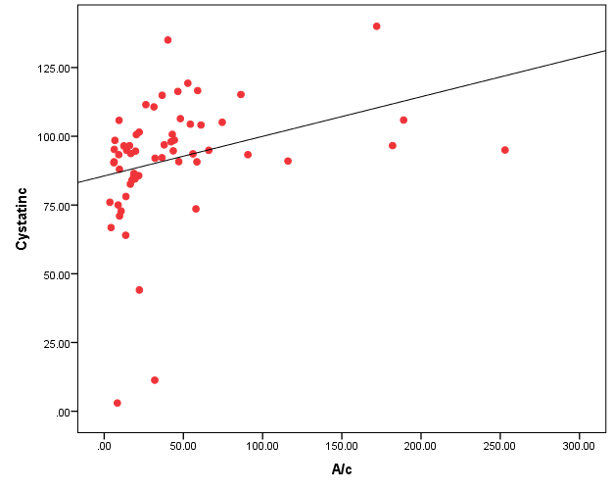
Fig (6): Correlation between Urinary Cystatin C and A/C ratio in the patient group.
P value = 0.000 positive correlation
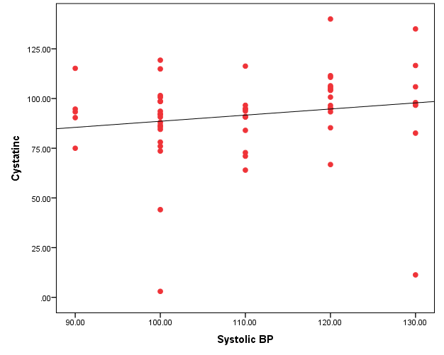
Fig (7): Correlation between Urinary Cystatin C and systolic BP in the patient group.
P value = 0.019 positive correlation
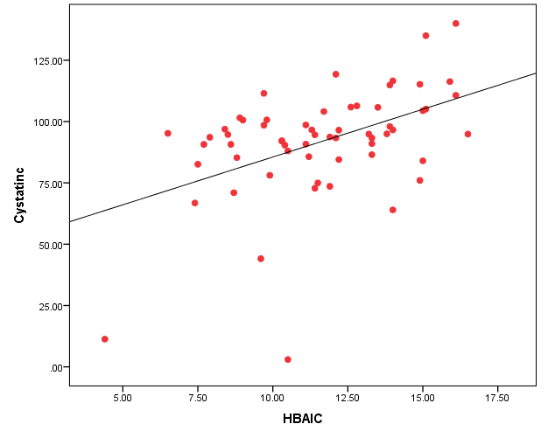
Fig (8): Correlation between Urinary Cystatin C and HbA1c in the patient group.
P value = 0.001 positive correlation
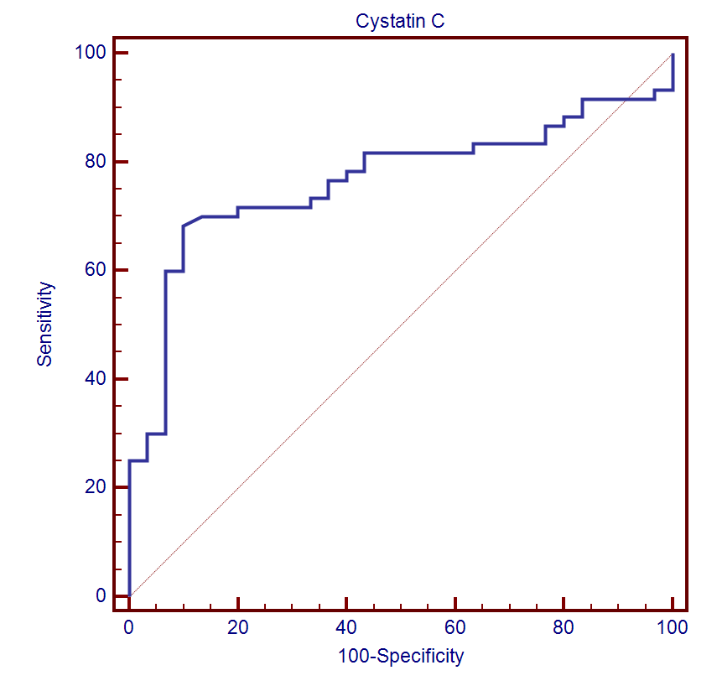

Cut off point | AUC | Sensitivity | Specificity | +PV | -PV
>90.4 | 0.766 | 68.33 | 90.00 | 93.2 | 58.7
Fig (9): ROC curve between patients group and control group
On doing a rock curve the cutoff point of Urinary Cystatin C was found to be 90.4 and it was moderately sensitive (sensitivity 68.33) and highly specific (specificity 90.0).
Table (3): Correlation of Cystatin C with the other studied parameters in all studied subjects.
 | Cystatin C
 | r | p-value
A/c | 0.556** | 0.000
Age | 0.043 | 0.685
W | 0.052 | 0.627
H | 0.085 | 0.426
BMI | -0.006 | 0.955
Systolic BP | 0.221* | 0.036
Diastolic BP | 0.151 | 0.154
Insulin/kg | 0.223 | 0.087
HBAIC | 0.559** | 0.000
P > 0.05: Non significant
P < 0.05: Significant
P < 0.01: Highly significant
As regards studying the relation between Cystatin C and the different parameters in all subjects, it revealed highly significant positive relation with A/C ratio, HbA1c, systolic blood pressure.
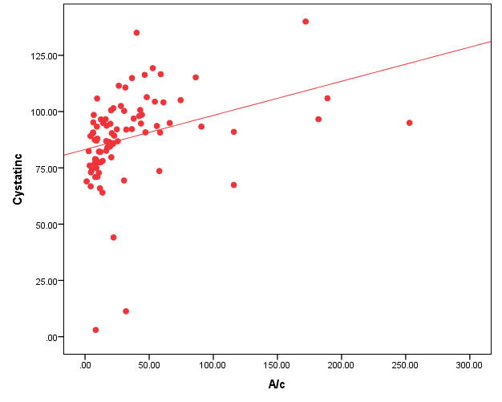
Fig (10): Correlation of Cystatin C with A/C ratio uric in studied patients.
P value = 0.000 highly significant
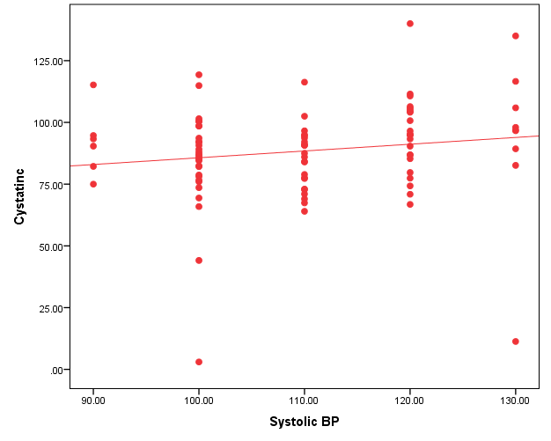
Fig (11): Correlation of cystatin C with systolic blood pressure in the studied subjects.
P value = 0.036 significant
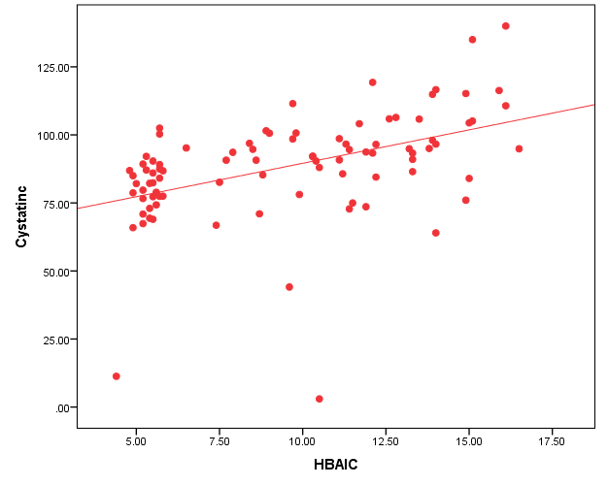
Fig (12): Correlation of cystatin C with HbA1c in the studied subjects.
P value = 0.000 highly significant
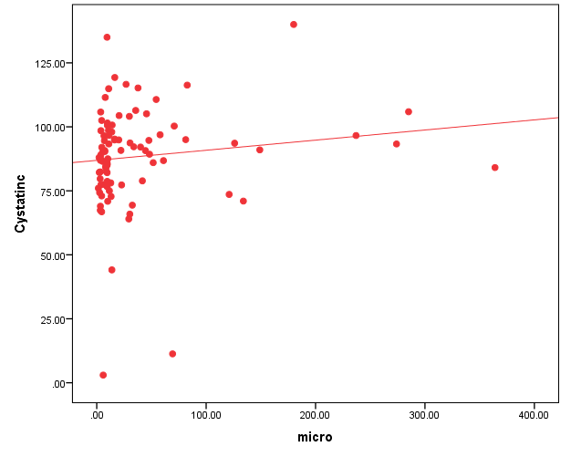
Fig (13): Correlation of cystatin C with micro albumin in the studied subjects.
P value = 0.008 highly significant
DISCUSSION
In our study urinary Cystatin C was found to be significantly high in 41 of the 60 diabetic patients and in none of the control group and was positively correlated to urinary albumin excretion and glycosylated hemoglobin.
Our results are in accordance with Ibrahim et al. (4). Who conducted a prospective observational study on 42 patients in addition to 6 healthy controls to assess urinary Cystatin C excretion and its correlation with microalbuminuria.
They found that there is statistical difference between the 2 groups in urinary Cystatin C which was higher in the patient group than the control one, and they found a positive correlation between urinary Cystatin C and A/C.
Our results were also in accordance with the results of Lee and Choi (5). who conducted a prospective study on 91 subjects (61 diabetics and 30 prediabetics) aiming to assess the level of novel urinary Biomarkers as Cystatin C, NGAL (Neutrophil Gelatinase Associated Lipocalin) in diabetes and prediabetes and their correlation with microalbuminuria and they found that urinary level of Cystatin C was significantly higher in microalbuminuric compared to normoalbuminuric patients.
Also our results are in accordance with Fiseha 2015 (2).who reviewed the recent literatures to determine if serum and urine Cystatin C measurements differ between diabetics and non diabetics, their search included 23 studies that have been published to date and all studies concluded that serum and urinary Cystatin C were elevated in type 2 diabetic patients compared to non diabetic controls including patients who had no signs indicating nephropathy, also these studies found a significant positive correlation between Cystatin C levels and albuminuria.
CONCLUSION & RECOMMENDATION
Urinary Cystatin C increased in type 1 diabetic children with more than three years duration. It was significantly correlated to microalbuminuria and glycosylated hemoglobin. It’s recommended to search its role as a marker of nephropathy in diabetic patients.
REFERENCES
American Diabetes Association (ADA) (2017): Standards of Medical care in Diabetes. Diabetes Care; 33 suppl (1):S10-66.
Fiseha T (2015): Cystatin C- A biomarker for early Nephropathy in type 2 Diabetic patients. J Mol Biomarkers Diagn; 58-010.
Gray V, Kumar M, Mahaptra H, et al. (2015): Novel Urinary biomarkers in pre diabetic nephropathy. Clin. Exp nephrol; 19: 895-900.
Ibrahim M, Ahmed Y, El Shinnawy H, et al. (2015): Value of Urinary Cystatin C in early Detection of diabetic nephropathy in type 2 Diabetes Mellitus. Int. Adv. Res. Biol. Sci; 2(3): 211-223.
International Society of Pediatric and Adolescent Diabetes (ISPAD) (2016): Consensus Guidelines for the definition, epidemiology and classification of type 1 DM in children and adolescent. Pediatric Diabetes; 15 (20): 4-17.
Lee S and Choi M (2014): Urinary biomarkers for early diabetic nephropathy: beyond albuminuria. Pediatr. Nephrol; 30: 1063-1075.
Miller C and Knapp R (1992): Clinical epidemiology and biostatistics, published by Williams and Wilkins. Maryland; 3rd edition.
Togashi Y and Miyarnoto Y (2012): Urinary cystatin C as a biomarker for diabetic nephropathy and its immunohistochemical localization in kidney in Zucker diabetic fatty (ZDF) rats;w Exp Toxical Pathol, 11.
Tresch G (2010): Review: Serum and urine biomarkers of kidney disease: A pathophysiological perspective. Nephrology (Carlton); 15(6):609-16.

